**Phase 1 Overview:**

It’s used to maintain the particular Termloan(TL) and borrower related documents. User can upload this file formats only .jpg, .jpeg, .bmp, .pdf, .txt. .xls, .xlsx, .doc, .docx, .zip, .txt files.

**Technology:**

* Angular
* Java (spring boot)
* MySQL
* AWS S3 Bucket

**Architecture:**

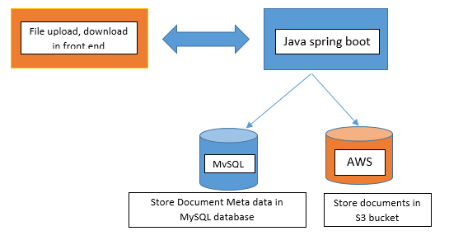

**Entity Relationship Diagram:**

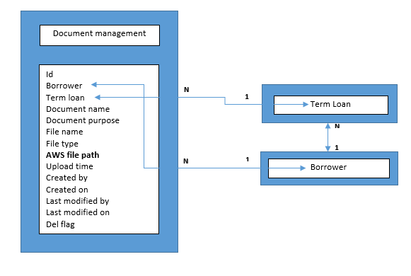

**API’s:**

1. Upload the document for selected TL and this phase 1 release only one file can upload at a time.

**URL:** http://devrorapi.cyncsoftware.com/termloan/document

**Method:** POST

**Response**: List out all the document which is not deleted, and the list should be sort in descending order of uploaded date and time

**Validation front/back end**: Max file size 50MB

**Backend**: create new Meta data record for upload document with S3 bucket file stored path URL.

1. Document listed by borrower and TL id

**URL**: http://devrorapi.cyncsoftware.com/termloan/document?borrowerId=1&termloanId=102&delete=false

**Method**: GET

**Response**: List out all the document

**Validation back end:**

If request parameter is false fetch which is not deleted document

If delete request parameter is true fetch the deleted document also from database

And list should be sort in descending order of document upload date and time

1. Download the document by id

**URL:** http://devrorapi.cyncsoftware.com/termloan/document/{documentId}

**Method:** GET

**Response**: return the selected document file

1. Delete the document by id

URL: [http://devrorapi.cyncsoftware.com/termloan/document/{documentId}](http://devrorapi.cyncsoftware.com/termloan/document/%7bdocumentId%7d)

**Method:** DELETE

**Response**: List out all the document which is not deleted, and list should sort in descending order of upload date and time

**Backend**: Update the Del flag as true for selected document record in MySQL DB then delete the document from S3 bucket.