AI/ML Revision Workbook

Prepared By:
Bhaskar Chauhan

Table of Content
- Python
- Numpy
- Pandas
- Seaborn
- Matplotlib

PYTHON

1. What is Python?

Definition
Python is a high-level, interpreted, object-oriented, and general-purpose programming language. It is easy to learn because of its simple syntax and is widely used in Web Development, Data Science, Machine Learning, Artificial Intelligence, Automation, and Software Development.

Features of Python
- Easy to Learn and Read
- Interpreted Language
- Platform Independent
- Object-Oriented
- Large Standard Library
- Open Source
- Supports Multiple Programming Paradigms

Why Python for AI/ML?
- Simple syntax
- Huge ecosystem
- Libraries like NumPy, Pandas, Matplotlib, Scikit-Learn, TensorFlow, PyTorch
- Fast development
2. Why is Python called an interpreted language?
Because Python code is executed line by line by the Python interpreter without requiring compilation into machine code beforehand.

3. Strings
A string is a sequence of characters enclosed within single quotes, double quotes, or triple quotes. Strings are one of the most commonly used data types because almost every application processes textual information.
Strings in Python are immutable, meaning their contents cannot be changed after creation. Any modification operation creates a new string instead of altering the original one.

Common Operations
- Concatenation
- Slicing
- Indexing
- String formatting
- Searching and replacing
- Splitting and joining

Common Methods
- upper()
- lower()
- replace()
- split()
- strip()
- find()

Applications
Strings are used in text processing, natural language processing, user input handling, data cleaning, and chatbot development.

4. Lists
A list is an ordered and mutable collection of elements. Lists can store multiple values of different data types in a single variable.
Lists support indexing, slicing, insertion, deletion, and modification of elements. Because of their flexibility, lists are one of the most widely used data structures in Python.

Characteristics
- Ordered
- Mutable
- Allows duplicate values
- Supports indexing

Common Methods
- append()
- insert()
- remove()
- pop()
- sort()
- reverse()
- extend()

Applications
Lists are used for storing datasets, managing records, implementing stacks and queues, and processing data in machine learning applications.

5. Tuples
A tuple is an ordered but immutable collection of elements. Once a tuple is created, its values cannot be modified.
Tuples are generally faster and more memory efficient than lists because they are immutable. They are used when data should remain constant throughout program execution.

Characteristics
- Ordered
- Immutable
- Allows duplicates
- Supports indexing

Advantages
- Faster than lists
- More secure
- Can be used as dictionary keys

Applications
Coordinates, configuration settings, database records, and fixed collections of values.
6. Sets
A set is an unordered collection of unique elements. Duplicate values are automatically removed when stored in a set.
Sets are optimized for membership testing and mathematical operations such as union, intersection, and difference.

Characteristics
- Unordered
- Mutable
- No duplicate values
- No indexing

Common Methods
- add()
- remove()
- discard()
- union()
- intersection()
- difference()

Applications
Removing duplicate records, searching, filtering unique values, and mathematical computations.

7. Dictionaries
A dictionary is a collection of key-value pairs. Each key maps to a specific value, making dictionaries highly efficient for data retrieval.
Dictionaries are one of the most powerful data structures in Python because they provide fast access to data using keys.

Characteristics
- Mutable
- Ordered (Python 3.7+)
- Unique keys
- Fast lookup operations

Common Methods
- keys()
- values()
- items()
- get()
- update()
- pop()

Applications
JSON processing, API responses, databases, configuration files, and machine learning feature mapping.

8. Conditional Statements
Conditional statements allow programs to make decisions based on specific conditions. They help control the flow of execution.
Python provides:
- if
- elif
- else
Conditions evaluate to either True or False. Based on the result, a specific block of code is executed.

Applications
- Authentication systems
- Eligibility checking
- Validation systems
- Recommendation systems
- Decision making in AI models

9. Loops
Loops are used to execute a block of code repeatedly.
Python supports:
- for loop
- while loop
A for loop is generally used when the number of iterations is known, while a while loop is used when repetition depends on a condition.

Advantages
- Reduces code repetition
- Improves efficiency
- Automates repetitive tasks

Applications
Dataset processing, model training, automation scripts, and report generation.

10. Functions
A function is a reusable block of code designed to perform a specific task.
Functions improve modularity, reusability, maintainability, and readability of programs.

Types of Functions
- Built-in Functions
- User-defined Functions
- Recursive Functions
- Lambda Functions

Advantages
- Reduces code duplication
- Makes debugging easier
- Improves program structure

Applications
Data processing pipelines, machine learning workflows, APIs, and automation.
11. Lambda Functions
Lambda functions are anonymous functions created using the lambda keyword.
Unlike normal functions, lambda functions are written in a single line and do not require a function name.

Features
- Small and concise
- Used for short operations
- Frequently used with map(), filter(), and sorted()

Applications
Data transformation, sorting operations, and functional programming.
12. List Comprehension
List comprehension is a concise way of creating lists using a single line of code.
It combines loops and conditional statements into a compact and readable syntax.

Benefits
- Less code
- Faster execution
- Better readability

Applications
Data filtering, transformation, preprocessing, and generating derived datasets.

13. Exception Handling
Exception handling is a mechanism used to handle runtime errors without terminating the program abruptly.
Python provides:
- try
- except
- else
- finally
- raise

Advantages
- Prevents program crashes
- Improves reliability
- Makes debugging easier

Applications
File handling, database operations, user input validation, and API requests.

14. File Handling
File handling allows programs to create, read, write, and modify files stored on a computer.
Python provides built-in functions for file operations.

File Modes
- r : Read
- w : Write
- a : Append
- x : Create
- rb : Read Binary
- wb : Write Binary

Applications
Log files, reports, datasets, configuration files, and machine learning data storage.

15. Modules and Packages
A module is a Python file containing functions, variables, and classes.
A package is a collection of related modules organized into directories.

Benefits
- Code reuse
- Better organization
- Easier maintenance
- Improved scalability

Common Modules
- math
- random
- datetime
- os
- statistics

Common Packages
- NumPy
- Pandas
- Matplotlib
- Scikit-Learn

NUMPY

1. Introduction to NumPy
NumPy (Numerical Python) is an open-source Python library used for numerical computations and mathematical operations on large datasets. It provides a powerful N-dimensional array object called ndarray, which is faster and more memory-efficient than Python lists.
NumPy is the foundation of Data Science, Machine Learning, Artificial Intelligence, Scientific Computing, Data Analysis, and Deep Learning. Libraries such as Pandas, Scikit-Learn, TensorFlow, and PyTorch internally use NumPy arrays for efficient computation.

Why NumPy?
Python lists are flexible but slow when performing mathematical operations on large amounts of data. NumPy solves this problem by storing data in contiguous memory locations and performing vectorized operations.

Advantages of NumPy
- Faster execution than Python lists
- Less memory consumption
- Supports multidimensional arrays
- Powerful mathematical functions
- Easy integration with ML libraries
- Supports broadcasting
- Efficient matrix operations

2. What is an Array?
An array is a collection of elements stored in contiguous memory locations. Unlike Python lists, NumPy arrays usually contain elements of the same data type.
Example:
import numpy as np

arr = np.array([10,20,30,40])

Why Arrays?
Arrays provide:
- Faster processing
- Better memory management
- Efficient mathematical calculations
3. Creating NumPy Arrays
Arrays can be created from Python lists.
Example:
import numpy as np

arr = np.array([1,2,3,4,5])
Output:
[1 2 3 4 5]

Creating 2D Array
arr = np.array([
[1,2,3],
[4,5,6]
])

Creating 3D Array
arr = np.array([
[[1,2],[3,4]],
[[5,6],[7,8]]
])

4. Dimensions in NumPy
NumPy supports multiple dimensions.

0-D Array
Contains a single value.
np.array(10)

1-D Array
Contains a single row.
np.array([1,2,3,4])

2-D Array
Contains rows and columns.
np.array([[1,2],[3,4]])

3-D Array
Contains multiple matrices.
np.array([[[1,2],[3,4]]])

5. Array Attributes

ndim
Returns number of dimensions.
arr.ndim

shape
Returns rows and columns.
arr.shape

size
Returns total elements.
arr.size

dtype
Returns datatype.
arr.dtype

itemsize
Returns memory occupied by each element.
arr.itemsize

6. Array Indexing
Indexing is used to access elements.

1-D Indexing
arr = np.array([10,20,30])

arr[1]

Output:
20

2-D Indexing
arr[1,2]

Means:
Row 1, Column 2

7. Array Slicing
Slicing extracts a portion of an array.
Syntax:
array[start:stop:step]

Example:
arr = np.array([10,20,30,40,50])

arr[1:4]

Output:
[20 30 40]

8. NumPy Data Types
Common datatypes:
Type | Meaning
int32 | Integer
float64 | Decimal
bool | Boolean
complex | Complex Number
str | String

Checking Datatype
arr.dtype

Changing Datatype
arr.astype(float)

9. Special Array Creation Functions

Zeros
Creates array of zeros.
np.zeros((3,3))

Ones
Creates array of ones.
np.ones((2,2))

Empty
Creates empty array.
np.empty((2,2))

Identity Matrix
np.eye(3)

Range
np.arange(1,10)

Equally Spaced Values
np.linspace(0,10,5)

10. Reshaping Arrays
Reshaping changes array dimensions without changing data.
Example:
arr = np.arange(12)

arr.reshape(3,4)

Output:
[[0 1 2 3]
[4 5 6 7]
[8 9 10 11]]

11. Mathematical Operations

Addition
arr + 10

Subtraction
arr - 10

Multiplication
arr * 2

Division
arr / 2

Power
arr ** 2

NumPy performs these operations element-wise.

12. Statistical Functions

Mean
np.mean(arr)

Median
np.median(arr)

Standard Deviation
np.std(arr)

Variance
np.var(arr)

Sum
np.sum(arr)

Minimum
np.min(arr)

Maximum
np.max(arr)

These functions are heavily used in Data Analysis and Machine Learning.

13. Aggregation Functions
Aggregation combines multiple values into a single result.
Examples:
arr.sum()
arr.mean()
arr.max()
arr.min()

14. Broadcasting
Broadcasting is a technique that allows NumPy to perform operations on arrays of different shapes without explicitly copying data.
Example:
arr = np.array([1,2,3])

arr + 5
Output:
[6 7 8]

Broadcasting is one of the reasons NumPy is extremely fast.

15. Random Module
Used to generate random values.

Random Integer
np.random.randint(1,100)

Random Float
np.random.rand()

Random Array
np.random.randint(1,100,10)

Seed
np.random.seed(42)
Ensures reproducible results.

16. Why is NumPy Faster than Python Lists?
- Homogeneous data storage
- Contiguous memory allocation
- Vectorized operations
- Implemented in C
- Reduced memory overhead
This is one of the most common interview questions.

PANDAS

1. Introduction to Pandas
Pandas is an open-source Python library used for data manipulation, cleaning, analysis, and transformation. It is built on top of NumPy and provides easy-to-use data structures for handling structured data.
The name "Pandas" comes from "Panel Data." It is widely used in Data Science, Machine Learning, Business Analytics, Financial Analysis, and Data Engineering.
Pandas helps us work with data stored in CSV files, Excel files, SQL databases, JSON files, and many other formats.

Why Pandas?
Real-world data is often:
- Incomplete
- Messy
- Unstructured
- Large in size
Pandas provides tools to clean, organize, transform, and analyze such data efficiently.

Applications
- Data Cleaning
- Data Analysis
- Machine Learning Preprocessing
- Financial Analysis
- Business Intelligence
- Data Visualization Preparation

3. What is a Series?
A Series is a one-dimensional labeled array capable of holding data of any type.
It consists of:
- Values
- Index
Example:
import pandas as pd
s = pd.Series([10,20,30,40])
print(s)
Output:
0 10
1 20
2 30
3 40

Characteristics
- One-dimensional
- Supports indexing
- Can store different data types

4. What is a DataFrame?
A DataFrame is a two-dimensional tabular data structure consisting of rows and columns.
It is the most important object in Pandas.
Example:
data = {
"Name":["Bhaskar","Rahul"],
"Age":[20,21]
}
df = pd.DataFrame(data)
Output:
Name Age
0 Bhaskar 20
1 Rahul 21

Characteristics
- Two-dimensional
- Rows and columns
- Similar to Excel sheet
- Most commonly used Pandas object

5. Reading Data

Reading CSV File
df = pd.read_csv("data.csv")

Reading Excel File
df = pd.read_excel("data.xlsx")

Reading JSON File
df = pd.read_json("data.json")
Why is read_csv() important?
Because most datasets used in Data Science are stored in CSV format.

6. Exploring Data

head()
Displays first 5 rows.
df.head()

tail()
Displays last 5 rows.
df.tail()

sample()
Displays random rows.
df.sample(5)

shape
Returns rows and columns.
df.shape

columns
Displays column names.
df.columns

info()
Displays dataset information.
df.info()

describe()
Displays statistical summary.
df.describe()

7. Selecting Data

Selecting Single Column
df["Age"]

Selecting Multiple Columns
df[["Name","Age"]]

Selecting Rows
df.iloc[0]

Selecting Specific Rows and Columns
df.iloc[0:5,0:3]

8. loc and iloc

loc
Uses labels.
df.loc[0]

iloc
Uses integer positions.
df.iloc[0]

9. Filtering Data
Filtering means selecting rows based on conditions.
Example:
df[df["Age"] > 20]

Multiple Conditions:
df[(df["Age"] > 20) & (df["Marks"] > 80)]

Applications
- Customer Analysis
- Sales Analysis
- Data Cleaning

10. Missing Values
Missing values are represented by NaN.

Checking Missing Values
df.isnull()

Counting Missing Values
df.isnull().sum()

Removing Missing Values
df.dropna()

Filling Missing Values
df.fillna(0)
Why handle missing values?
Machine Learning algorithms cannot effectively work with missing data.

11. Renaming Columns
df.rename(columns={
"old_name":"new_name"
})

12. Sorting Data

Ascending
df.sort_values("Age")

Descending
df.sort_values(
"Age",
ascending=False
)

13. GroupBy
GroupBy is used to split data into groups and perform aggregations.
Example:
df.groupby("Team")["Runs"].sum()

Applications
- IPL Analysis
- Sales Analysis
- Customer Analysis

14. Aggregation Functions

Sum
df["Sales"].sum()

Mean
df["Sales"].mean()

Max
df["Sales"].max()

Min
df["Sales"].min()

Count
df["Sales"].count()

15. Value Counts
Used to count frequency.
df["Team"].value_counts()

16. Unique Values

Unique
df["Team"].unique()

Number of Unique Values
df["Team"].nunique()

17. Merge
Merge combines multiple DataFrames.
Example:
pd.merge(df1,df2,on="ID")

Types
- Inner Join
- Left Join
- Right Join
- Outer Join

Interview Question
Difference between merge() and concat()?
merge():
Joins using common columns.
concat():
Combines DataFrames vertically or horizontally.
18. Concatenation
pd.concat([df1,df2])
Used for combining datasets.

19. Pivot Table
Used for data summarization.
Example:
pd.pivot_table(
df,
values="Sales",
index="Region"
)

20. Duplicate Values

Check Duplicates
df.duplicated()

Remove Duplicates
df.drop_duplicates()

21. Apply Function
Used to apply custom functions.
Example:
df["Age"] = df["Age"].apply(
lambda x:x+1
)

22. String Operations
df["Name"].str.upper()
df["Name"].str.lower()
df["Name"].str.contains("a")
Important for text preprocessing.

23. Exporting Data

CSV
df.to_csv("output.csv")

Excel
df.to_excel("output.xlsx")

24. Why are Pandas Important in Machine Learning?
Before training any model:
- Data Cleaning
- Missing Value Handling
- Feature Engineering
- Data Transformation
- Data Analysis
are performed using Pandas.
Almost every Machine Learning project starts with Pandas.

Seaborn

1. Introduction to Seaborn
Seaborn is an open-source Python data visualization library built on top of Matplotlib. It provides a high-level interface for creating attractive, informative, and statistical graphics with minimal code.
Seaborn is specifically designed for data analysis and statistical visualization. It integrates seamlessly with Pandas DataFrames and allows users to create professional-looking plots quickly.
Seaborn is widely used in:
- Data Science
- Machine Learning
- Artificial Intelligence
- Business Analytics
- Exploratory Data Analysis (EDA)

Why Seaborn?
Although Matplotlib is powerful, it requires more code to create attractive visualizations. Seaborn simplifies this process and provides better default styles.

Advantages of Seaborn
- Beautiful default themes
- Easy integration with Pandas
- Statistical visualization support
- Less code compared to Matplotlib
- Built-in datasets
- Better color palettes
- Advanced plotting functions

3. Built-in Datasets
Seaborn provides several built-in datasets useful for learning and practice.

View Available Datasets
sns.get_dataset_names()

Load Dataset
tips = sns.load_dataset("tips")

Display Data
tips.head()
Popular datasets:
- tips
- titanic
- iris
- flights
- diamonds

4. Distribution Plot (Histplot)
A histogram shows how data is distributed across different intervals.

Syntax
sns.histplot(data=df, x="column")

Example
sns.histplot(data=tips, x="total_bill")
plt.show()

Uses
- Understanding data distribution
- Detecting skewness
- Identifying outliers
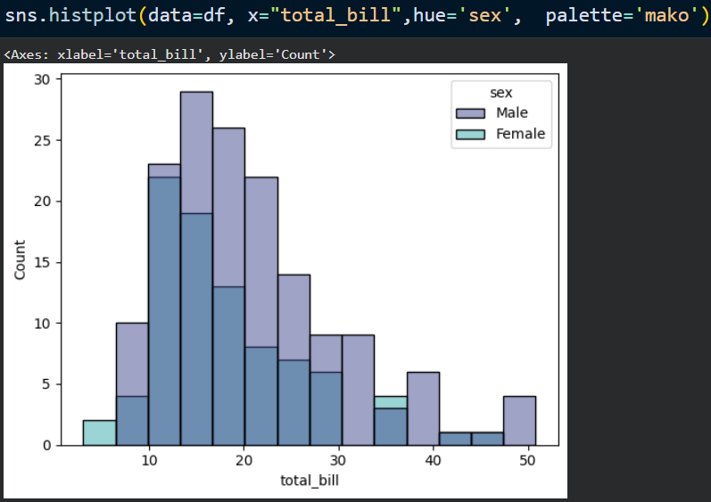

5. KDE Plot (Kernel Density Estimation)
A KDE plot displays the probability density distribution of a continuous variable.

Example
sns.kdeplot(data=tips, x="total_bill")
plt.show()

Uses
- Understanding data density
- Comparing distributions
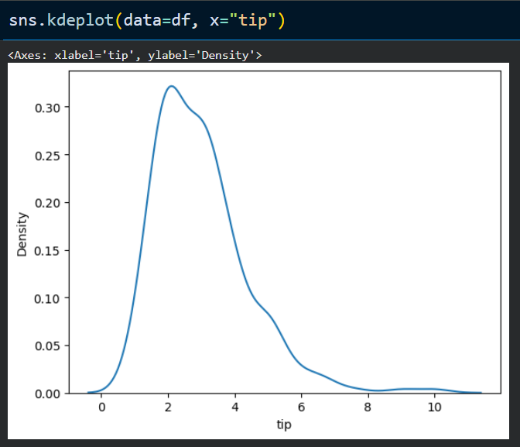

6. Scatter Plot
A scatter plot shows the relationship between two numerical variables.

Example
sns.scatterplot(
data=tips,
x="total_bill",
y="tip"
)
plt.show()

Uses
- Relationship analysis
- Correlation detection
- Trend identification
What does a scatter plot show?
A scatter plot shows the relationship between two numerical variables.

7. Line Plot
A line plot is used to show trends over time or continuous data.

Example
sns.lineplot(
data=flights,
x="year",
y="passengers"
)
plt.show()

Uses
- Trend analysis
- Time series visualization

8. Bar Plot
A bar plot compares categorical data.

Example
sns.barplot(
data=tips,
x="day",
y="total_bill"
)
plt.show()

Uses
- Category comparison
- Average value comparison
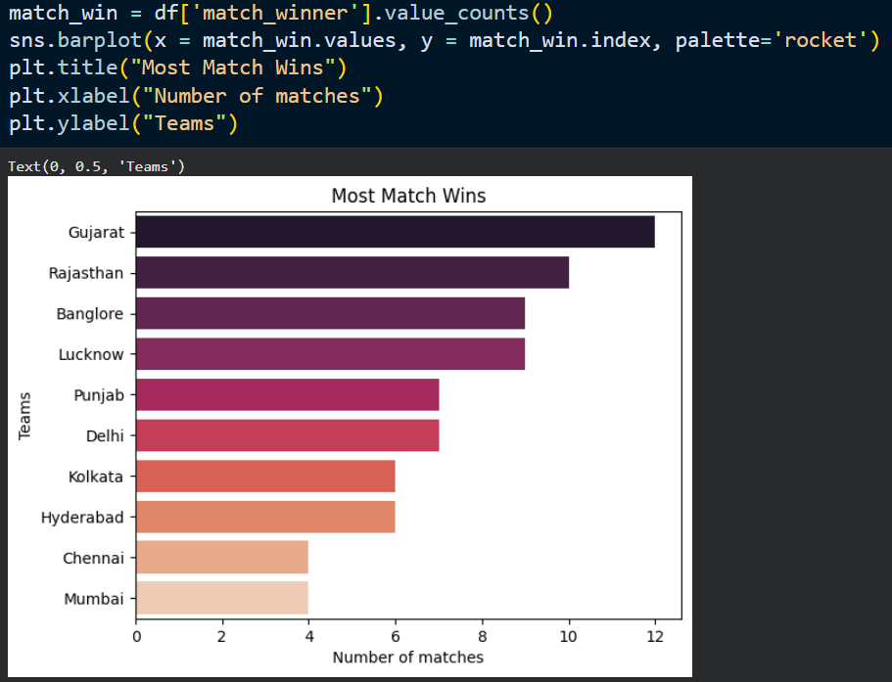
Difference between countplot and barplot?
Barplot:
Displays aggregated values.
Countplot:
Displays frequency counts.

9. Count Plot
A count plot shows the number of occurrences of each category.

Example
sns.countplot(
data=tips,
x="day"
)
plt.show()

Uses
- Frequency analysis
- Class distribution checking
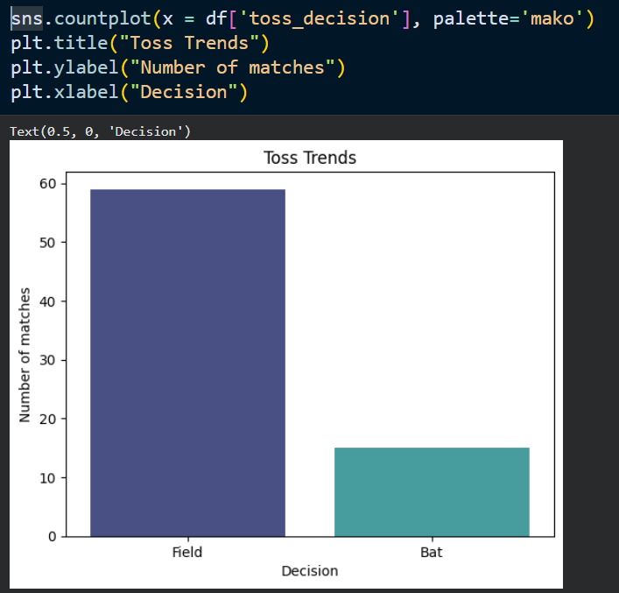

10. Box Plot
A box plot visualizes the spread of data and identifies outliers.

Example
sns.boxplot(
data=tips,
x="day",
y="total_bill"
)
plt.show()

Components
- Minimum
- Q1
- Median
- Q3
- Maximum
- Outliers

Uses
- Detecting outliers
- Comparing distributions
Why use a box plot?
To visualize distribution and identify outliers.

11. Violin Plot
A violin plot combines a box plot and a KDE plot.

Example
sns.violinplot(
data=tips,
x="day",
y="total_bill"
)
plt.show()

Uses
- Distribution analysis
- Density visualization

12. Pair Plot
Pairplot creates scatter plots between all numerical columns.

Example
sns.pairplot(iris)
plt.show()

Uses
- Exploratory Data Analysis
- Feature relationship analysis
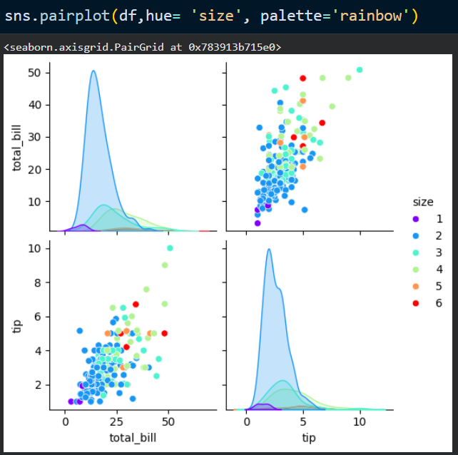

13. Heatmap
A heatmap represents data using colors.

Example
corr = tips.corr(numeric_only=True)
sns.heatmap(
corr,
annot=True
)
plt.show()

Uses
- Correlation analysis
- Feature selection
- Pattern recognition
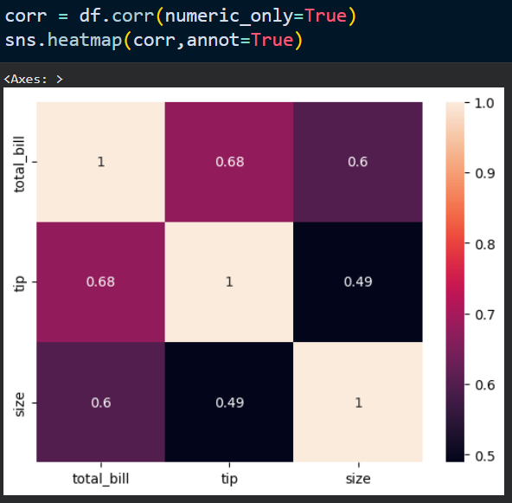

Why is a heatmap important in Machine Learning?
It helps identify relationships between variables and detect multicollinearity.

14. Correlation Matrix
Correlation measures the relationship between variables.
Range:
- +1 → Perfect Positive Correlation
- 0 → No Correlation
- -1 → Perfect Negative Correlation

Example
tips.corr(numeric_only=True)

Applications
- Feature Selection
- Data Analysis
- Machine Learning

15. Hue Parameter
Hue adds an additional categorical variable to visualizations.

Example
sns.scatterplot(
data=tips,
x="total_bill",
y="tip",
hue="sex"
)

Benefits
- More information in a single plot
- Better comparison
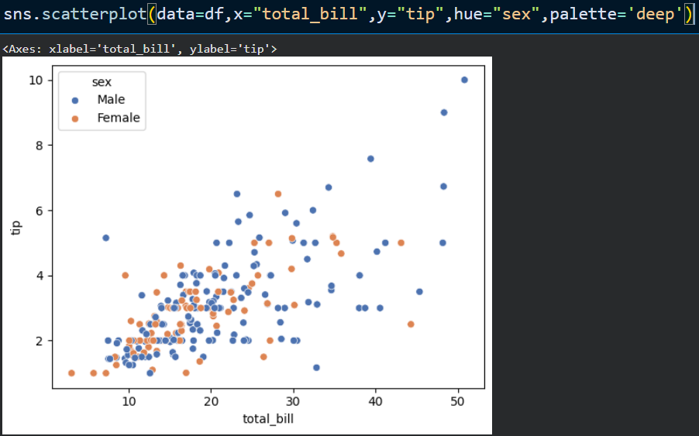

16. FacetGrid
FacetGrid creates multiple plots based on category values.

Example
g = sns.FacetGrid(
tips,
col="sex"
)
g.map(
sns.histplot,
"total_bill"
)

Uses
- Subgroup analysis
- Comparative visualization
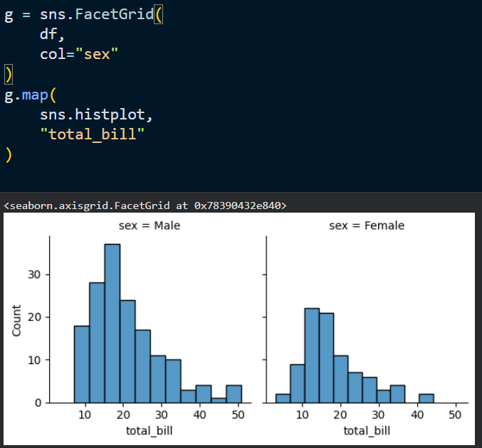

17. Joint Plot
Jointplot combines:
- Scatter Plot
- Histogram

Example
sns.jointplot(
data=tips,
x="total_bill",
y="tip"
)
plt.show()

Uses
- Distribution analysis
- Relationship analysis
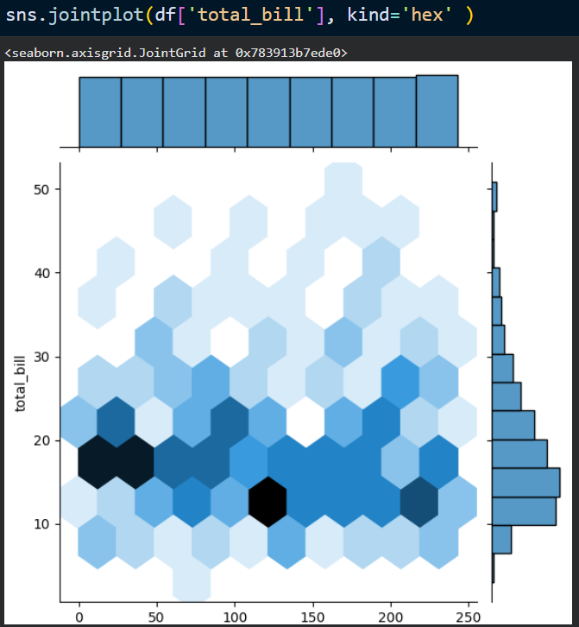

19. Color Palettes
Seaborn provides attractive color schemes.

Example
sns.color_palette()
Popular palettes:
- deep
- muted
- pastel
- bright
- Dark

20. Why is Seaborn Important in Machine Learning?
Before building a model, data scientists perform Exploratory Data Analysis (EDA).
Seaborn helps in:
- Understanding distributions
- Detecting outliers
- Identifying correlations
- Analyzing relationships
- Feature selection
A large portion of data understanding happens through Seaborn visualizations.

MATPLOTLIB

1. Introduction to Matplotlib
Matplotlib is an open-source Python library used for creating static, animated, and interactive visualizations. It is one of the most popular data visualization libraries in Python and serves as the foundation for many other visualization libraries, including Seaborn.
Matplotlib allows users to create a wide variety of charts and graphs to understand, analyze, and present data effectively.

Why Matplotlib?
Data becomes easier to understand when represented visually. Matplotlib helps transform numerical data into graphical representations that reveal patterns, trends, and relationships.

Applications
- Data Analysis
- Data Science
- Machine Learning
- Business Analytics
- Scientific Research
- Financial Analysis

Advantages
- Easy to use
- Highly customizable
- Supports multiple chart types
- Works well with NumPy and Pandas
- Large community support

2. Installing and Importing Matplotlib

Installation
pip install matplotlib
]

Importing
import matplotlib.pyplot as plt
The pyplot module provides functions for creating visualizations.

3. Basic Plot
A plot is the simplest graph used to visualize relationships between variables.
Example:
import matplotlib.pyplot as plt
x = [1,2,3,4]
y = [10,20,30,40]
plt.plot(x,y)
plt.show()

Components of a Plot
- X-axis
- Y-axis
- Data Points
- Title
- Labels

4. Figure and Axes
A Figure represents the entire window or canvas.
An Axes represents the actual graph area where data is plotted.
Example:
fig, ax = plt.subplots()
ax.plot([1,2,3],[4,5,6])
plt.show()
Difference between Figure and Axes?
Figure:
Entire plotting area.
Axes:
Individual graph inside the figure.

5. Adding Title and Labels

Title
plt.title("Sales Analysis")

X-axis Label
plt.xlabel("Months")

Y-axis Label
plt.ylabel("Sales")
Example:
plt.plot(x,y)
plt.title("Sales Trend")
plt.xlabel("Months")
plt.ylabel("Sales")
plt.show()
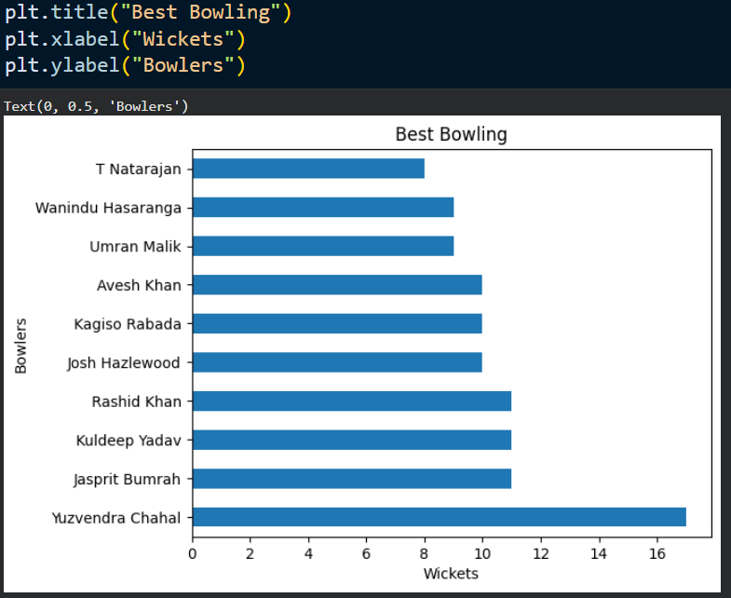

6. Line Plot
A line plot displays trends over time or continuous data.
Example:
months = [1,2,3,4]
sales = [100,150,200,250]
plt.plot(months,sales)
plt.show()

Applications
- Stock Market Analysis
- Sales Trends
- Weather Analysis
- Time Series Data
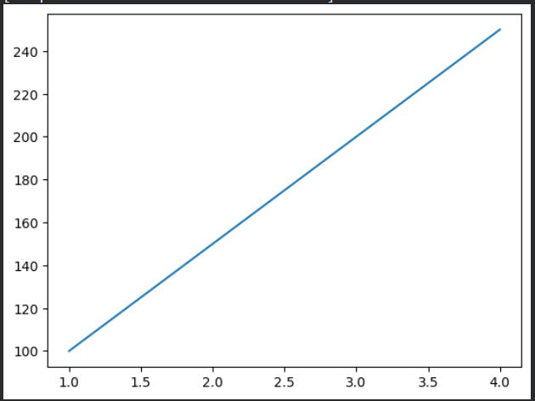

7. Scatter Plot
A scatter plot displays relationships between two numerical variables.
Example:
x = [1,2,3,4]
y = [10,15,25,35]
plt.scatter(x,y)
plt.show()

Applications
- Correlation Analysis
- Trend Detection
- Relationship Analysis
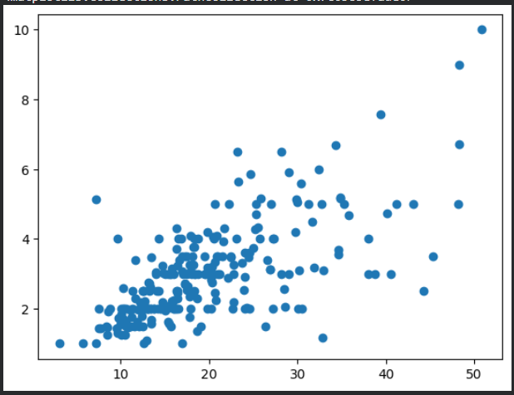

8. Bar Chart
A bar chart compares categorical data.
Example:
students = ["A","B","C"]
marks = [80,90,75]
plt.bar(students,marks)
plt.show()

Applications
- Category Comparison
- Product Sales
- Customer Analysis

9. Horizontal Bar Chart
Example:
plt.barh(students,marks)
plt.show()
Used when category names are long.
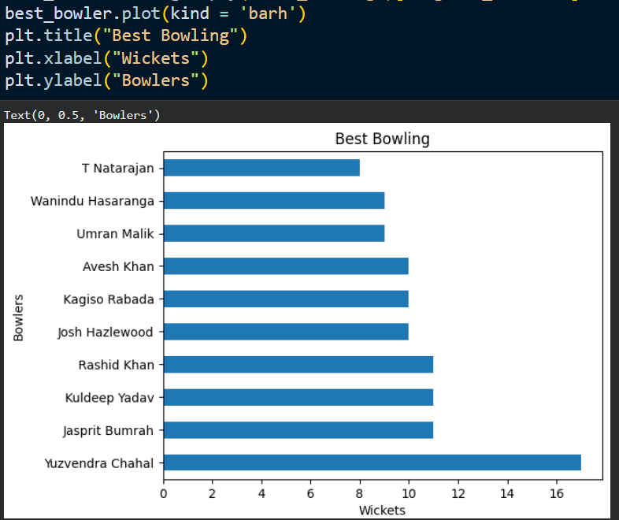

10. Histogram
A histogram displays the distribution of numerical data.
Example:
import numpy as np
data = np.random.randn(100)
plt.hist(data)
plt.show()

Applications
- Distribution Analysis
- Outlier Detection
- Understanding Data Spread

Difference between Histogram and Bar Chart?
Histogram:
Numerical data distribution.
Bar Chart:
Categorical data comparison.

11. Pie Chart
A pie chart displays proportions of categories.
Example:
sizes = [40,30,20,10]
labels = ["A","B","C","D"]
plt.pie(sizes,labels=labels)
plt.show()

Applications
- Market Share
- Survey Results
- Percentage Distribution

12. Box Plot
A box plot visualizes data distribution and outliers.
Example:
data = [1,2,3,4,5,100]
plt.boxplot(data)
plt.show()

Components
- Minimum
- Q1
- Median
- Q3
- Maximum
- Outliers

Applications
- Outlier Detection
- Distribution Analysis

13. Subplots
Subplots allow multiple graphs within a single figure.
Example:
plt.subplot(1,2,1)
plt.plot([1,2,3],[4,5,6])
plt.subplot(1,2,2)
plt.bar([1,2,3],[4,5,6])
plt.show()

Benefits
- Comparative Analysis
- Dashboard Creation
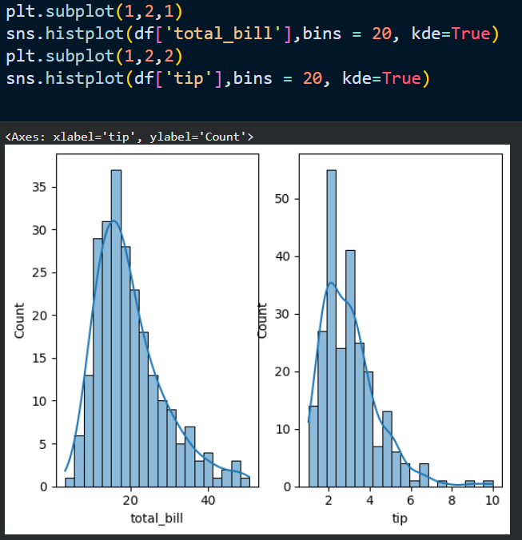

14. Legends
Legends identify plotted data.
Example:
plt.plot(
[1,2,3],
[4,5,6],
label="Sales"
)
plt.legend()
plt.show()

15. Grid
A grid improves graph readability.
Example:
plt.grid(True)

16. Colors and Styles
Example:
plt.plot(
x,
y,
color="red",
linestyle="--"
)

Common Colors
- red
- blue
- green
- black

17. Saving Figures
Example:
plt.savefig("graph.png")

Benefits
- Report Generation
- Project Documentation
- Presentation Preparation

18. Working with NumPy
Matplotlib integrates closely with NumPy.
Example:
import numpy as np
x = np.arange(0,10)
y = x**2
plt.plot(x,y)
plt.show()

Applications
- Mathematical Functions
- Scientific Visualization

19. Working with Pandas
Example:
df["Sales"].plot()
plt.show()

Benefits
Quick visualization of DataFrame columns.

20. Why is Matplotlib Important in Machine Learning?
Before training a model, data scientists analyze and understand data through visualizations.
Matplotlib helps in:
- Trend Analysis
- Outlier Detection
- Feature Understanding
- Model Performance Visualization
- Result Interpretation
Many ML evaluation metrics are visualized using Matplotlib.

Difference Between Matplotlib and Seaborn
Matplotlib | Seaborn
Base visualization library | Built on Matplotlib
More customization | More attractive defaults
Requires more code | Requires less code
General purpose | Statistical visualization
Basic styling | Advanced styling

