Introduction

Computer program input generally has some structure; in fact, every computer program that does input can be thought of as defining an ``input language'' which it accepts. An input language may be as complex as a programming language, or as simple as a sequence of numbers. Unfortunately, usual input facilities are limited, difficult to use, and often are lax about checking their inputs for validity.

During the first phase the compiler reads the inputand converts strings in the source to tokens. With regular expressions patterns can be specified to lex so it can generate code that will allow it to scan and match strings in the input. Each pattern specified in the input to lex has an associated action. Typically an action returns a token that represents the matched string for subsequent use by the parser. Initially the matched string will simply be printed rather than return a token value.

Yacc provides a general tool for describing the input to a computer program. The Yacc user specifies the structures of his input, together with code to be invoked as each such structure is recognized. Yacc turns such a specification into a subroutine that handles the input process; frequently, it is convenient and appropriate to have most of the flow of control in the user's application handled by this subroutine.

The input subroutine produced by Yacc calls a user-supplied routine to return the next basic input item. Thus, the user can specify his input in terms of individual input characters, or in terms of higher level constructs such as names and numbers. The user-supplied routine may also handle idiomatic features such as comment and continuation conventions, which typically defy easy grammatical specification.

Yacc is written in portable C. The class of specifications accepted is a very general one: LALR(1) grammars with disambiguating rules.

Purpose
- This application is used to download and save all the available faculty web pages of CS department of IIT Kharagpur using a crawler.
- The saved data can be exported in a database from the local system.
- The database can be queried and result can be displayed in a user interface in Client side.

3. BLOCK DIAGRAM:
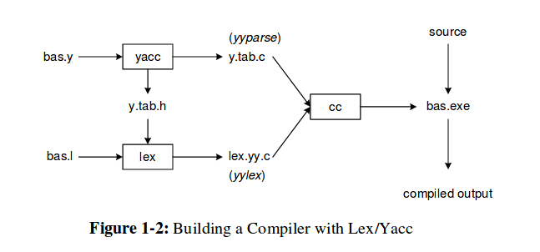

5. API’s used:
- Flex(For lex)
- Bison(For Yacc)

6. Programming Language:
- Python (For Crawling)
- C (For Parsing)

