**SSIS Homework – 1**

**INFO 7290 SEC 01**

**Mayur Bhat**

**001886566**

Question 1. Export the HumanResources.Employee table from AdventureWorks. If you use the wizard to learn that is fine but you must create a SSIS package in the SQL Server Data Tools / Visual studio environment.

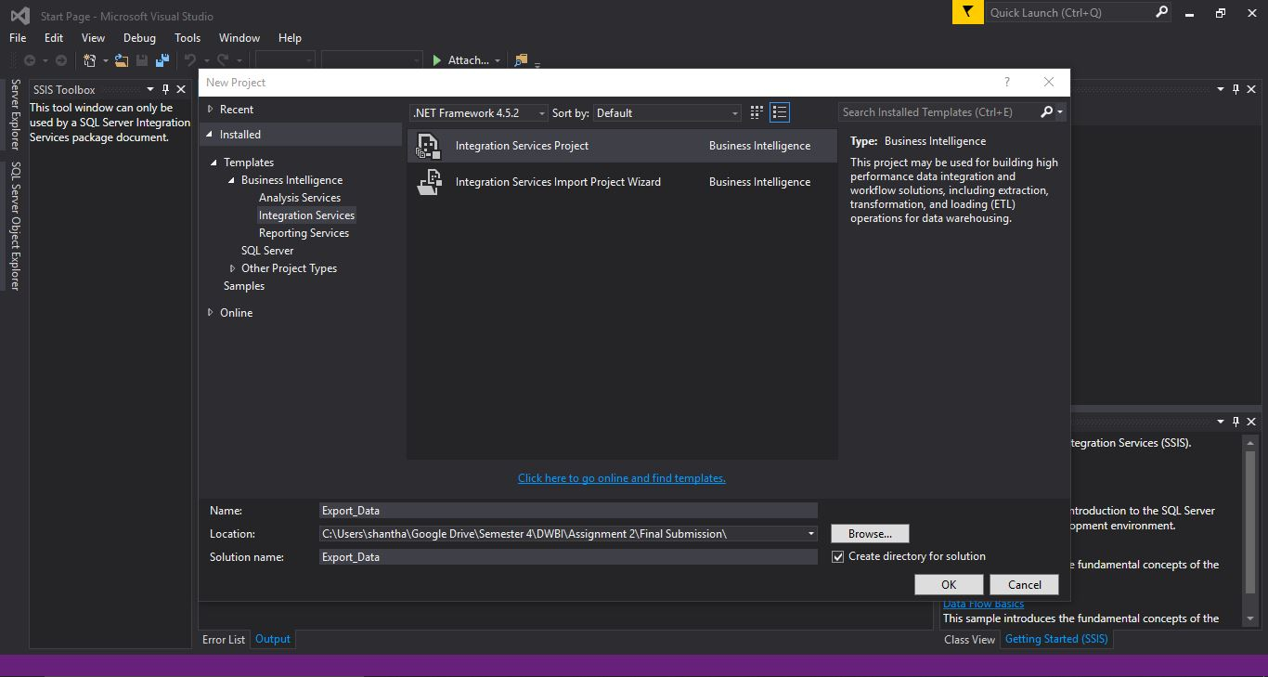Step – 1. Open Visual Studio and create a New Project. Save it as whatever name you see fit. I chose “Export_Data”. This creates a package “Export_Data” in the location chosen.

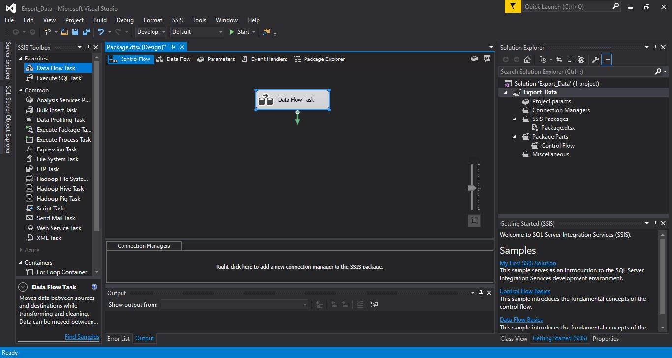Step – 2. Drag and drop “Data Flow Task” to create a New Data Flow Task in the project.

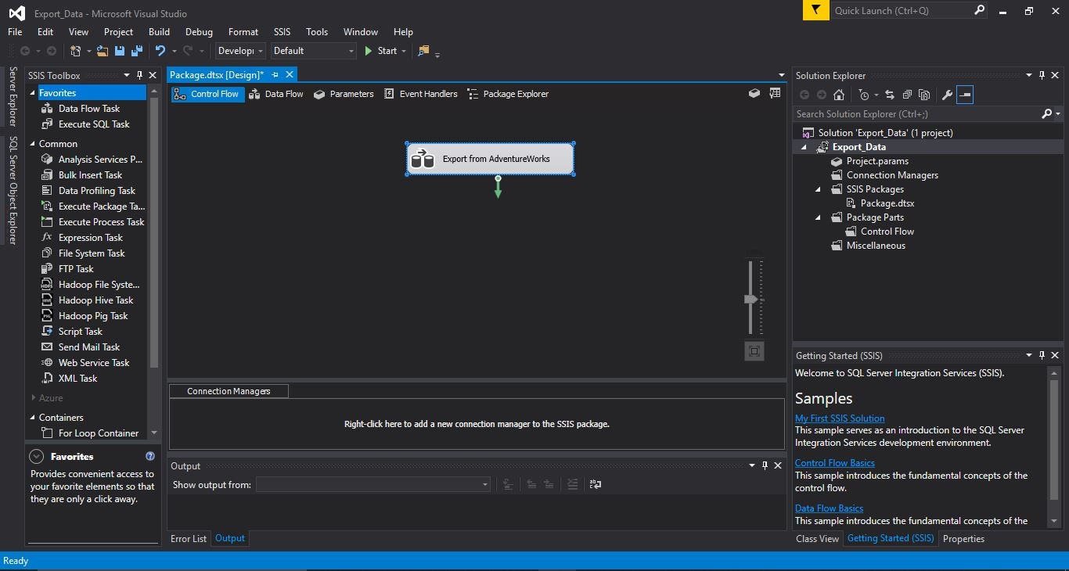Step – 3. Rename the Data Flow Task to whatever you see fit, I chose “Export from AdventureWorks”

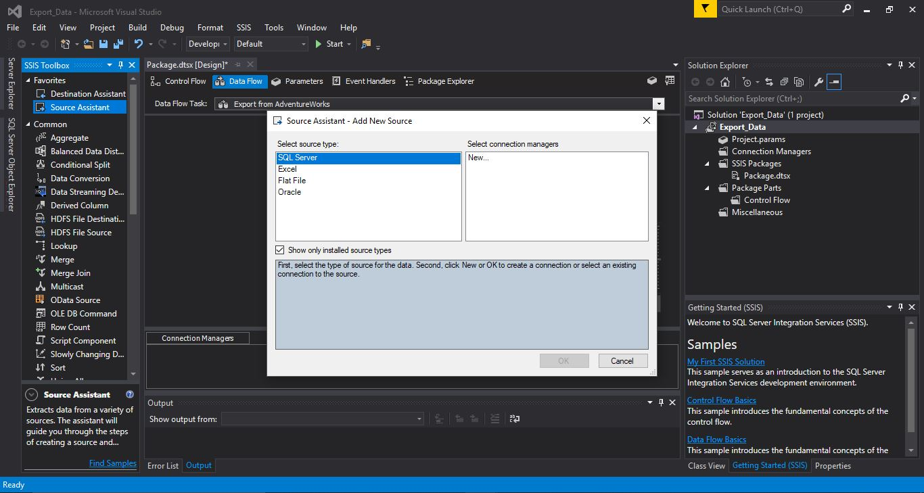Step – 4. Double click on the Data Flow Task to open the Data Flow Tab. In this window, drag and drop “Source Assistant” to define the source of your data. In this case, we choose SQL server as our data is present in the SQL server in the database “AdventureWorks” under the table “HumanResources.Employee”. Click on “New..”.

Step – 5. Choose your Server Name and Select your database as “AdventureWorks”. Click on “OK”. Note that your Microsoft SQL Server Management Studio should be running before this step for Visual Studio to detect your Server.

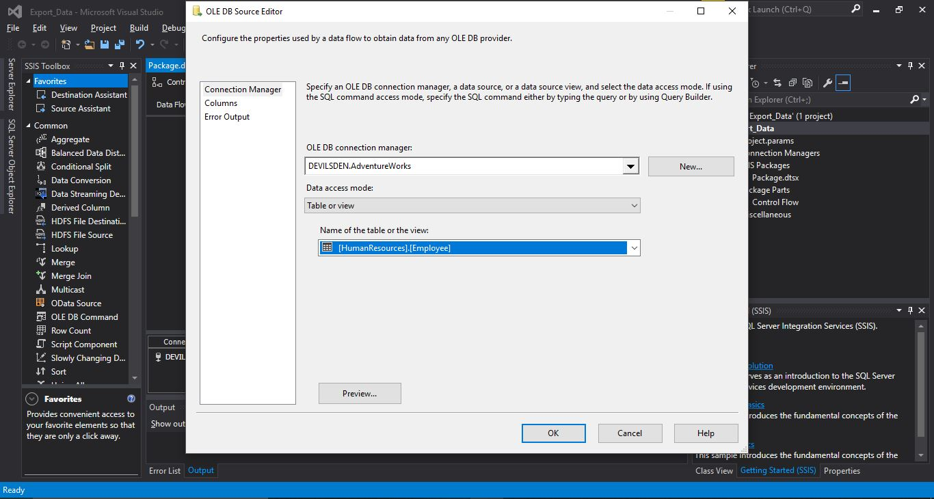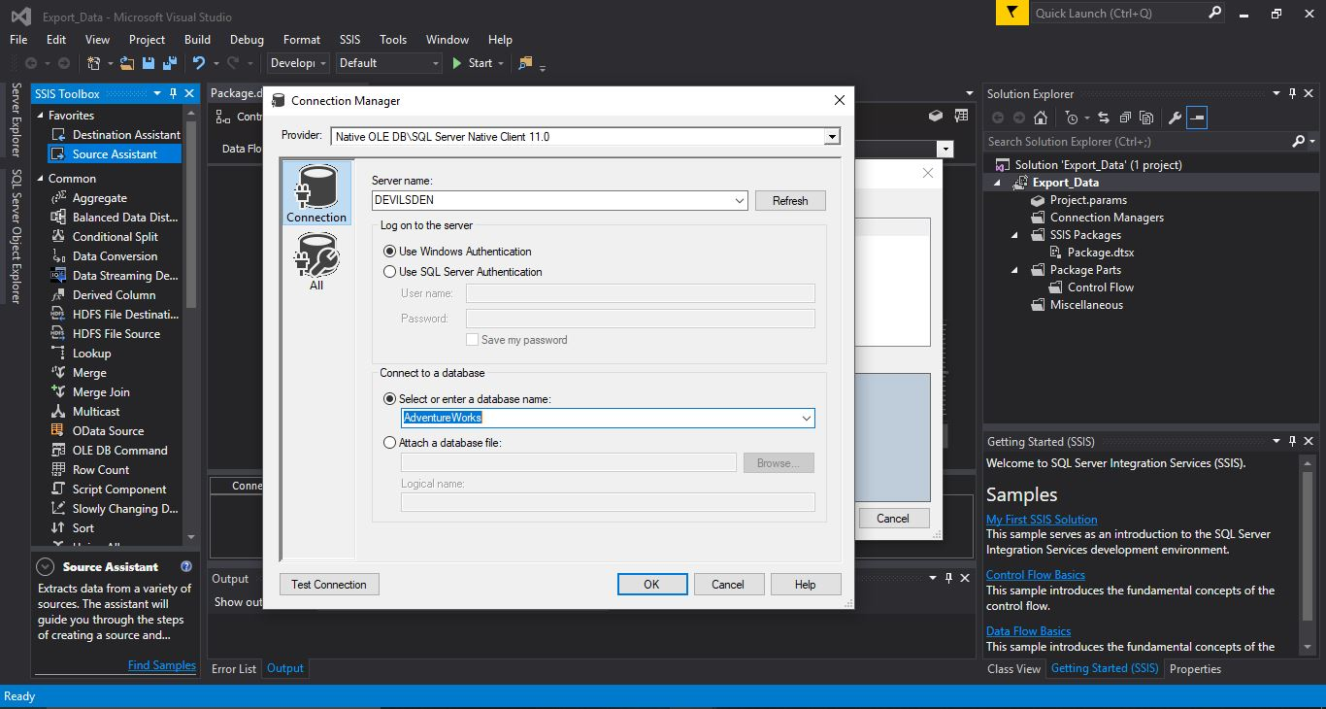Step – 6. Double click on the newly Created OLE DB Source to select which table within the AdventureWorks database is to be utilised to export data from. In this case, we are interested in “[HumanResources].[Employee]”. Click “OK”.

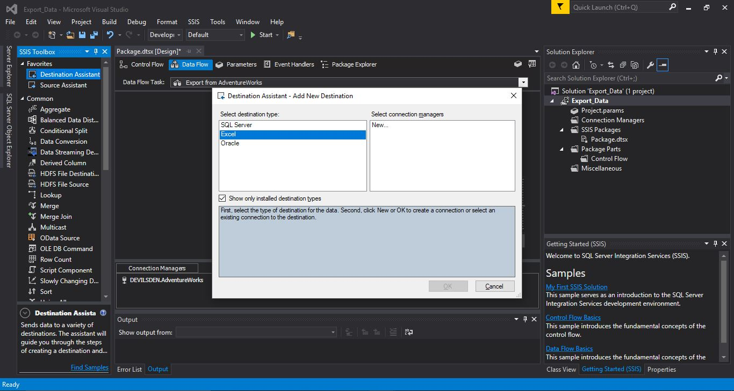Step – 7. Drag and drop the “Destination Assistant” into your project area. Select destination type as “Excel”. Then click on “New..”.

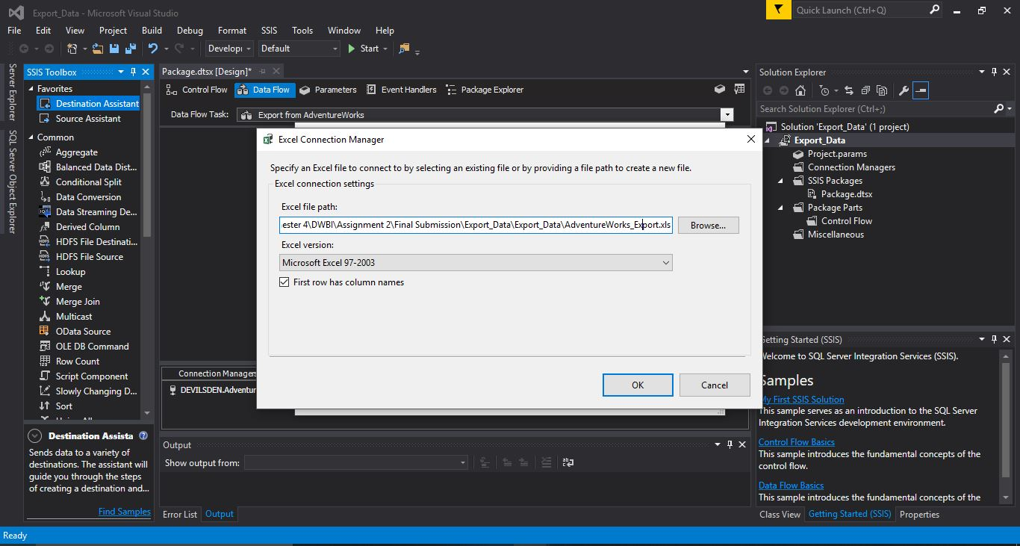Step – 8. Choose the path to save your Excel file. In this case, I chose the project folder as the location for saving the Excel File. Hit “OK”.

Step – 9. Connect the OLE DB Source and Excel Destination. Then, double click on your Excel Destination to define the Sheet name in your Excel file where the data should export to. Click on “New..” to select a Sheet Name. In this case, I chose “Excel_Export”. Ensure that the Mappings are concurrent with your Database table.

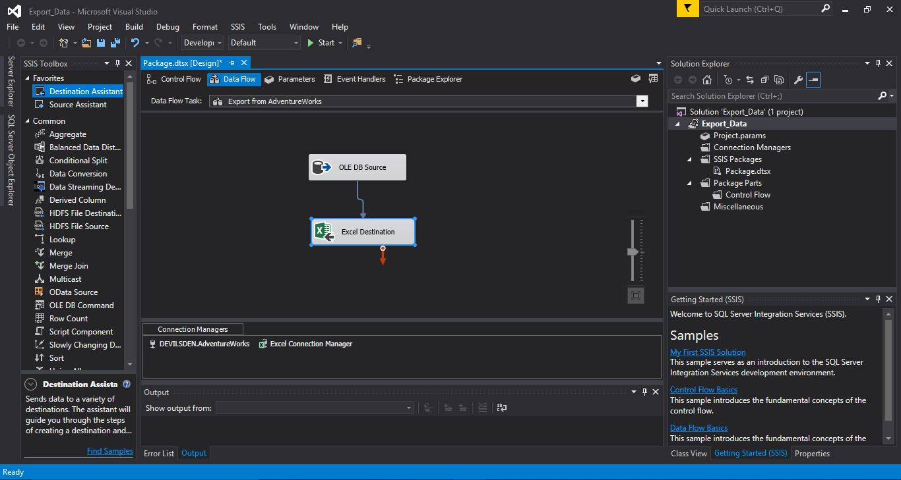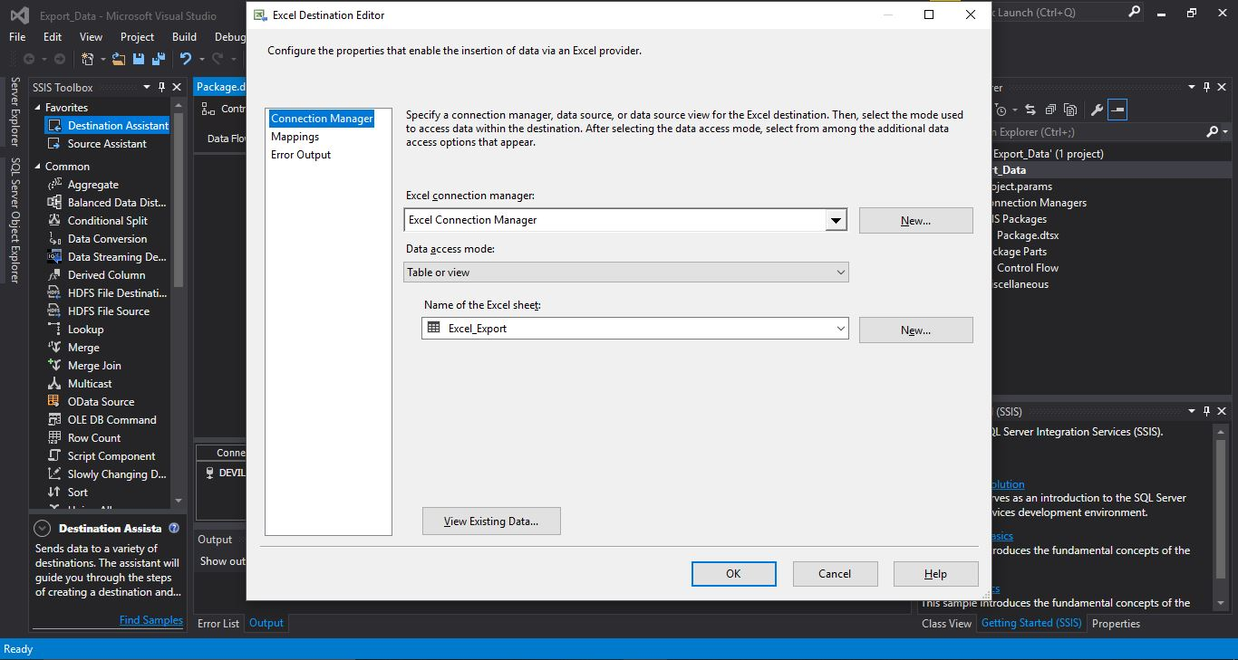Step – 10. Your data is now ready to be exported. Click on “Start” to begin the data export process.

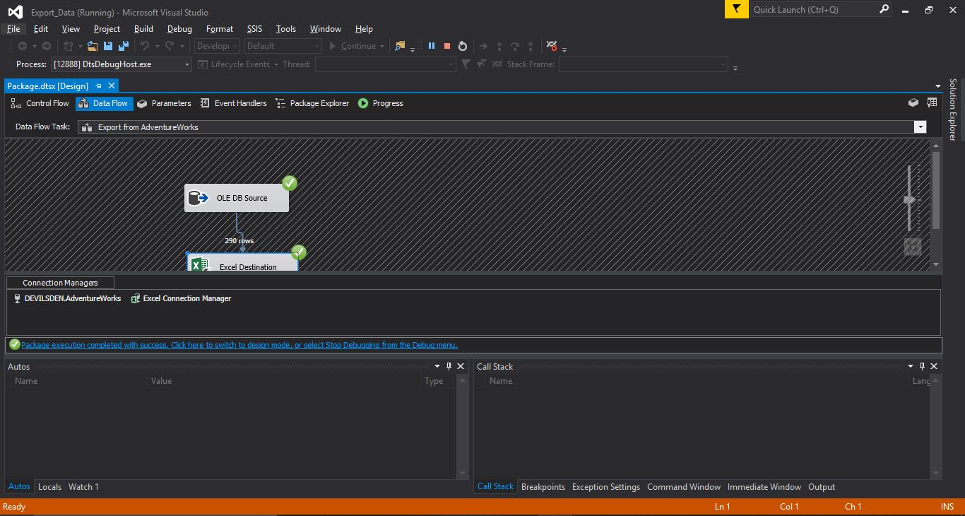Step – 11. Upon successful execution, we get the following screen which indicates that 290 rows have exported from the OLE DB Source (“HumarResources.Employees”) to Excel Destination.

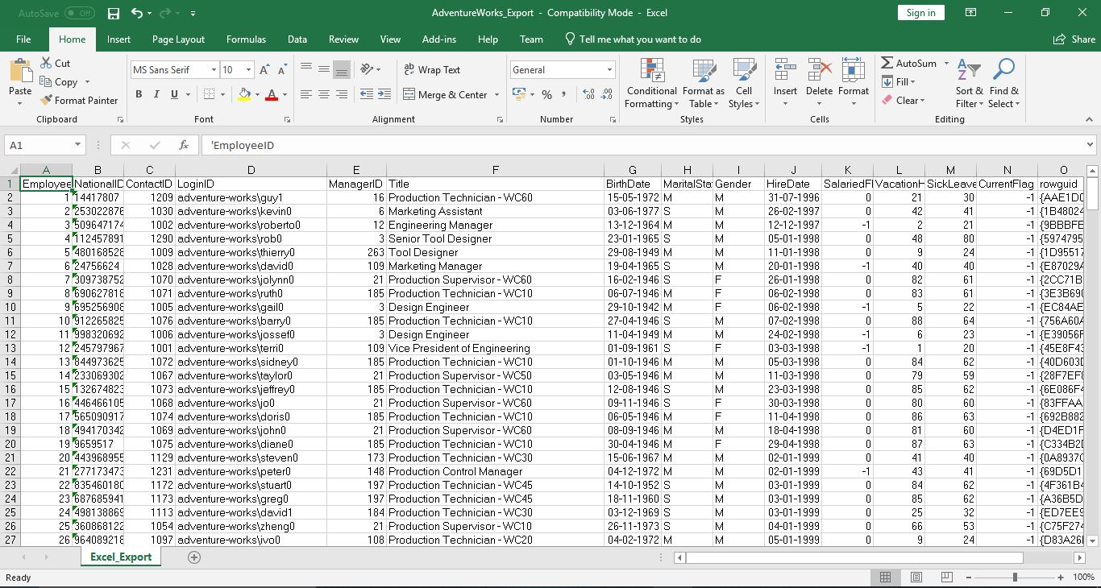Step – 12. Open the Excel file in the location mentioned earlier to ensure that the data has indeed exported successfully.

Question 2. Create a script for staging table for importing the employee data. Remember staging tables are less restrictive. You can use the existing table as a template but should rename it and consider the constraints and data types during the design.

Create a new Database to store the Staging table. I chose to create a Database called “StagingAdventureWorks”. In this, open a New Query and enter the following script ensuring that there are no constraints on the Staging Table. The Staging Table has been named “StagingEmployee”.

CREATE TABLE StagingEmployee (

    [EmployeeID] float,

    [NationalIDNumber] nvarchar(max),

    [ContactID] float,

    [LoginID] nvarchar(max),

    [ManagerID] float,

    [Title] nvarchar(max),

    [BirthDate] datetime,

    [MaritalStatus] nvarchar(max),

    [Gender] nvarchar(max),

    [HireDate] datetime,

    [SalariedFlag] float,

    [VacationHours] float,

    [SickLeaveHours] float,

    [CurrentFlag] float,

    [rowguid] nvarchar(255),

    [ModifiedDate] datetime

)

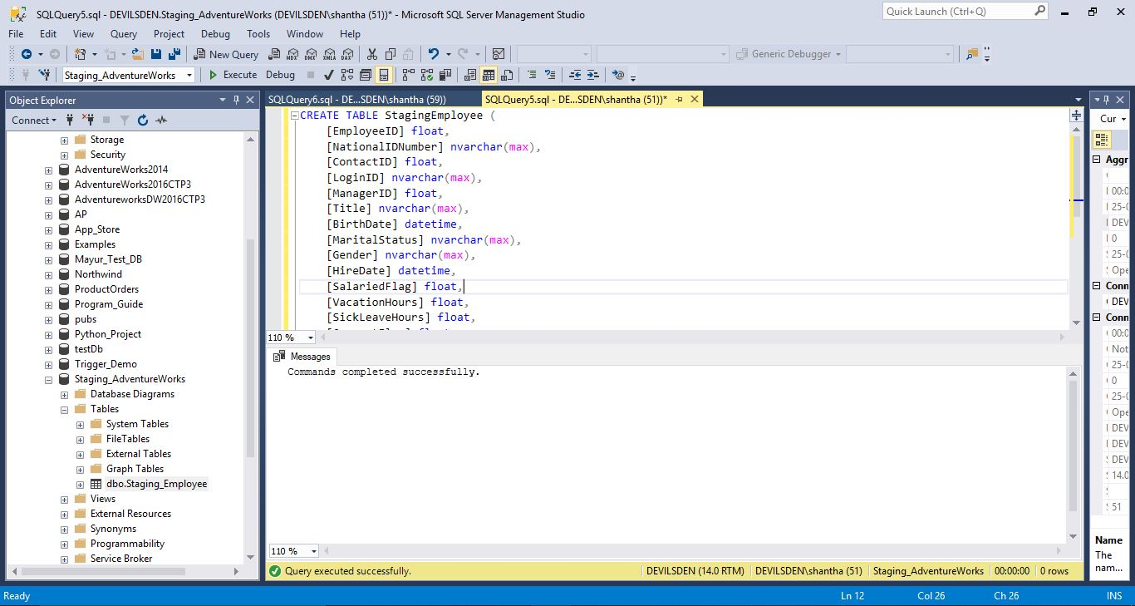

Question 3. Create a SSIS package to load the data. Again, using the wizard to learn is fine but you need to make a package in ssis from scratch.

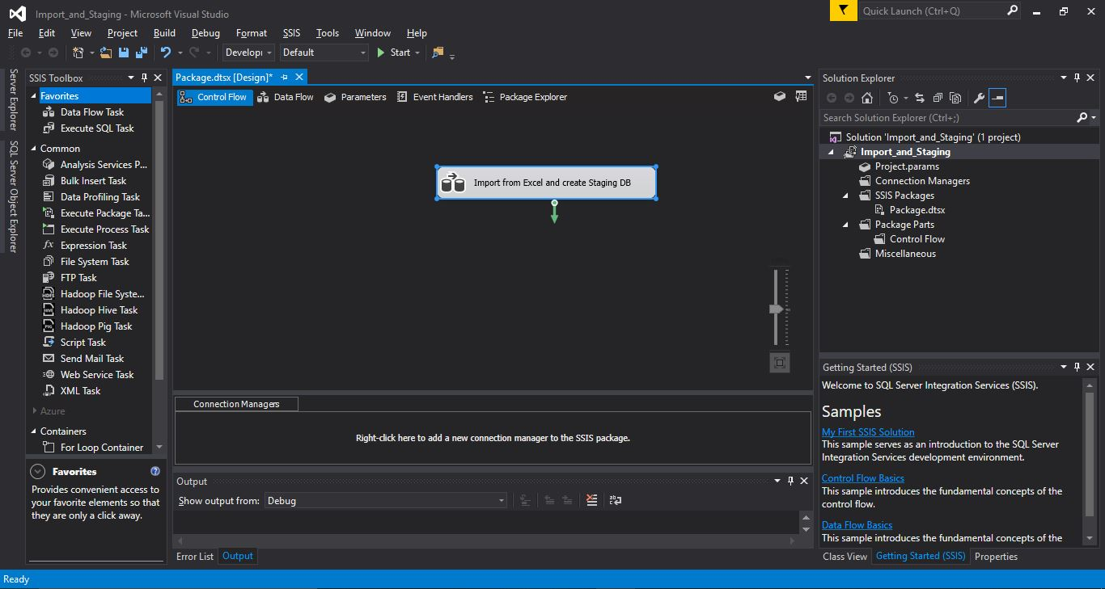Step – 1. Open Visual Studio and create a New Project. Save it as whatever name you see fit. I chose “Import_and_Staging”. Drag and drop “Data Flow Task” to create a New Data Flow Task in the project. Rename the New Data Flow Task as you see fit. In this instance, it has been named “Import from Excel and create Staging DB”.

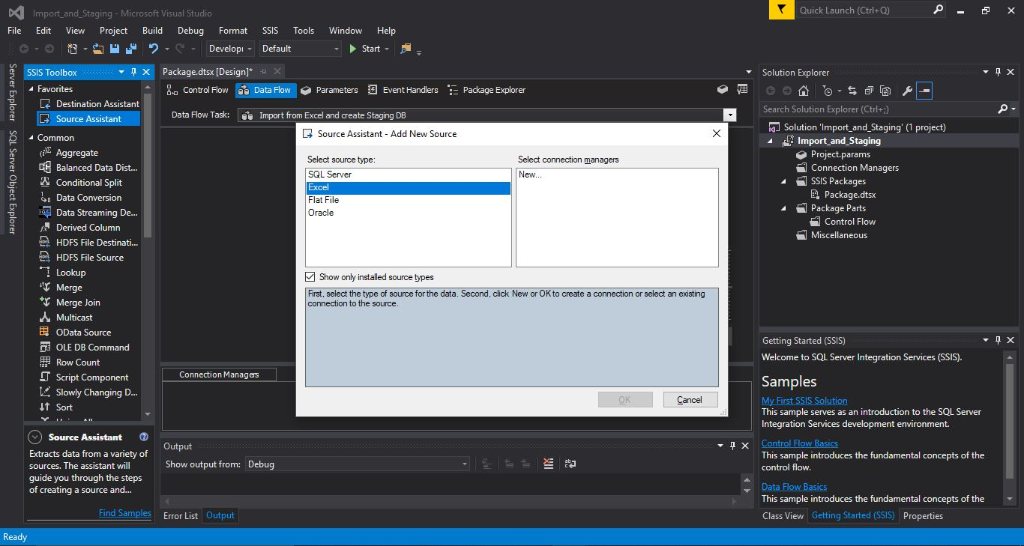Step – 2. Double click on the Data Flow Task to open it and drag and drop the “Source Assistant” in the project area. Here Select “Excel” as Source Type and Click on “New..”.

Step – 3. Choose the path for the Excel file from which the data needs to be loaded. This is the same file location as in Question 1 to export the data. Click on “OK”.

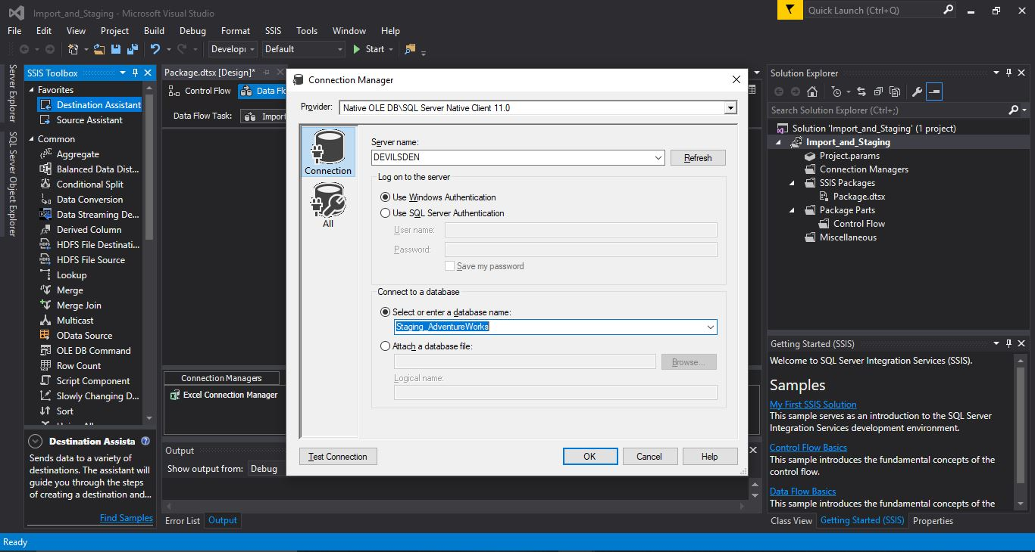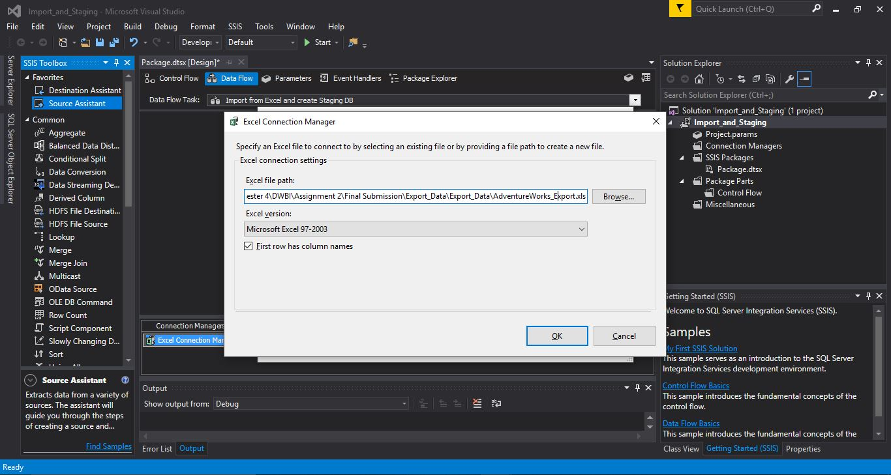Step – 4. Once the Source has been set, Drag and Drop the “Destination Assistant” to the project area. As we are looking to create a staging Database Table. Choose your destination as “SQL Server”. Choose your Server Name and Choose the Database created in Question 2 (“StagingAdventureWorks”) and click on “OK”.

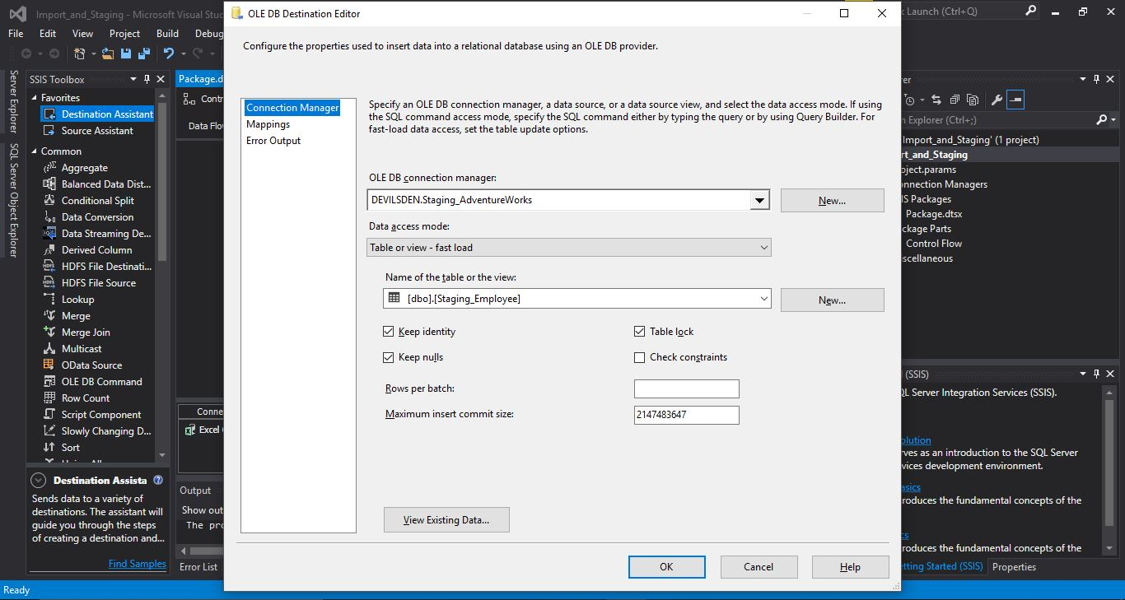Step – 5. Connect the Excel Source and OLE DB Destination with the arrows. Now double click on the OLE DB Destination and define the table in the “StagingAdventureWorks” to which the data needs to be imported, in this case that would be “StagingEmployee”. Make sure that “Keep identity” and “Keep nulls” is turned on to ensure that all data migrates without any issue. Also check the “Mappings” to make sure that the data is imported to the right column names.

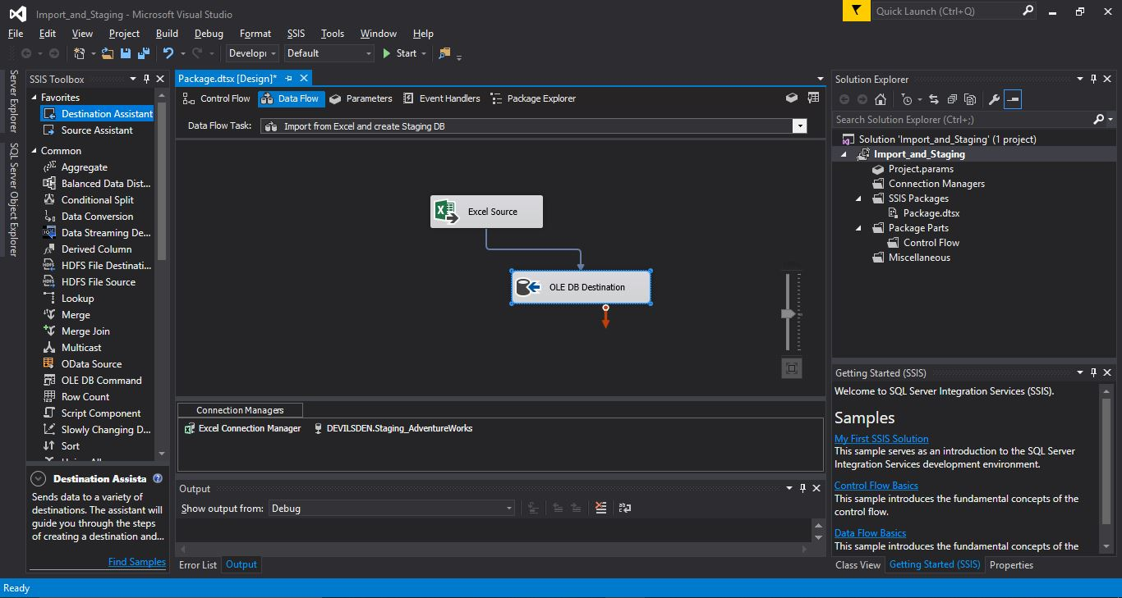Step – 6. Now the data is ready to be migrated from the Excel file to the OLE DB destination in the SQL server.

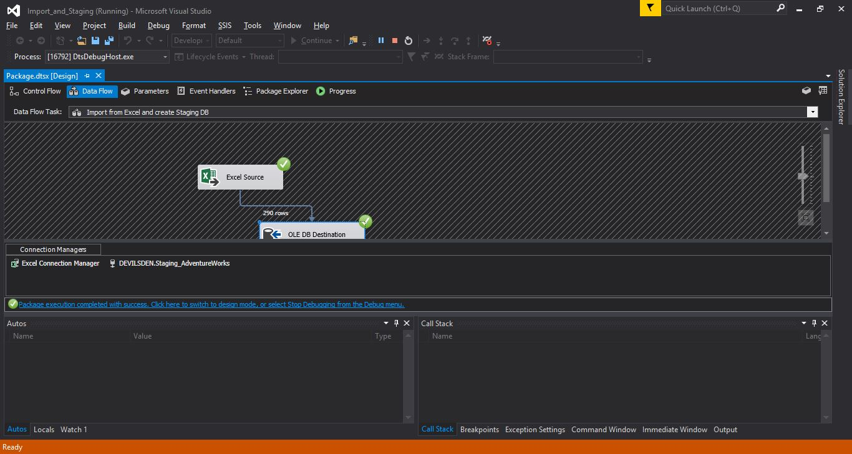Step – 7. Click on “Start” to begin the data migration process. Upon successful data migration, we can see that 290 rows have been copied from the Excel Source to the OLE DB destination table(“Staging.Employee”)

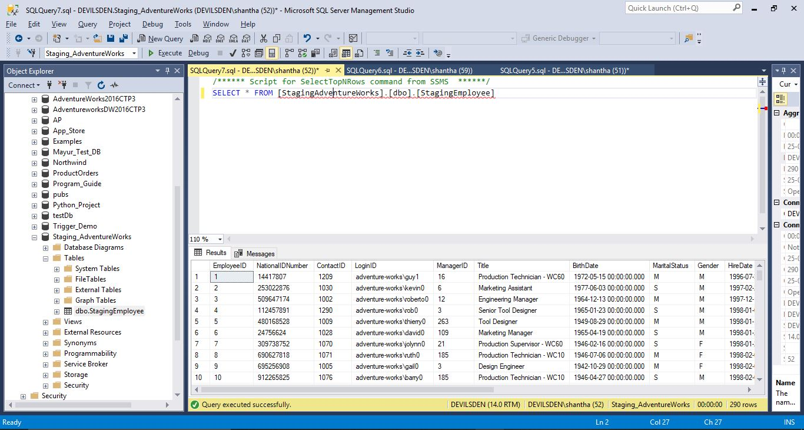Step – 8. Open SQL Server Management Studio to ensure that all data has been copied to the staging table as expected.