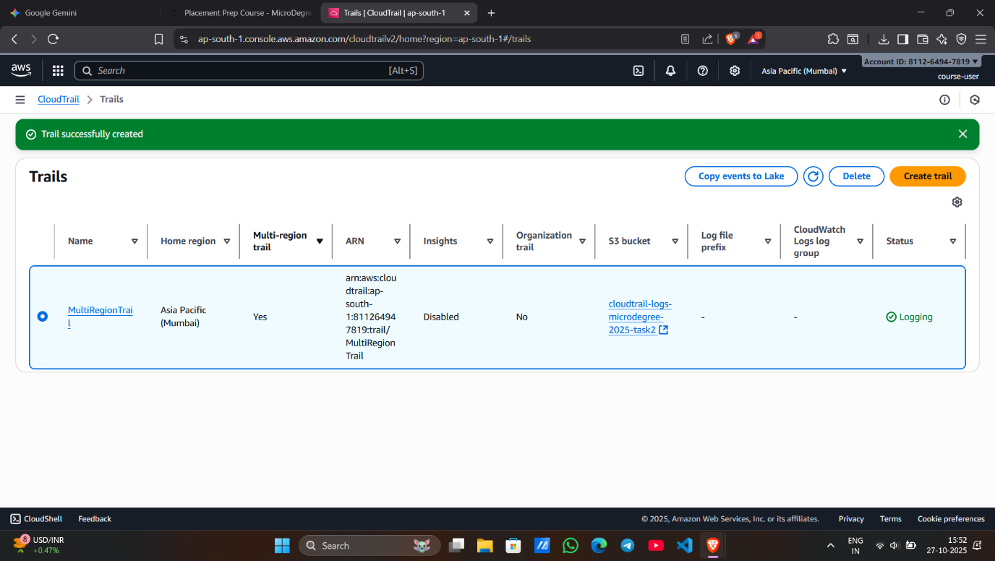

**Screenshot 1 – Create CloudTrail Configuration**

* Shows the creation screen of the CloudTrail named **MultiRegionTrail**.
* Confirms an **S3 bucket** has been selected to store all logs.
* Indicates that CloudTrail will capture management events from the AWS account.
* Displays that **Multi-Region** option is enabled for the trail.
* Confirms both **Read and Write management events** are being logged.
* Ensures activity from all AWS regions will be recorded.

**Screenshot 2 – Trail Successfully Created**

* Shows the new trail **MultiRegionTrail** listed in the **CloudTrail console**.
* Confirms the trail is in **“Enabled”** status.
* Indicates logs are being delivered to the specified **S3 bucket**.

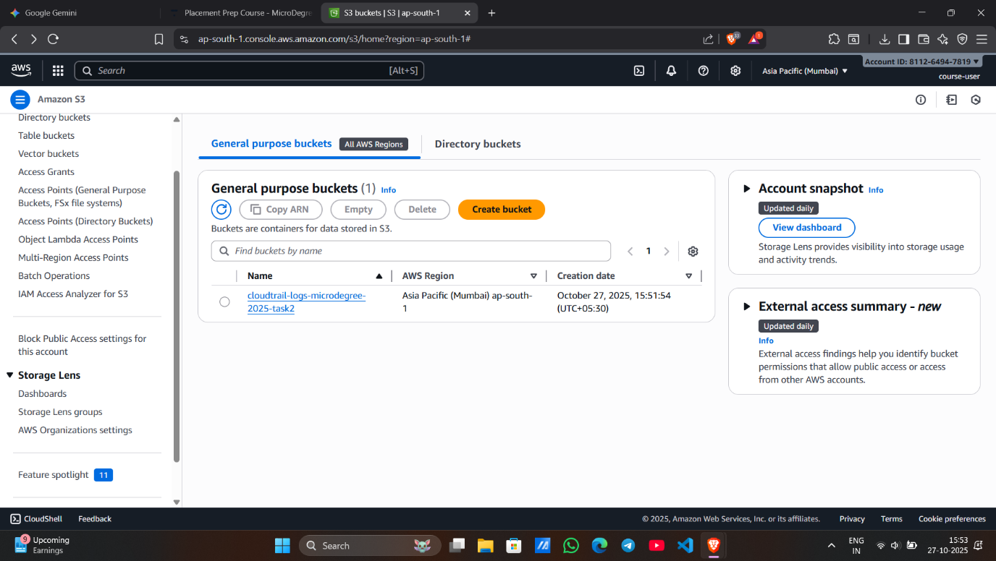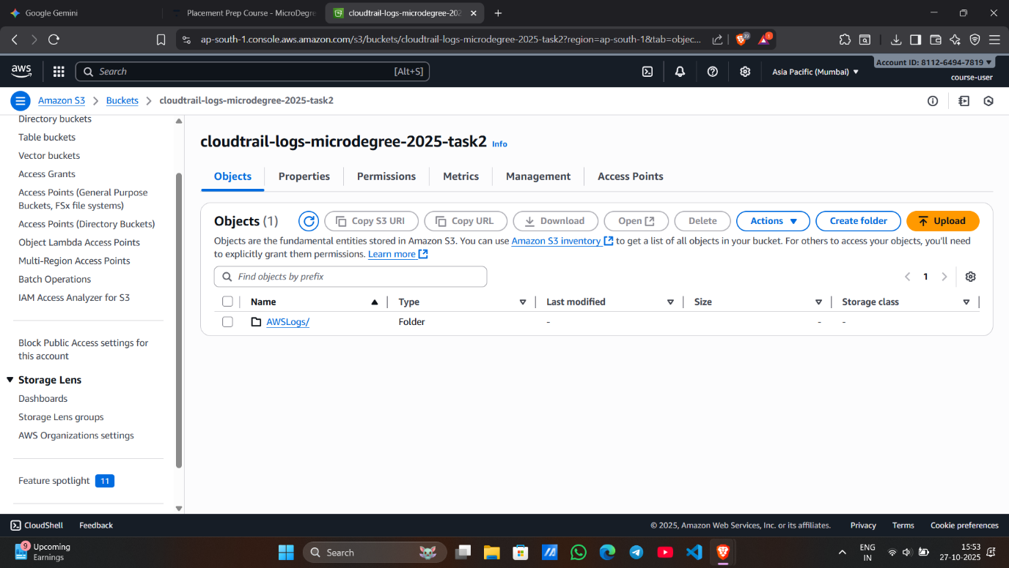

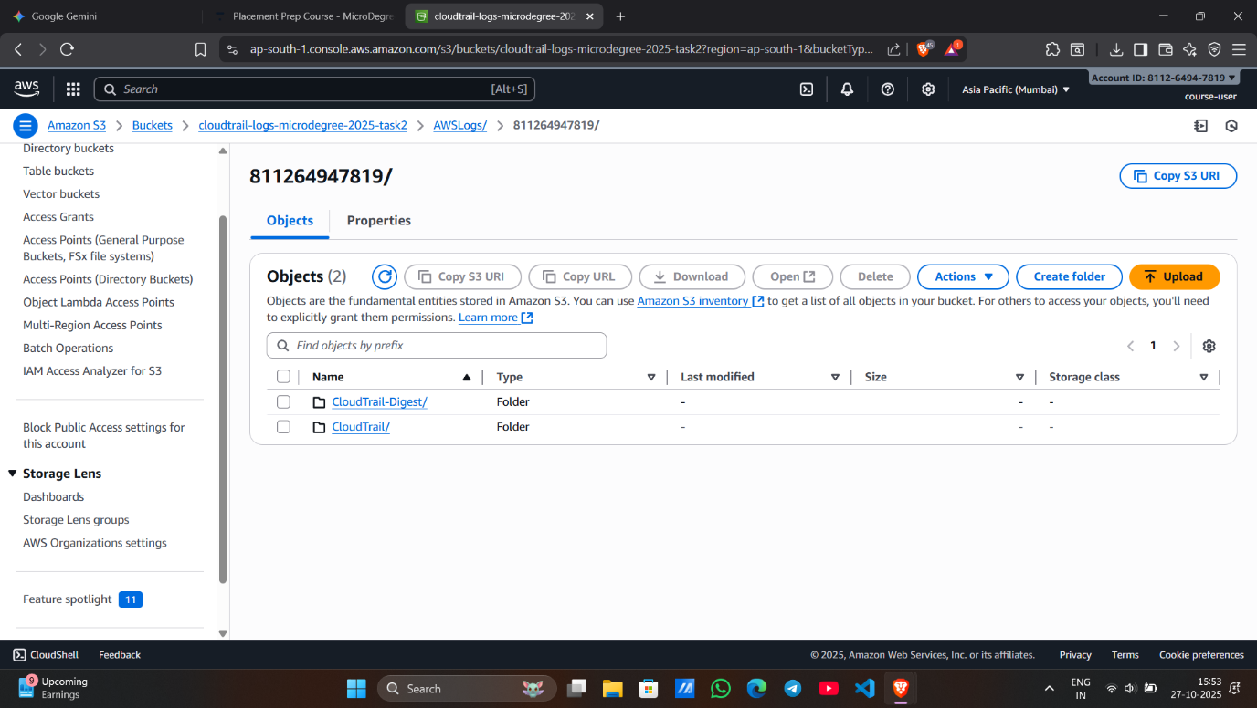

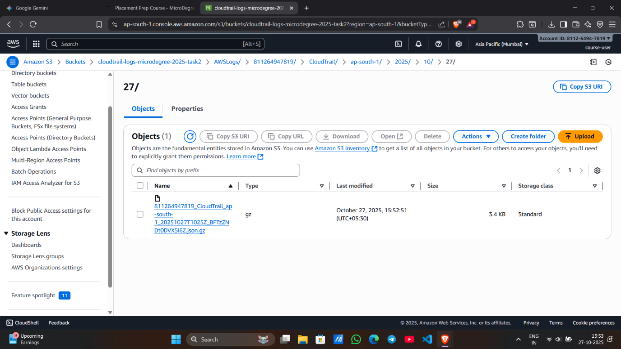

**Screenshot 4 – S3 Bucket with CloudTrail Logs**

* Displays the **S3 bucket** where CloudTrail logs are stored.
* Shows folder structure with **AWSLogs/** path confirming delivery.
* Proves that CloudTrail is successfully writing logs to the bucket.