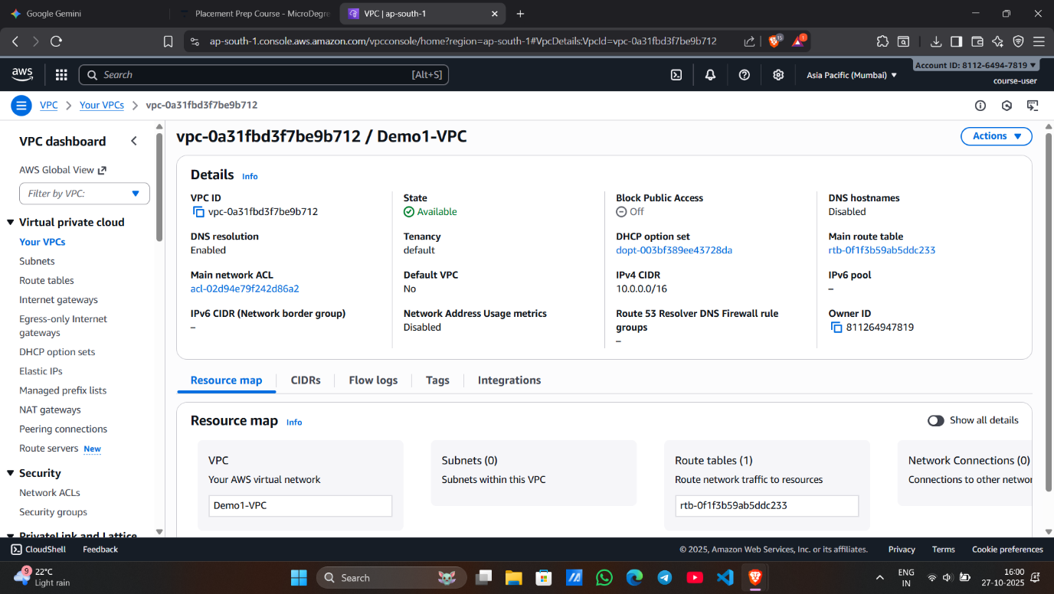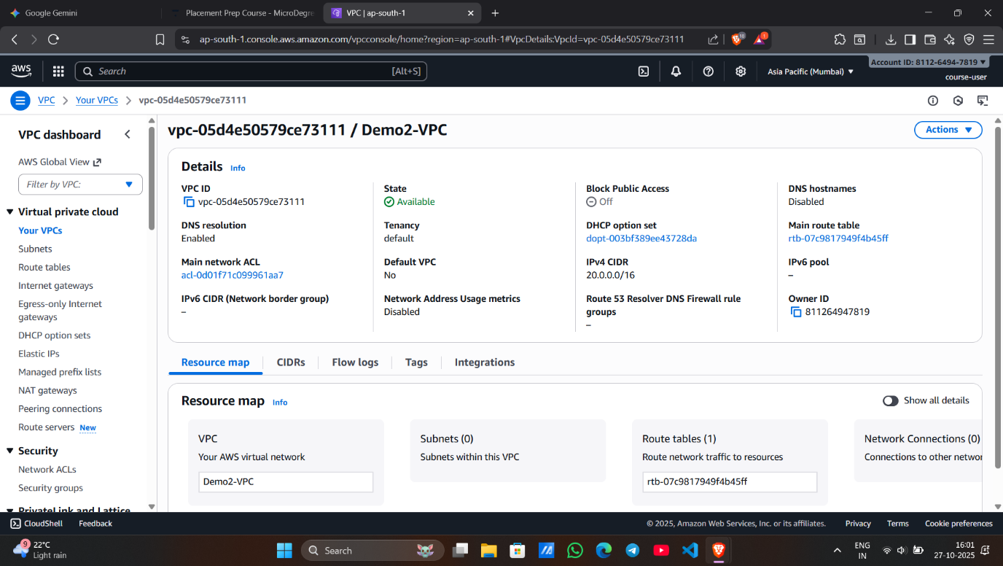

**Screenshot 1 – Demo1-VPC Created**

* Shows the creation of the **first VPC named Demo1-VPC**.
* Confirms the **CIDR block 10.0.0.0/16** has been assigned.
* Indicates successful creation under the selected region.

**Screenshot 2 – Demo2-VPC Created**

* Displays the **second VPC named Demo2-VPC** created successfully.
* Confirms the **CIDR block 20.0.0.0/16** is used.
* Both VPCs now exist in the **same region (ap-south-1)**.

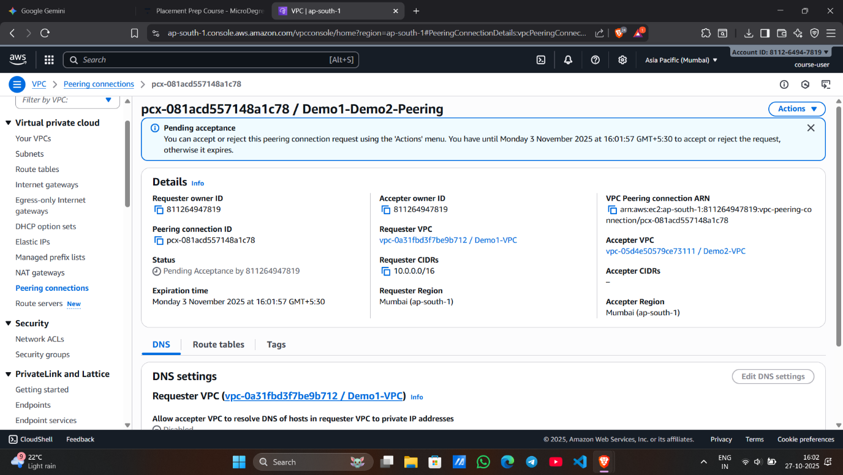

**Screenshot 3 – VPC Peering Request Created**

* Shows the creation of the **peering connection Demo1-Demo2-Peering**.
* Indicates the **requester VPC** as Demo1-VPC and **accepter VPC** as Demo2-VPC.
* Status shows **Pending Acceptance**, awaiting approval.

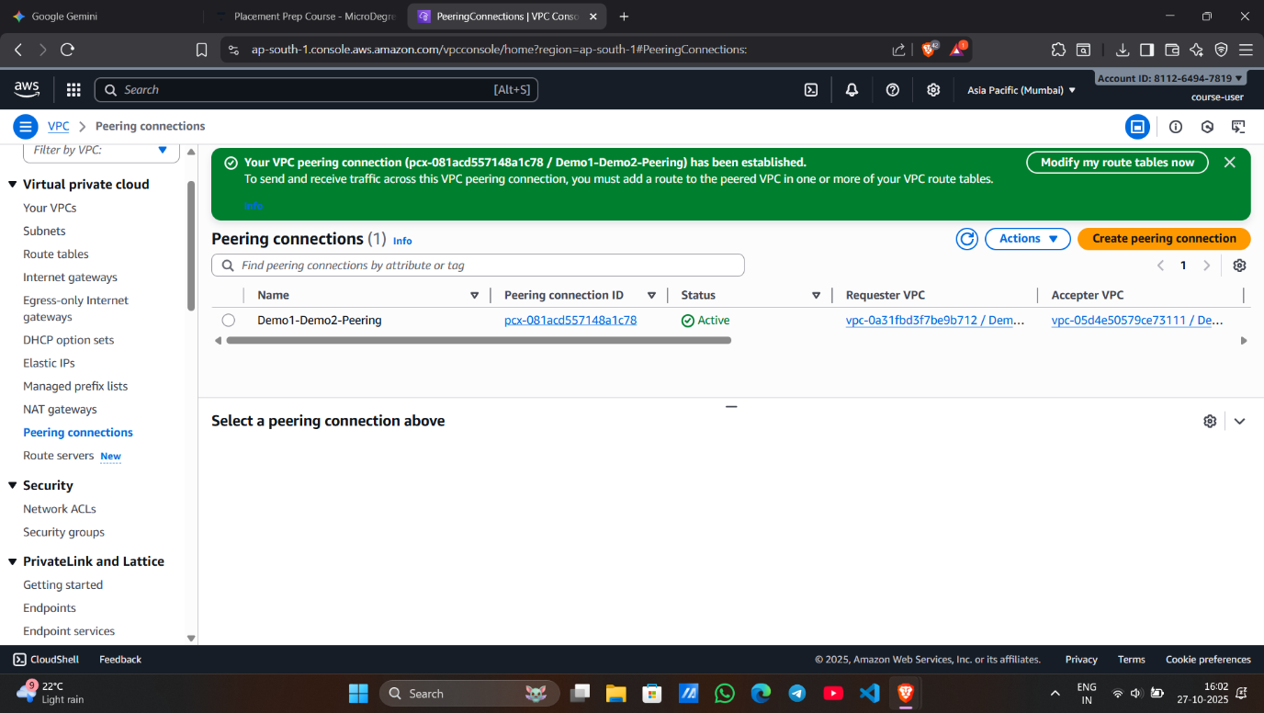

**Screenshot 4 – Peering Connection Accepted**

* Displays that the **peering request has been accepted** successfully.
* Status changed to **Active**, meaning both VPCs are now connected.
* Confirms that peering is within the same region.

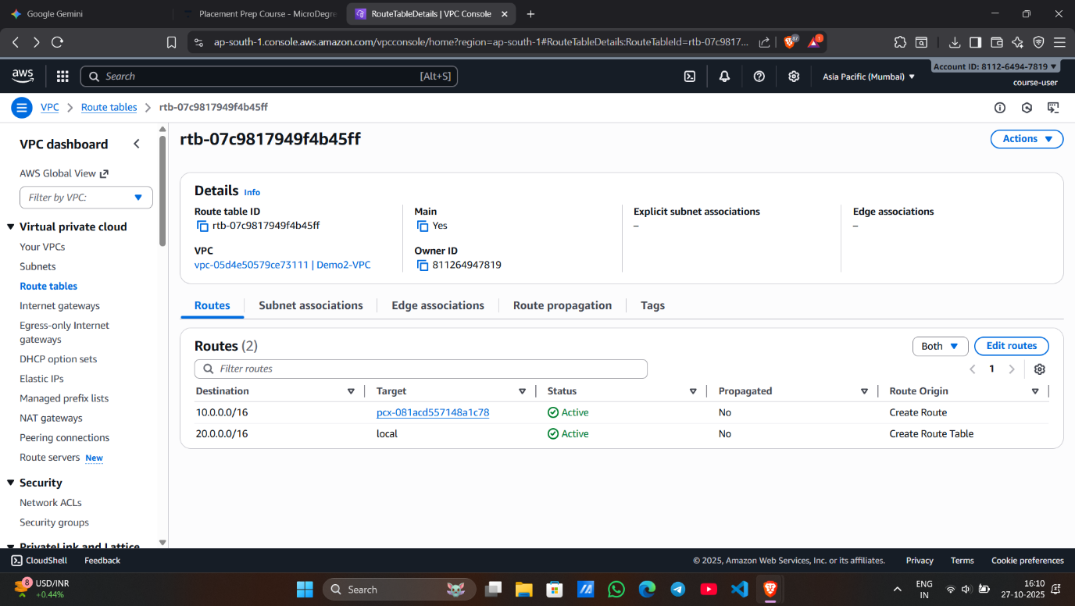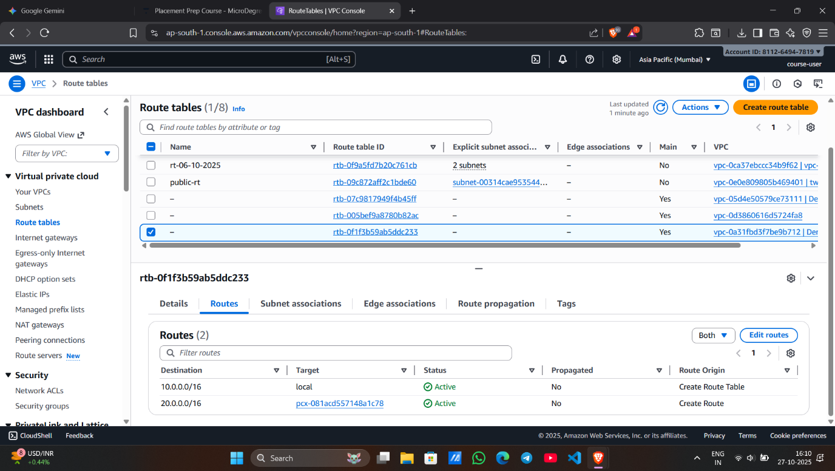

**Screenshot 5&6 – Route Tables Updated**

* Shows **updated route tables** for both VPCs.
* Each VPC now routes traffic to the other’s CIDR block through the peering connection.
* Confirms network communication between **Demo1-VPC and Demo2-VPC** is enabled.