1. Grade Checker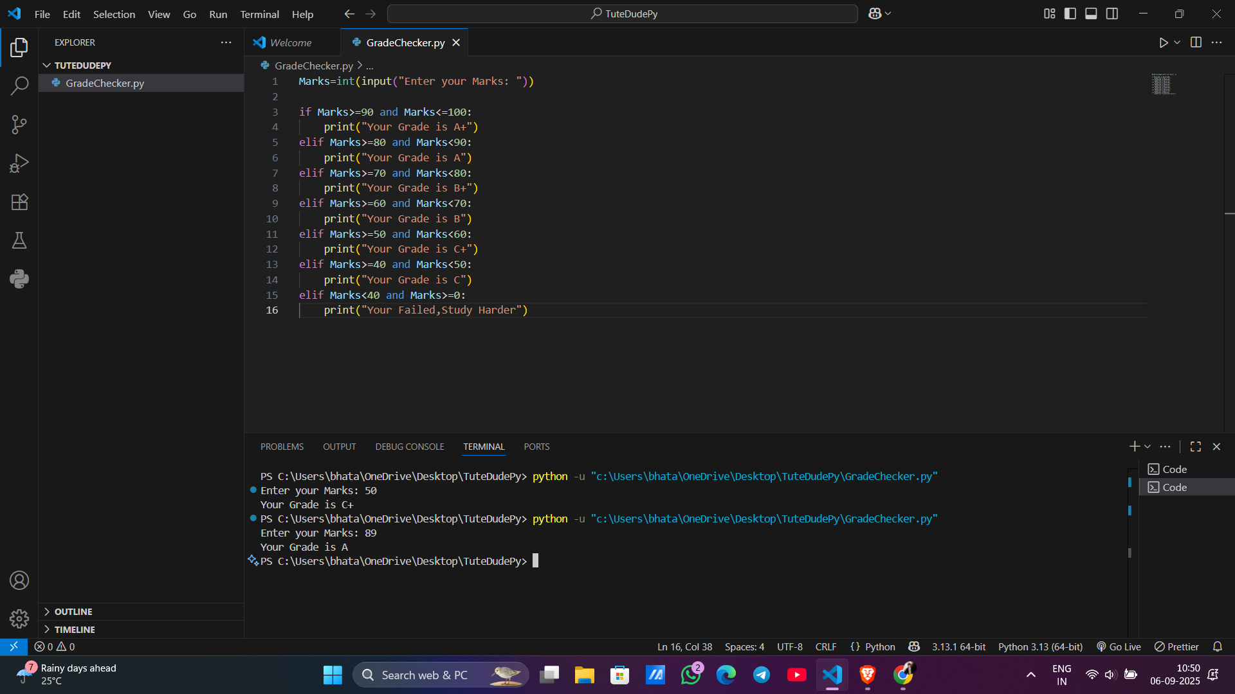

This program takes a score as input and uses conditional statements to assign a grade. It demonstrates basic if-else logic in Python.

2 Student Grades  
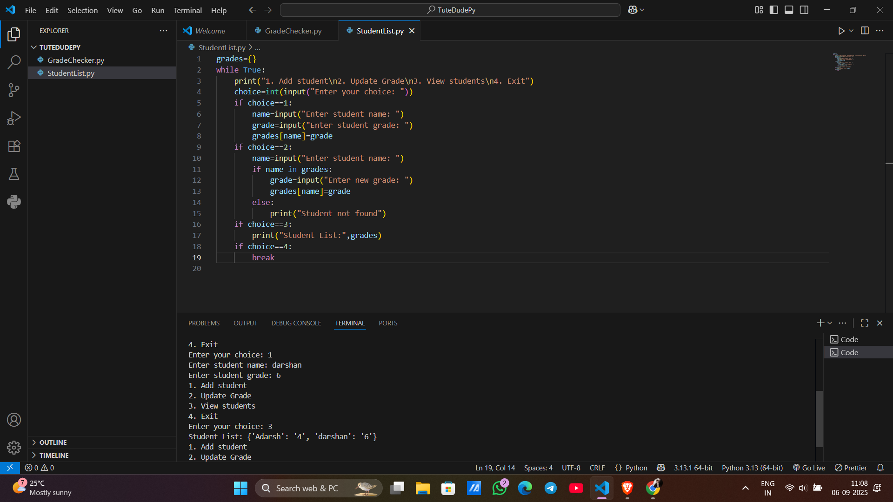

This program uses a dictionary to store and manage student grades. It allows adding, updating, and printing student records.

3.Write to a File

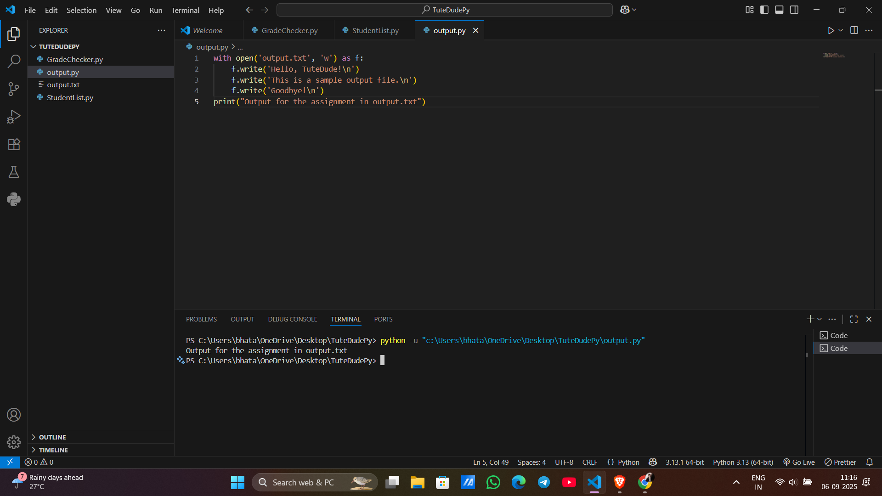

This program opens a file in write mode and writes text into it.

Using file functions like write and open.

4. Read from a File

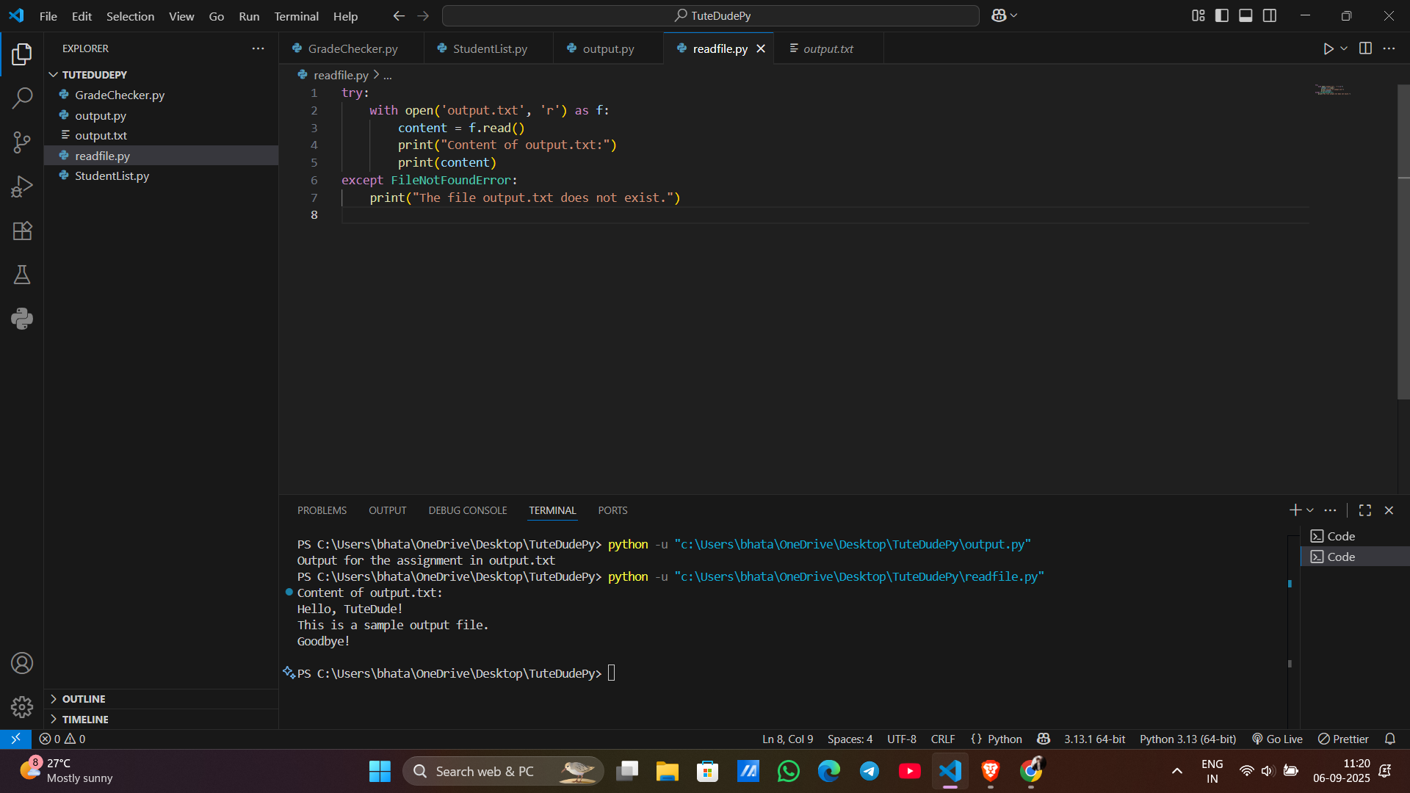

This program opens a file in read mode and displays its contents. It also handles the case if the file is missing.