Jenkins_Task1:
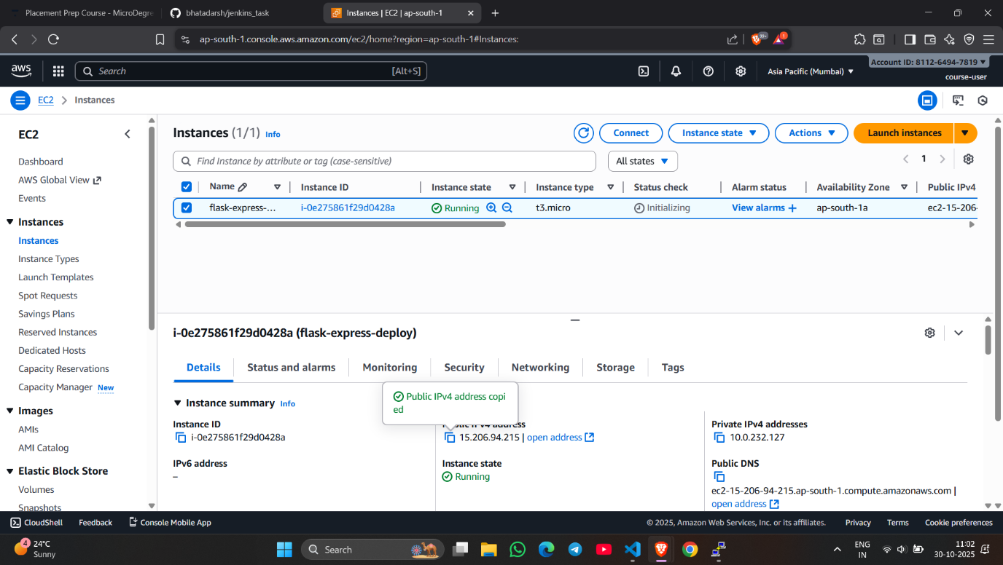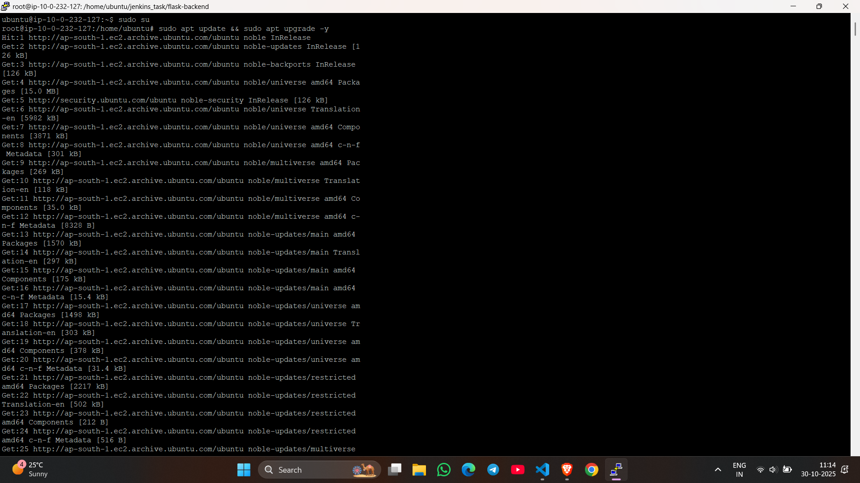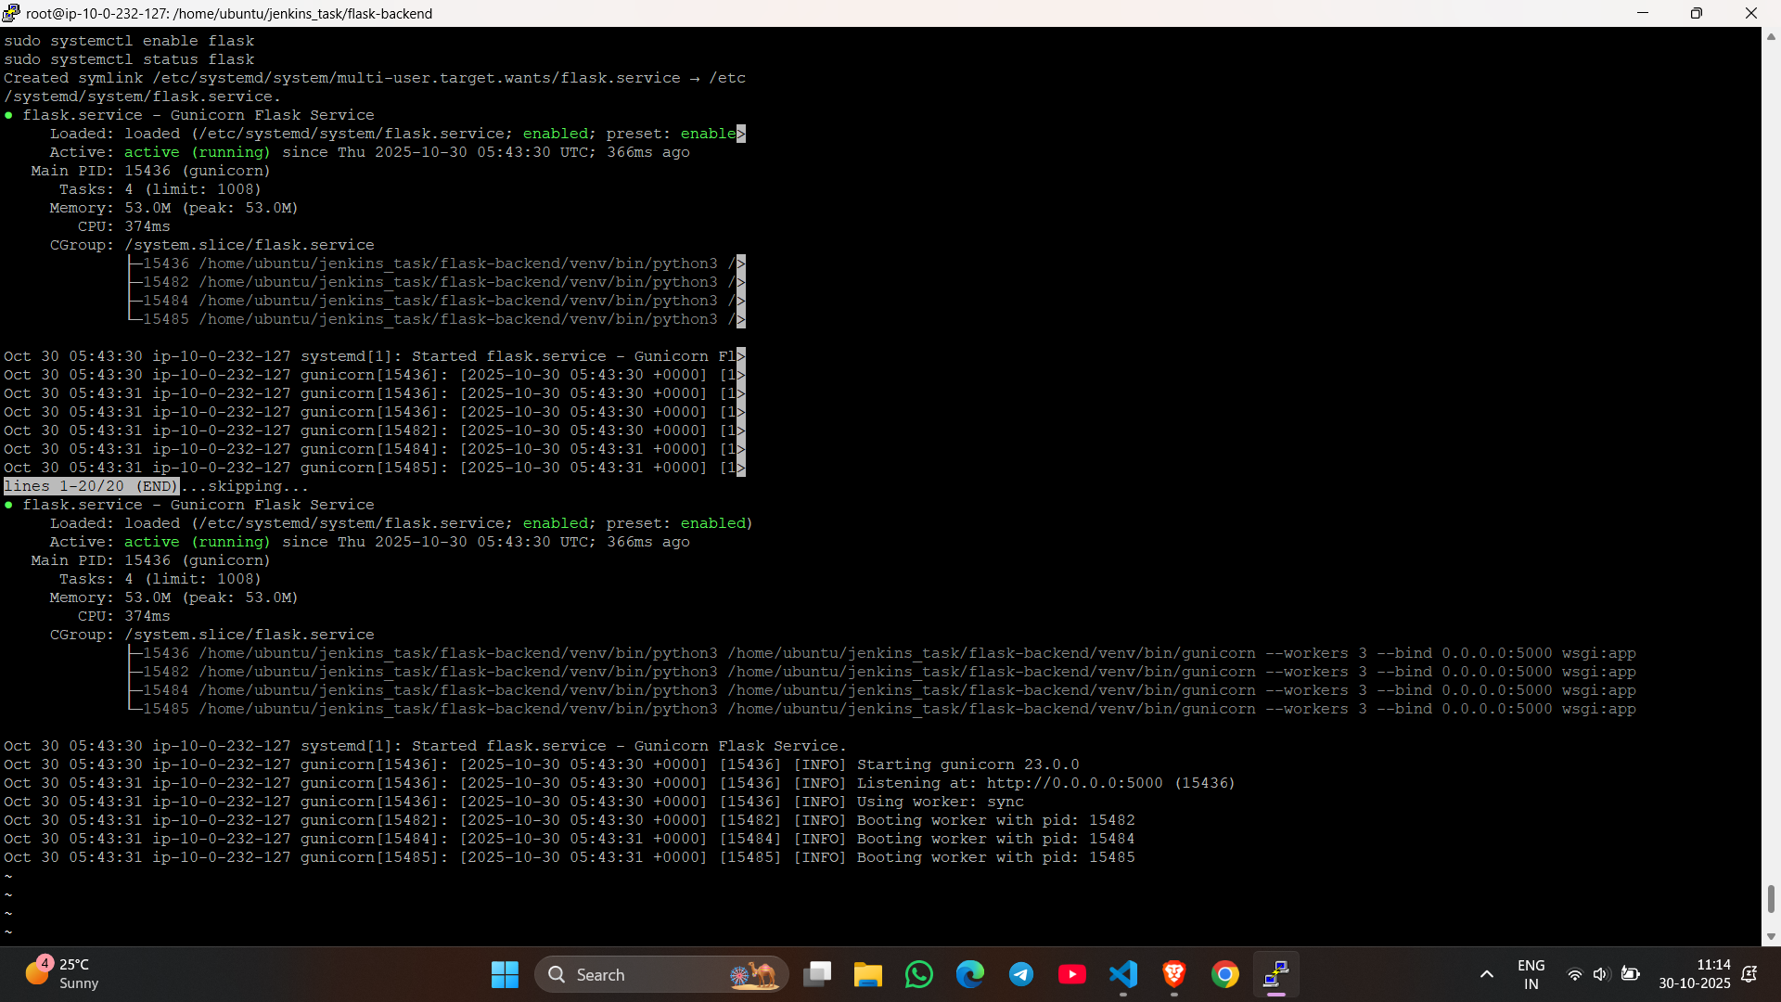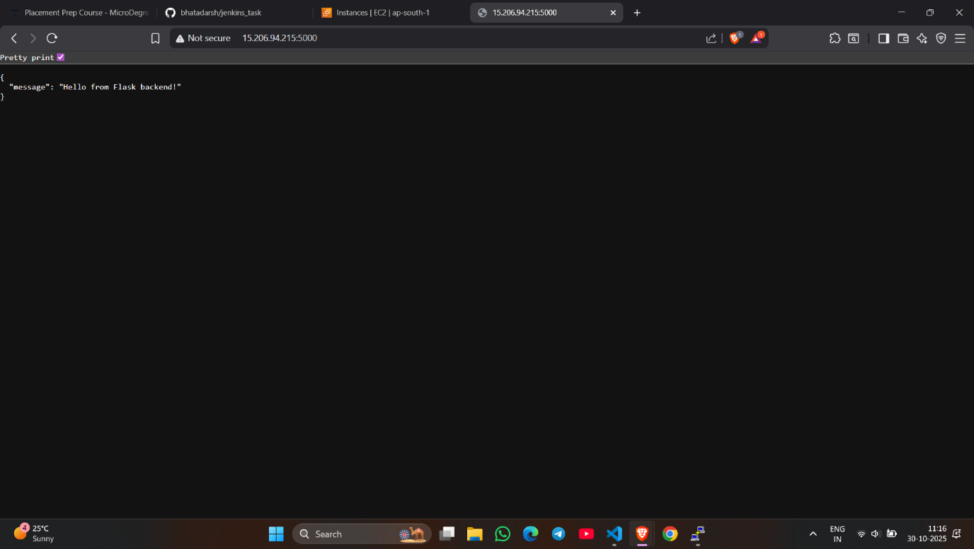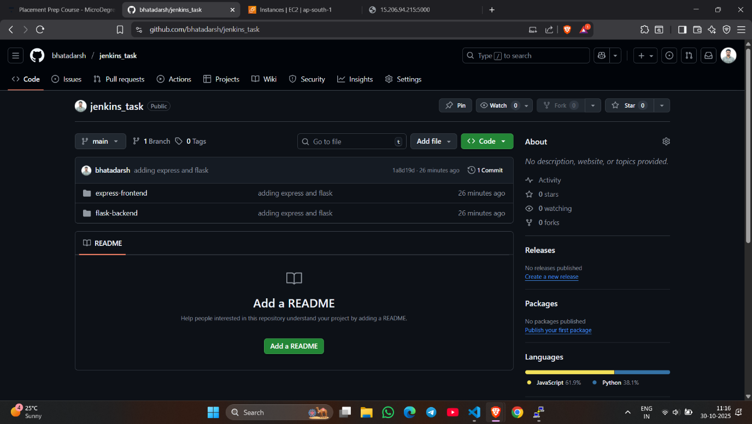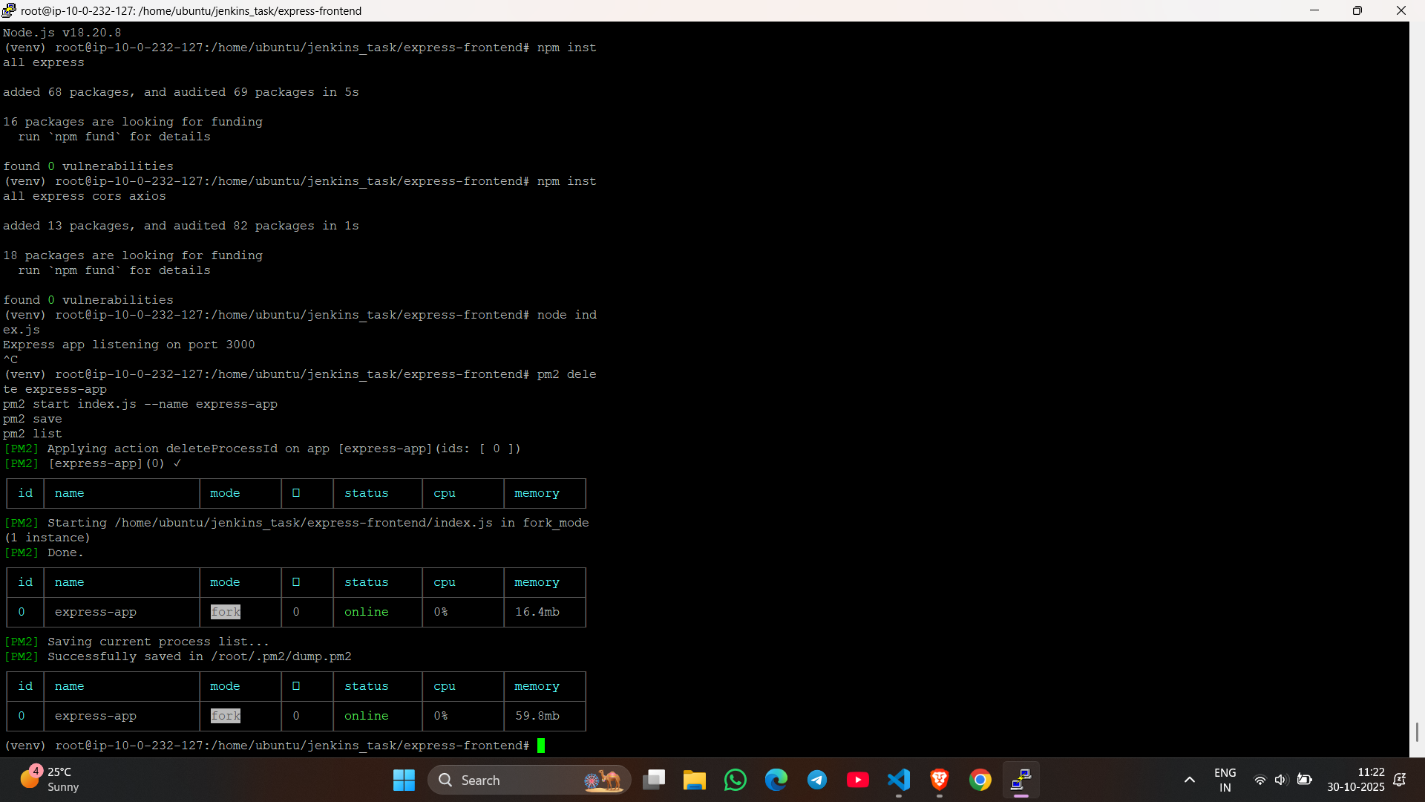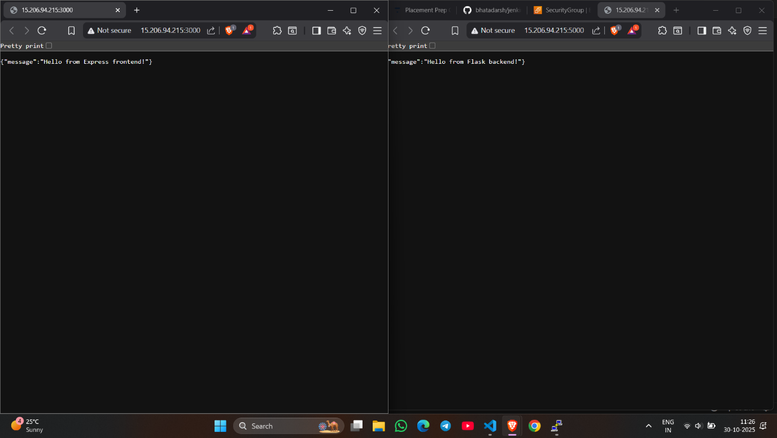
In this task, both the Flask backend and Express frontend applications were deployed on a single Ubuntu EC2 instance in the AWS ap-south-1 (Mumbai) region using a t3.micro instance type. The instance was launched with the existing key pair key-06-10-2025, and the required inbound ports (22 for SSH, 5000 for Flask, and 3000 for Express) were opened in the security group. After connecting to the instance via SSH, essential packages like Git, Python3, pip, Node.js, npm, Gunicorn, and PM2 were installed. The project repository containing both applications (jenkins_task) was cloned from GitHub. The Flask backend was set up inside a Python virtual environment and configured to run persistently using Gunicorn and a systemd service on port 5000. The Express frontend was installed with npm and managed using PM2 on port 3000. Both applications were verified to be running and accessible through the public IP address of the EC2 instance — Flask on http://15.206.94.215:5000 and Express on http://15.206.94.215:3000. To save cost under the AWS Free Tier, an Elastic IP was not used. This setup demonstrates a full-stack deployment on a single EC2 instance, ensuring both services start automatically on system reboot and remain continuously available.
Task2
