**Zomato Project**

**Objective questions**

1. What is the total no. of tables present in the data?

* The total no. of tables present in the data is 2.

Raw table Country description

1. What is the total no. of attributes present in the data?

* 25 attributes present in the data.

1. How many categorical columns are there in the data? [Search about categorical and continuous data, and try to answer this question]

* Categorical Columns are 14 Continuous Columns are 7

• Restaurant ID • Longitude

• Restaurant Name • Latitude

• Country Code • Price range

• Country • Votes

• City • Average Cost for two

• Address • Rating

• Locality • Date key Opening

• Locality Verbose

• Cuisines

• Currency

• Has Table booking

• has online delivery

• is delivering now

• Switch to order menu

1. The data consists of some inconsistent and missing values so ensure that the data used for further analysis is cleaned.

* Used functions like Remove Duplicates, Find and Replace, TRIM to ensure data accuracy so that becomes usable and suitable to work on.

I'm used the find and replace function to find the empty cell by the regular expression ^\s*\s and replace with other values.

1. Using the LookUp functions, fill up the countries in the original data using the country code.

* Fill up the countries in the original data using the country code we use vlookup function



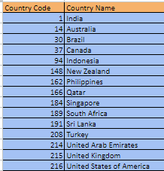

1. Create a table to represent the number of restaurants opened in each country.

* We make a table to represent the number of restaurants opened in each country by using the count if function.



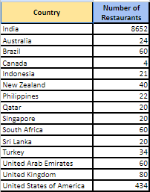

1. Also, the management wants to look at the number of restaurants opened each year, so provide them with something here.

* We make the pivot table to make the table which shows the number of restaurants opened each year.

Country in rows, Year in columns and in values set as count A which shows the count of restaurants open in each year.

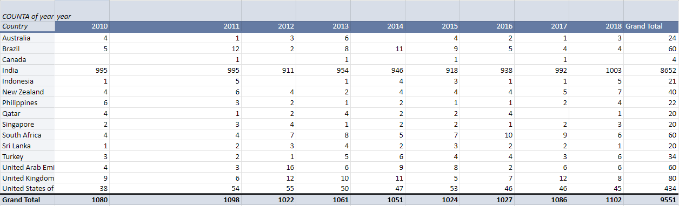

1. What is the total number of restaurants in India in the price range of 4?

* We find the total number of restaurants in India in the price range of 4 by using the count if function.



And the total number of restaurants in India in the price range of 4 is 388.

1. What is the average number of voters for the restaurants in each country according to the data?

* The average number of voters for the restaurants in each country according to the data is find by the average if function.



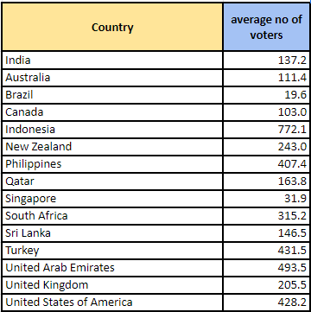

1. Calculate the average rating for all the restaurants that have price_range < 4 and provide online delivery. Use only the “IF” function, Logical Operators, and Aggregation functions to solve this problem. **[Note: Don’t use Conditional aggregation in this question.]**

* To calculate the average rating for all the restaurants that have price range < 4 and provide online delivery by using the “IF” function, Logical Operators, and Aggregation functions



Using this formula we make a column as filtered data and apply the average function on the filtered data column.



Which shows the average rating of 3.3.

1. Using Conditional formatting highlights the rows of restaurants that are located in the countries or cities that you’ve suggested to the management for opening new restaurants.

* To highlight the rows of restaurants located in your suggested countries or cities using Conditional Formatting in Google Sheets, follow this detailed approach:

1. **Select the Data Range**: Highlight all the rows and columns containing the restaurant data, ensuring you cover all relevant fields (e.g., country, city, restaurant name, etc.).
2. **Access Conditional Formatting**:
   * Navigate to **Format** in the menu bar.
   * Select **Conditional formatting** from the dropdown.
3. **Apply Custom Formula**:
   * In the conditional formatting panel, under the "Format cells if" dropdown, choose **Custom formula is**.

Enter the following custom formula:  
bash  
Copy code  
=OR($D2="Indonesia", $D2="Qatar", $D2="Singapore", $D2="Sri Lanka", $E2="Jakarta", $E2="Tangerang", $E2="Doha", $E2="Singapore", $E2="Colombo")

* + - $D2 refers to the "Country" column, and $E2 refers to the "City" column. This formula highlights any rows where the country is Indonesia, Qatar, Singapore, or Sri Lanka, or if the city is Jakarta, Tangerang, Doha, Singapore, or Colombo.

1. **Set Formatting Style**:
   * Choose the formatting style for highlighted rows, such as background color or bold text.
2. **Apply and Review**:
   * Once you apply the rule, rows corresponding to the countries or cities mentioned in the formula will be automatically highlighted.

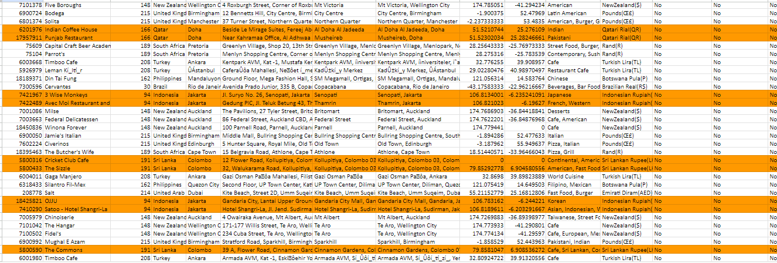

1. Create a new customized price column that consists of the abbreviation/symbol of the currency along with the Average_cost_for_two value. [Use string operations to do this task]

* Create a new customized price column in the raw data firstly we have to separate the currency symbol form the column name currency. To separate the symbol we use this formula to the other column name as a symbol from currency.



After using this formula we have to concatenate the value of the column symbol from currency and the column value of two by using the concatenate function in the column name as customised price.



1. How can you create an array formula in Excel or Google Sheets to count the number of restaurants listed that do not offer online delivery, are in the lowest price range, and have an average cost for two people less than or equal to 250 Indian Rupees?

To create an array formula in Excel or Google Sheets to count the number of restaurants listed that do not offer online delivery, are in the lowest price range, and have an average cost for two people less than or equal to 250 Indian Rupees we use count if formula with array function.

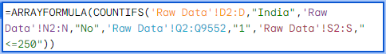

So there are 1685 restaurants.

**Subjective question**

1. **Suggest a few countries where the team can open newer restaurants with lesser competition. Which visualization/technique will you use here to justify the suggestions?**

### Solution:

### **Suggest a Few Countries for New Restaurant Openings with Lesser Competition**

**Factors Considered**:

* **Restaurant Count**: Fewer restaurants indicate lower competition.
* **Average Ratings**: Lower average ratings may indicate unmet customer expectations, offering room for better service.

**Solution**: We analyzed countries for potential restaurant openings by focusing on the number of existing restaurants and customer satisfaction levels (average ratings).

**Pivot Table**:  
We created a pivot table with **countries in rows** and **restaurant count in values** to identify regions with fewer existing restaurants, highlighting opportunities for expansion where competition is relatively low.

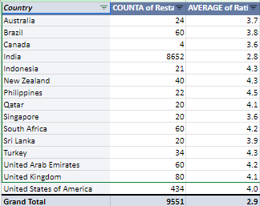

**Filter by Ratings**:  
We applied a filter to show countries with an **average rating below 4.5**, indicating potential for improved customer satisfaction.

**Bar Chart**:  
Visualized the restaurant counts by country using a bar chart. India and the USA were excluded due to their high number of restaurants, as the focus was on lesser-known or emerging markets.

**Visualization Technique**:

* **Bar Chart** to compare restaurant counts across countries.
* **Pivot Table** to summarize key metrics and apply filters for more granular analysis.

**Insights**:

* Countries like **Australia, Canada, Indonesia, Qatar, Singapore, and Sri Lanka** are ideal for expansion due to lower competition and moderate ratings, offering an opportunity to improve customer satisfaction and capture market share.

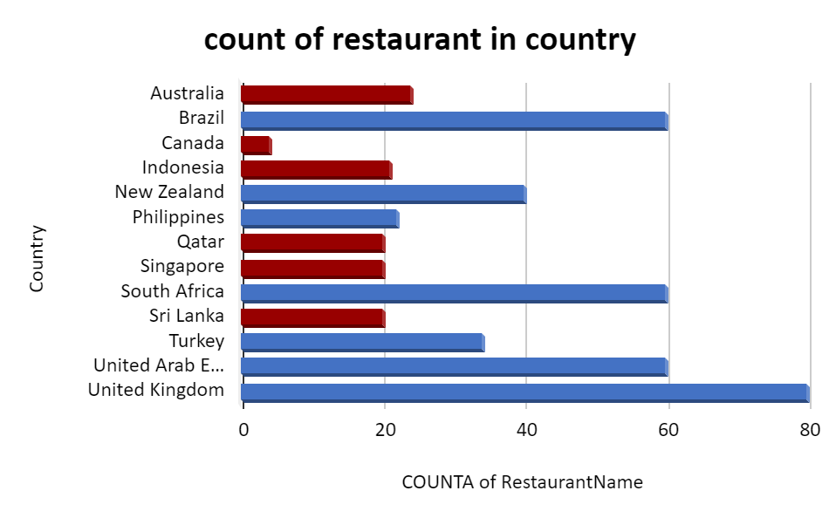

1. **Come up with the names of States and cities in the suggested countries suitable for opening restaurants.**

### Solution:

### **Names of States and Cities in Suggested Countries Suitable for Opening Restaurants**

**Factors Considered**:

* **City/State-level Ratings**: Lower ratings may indicate areas where existing services are not meeting expectations.
* **Potential for Improved Customer Satisfaction**: Locations with lower average ratings present opportunities for new businesses to excel.

**Solution**: We analyzed specific states and cities within the previously identified countries to determine their suitability for new restaurant openings.

* **Pivot Table**:  
  We created a pivot table with **countries in rows**, **states/cities in columns**, and **average restaurant ratings as values**. We applied a filter to display only cities with average ratings below 4, suggesting these areas have room for improvement in customer satisfaction.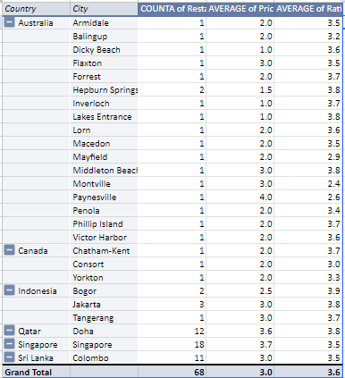
* **Line Chart**:  
  We visualized the average ratings for selected cities/states to observe any clear patterns and confirm the suitability of these locations.

**Visualization Technique**:

* **Line Chart** to compare the average ratings of cities and states across different countries, helping to pinpoint areas with lower satisfaction and potential for growth.

**Insights**:

* Cities with lower average ratings (< 4) and opportunities for improvement include:
  + **Australia**: Armidale, Balingup, Dicky Beach, Flaxton, Hepburn Springs, Lakes Entrance, Phillip Island.
  + **Canada**: Chatham-Kent, Consort, Yorkton.
  + **Indonesia**: Bogor, Jakarta, Tangerang.
  + **Qatar**: Doha.
  + **Singapore**: Singapore.
  + **Sri Lanka**: Colombo.

These cities offer fertile ground for new restaurant ventures due to their lower average ratings and opportunities to capture market share by providing better customer experiences.

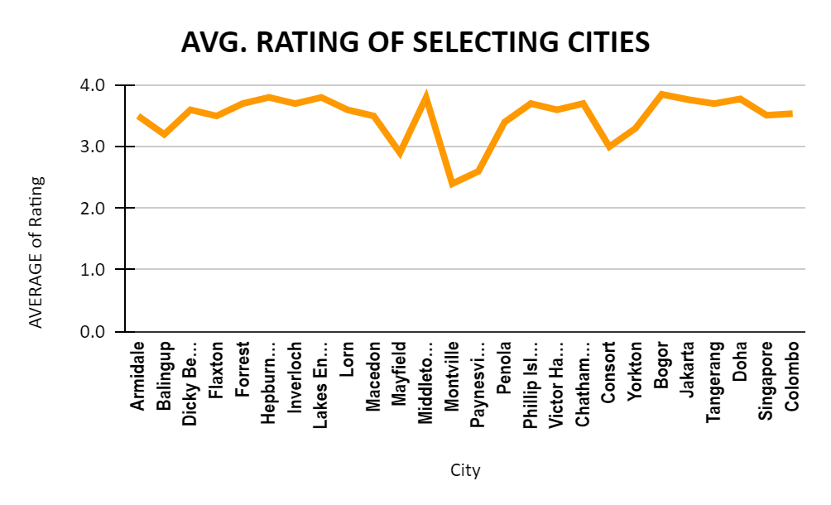

1. **According to the countries you suggested, what is the current quality regarding ratings for restaurants that are open there?**

### Solution:

To assess the current quality of restaurants in our suggested countries, we used a data-driven approach by creating a pivot table and a bar graph.

Pivot Table Setup:

* 1. Rows: Selected countries
  2. Values: Restaurant ratings, set as average
  3. Filter: Applied a filter to show only the selected countries.

Bar Graph for Analysis:

* 1. We visualized the average restaurant ratings for each country using a bar graph, naming it "Average Rating of Suggested Countries." This allowed for a clear comparison of restaurant quality across the chosen locations.

### Insights:

The analysis shows the following average ratings:

Indonesia: 4.3 (excellent quality)

Qatar: 4.1 (high quality)

Sri Lanka: 3.9 (strong satisfaction)

Australia: 3.7 (good but with room for improvement)

Canada & Singapore: 3.6 (decent quality).

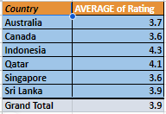

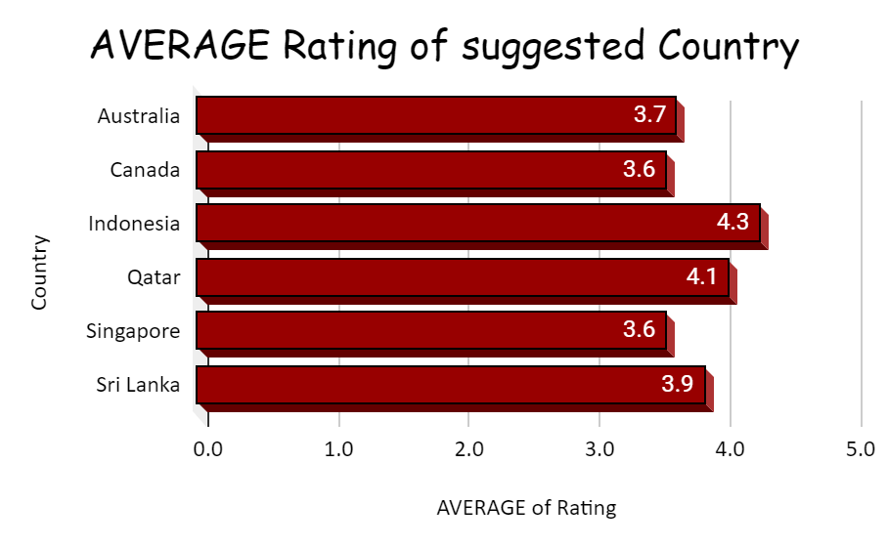

1. **Also, what is the current expenditure on food in the suggested countries, so we can keep our financial expenditure in control?**

### Solution:

To calculate the current expenditure on food in the suggested countries, we first converted all currencies into Indian Rupees (INR) to maintain consistency.

1. Convert Currencies:
   * We created a column called "Price in INR".
   * Applied a filter to select currencies based on their symbols.
   * Multiplied the average cost for two by the respective exchange rate to fill the Price in INR column.
2. Pivot Table Setup:
   * Rows: Countries
   * Values: Average price in INR
   * Filter: Selected only the suggested countries for analysis.
3. Column Chart:
   * A column chart was created to visualize the average price expenditure in each country.

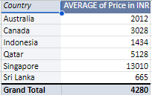

### Insights on Average Price Expenditure:

1. Australia (INR 2012): Moderate pricing. A balanced market where unique dining experiences can attract customers.
2. Canada (INR 3028): Higher prices suggest a wealthier market. Target middle to upper-class diners.
3. Indonesia (INR 1434): Lower prices indicate a competitive, cost-sensitive market. Affordable or local cuisine could thrive.
4. Qatar (INR 5128): High prices in a luxury market. Focus on premium services for affluent customers.
5. Singapore (INR 13010): Highest prices. Offers potential for premium dining experiences.
6. Sri Lanka (INR 665): Lowest prices. A cost-sensitive market, ideal for affordable operations.

### Overall:

* High-end markets (Qatar, Singapore): High profits with premium services.
* Moderate markets (Australia, Canada): Steady growth with innovation.
* Price-sensitive markets (Indonesia, Sri Lanka): Lower margins, but potential for high volume.

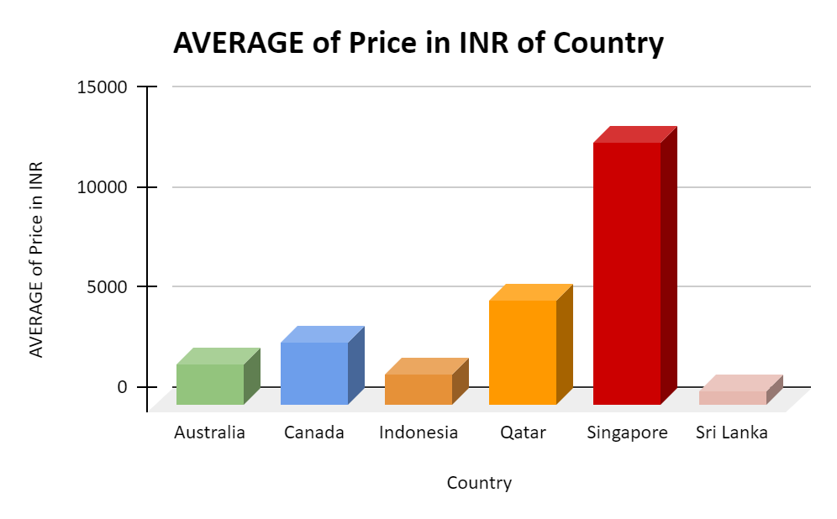

1. **Come up with the names of restaurants from the recommended states that are our biggest competitors and also those that are rated in the lower brackets, i.e. 1-2 or 2-3.**

### Solution:

To identify the biggest competitors from the recommended states, we focused on restaurants with high ratings in the suggested cities. A higher rating indicates stronger competition, as it reflects customer satisfaction.

1. Pivot Table Setup:
   * Rows: Countries and cities
   * Values: Average rating and price
   * Filter: Selected restaurants with ratings between 3 and 3.9 in the suggested countries.
2. Line Chart for Analysis:
   * Created a line chart to visually analyze the ratings of our competitors' restaurants in the selected cities.

### Insights:

* Restaurants with ratings between 3 and 3.9 are our main competitors, as they indicate satisfied customers and stronger market presence.
* The line chart highlights these competitors across various cities, providing a clear view of where competition is strongest.

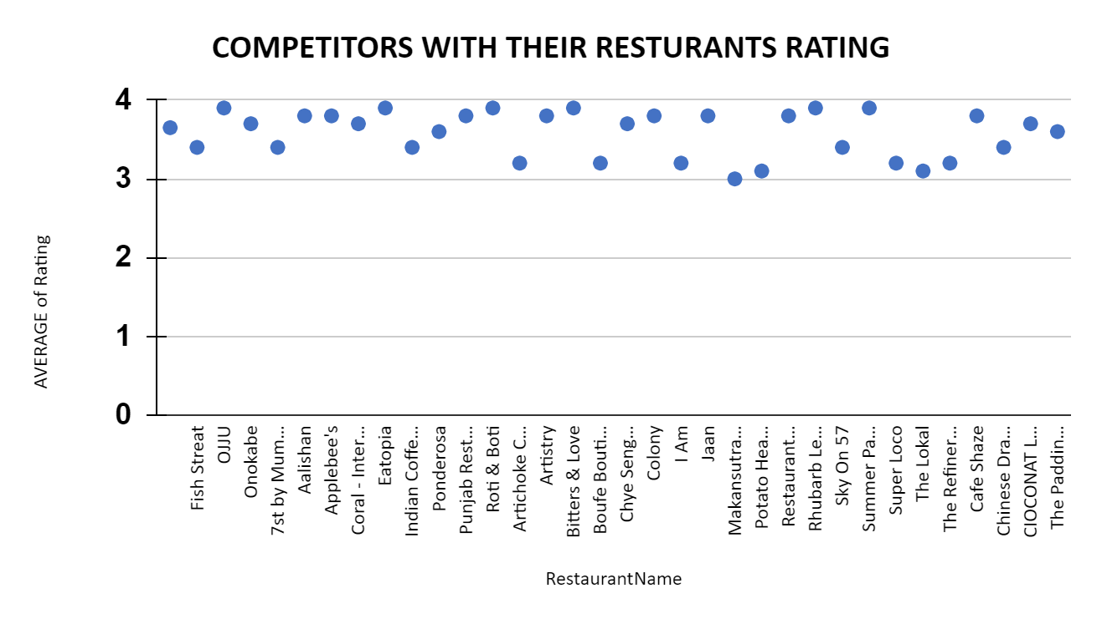

There are total 4 countries(Australia,Canada,Singapore,Sri lanka) and 7 restaurants who are coming under the lower brackets i.e. 1-2 or 2-3 .

Create a Pivot table and add Country,City,Restaurant Name,Average Rating in Rows and Rating in values and summarise by average function and at last add filters on Country and select suggested 5 countries only i.e. (Australia, Canada, Qatar, Singapore, Sri Lanka) and on Rating select it as less than 3 and group rating as 1-2, 2-3.

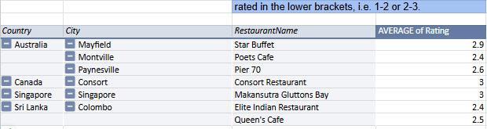

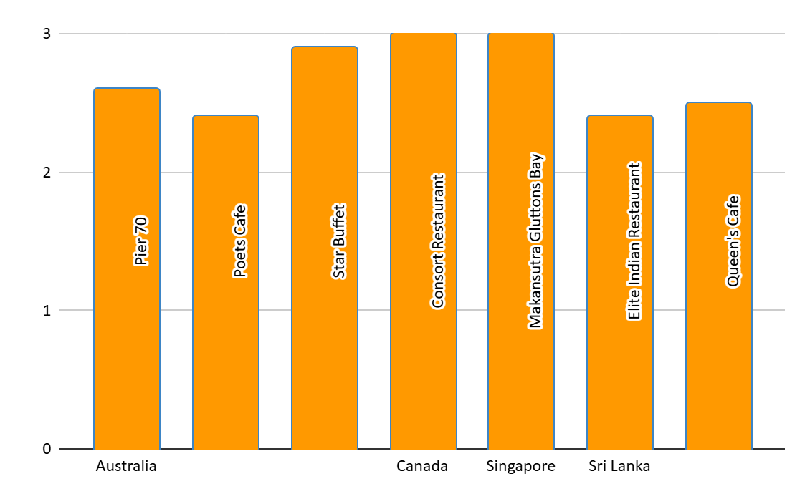

1. **Which cuisines should we focus on in the newer restaurants to get better feedback? Does the choice of cuisines affect the restaurant ratings?**

### Solution:

To determine the best cuisines for new restaurants to receive better feedback, we used a pivot table approach.

1. Pivot Table Setup:
   * Rows: Suggested countries
   * Columns: Cuisines
   * Values: Average rating
2. Refined Pivot Table:
   * We created a second pivot table from the first one.
   * Rows: Cuisines
   * Values: Average rating
   * Filter: Selected cuisines with ratings above 3.
3. Bar Chart:
   * A line chart was created to visualize the rating of top cuisines.

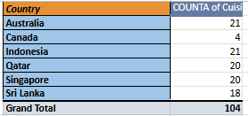

### Insights:

Yes, the choice of cuisines can greatly impact restaurant ratings. By focusing on high-rated cuisines (above 3), newer restaurants can cater to popular tastes, improving customer feedback and overall satisfaction.

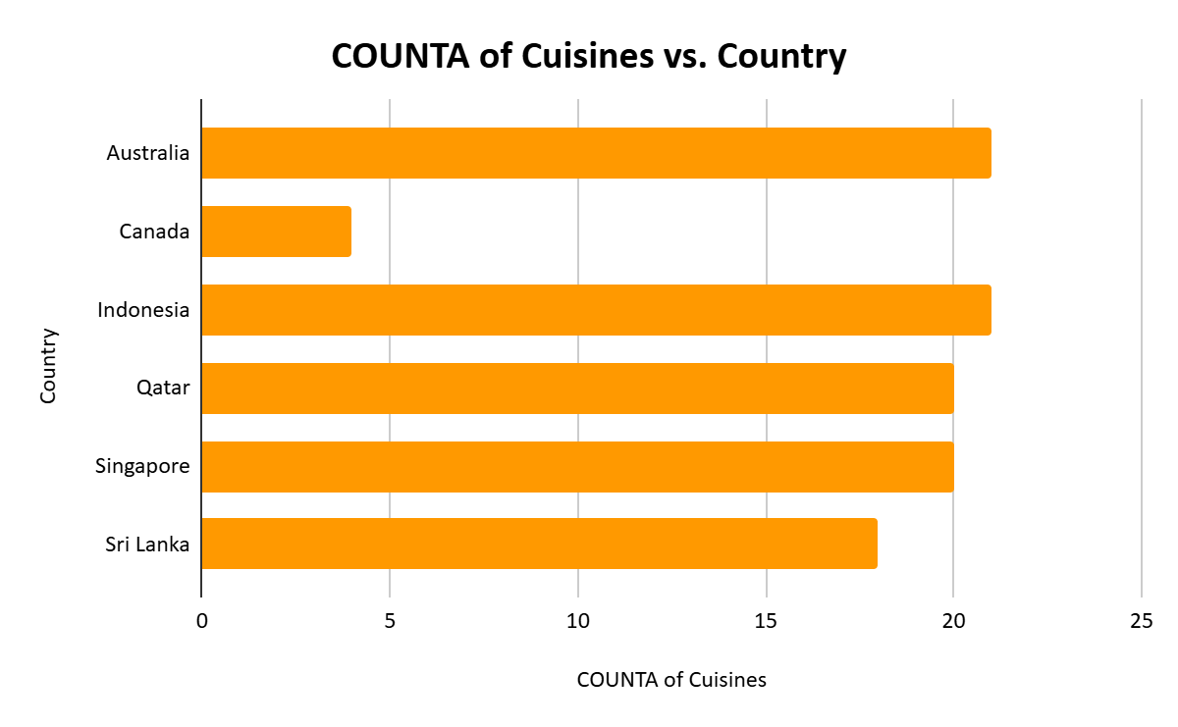

1. **According to our current data, should we go for online delivery and table booking? Does that affect the customer’s ratings?**

### Solution:

To determine if offering online delivery and table booking can improve ratings, we created a pivot table:

1. Pivot Table Setup:
   * Columns: Online delivery, table booking
   * Values: Average rating
2. Bar Graph:
   * Visualized the pivot table using a bar graph to compare ratings of restaurants with and without online delivery and table booking.

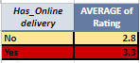 

### Insights:

Restaurants offering both online delivery and table booking have the highest ratings.

The second and fourth bars (in red) highlight that restaurants providing online table booking, whether they offer online delivery or not, receive higher ratings.

Implementing both features could significantly boost customer satisfaction and ratings for new restaurants.

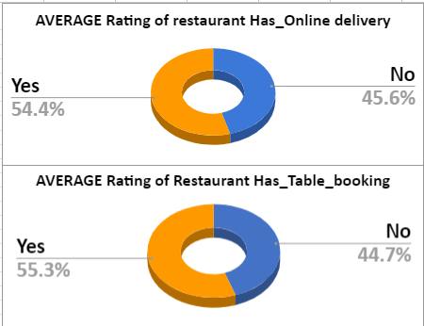

1. **Should the team keep the rate of cuisines higher? Will that affect the feedback? According to our data are the rates of cuisines and ratings, correlated?**

### Solution:

1. **Examine the Data Trend**:  
   Looking at the data, the sum of the average cost for two tends to be highest in the 3.0–4.0 rating range and drops off both below and above that range:
   * For ratings between 1.0 and 2.0, the cost is the lowest (6,565).
   * As the rating increases from 2.0 to 3.0, the cost increases significantly (196,630).
   * The cost is highest in the 3.0–4.0 range (12,008,298), suggesting that mid-range ratings tend to correspond with higher cuisine prices.
   * In the 4.0–5.0 range, the cost decreases to 4,534,165, showing that the highest-rated restaurants may not have the highest average cost.

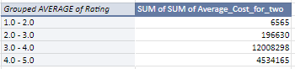

1. **Possible Explanation**:
   * **Mid-Range Ratings (3.0–4.0)**: These restaurants likely balance price and quality well, resulting in a higher customer base and therefore more revenue.
   * **High-End Ratings (4.0–5.0)**: While these restaurants are highly rated, their customer base may be smaller, possibly due to higher expectations or niche offerings.
   * **Low Ratings (1.0–3.0)**: The significantly lower costs are likely associated with lower-quality service or food, leading to lower customer satisfaction.
2. **Correlation Between Cost and Ratings**:
   * To statistically assess the correlation between cost and ratings, you would typically calculate the **Pearson correlation coefficient** between the two variables. However, from this data, it appears that the relationship is not linear. The highest revenue does not correspond to the highest ratings; rather, it peaks in the middle.
   * Thus, **the correlation between the rate of cuisines (average cost) and ratings seems weak or even negative at the extremes**. Lower costs are linked with low ratings, and very high costs do not necessarily result in high ratings.

### **Insights:**

* **Will keeping the rates of cuisines higher affect feedback?**Based on the data, keeping the rate of cuisines higher does not necessarily lead to better feedback. While there may be an initial positive correlation between moderately high costs and ratings (in the 3.0–4.0 range), raising prices further into the 4.0–5.0 range may not improve customer satisfaction and could even reduce it.
* **Correlation**:  
  The correlation between cost and rating is **non-linear**. Restaurants with moderate prices tend to have better ratings, while both the lowest and highest price points may result in lower ratings.

### **Recommendation:**

* **Optimal Pricing Strategy**:  
  Instead of increasing prices across the board, it may be better to focus on offering value for money in the mid-range (3.0–4.0 rating) group, where customer satisfaction is high and cost is reasonable. Aiming for quality improvements to boost ratings in this group could also help attract more customers without overpricing.

### **Next Steps:**

* Perform a statistical analysis (e.g., Pearson correlation or regression) to quantify the exact relationship between the rate of cuisines and ratings.
* Focus on improving quality in mid-range restaurants while maintaining competitive pricing.

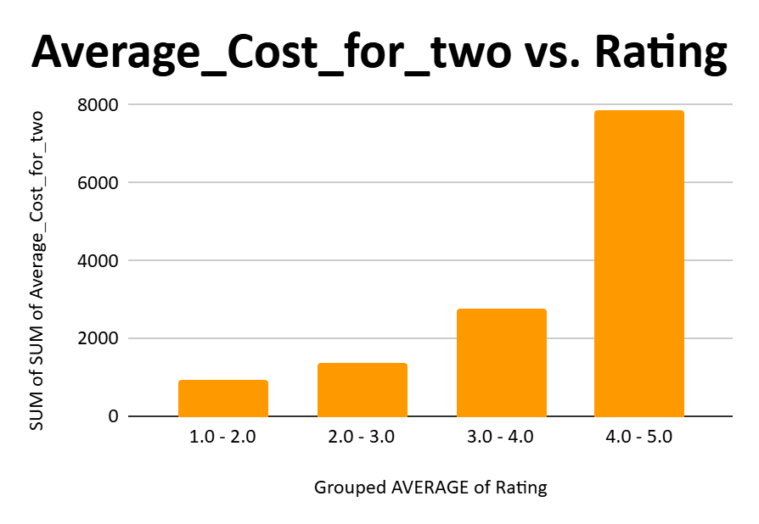

1. **What is the distribution of the number of restaurants of different price ranges in all the countries?**

### Solution:

To understand the distribution of restaurants across different price ranges in various countries, we used a pivot table.

1. Pivot Table Setup:
   * Rows: Countries
   * Columns: Price range
   * Values: Count of restaurant names (set as count)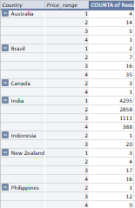

This setup helped us visualize how many restaurants fall into each price range across different countries, providing insight into where restaurants of varying affordability are concentrated.

### Insights:

* India: Highest number of restaurants in Price Range 1 and 2, indicating a preference for affordable dining. The market is price-sensitive and competitive in the budget segment.
* United States: Balanced distribution across Price Ranges 2 and 3, catering to both mid-range and higher-spending consumers, suggesting a versatile market.
* Brazil: Significant focus on Price Range 4, highlighting a demand for upscale, premium dining experiences.
* Other Countries:
  + South Africa, UK, UAE, Turkey: Diverse price range distribution, catering to varied income levels and consumer preferences.

Overall, countries with lower price ranges (like India) are competitive in budget dining, while those with higher price ranges (like Brazil) present opportunities for premium restaurants.

**10.Explain your approach in brief for suggesting countries/cities in order to open new restaurants, if the objective and subjective questions would have not been given to assist you. [you have to give bullet pointers in order to answer this question]**

### **Approach for Suggesting Countries/Cities to Open New Restaurants:**

1. **Data Analysis**:
   * Begin by gathering and analyzing relevant data such as the number of restaurants, ratings, pricing, and customer feedback for various countries and cities.
2. **Identify Low-Competition Markets**:
   * Focus on countries and cities with a lower count of restaurants to target regions with less competition.
3. **Restaurant Rating Evaluation**:
   * Prioritize countries/cities where the average restaurant rating is less than 4.5 to identify potential areas for improving customer satisfaction.
4. **Cost Analysis**:
   * Evaluate the average price for meals across countries/cities. Consider markets with a moderate price range to balance affordability and profitability.
5. **Customer Preferences**:
   * Identify popular cuisines and dining preferences in each region to ensure the new restaurant concept aligns with local demand.
6. **Economic and Demographic Factors**:
   * Consider factors like disposable income, population density, and tourism to assess the potential customer base and spending behavior.
7. **Visual Data Representation**:
   * Use pivot tables and visual tools (charts/graphs) to clearly present insights like rating trends, price ranges, and cuisine preferences.
8. **Strategic Location Selection**:
   * Based on the above analysis, select countries and cities with the right balance of low competition, favorable ratings, and profitable price ranges for new restaurant openings.

