**USING BINARY REPRESENTATION** FOR WEEKLY ROUTINE GENERATION ?

**CHROMOSOME**

* We have 4 time slots (T1, T2, T3, T4) and 6 subjects (S1, S2, S3, S4, S5, S6).
* We can represent a weekly routine as a 2D matrix with 7 rows (one for each day of the week) and 4 columns (one for each time slot).

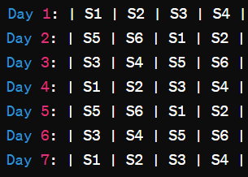

* each cell (i, j) in the matrix represents the subject scheduled for day i and time slot j.

|  |  |  |  |  |  |  |  |  |  |  |  |
| --- | --- | --- | --- | --- | --- | --- | --- | --- | --- | --- | --- |
| |  |  | | --- | --- | | S3 | Teacher | | |  |  | | --- | --- | | S5 | Teacher | | |  |  | | --- | --- | | S4 | Teacher | | |  |  | | --- | --- | | S2 | Teacher | |
| |  |  | | --- | --- | |  |  | | |  |  | | --- | --- | |  |  | | |  |  | | --- | --- | |  |  | | |  |  | | --- | --- | |  |  | |
| |  |  | | --- | --- | |  |  | | |  |  | | --- | --- | |  |  | | |  |  | | --- | --- | |  |  | | |  |  | | --- | --- | |  |  | |
| |  |  | | --- | --- | |  |  | | |  |  | | --- | --- | |  |  | | |  |  | | --- | --- | |  |  | | |  |  | | --- | --- | |  |  | |
| |  |  | | --- | --- | |  |  | | |  |  | | --- | --- | |  |  | | |  |  | | --- | --- | |  |  | | |  |  | | --- | --- | |  |  | |
| |  |  | | --- | --- | |  |  | | |  |  | | --- | --- | |  |  | | |  |  | | --- | --- | |  |  | | |  |  | | --- | --- | |  |  | |