Website design is refers to the process of creating visual aspects of the interface. The process of website design entails logos type design and design elements such as links, color schemes as well as anything visible this can be done with the help of css and js. The major aspect which is fundamentally required in web design is good design, which gives consideration of the color , typography , responsiveness and usability of the website and the layout.

This paper will be focusing on developing a website for the Health Care Clinic through the use of the front end technologies a website for a local clinic, featuring a BMI calculator for patients to gauge their health status and a contact form for appointment requests . i.e. done with the use of HTML, CSS, and the JavaScript to ensure more functional ness and responsiveness to the company website, and customers access to online service such as body mass index ( BMI ) calculation and online appointment through the online self selection services by using or filling the form given the website.

We use these three dimensions which is JavaScript, HTML, and CSS work to create responsiveness design of the website. In the web design process, the hypertext mark-up language (HTML), gives the structure of the website which is also known as blueprint of the website using different tags eg h1 ,p , image, form, div, etc .

The cascading style sheets ( CCS ), is applied in the website design. Cascading Style Sheets is a style sheet language used for specifying the presentation and styling of a document written in a markup language such as HTML

The JavaScript, on the other hand, regards to a programming language that enables the addition of customs behavior and interactive behaviors on the customers’ sites. JavaScript, often abbreviated as JS, is a programming language and core technology of the Web, alongside HTML and CSS. 99% of websites use JavaScript on the client side for webpage behavior. Web browsers have a dedicated JavaScript engine that executes the client code.

In ensuring that the achievement of the web development and design goals, the web design principles will be applied which are website design structure, topography and forms , use of color palette and imagery, navigate etc.

The first step is to sketching a design of the website in a piece of paper or using different design software. This make sure , focuses on ensuring that every detail required for the creation of the desired website, is linked as required to be present on the home page. For example, the our health care client website we create nav , then description div, then body mass index ( BMI ) calculation div, then appointment form and footer section as show in figure below:-

Figure 1 .Healthcare Clinic basic design

For this project we use xampp and visual studio code for creating the website.

We use parallel x in our website that give a visual animation that is activated while the website is scrolled. Parallax scrolling is a web site trend where the background content (i.e. an image) is moved at a different speed than the foreground content while scrolling. This is done using the java script.

Js code

const parallax_1 = document.getElementById("parallax_1");

window.addEventListener("scroll", function () {

let offset = window.pageYOffset;

parallax_1.style.backgroundPositionY = offset * 0.7 + "px";

});

The window off set is taken form the window.pageYOffset and then the div ie parallax_1 background position y is updated or changed every time the scroll through the webpage happens.

In Navbar, it contains the link when click it scrolled to respective div for example when clicking in BMI link the body mass index ( BMI ) calculation section is focused on.

<nav class=" navbar">

<img class="logo" src=" logo.png" alt=" Health Care">

<a href =" #home"> Home </a>

<a href =" #secondDiv"> BMR </a>

<a href =" #appoinment"> Appoinment </a>

</nav>

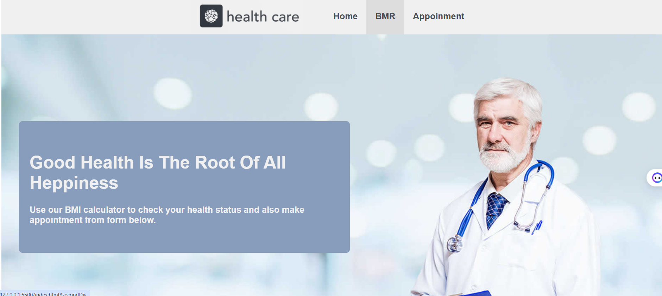

Figure 2 nav bar and div screenshot

In another div there is a image of doctor in the background and above the image there is a div that contains the information or some content on the website as shown in the above image.

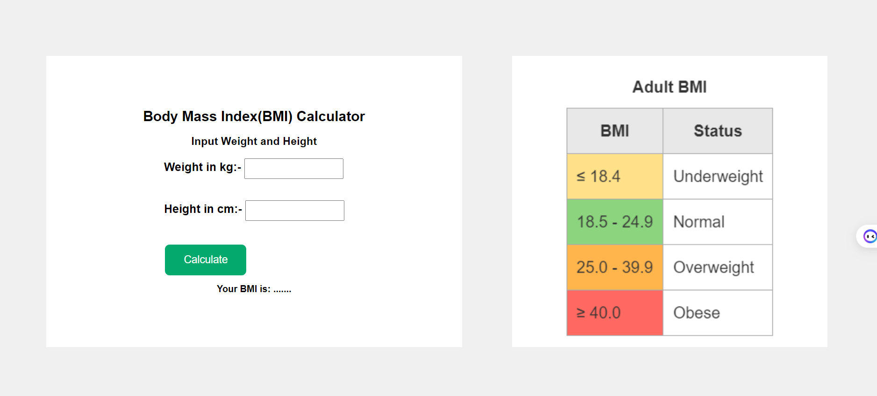

Figure 3 body mass index calculator

In another section there is a body mass index calculator that takes the input which is weight in kg and height in cm . when button calculate is clicked then bmi is calculated.

This is done with the help of js . The weight in kg and heignt in cm is taken by using js and calculation is made and then finally the result is appended in the inner html of the website which is shown the above figure.

Js code

document.getElementById("bmiForm").onsubmit = function () {

// Get input values

var weight = parseFloat(document.getElementById("weight").value);

var height = parseFloat(document.getElementById("height").value) / 100; // Convert height to meters

// Calculate BMI

var bmi = weight / (height * height);

// Display result

document.getElementById("reasultBMI").innerHTML =

"Your BMI is: " + bmi.toFixed(2);

return false; // Prevent form submission

};

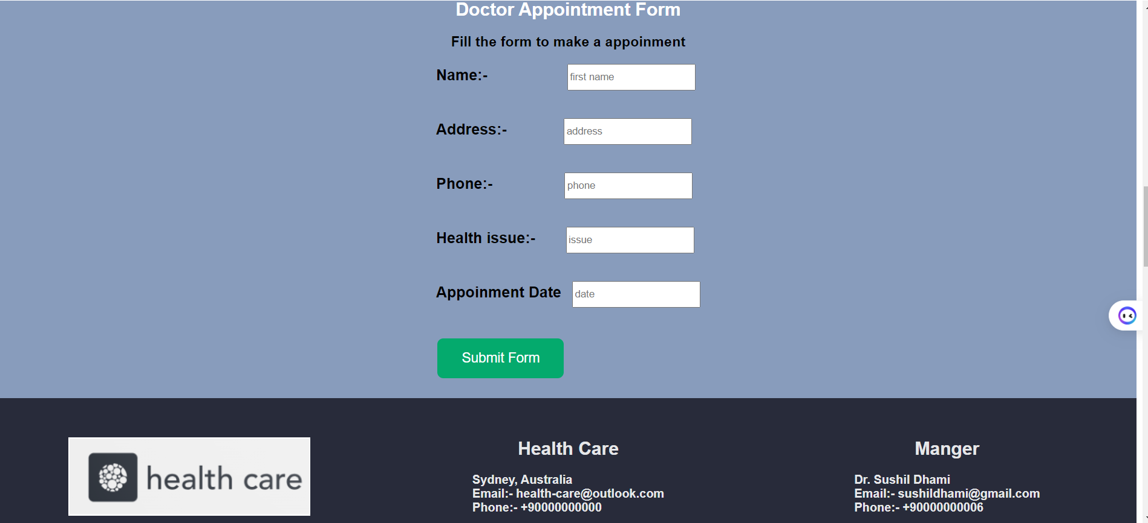

Another section contains the appointment form that user can input the data into the form for appointment the doctor. And the last section is the footer section that contains the contact information and location of the healthcare clinic.

Responsiveness in the website is maintained through media query. When the screen size width is changed ( ie small width for mobile devices ) the the css property is change when the width is applied to a condition.

In our code we use

@media only screen and (max-width: 600px) {

div {

flex-direction: column !important;

width: auto !important;

height: auto !important;

}

.adultBMI {

height: 400px !important;

}

.logo {

display: block;

}

}

Working process of above code is when the screen width is less than 600 px the div flex direction ,width and height is changed and similarly for other.

This html, css, and js code is developed and run through using the localhost and it is run successfully.

In conclusion, it is clear that Html , css and JavaScript are the basic fundamental for the design of a web page, which enables to create different responsive websites that is used by the customers for different services and also these maintain its productivity.

To sum up, there is a need to keep learning how to update the codes, as the level of technology changes to ensure that the right development of the company’s needs is achieved especially those linked with the clients.