Introduction

A Real Estate Property Management System is intended to centralize real estate property information, client records, agent information, and sale records of property. It is vital for real estate agencies and Property Management companies to keep records, to have an organized communication and to deliver better customer service. With this documentation, the user will be able to understand the Real Estate Property Management System through the database schema of the system, the key features of the system and samples of its usage.

Introduction of Real Estate Property Management System using PHP,HTML,CSS & JavaScript. Implementing an effective Real Estate Property Management System involves the design of a complete environment which encompasses Property posting and filtering. The front-end developed using HTML and CSS offers the users including property managers an easy and efficient way of accessing these services. HTML forms are used to enable property details, filtering the properties , adding properties, registration and login. CSS styling is used to provide an attractive and responsive layout. JavaScript improves on the end-user comfort as it can be used for client-side form validation. The back-end developed from PHP is to implement server-side processes and most of the computations like form submits, database interactions and business logics. The PHP scripts then input new properties in the database.

Database Schema Explanation

Any property management system needs a strong base that is a good database structure or the database schema if put in proper terms. It affords an opportunity to order records in a particular manner to make their retrieval easier. The following section will discuss the detailed database schema for Real Estate Property Management System.

Table :-- Users

1. id (Primary Key)

Type :- int(30)

Explanation :- User – an identification number/ code that should be unique and assigned to a specific user.

1. full_name

Type :- varchar(30)

Explanation :- The name a user may have fully.

1. email

Type :- varchar(50)

Explanation :- The ever important e-mail address of the user can include.

1. contact

Type :- varchar(30)

Explanation :- This can be the phone number of the user which is also important for providing the service.

1. password

Type :- varchar(256)

Explanation :- This password is used to log into the user’s account and is usually stored in hashed form.

Table :- Properties

1. id (Primary Key)

Type :- int(11)

Explanation :- A File Identifier for unique identification of the property.

1. title

Type :- varchar(200)

Explanation :- It refers to the identity or the tag that is given to the property in question in the advertisement.

1. description

Type :- text

Explanation :- A description of the property in accordance with the characteristics required by CVM.

1. price

Type :- int(11)

Explanation :- The initial asking price of the property based on its location, size and other relevant features.

1. location

Type :- varchar(200)

Explanation :- Refers to the physical identifier or the street number and name of the property.

1. size

Type :- int(200)

Explanation :- Details that is usually related to the size of the property, possibly in terms of square footage or meters.

1. img

Type :- varchar(50)

Explanation :- The SAIS of the property image which can be either a filename or a path.

1. type

Type :- enum('house', 'apartment', 'condo')

Explanation :- Conventional property characteristics (e. g. , type of dwelling – house, apartment, condominium. ).

1. user_id

Type :- int(200)

Explanation :- A reference to the user, or agent as it is referred to here, who has the property and is managing it.

1. created_at

Type :- datetime

Explanation :- The actual date and time when the property record was first created and registered in the database.

**Features**

1. Property Listings:-

Enables the agents to upload property listing. The parameters for each listing include title, description, price, availability, location, size, type, and pictures. Agents can get new properties and post the complete details and images of the desired property.

1. Search and Filter

They allow the users to refine search results and select the properties of their choice based on various factors such as the geographical location of the property, price range, type of property, and size of the property.

**ER – Diagram**

ER diagram stands for Entity Relationship diagram which is a visual representation of the types of data used in database system. They provide distinct structural representation on how properties-user (agent), and transactions are necessarily linked and aligned in the real estate property management system. Here’s a detailed explanation of the ER diagram based on the provided schema: Here’s a detailed explanation of the ER diagram based on the provided schema:

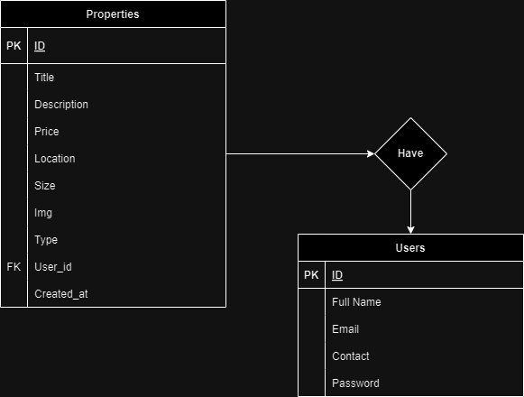

**Pages**

Home.php

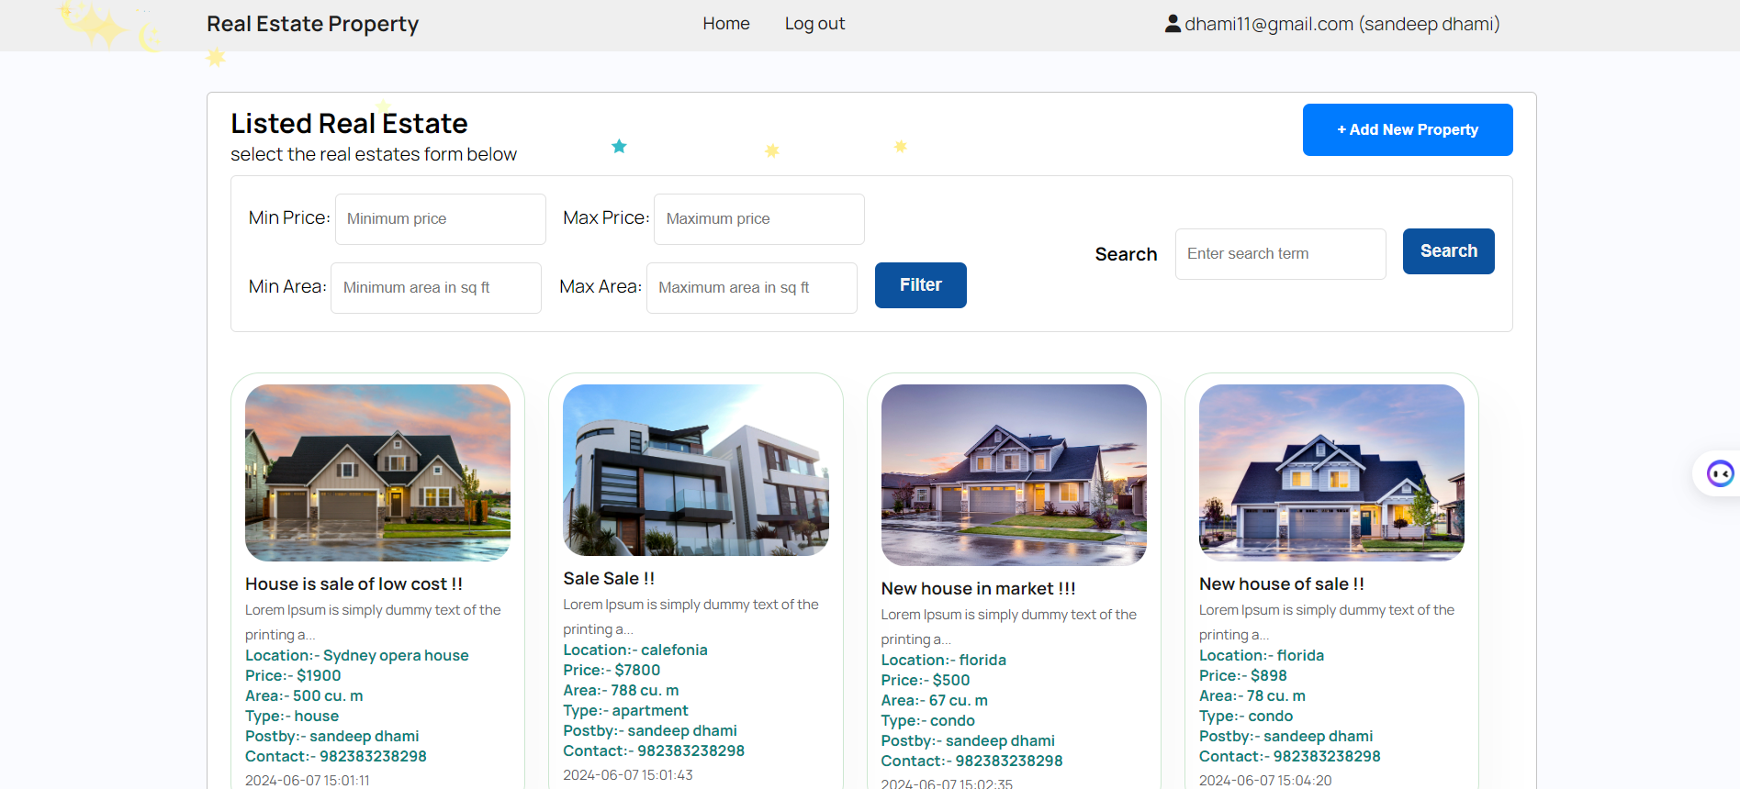

This is the home page of our website real estate management. We can see different components such as nav bar , properties post , filter and search option so that users can search the property of their desire one. The first one is the homepage that has the navbar, search option to search the properties post and filter to narrow down the post. Here you have title, options to go to the home page and log out, and information that the user is currently logged in because of the email and first name/last name in the header.

The main menu anchored with the title ‘Listed Real Estate’ contains options for price and area that can be used to select the range of results that are desirable. There is a dual-box search to look up properties based on certain keywords and an easily noticeable ‘Add New Property’ option to help out the agents with listing new properties.

You are welcome to browse properties in cards, every card is equipped with an image, title, short description, location, price, area, type of property as well as the name and contact details of the agent who lists the property. The date and time when an item was listed are also posted in order to assist users in determining how recent; the listings are.

The layout makes it possible for the agents that post the houses or properties on the website to organize themselves while the clients search for the house that fit their needs. Simplicity of structure coupled with easy to greet navigation further optimizes the process of real estate management, and relationships between the brokers and customers.

Add-properties.php

When the user click add property post in our website home page, the user is redirected to this form. Where the user fill all the details about their real estate property. It enables users to place properties and property information within a website. Fields in the above form are described below :-

Title: This field is where you can enter a title for your property listing. A second instruction is to add a title, and another input field is provided for this purpose.

Description: Here is where specific details about the property can be disclosed.

Price: This is the field where you input the value of your property or the price of the property.

Location: This field is where you can enter the physical address of the property for which you need translation services.

Size: This field is where you need to input the size of your property in terms of area in sq ft.

Type: This field is an enlargement of a drop list wherein you have to make a choice as to the category you are offering for rent.

Upload Images: It is used to upload pictures of properties.

List Property: With this button, you will be able to post your house in the website.

After completing and entering all the required fields and selecting the requred images of the property, the form data is stored in the mysql database and also the uploaded images are stored in the folder named “uploads” inside the assets folder. These images are then late fetched so they can be displaied.

Login.php

It enables users to submit their logins details for them to be granted access into a website or an application. If the entered information is not valid such as password or email address doesn’t match then the php returns with the error. If the entered information is correct the user is then redirected to the home page.

Register.php

This is the registration for form where the new users can register their account to our system. This can be done by entering full name , email address, contact details, and finally the password of the user. The registration form is used to submit the form to the backend for validation. If some is working with the form data php return a error such as email is not valid, password is not strong enough , etc. if every thing is good the form details are stored to database.

**Conclusion**

This paper defines a Real Estate Property Management System as an important and useful software that is used in managing property details, client and agent data as well as carrying out transactions. Thus, introduction of such a system can bring significant benefits for real estate agencies meaning better organization, improved communication and improved service to customers. As a result, reading this documentation will acquaint a user with system’s database schema, unique features, strengths, and areas of application, which will help create a proper framework for its usage.