Design System Creation Report
Project Link: https://www.figma.com/make/Qqm3aoasE1jQdswMomUs0I/Design-System-Creation

Introduction
This report presents the Design System Creation project developed in Figma. A design system is a collection of reusable components, design tokens, typography standards, color palettes, spacing rules, and documentation that helps teams create consistent digital products.

Project Overview
The goal of this project is to establish a scalable and reusable design language that can be used across multiple products and platforms. The system improves consistency, efficiency, collaboration, and development speed.

Color System
The design system includes primary, secondary, background, foreground, success, warning, and error colors. These color tokens ensure consistency and accessibility throughout the user interface.

Typography System
Typography guidelines define font families, sizes, weights, hierarchy, and spacing. A clear typographic scale improves readability and creates a structured visual hierarchy.

Components and Tokens
Reusable design components and tokens help designers and developers maintain consistency. Buttons, forms, cards, spacing units, and color variables can be reused throughout projects.

Benefits of the Design System
The system reduces design inconsistencies, speeds up development, improves collaboration, and creates a better user experience across products.

Conclusion
The Design System Creation project demonstrates the importance of standardized UI elements and documentation. It provides a strong foundation for building scalable and maintainable digital products.

Screenshots and Analysis

Design System Overview
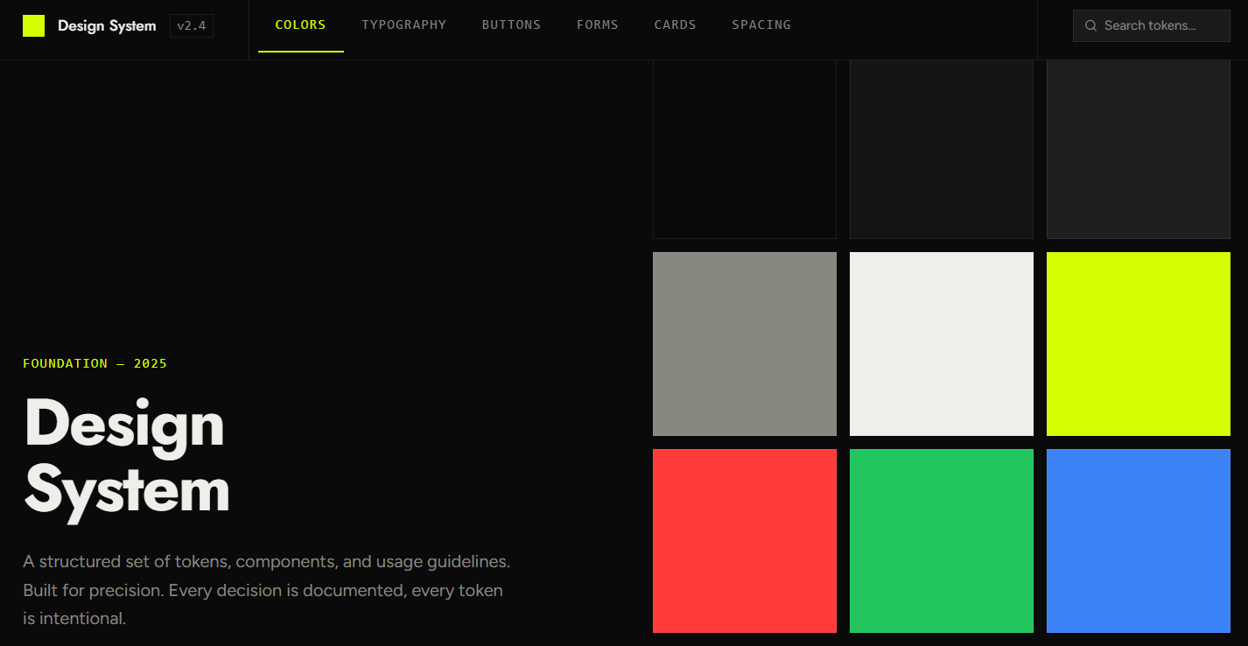

Typography and Grid System
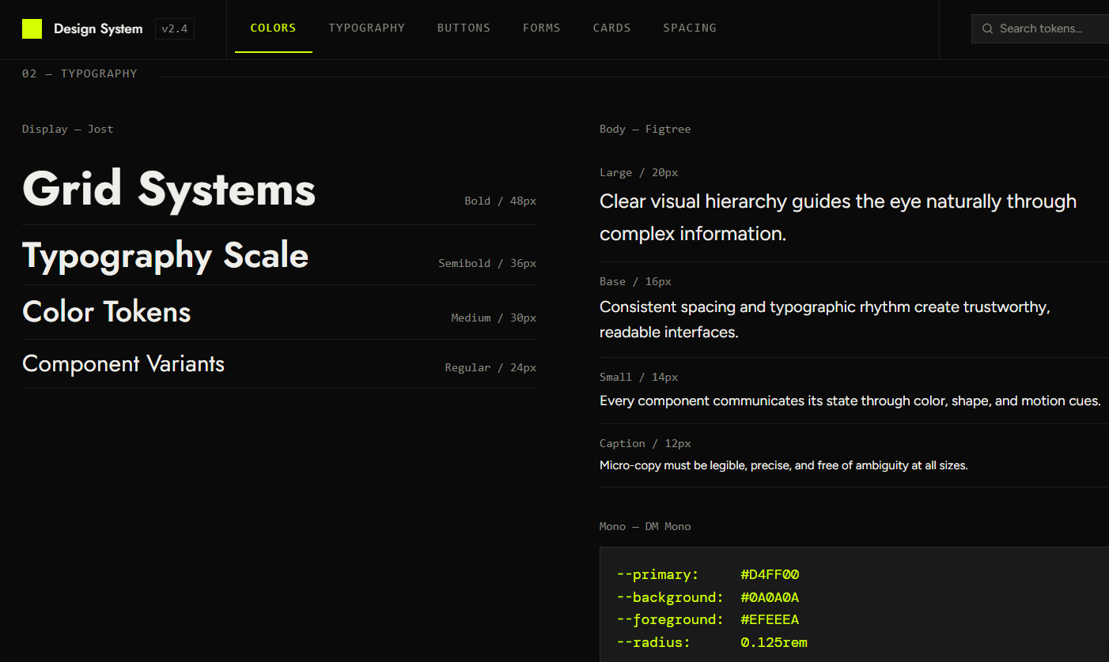

Features and Components
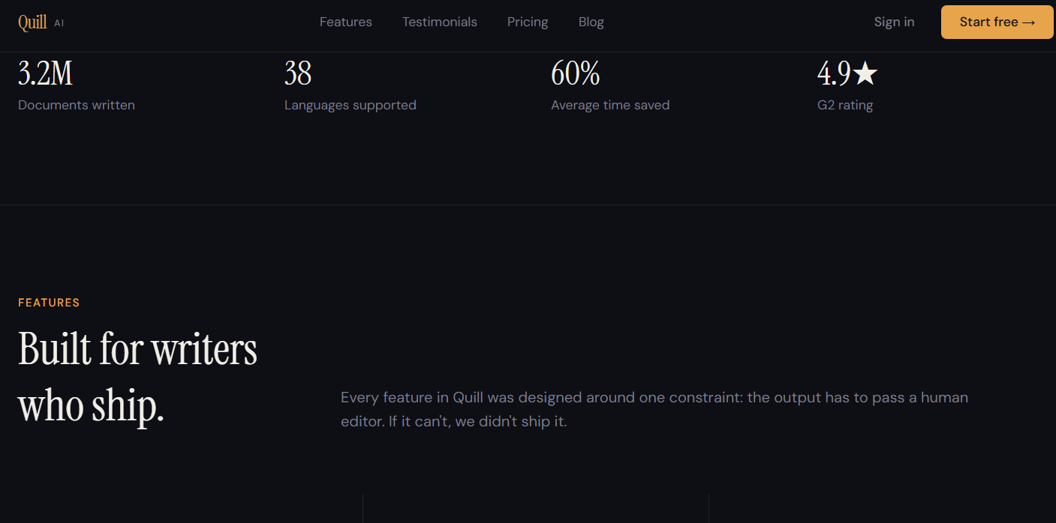

UI Component Examples
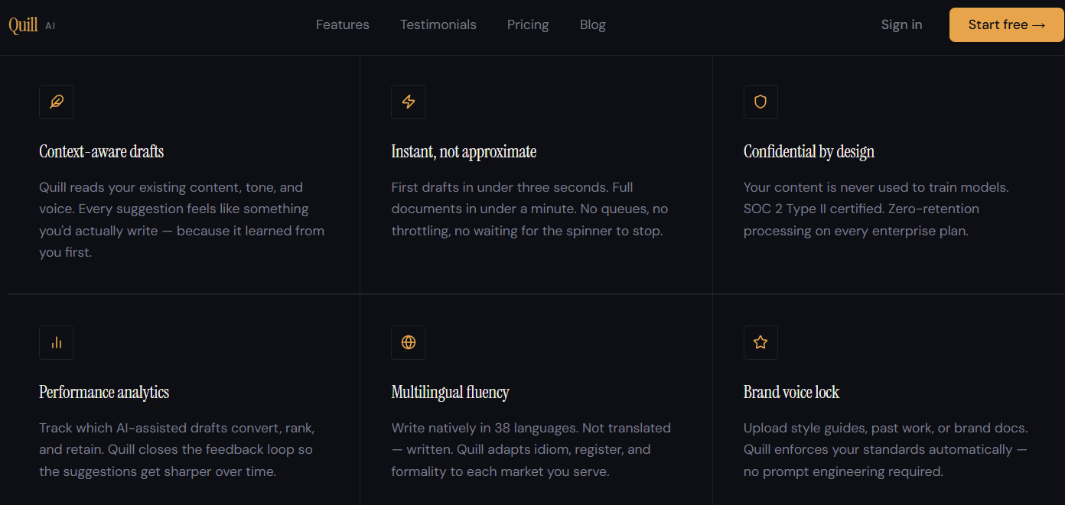

Design Validation and Results
