Landing Page Design Report – Quill AI
Project Link: https://www.figma.com/make/1vgGPRAFS73FoMVLuOitcz/Landing-page-design

Introduction
Quill AI is an AI-powered writing assistant platform that helps users create high-quality content while preserving their writing style. This report explains the design, features, and user experience of the landing page.

Project Overview
The landing page is designed to attract users, explain the product’s benefits, and encourage registrations through strong calls to action.

Hero Section
The hero section immediately communicates the product value proposition using bold typography and a live product preview.

Features
The page highlights context-aware drafts, multilingual support, analytics, privacy protection, and brand voice management.

Social Proof
Testimonials and user success stories help establish trust and credibility.

Conclusion
The landing page successfully combines modern UI design and UX principles to create a professional SaaS marketing website.

Screenshot 1
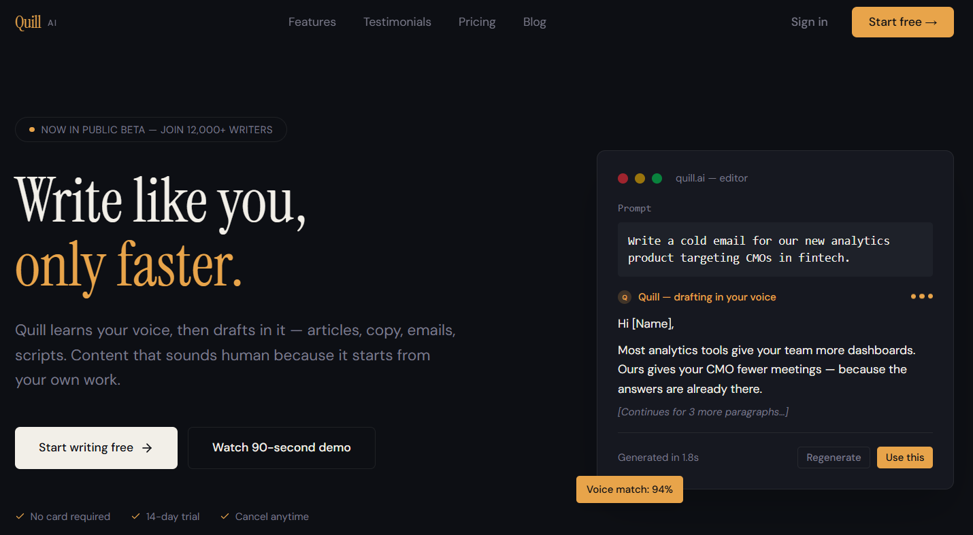

Screenshot 2
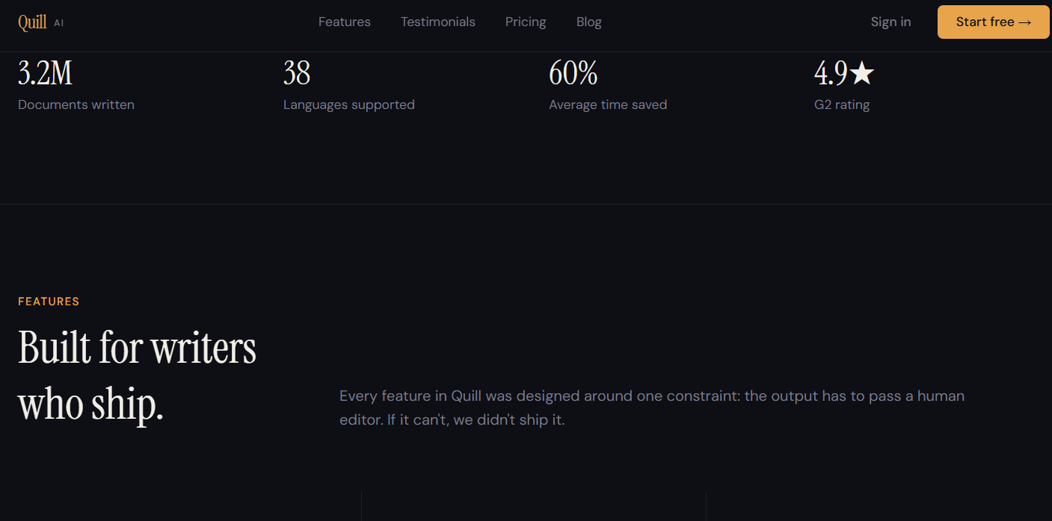

Screenshot 3
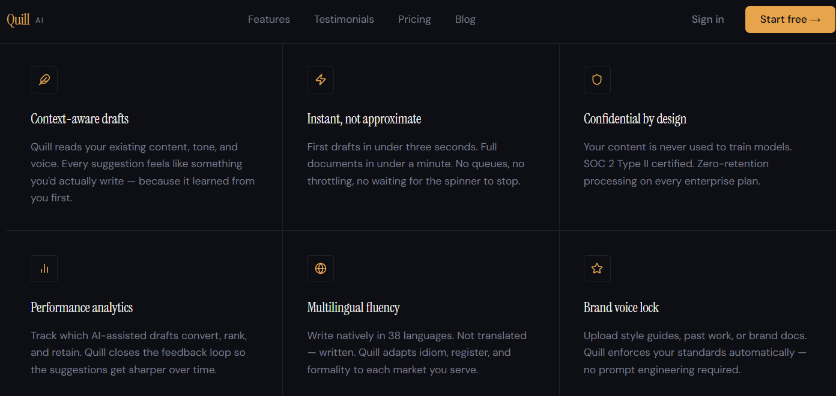

Screenshot 4
