UX Case Study Design Report – FocusFlow Task Manager App
Figma Project Link: https://www.figma.com/make/PtVmaBaajVbDhJnLBR7KH2/UX-Case-Study-Design

1. Introduction
FocusFlow is a mobile task management application designed to help busy professionals organize their daily activities, improve productivity, and maintain focus on important tasks. This UX case study demonstrates the complete design process from research to prototype and developer handoff.

2. Project Overview
The application helps users create tasks, prioritize work, track progress, and stay focused. The design follows a user-centered approach to solve productivity challenges.

3. User Research and Personas
Research interviews and surveys were conducted to understand user pain points. The findings helped create user personas and guided design decisions.

4. User Flows and Wireframes
User journeys were mapped from onboarding to task completion. Low-fidelity wireframes were created to validate layouts and navigation.

5. High-Fidelity Prototype
The final prototype includes splash screen, dashboard, task list, task details, focus mode, and completion screens with a modern dark theme.

6. Design System
A design system was created with reusable colors, typography, spacing, and UI components to maintain consistency.

7. Developer Handoff
Developer-ready documentation includes design tokens, spacing guidelines, specifications, and implementation details.

8. Documentation and Deliverables
The project contains research reports, wireframes, prototypes, design system assets, and handoff documents.

9. Conclusion
The FocusFlow case study demonstrates the complete UX process and delivers a practical, user-friendly productivity solution.

Screenshots

Case Study Overview
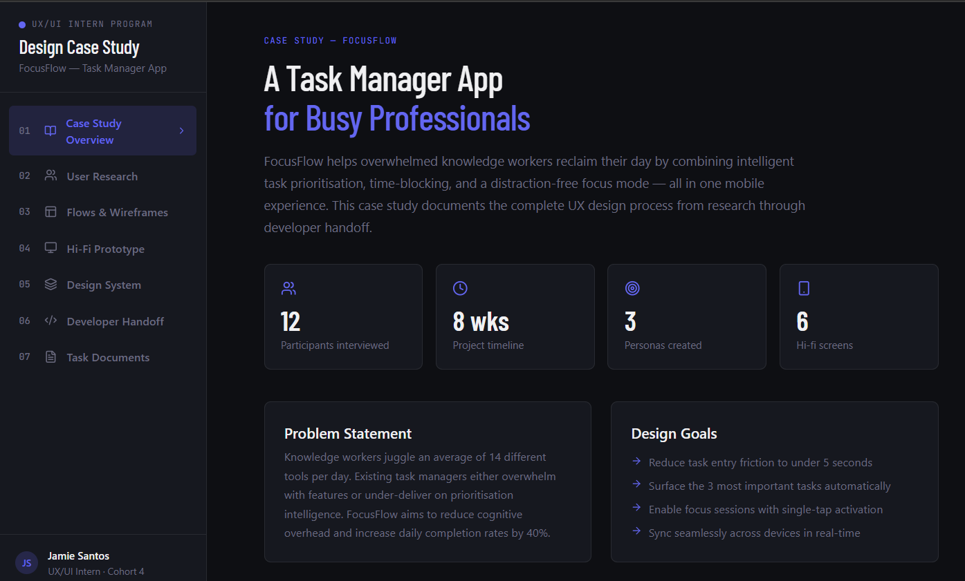

User Research & Personas
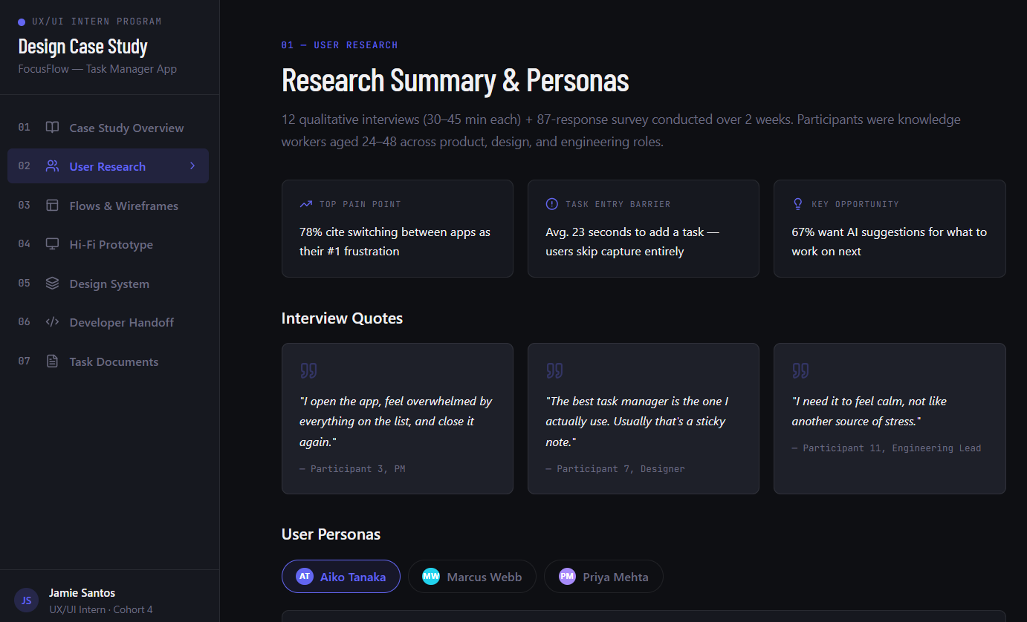

User Flows & Wireframes
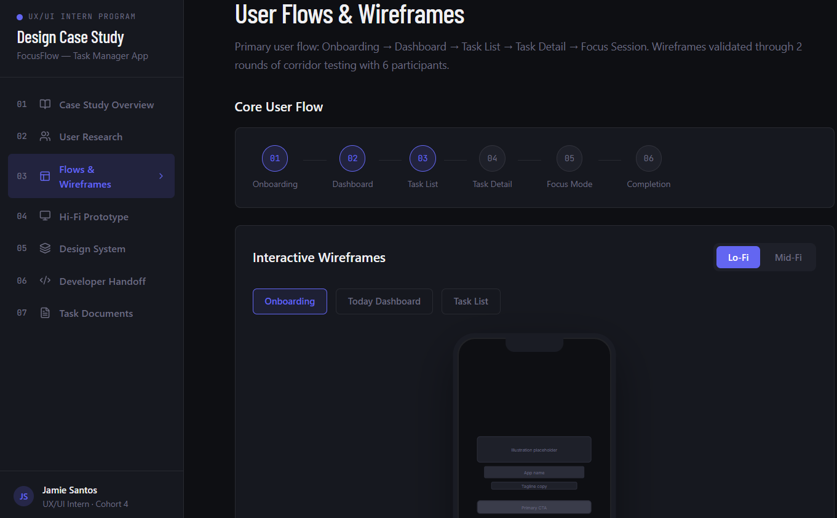

High-Fidelity Prototype
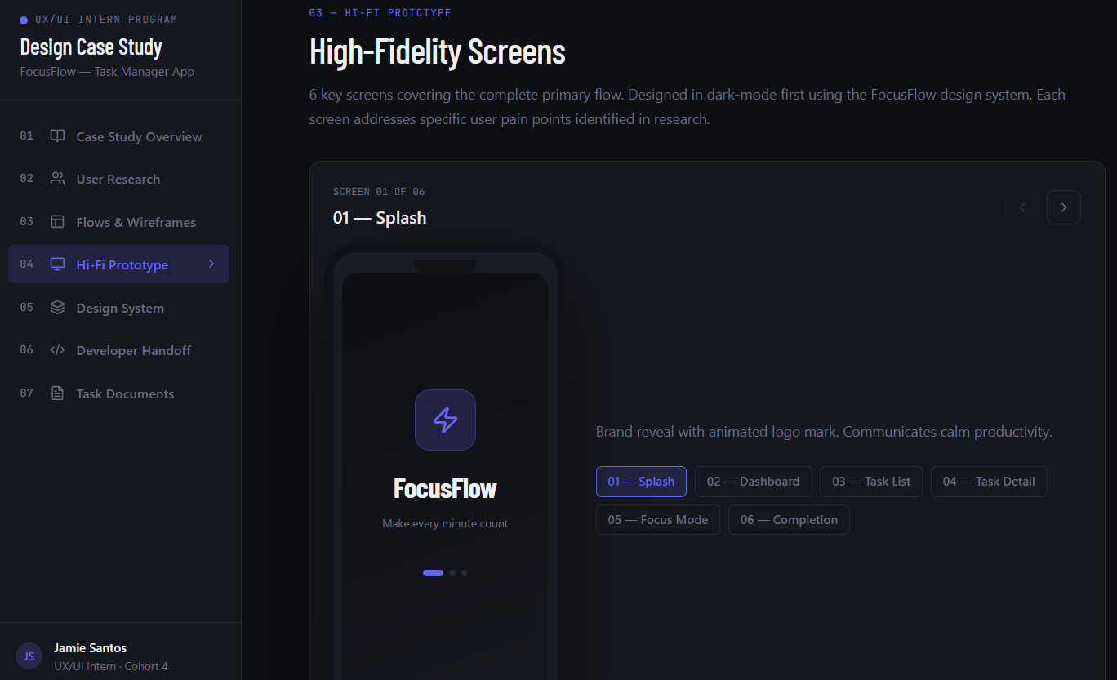

Design System
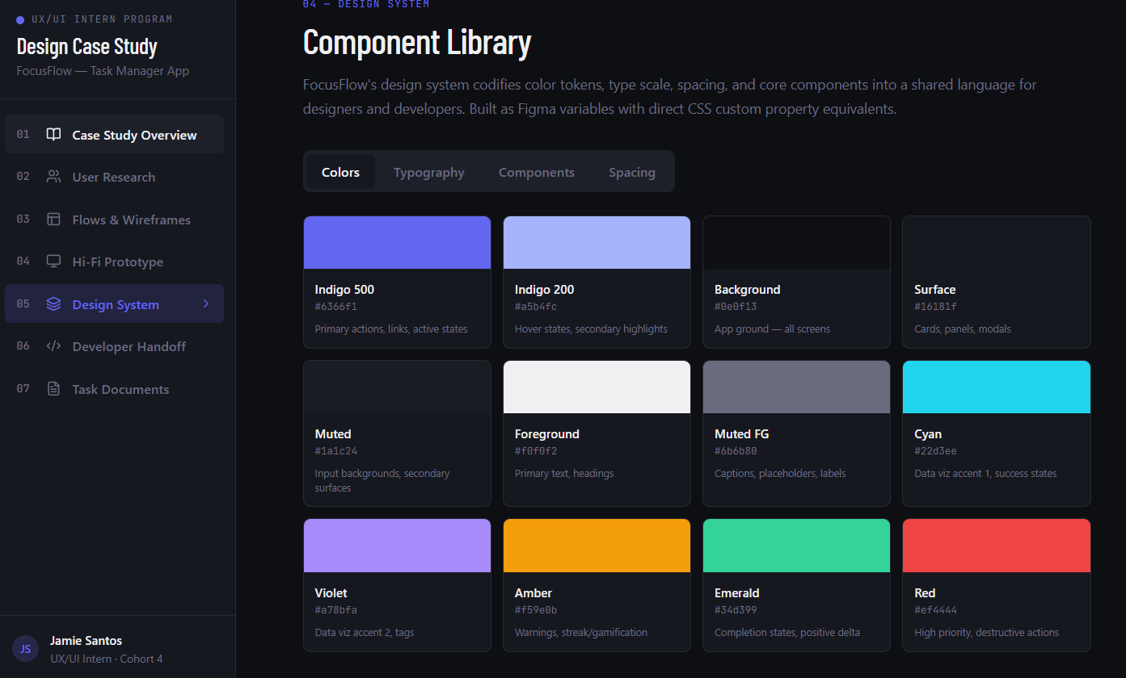

Developer Handoff
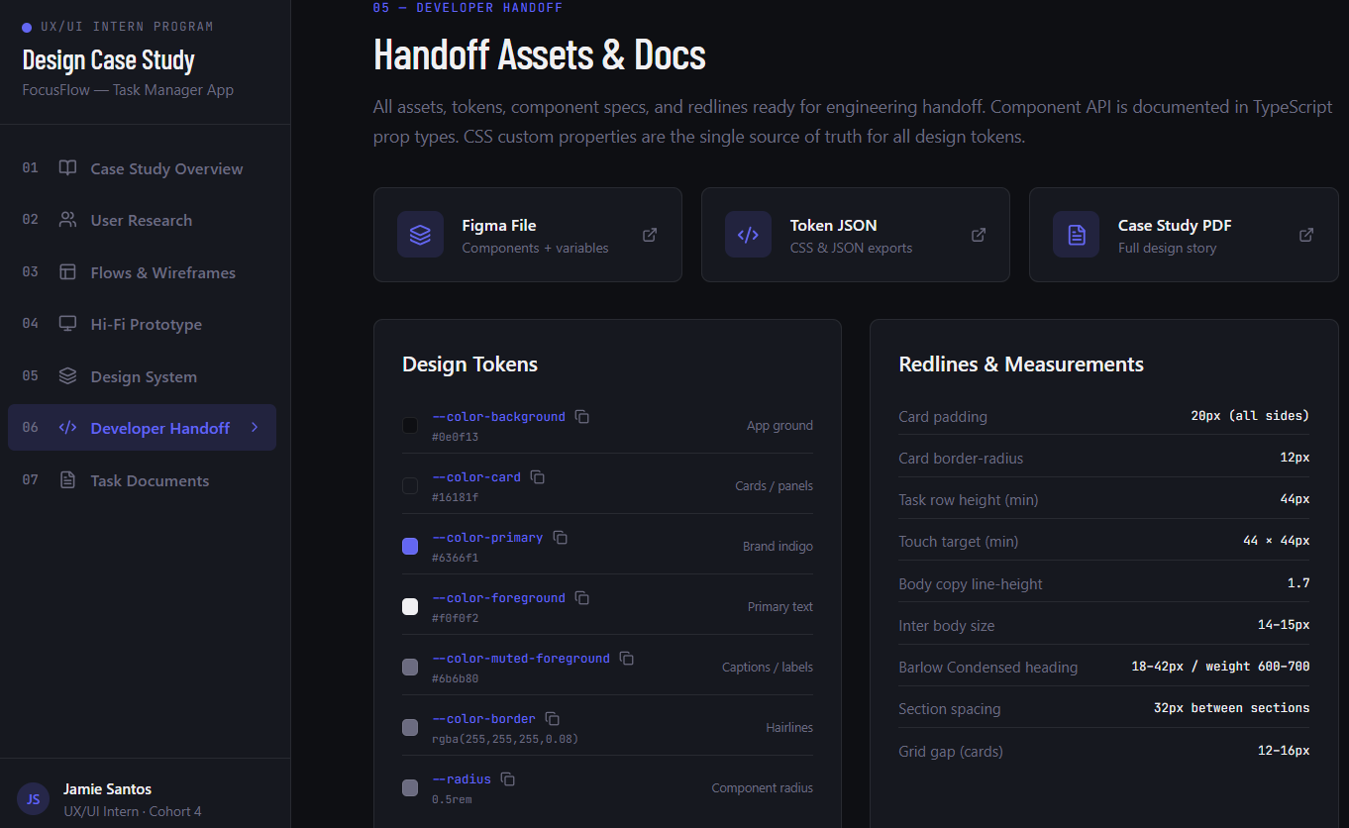

Task Documents & Exports
