**DESIGN OF D FLIPFLOP:**

**TRUTH TABLE:**

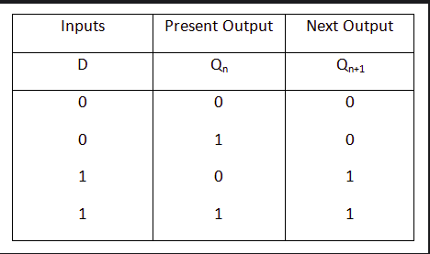

**RTL SCHEMATIC:**

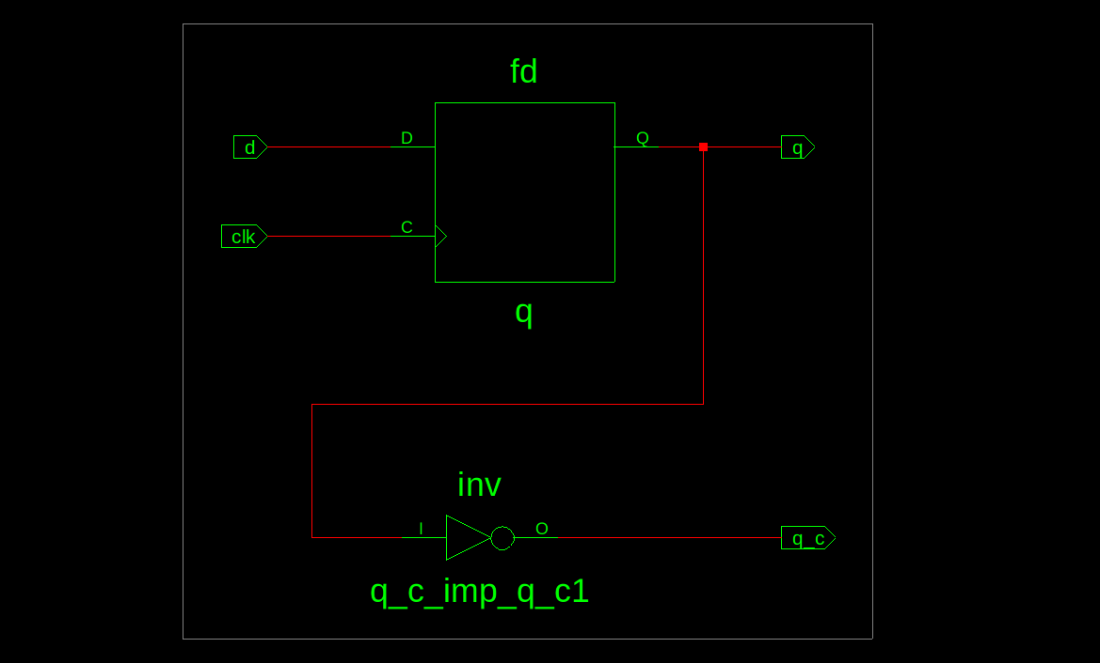

**INNOVUS DESIGN:**

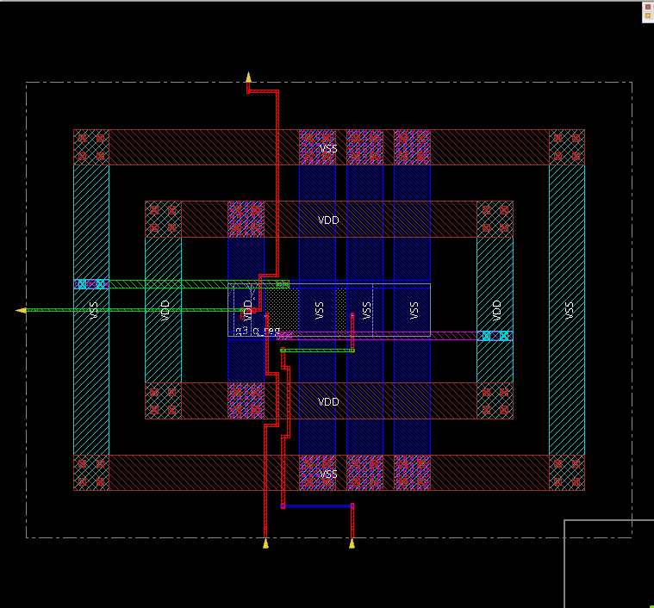

**AREA REPORT:**

**(from Genus):**

Gate Instances Area Library

----------------------------------

DFFQX1 1 15.895 slow

INVXL 1 2.271 slow

----------------------------------

total 2 18.166

Type Instances Area Area %

---------------------------------------

sequential 1 15.895 87.5

inverter 1 2.271 12.5

physical_cells 0 0.000 0.0

---------------------------------------

total 2 18.166 100.0

**(from Innovus)**

Depth Name #Inst Area (um^2)

----------------------------------

0 dff 2 18.1656

**POWER REPORT:**

**(from Genus):**

Leakage Dynamic Total

Instance Cells Power(nW) Power(nW) Power(nW)

dff 2 107.642 4123.272 4230.914

**(from Innovus):**

Total Power

Total Internal Power: 0.00415490 95.5212%

Total Switching Power: 0.00008718 2.0042%

Total Leakage Power: 0.00010764 2.4747%

Total Power: 0.00434972

**TIMING REPORTS:**

#------------------------------------------------------------------------------

# Timing Point Flags Arc Edge Cell Fanout Load Trans Delay Arrival

# (fF) (ps) (ps) (ps)

#------------------------------------------------------------------------------

q_reg/CK - - R (arrival) 1 - 100 - 0

q_reg/Q - CK->Q F DFFQX1 2 1.6 40 322 322

g3/Y - A->Y R INVXL 1 0.0 17 24 346

q_c - - R (port) - - - 0 346

#------------------------------------------------------------------------------

**COMPARISON OF AREAs WITH OTHER DEVICES:**

|  |  |  |
| --- | --- | --- |
| DEVICE | AREA (GENUS) | AREA (INNOVUS) |
| D FLIPFLOP | 18.166 um^2 | 18.1656 um^2 |
| SERIAL ADDER | 637.310 um^2 | 637.3105 um^2 |
| SERIAL MULTIPLIER | 645.636 um^2 | 645.6357 um^2 |

**COMPARISON OF POWERs:**

|  |  |  |
| --- | --- | --- |
| DEVICE | POWER (GENUS) | POWER (INNOVUS) |
| D FLIPFLOP | 4230.914 nW | 0.00434972 mW |
| SERIAL ADDER | 175193.063 nW | 0.12726743 mW |
| SERIAL MULTIPLIER | 178773.456 nW | 0.13222011 mW |

**OBSERVATIONS:**

* D flipflop is clearly simpler in design than the other devices, so it has lower power and area.