REPORT FOR 8*3 PRIORITY ENCODER:

a. TRUTH TABLE:

INPUTS |  |  |  |  |  |  |  | OUTPUT
D7 | D6 | D5 | D4 | D3 | D2 | D1 | D0 | Y2 | Y1 | Y0
0 | 0 | 0 | 0 | 0 | 0 | 0 | 0 | X | X | X
0 | 0 | 0 | 0 | 0 | 0 | 0 | 1 | 0 | 0 | 0
0 | 0 | 0 | 0 | 0 | 0 | 1 | X | 0 | 0 | 1
0 | 0 | 0 | 0 | 0 | 1 | X | X | 0 | 1 | 0
0 | 0 | 0 | 0 | 1 | X | X | X | 0 | 1 | 1
0 | 0 | 0 | 1 | X | X | X | X | 1 | 0 | 0
0 | 0 | 1 | X | X | X | X | X | 1 | 0 | 1
0 | 1 | X | X | X | X | X | X | 1 | 1 | 0
1 | X | X | X | X | X | X | X | 1 | 1 | 1

b. KMAP:

FOR Y0:

D7 D6 D5 D4\D3 D2 D1 D0 | XXX1 | XX1X | X1XX | 1XXX
XXX1 | 0 | 1 | 0 | 1
XX1X | 0 | 1 | 0 | 1
X1XX | 0 | 1 | 0 | 1
1XXX | 0 | 1 | 0 | 1

Similarly for Y1 & Y2 we can draw similar Kmaps.

c. RTL Schematic ( from genus & xilinx):

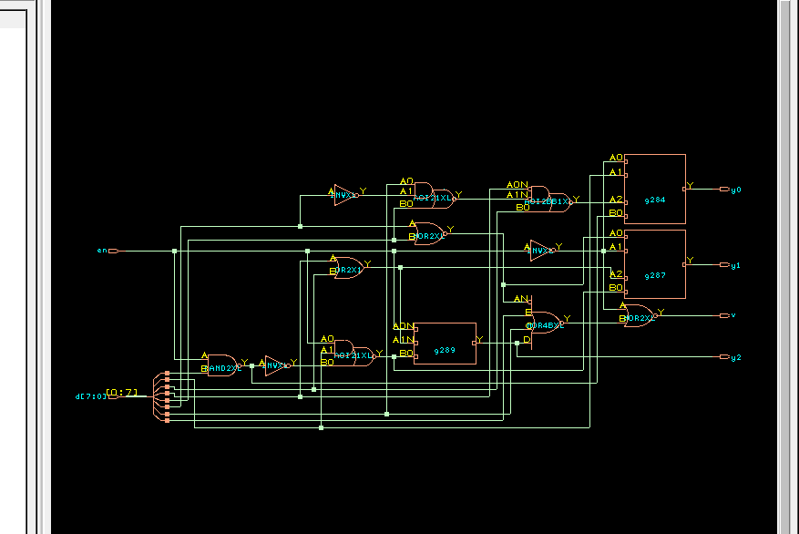

d. TIMING DIAGRAM:
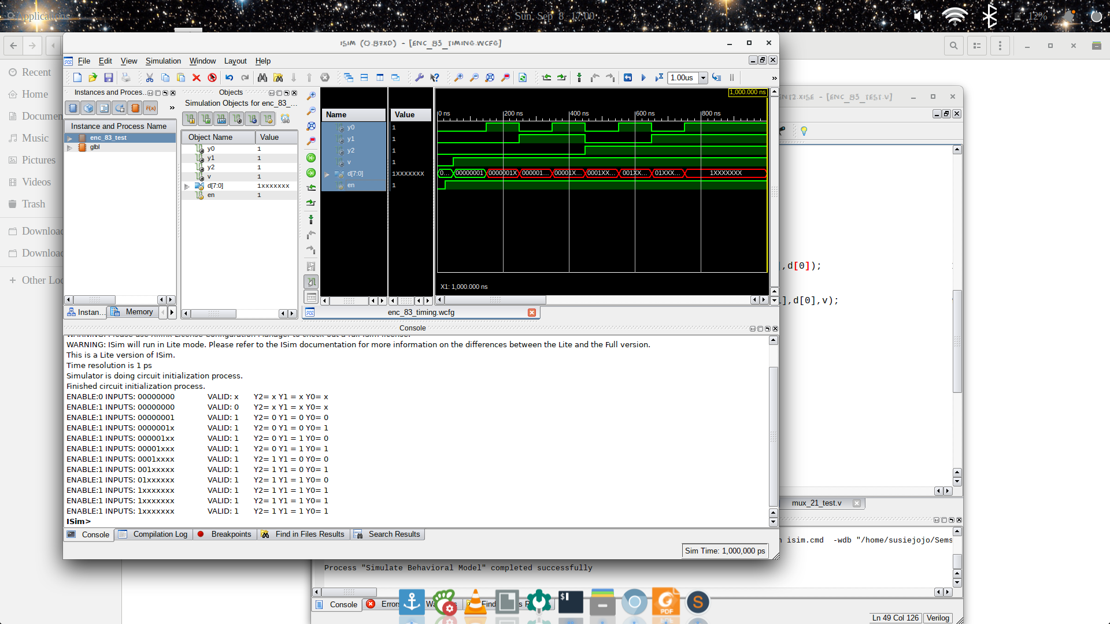

e. LAYOUT From Innovus:
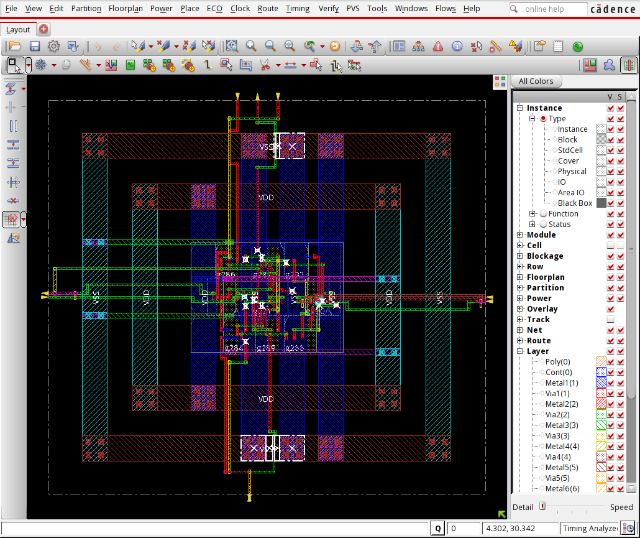

f. AREA STATISTICS:

(from Genus):

Gate Instances Area Library
-------------------------------------
AOI21XL 2 9.083 slow
AOI2BB1XL 1 6.055 slow
INVXL 3 6.812 slow
NAND2XL 1 3.028 slow
NOR2XL 2 6.055 slow
NOR4BXL 1 6.812 slow
OAI2BB1XL 1 5.298 slow
OAI31XL 2 12.110 slow
OR2X1 1 4.541 slow
-------------------------------------
total 14 59.795

Type Instances Area Area %
---------------------------------------
inverter 3 6.812 11.4
logic 11 52.983 88.6
physical_cells 0 0.000 0.0
---------------------------------------
total 14 59.795 100.0

(from Innovus):

Depth Name #Inst Area (um^2)
---------------------------------------
0 encoder_83 14 59.7951

g. POWER STATISTICS:

(from Genus)

Leakage Dynamic Total
Instance Cells Power(nW) Power(nW) Power(nW)
-----------------------------------------------
encoder_83 14 212.476 1331.364 1543.840

(from Innovus)

#Power Units = 1mW

Total Power
Total Internal Power: 0.00089284 59.3015%
Total Switching Power: 0.00040028 26.5861%
Total Leakage Power: 0.00021248 14.1124%
Total Power: 0.00150560
h. NETLIST STATISTICS: (from Innovus)

*** Statistics for net list encoder_83 ***
Number of cells = 15
Number of nets = 24
Number of tri-nets = 0
Number of degen nets = 0
Number of pins = 64
Number of i/os = 13

Number of nets with 2 terms = 11 (45.8%)
Number of nets with 3 terms = 12 (50.0%)
Number of nets with 6 terms = 1 (4.2%)
Number of nets with >=10 terms = 0 (0.0%)

*** 9 Primitives used:
Primitive OAI2BB1XL (1 insts)
Primitive AOI21XL (2 insts)
Primitive NOR2XL (1 insts)
Primitive NAND2BXL (1 insts)
Primitive INVXL (4 insts)
Primitive OAI31XL (3 insts)
Primitive NAND2XL (1 insts)
Primitive OR2X1 (1 insts)
Primitive AOI2BB1XL (1 insts)

i. TIMING REPORT: (from Xilinx_ISE)

Timing constraint: Default path analysis
Total number of paths / destination ports: 29 / 4
-------------------------------------------------------------------------
Delay: 1.375ns (Levels of Logic = 4)
Source: d<3> (PAD)
Destination: y0 (PAD)

Data Path: d<3> to y0
Gate Net
Cell:in->out fanout Delay Delay Logical Name (Net Name)
---------------------------------------- ------------
IBUF:I->O 3 0.001 0.521 d_3_IBUF (d_3_IBUF)
LUT3:I0->O 1 0.097 0.379 y0_SW0 (N2)
LUT6:I4->O 1 0.097 0.279 y0 (y0_OBUF)
OBUF:I->O 0.000 y0_OBUF (y0)
----------------------------------------
Total 1.375ns (0.195ns logic, 1.180ns route)
(14.2% logic, 85.8% route)

j. ANALYSIS:

- The total power obtained from Genus is clearly higher than that from Innovus, which is justified by the fact that Innovus optimised the design.

- In the timingReports, the delays are listed due to the local and global buffers, but for WNS & TNS the time is 0 as it is a combinational circuit.

