REPORT FOR 1*2 DECODER:

a. TRUTH TABLE:

ENABLE | INPUTS | OUTPUT(Y)
 | A | Y1 | Y0
0 | 0 | 0 | 0
0 | 1 | 0 | 0
1 | 0 | 0 | 1
1 | 1 | 1 | 0

b. KMAP:

FOR Y0:

En \ A | 0 | 1
0 | 0 | 0
1 | 1 | 0

So, Y0 = En.A’
FOR Y1:

En \ A | 0 | 1
0 | 0 | 0
1 | 0 | 1

So, Y1 = En.A

c. RTL Schematic ( from genus & xilinx):

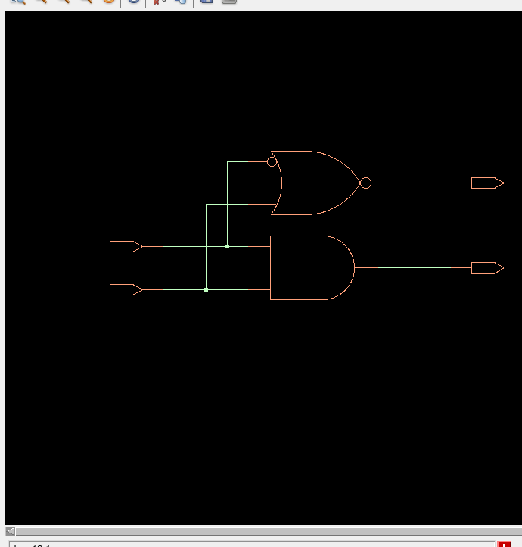

d. TIMING DIAGRAM:
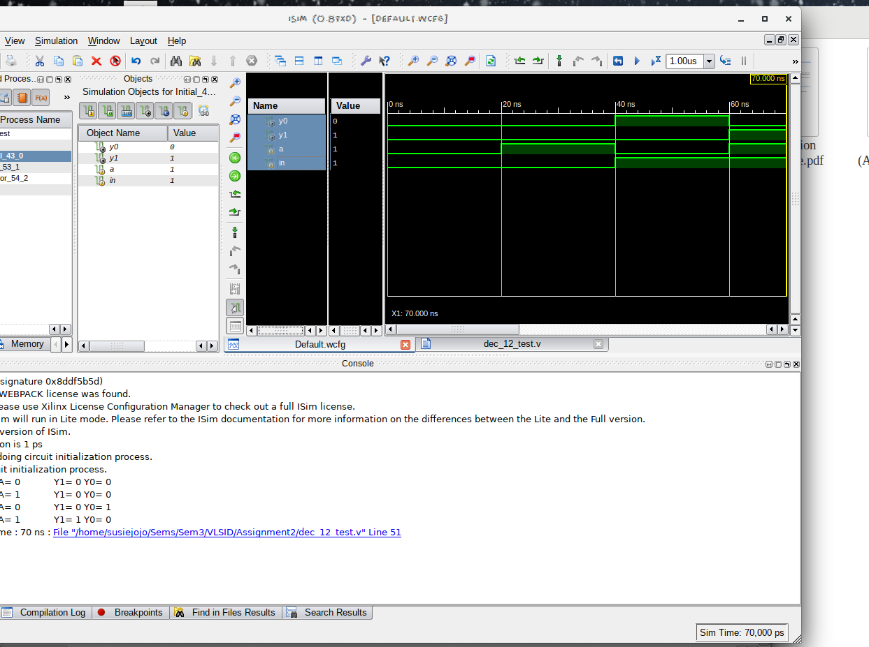

e. LAYOUT From Innovus:
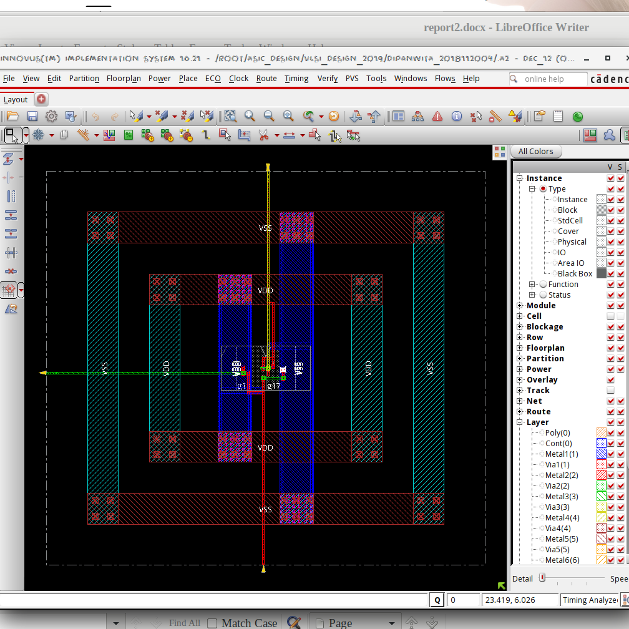

f. AREA STATISTICS:

(from Genus):

Gate Instances Area Library
----------------------------------
AND2XL 1 4.541 slow
NOR2BXL 1 4.541 slow
----------------------------------
total 2 9.083

Type Instances Area Area %
--------------------------------------
logic 2 9.083 100.0
physical_cells 0 0.000 0.0
--------------------------------------
total 2 9.083 100.0

(from Innovus):

Depth Name #Inst Area (um^2)
-----------------------------------
0 dec_12 2 9.0828

g. POWER STATISTICS:

(from Genus)

Leakage Dynamic Total
Instance Cells Power(nW) Power(nW) Power(nW)
---------------------------------------------
dec_12 2 41.288 200.343 241.631
(from Innovus)

#Power Units = 1mW

Total Power
Total Internal Power: 0.00013704 69.0971%
Total Switching Power: 0.00002000 10.0857%
Total Leakage Power: 0.00004129 20.8172%
Total Power: 0.00019833
h. NETLIST STATISTICS: (from Innovus)

*** Statistics for net list dec_12 ***
Number of cells = 2
Number of nets = 4
Number of tri-nets = 0
Number of degen nets = 0
Number of pins = 10
Number of i/os = 4

Number of nets with 2 terms = 2 (50.0%)
Number of nets with 3 terms = 2 (50.0%)
Number of nets with >=10 terms = 0 (0.0%)

*** 2 Primitives used:
Primitive NOR2BXL (1 insts)
Primitive AND2XL (1 insts)

i. TIMING REPORT: (from Xilinx_ISE)

Timing Details:
---------------
All values displayed in nanoseconds (ns)

Timing constraint: Default path analysis
Total number of paths / destination ports: 4 / 2
-------------------------------------------------------------------------
Delay: 0.761ns (Levels of Logic = 3)
Source: a (PAD)
Destination: y0 (PAD)

Data Path: a to y0
Gate Net
Cell:in->out fanout Delay Delay Logical Name (Net Name)
---------------------------------------- ------------
IBUF:I->O 2 0.001 0.383 a_IBUF (a_IBUF)
LUT2:I0->O 1 0.097 0.279 y11 (y1_OBUF)
OBUF:I->O 0.000 y1_OBUF (y1)
----------------------------------------
Total 0.761ns (0.098ns logic, 0.663ns route)
(12.9% logic, 87.1% route)

j. ANALYSIS:

- The transistor-level design is expected to have 5 NMOS + 5 PMOS ((1 NMOS + 1 PMOS for inverter) + andgate). Hence the area is justified.
- The total power obtained from Genus is clearly higher than that from Innovus, which is justified by the fact that Innovus optimised the design.
- In the timingReports, the delays are listed due to the local and global buffers, but for WNS & TNS the time is 0 as it is a combinational circuit.

