REPORT FOR 2*4 DECODER:(using 1*2 DECODER)

a. TRUTH TABLE:

ENABLE | INPUTS |  | OUTPUT(Y)
 | S1 | S0 | Y3 | Y2 | Y1 | Y0
0 | 0 | 0 | 0 | 0 | 0 | 0
0 | 0 | 1 | 0 | 0 | 0 | 0
0 | 1 | 1 | 0 | 0 | 0 | 0
0 | 1 | 1 | 0 | 0 | 0 | 0
1 | 0 | 0 | 0 | 0 | 0 | 1
1 | 0 | 1 | 0 | 0 | 1 | 0
1 | 1 | 0 | 0 | 1 | 0 | 0
1 | 1 | 1 | 1 | 0 | 0 | 0

b. KMAP:

FOR Y0:

S1S0 \ En | 0 | 1
00 | 0 | 1
01 | 0 | 0
10 | 0 | 0
11 | 0 | 0

So, Y0 = S1’.S0’.En

FOR Y1:

S1S0 \ En | 0 | 1
00 | 0 | 0
01 | 0 | 1
10 | 0 | 0
11 | 0 | 0

So, Y1 = S1’.S0.En

FOR Y2:

S1S0 \ En | 0 | 1
00 | 0 | 0
01 | 0 | 0
10 | 0 | 1
11 | 0 | 0

So, Y2 = S1.S0’.En

FOR Y3:

S1S0 \ En | 0 | 1
00 | 0 | 0
01 | 0 | 0
10 | 0 | 0
11 | 0 | 1
So, Y3 = S1.S0.En

c. RTL Schematic ( from genus & xilinx):

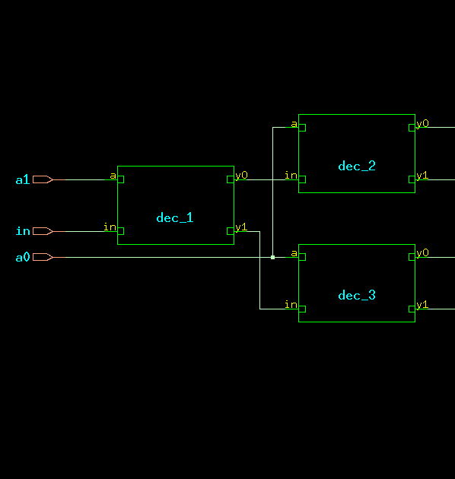

d. TIMING DIAGRAM:
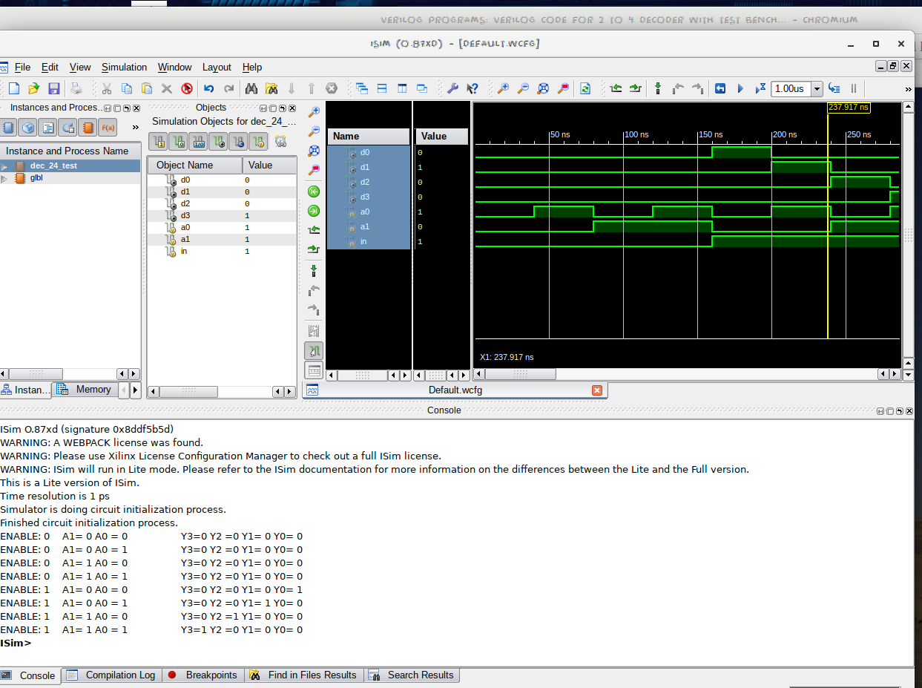

e. LAYOUT From Innovus:
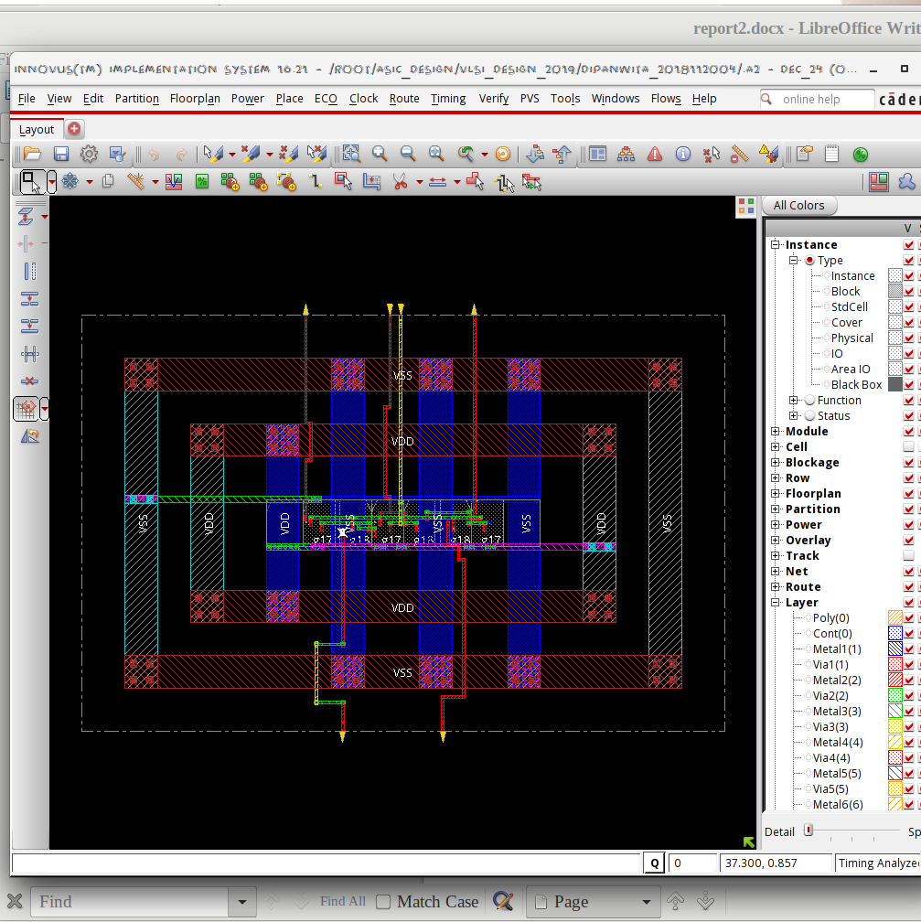

f. AREA STATISTICS:

(from Genus):

Gate Instances Area Library
-----------------------------------
AND2X1 1 4.541 slow
AND2XL 2 9.083 slow
NOR2BXL 3 13.624 slow
-----------------------------------
total 6 27.248

Type Instances Area Area %
---------------------------------------
logic 6 27.248 100.0
physical_cells 0 0.000 0.0
---------------------------------------
total 6 27.248 100.0

(from Innovus):
Depth Name #Inst Area (um^2)
-----------------------------------
0 dec_24 6 27.2484
1 dec_3 2 9.0828
1 dec_1 2 9.0828
1 dec_2 2 9.0828

g. POWER STATISTICS:

(from Genus)

Leakage Dynamic Total
Instance Cells Power(nW) Power(nW) Power(nW)
---------------------------------------------
dec_24 6 126.371 553.507 679.878
dec_1 2 43.796 227.409 271.205
dec_2 2 41.288 66.334 107.622
dec_3 2 41.288 142.482 183.770

(from Innovus)

#Power Units = 1mW

Total Power
-----------------------------------------------------------------------------------------
Total Internal Power: 0.00037401 61.7835%
Total Switching Power: 0.00010497 17.3407%
Total Leakage Power: 0.00012637 20.8758%
Total Power: 0.00060535

h. NETLIST STATISTICS: (from Innovus)

*** Statistics for net list dec_38 ***
Number of cells = 14
Number of nets = 18
Number of tri-nets = 0
Number of degen nets = 0
Number of pins = 54
Number of i/os = 12

Number of nets with 2 terms = 8 (44.4%)
Number of nets with 3 terms = 8 (44.4%)
Number of nets with 5 terms = 1 (5.6%)
Number of nets with 9 terms = 1 (5.6%)
Number of nets with >=10 terms = 0 (0.0%)

*** 3 Primitives used:
Primitive NOR2BXL (7 insts)
Primitive AND2XL (4 insts)
Primitive AND2X1 (3 insts)

i. TIMING REPORT: (from Xilinx_ISE)

Timing Details:
---------------
All values displayed in nanoseconds (ns)

Timing constraint: Default path analysis
Total number of paths / destination ports: 12 / 4
-------------------------------------------------------------------------
Delay: 0.903ns (Levels of Logic = 3)
Source: a0 (PAD)
Destination: d0 (PAD)

Data Path: a0 to d0
Gate Net
Cell:in->out fanout Delay Delay Logical Name (Net Name)
---------------------------------------- ------------
IBUF:I->O 4 0.001 0.525 a0_IBUF (a0_IBUF)
LUT3:I0->O 1 0.097 0.279 dec_3/y01 (d2_OBUF)
OBUF:I->O 0.000 d2_OBUF (d2)
----------------------------------------
Total 0.903ns (0.098ns logic, 0.805ns route)
(10.9% logic, 89.1% route)

j. ANALYSIS:

- The transistor-level design is expected to have 5 NMOS + 5 PMOS ((1 NMOS + 1 PMOS for inverter) + andgate) for each 1*2 DECODER. 2*4 DECODER has 3 such 1*2 DECODERs. Hence the area is justified.
- The total power obtained from Genus is clearly higher than that from Innovus, which is justified by the fact that Innovus optimised the design.
- In the timingReports, the delays are listed due to the local and global buffers, but for WNS & TNS the time is 0 as it is a combinational circuit.

