REPORT FOR 3*8 DECODER:(using 2*4 & 1*2 DECODERS)

a. TRUTH TABLE:

ENABLE | INPUTS |  |  | OUTPUT(Y)
En | S2 | S1 | S0 | Y7 | Y6 | Y5 | Y4 | Y3 | Y2 | Y1 | Y0
0 | 0 | 0 | 0 | 0 | 0 | 0 | 0 | 0 | 0 | 0 | 0
0 | 0 | 0 | 1 | 0 | 0 | 0 | 0 | 0 | 0 | 0 | 0
0 | 0 | 1 | 0 | 0 | 0 | 0 | 0 | 0 | 0 | 0 | 0
0 | 0 | 1 | 1 | 0 | 0 | 0 | 0 | 0 | 0 | 0 | 0
0 | 1 | 0 | 0 | 0 | 0 | 0 | 0 | 0 | 0 | 0 | 0
0 | 1 | 0 | 1 | 0 | 0 | 0 | 0 | 0 | 0 | 0 | 0
0 | 1 | 1 | 0 | 0 | 0 | 0 | 0 | 0 | 0 | 0 | 0
0 | 1 | 1 | 1 | 0 | 0 | 0 | 0 | 0 | 0 | 0 | 0
1 | 0 | 0 | 0 | 0 | 0 | 0 | 0 | 0 | 0 | 0 | 1
1 | 0 | 0 | 1 | 0 | 0 | 0 | 0 | 0 | 0 | 1 | 0
1 | 0 | 1 | 0 | 0 | 0 | 0 | 0 | 0 | 1 | 0 | 0
1 | 0 | 1 | 1 | 0 | 0 | 0 | 0 | 1 | 0 | 0 | 0
1 | 1 | 0 | 0 | 0 | 0 | 0 | 1 | 0 | 0 | 0 | 0
1 | 1 | 0 | 1 | 0 | 0 | 1 | 0 | 0 | 0 | 0 | 0
1 | 1 | 1 | 0 | 0 | 1 | 0 | 0 | 0 | 0 | 0 | 0
1 | 1 | 1 | 1 | 1 | 0 | 0 | 0 | 0 | 0 | 0 | 0

b. KMAP:

FOR Y0:

S2S1S0 / En | 0 | 1
000 | 0 | 1
001 | 0 | 0
010 | 0 | 0
011 | 0 | 0
100 | 0 | 0
101 | 0 | 0
110 | 0 | 0
111 | 0 | 0

So, Y0 = S2’.S1’.S0’.En
Similarly for Y1, Y2 ... Y7 we can draw similar Kmaps to get
Y1 = S2’.S1’.S0.En
Y2 = S2’.S1.S0’.En and so on.

c. RTL Schematic ( from genus & xilinx):

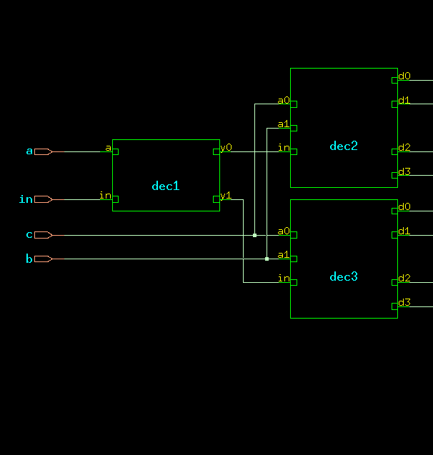

d. TIMING DIAGRAM:
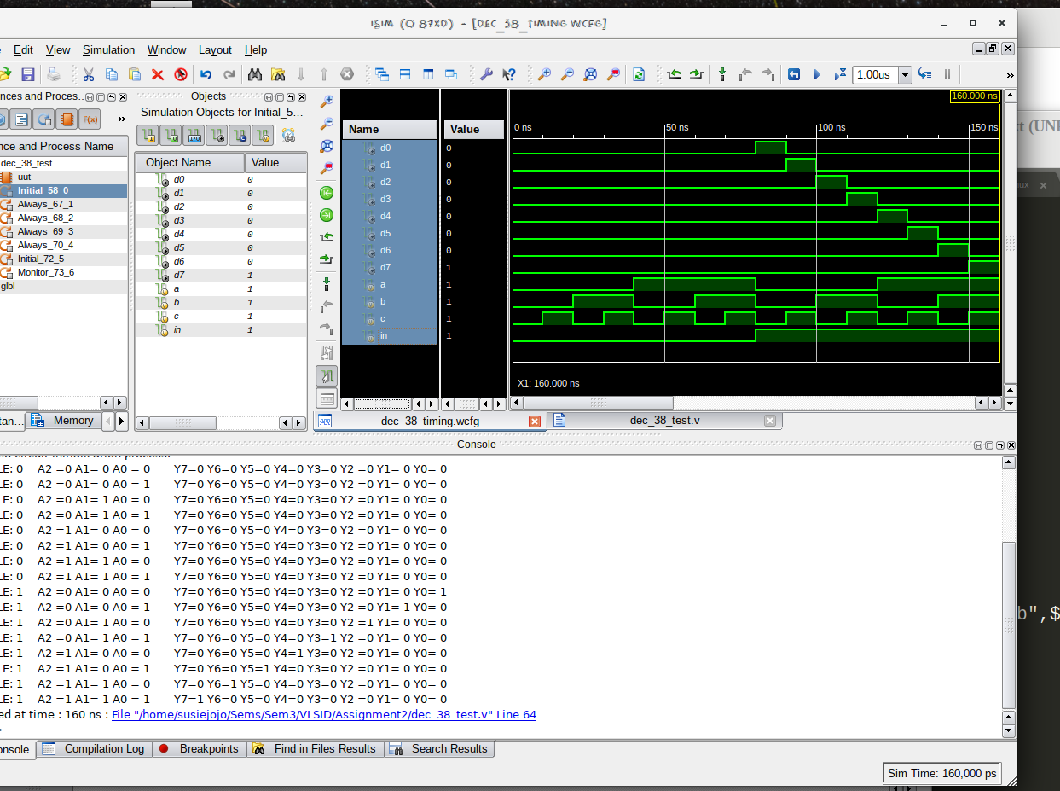

e. LAYOUT From Innovus:
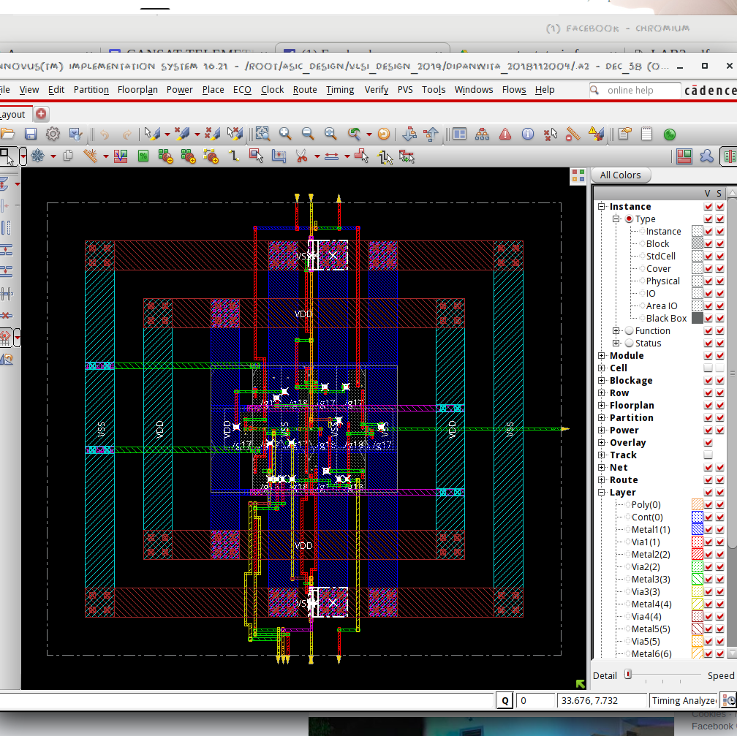

f. AREA STATISTICS:

(from Genus):

Depth Name #Inst Area (um^2)
---------------------------------------
0 dec_38 14 63.5796
1 dec3 6 27.2484
1 dec2 6 27.2484
1 dec1 2 9.0828
2 dec3/dec_2 2 9.0828
2 dec2/dec_2 2 9.0828
2 dec3/dec_3 2 9.0828
2 dec3/dec_1 2 9.0828
2 dec2/dec_3 2 9.0828
2 dec2/dec_1 2 9.0828

(from Innovus):

Depth Name #Inst Area (um^2)
---------------------------------------
0 dec_38 14 63.5796
1 dec3 6 27.2484
1 dec2 6 27.2484
1 dec1 2 9.0828
2 dec3/dec_2 2 9.0828
2 dec2/dec_2 2 9.0828
2 dec3/dec_3 2 9.0828
2 dec3/dec_1 2 9.0828
2 dec2/dec_3 2 9.0828
2 dec2/dec_1 2 9.0828

g. POWER STATISTICS:

(from Genus)

Leakage Dynamic Total
Instance Cells Power(nW) Power(nW) Power(nW)
----------------------------------------------
dec_38 14 296.538 1179.280 1475.818
dec2 6 126.371 339.515 465.886
dec_1 2 43.796 171.047 214.843
dec_2 2 41.288 60.600 101.888
dec_3 2 41.288 107.868 149.156
dec3 6 126.371 376.462 502.833
dec_1 2 43.796 204.512 248.307
dec_2 2 41.288 106.337 147.625
dec_3 2 41.288 65.613 106.901
dec1 2 43.796 227.896 271.692

(from Innovus)

#Power Units = 1mW

Total Power
Total Internal Power: 0.00069760 56.9315%
Total Switching Power: 0.00023119 18.8678%
Total Leakage Power: 0.00029654 24.2008%
Total Power: 0.00122532

h. NETLIST STATISTICS: (from Innovus)

*** Statistics for net list dec_38 ***
Number of cells = 14
Number of nets = 18
Number of tri-nets = 0
Number of degen nets = 0
Number of pins = 54
Number of i/os = 12

Number of nets with 2 terms = 8 (44.4%)
Number of nets with 3 terms = 8 (44.4%)
Number of nets with 5 terms = 1 (5.6%)
Number of nets with 9 terms = 1 (5.6%)
Number of nets with >=10 terms = 0 (0.0%)

*** 3 Primitives used:
Primitive NOR2BXL (7 insts)
Primitive AND2XL (4 insts)
Primitive AND2X1 (3 insts)

i. TIMING REPORT: (from Xilinx_ISE)

Timing Details:
---------------
All values displayed in nanoseconds (ns)

Timing constraint: Default path analysis
Total number of paths / destination ports: 32 / 8
-------------------------------------------------------------------------
Delay: 0.966ns (Levels of Logic = 3)
Source: c (PAD)
Destination: d0 (PAD)

Data Path: c to d0
Gate Net
Cell:in->out fanout Delay Delay Logical Name (Net Name)
---------------------------------------- ------------
IBUF:I->O 8 0.001 0.589 c_IBUF (c_IBUF)
LUT4:I0->O 1 0.097 0.279 dec2/dec_2/y11 (d1_OBUF)
OBUF:I->O 0.000 d1_OBUF (d1)
----------------------------------------
Total 0.966ns (0.098ns logic, 0.868ns route)
(10.1% logic, 89.9% route)

j. ANALYSIS:

- The transistor-level design is expected to have 5 NMOS + 5 PMOS ((1 NMOS + 1 PMOS for inverter) + andgate) for each 1*2 DECODER. 1*4 DECODER has 3 such 1*2 DECODERs. 1*8 DECODER has 2 1*4 and 1 1*2 DECODER. Hence equivalent to 7 1*2 DECODERs. Hence the area is justified.

- The total power obtained from Genus is clearly higher than that from Innovus, which is justified by the fact that Innovus optimised the design.

- In the timingReports, the delays are listed due to the local and global buffers, but for WNS & TNS the time is 0 as it is a combinational circuit.

