REPORT FOR 1*2 DEMUX:

a. TRUTH TABLE:

SELECT LINE(S) | INPUTS | OUTPUT(Y)
 | A | Y1 | Y0
0 | 0 | 0 | 0
0 | 1 | 0 | 1
1 | 0 | 0 | 0
1 | 1 | 1 | 0

b. KMAP:

FOR Y0:

S \ A | 0 | 1
0 | 0 | 1
1 | 0 | 0

So, Y0 = S’.A
FOR Y1:

S \ A | 0 | 1
0 | 0 | 0
1 | 0 | 1

So, Y1 = S.B

c. RTL Schematic ( from genus & xilinx):

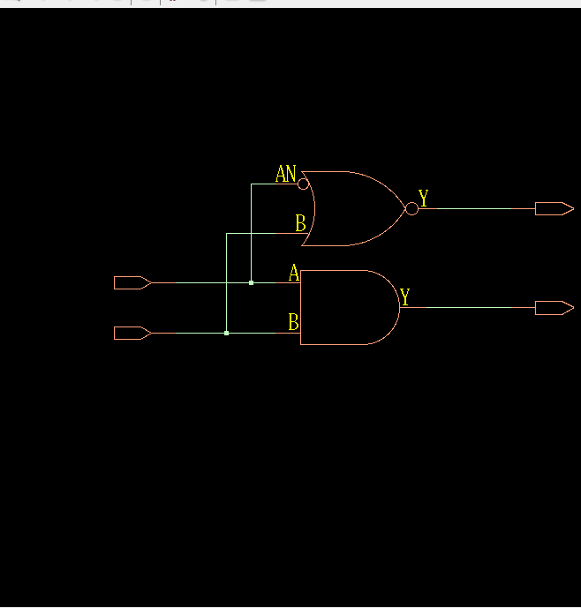

d. TIMING DIAGRAM:
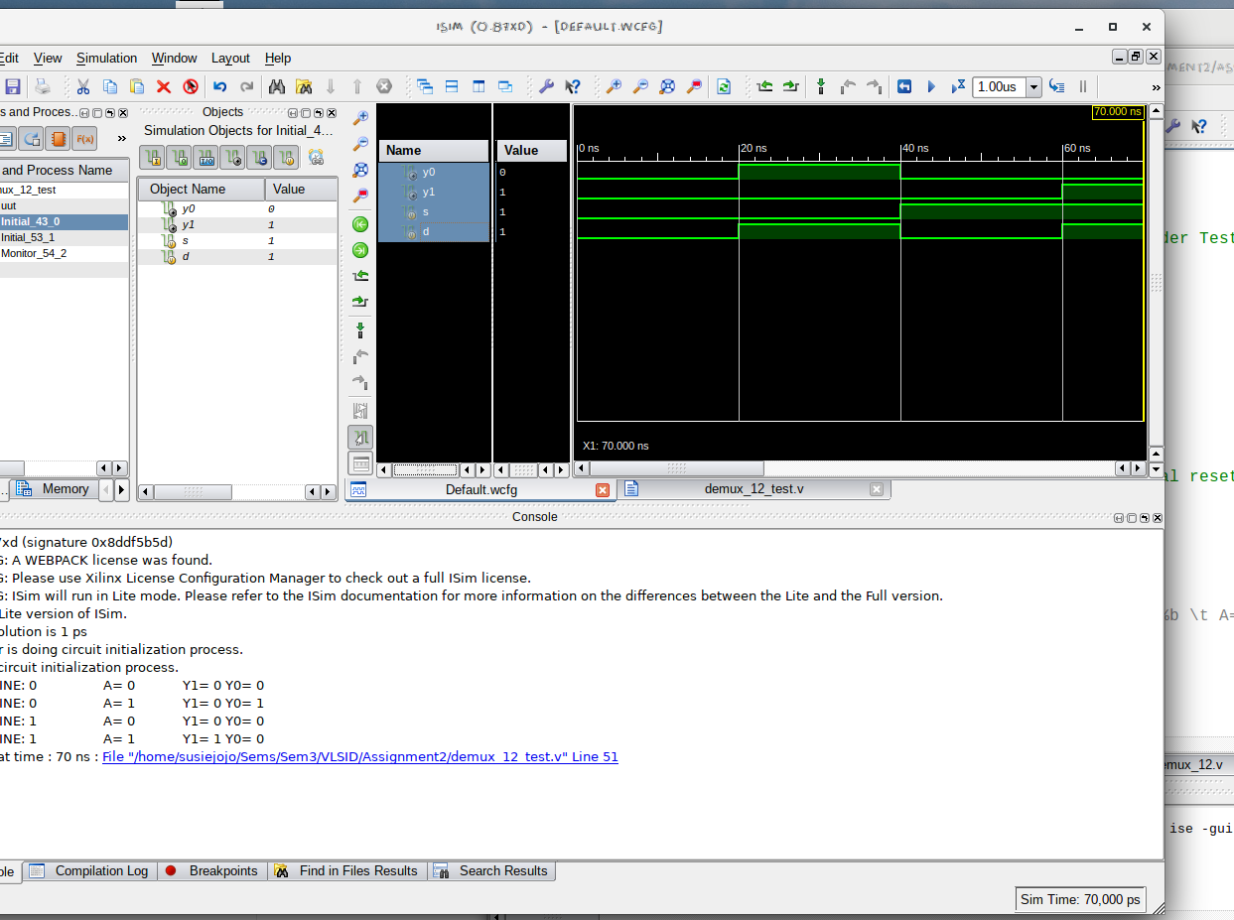

e. LAYOUT From Innovus:
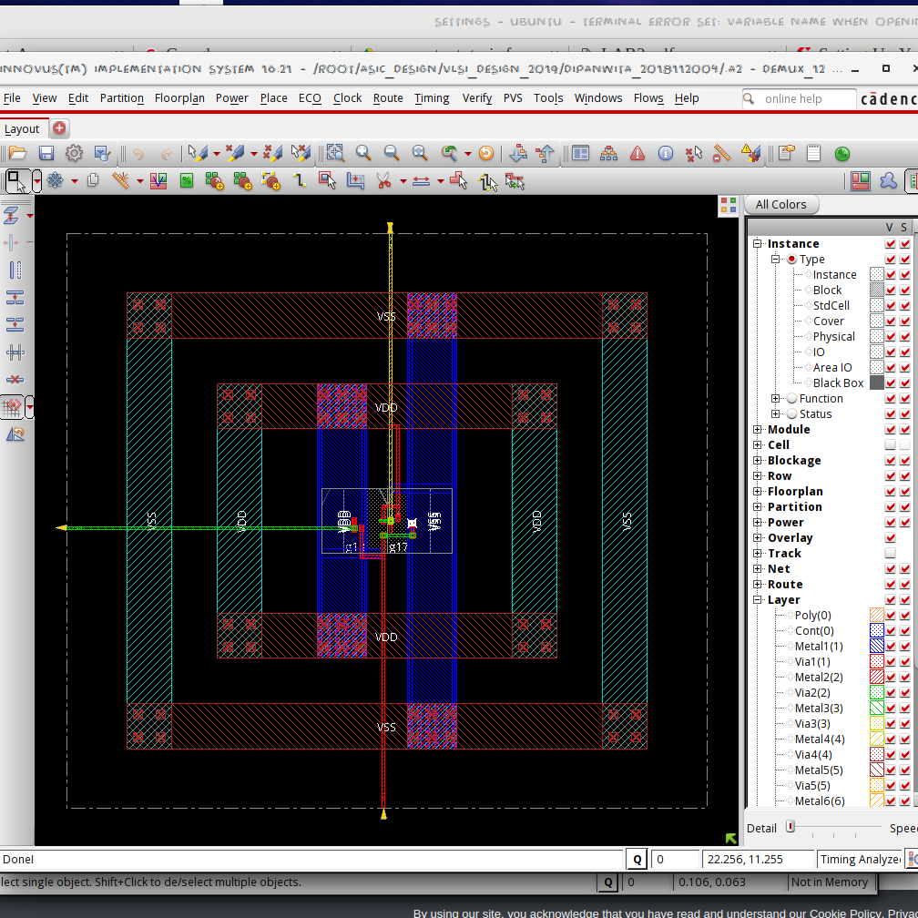

f. AREA STATISTICS:

(from Genus):

Gate Instances Area Library
----------------------------------
AND2XL 1 4.541 slow
NOR2BXL 1 4.541 slow
----------------------------------
total 2 9.083

Type Instances Area Area %
--------------------------------------
logic 2 9.083 100.0
physical_cells 0 0.000 0.0
--------------------------------------
total 2 9.083 100.0

(from Innovus):

Depth Name #Inst Area (um^2)
-------------------------------------
0 demux_12 2 9.0828

g. POWER STATISTICS:

(from Genus)

Leakage Dynamic Total
Instance Cells Power(nW) Power(nW) Power(nW)
---------------------------------------------
demux_12 2 41.288 200.353 241.641

(from Innovus)

#Power Units = 1mW

Total Power
Total Internal Power: 0.00013704 69.0971%
Total Switching Power: 0.00002000 10.0857%
Total Leakage Power: 0.00004129 20.8172%
Total Power: 0.00019833

h. NETLIST STATISTICS: (from Innovus)

*** Statistics for net list demux_12 ***
Number of cells = 2
Number of nets = 4
Number of tri-nets = 0
Number of degen nets = 0
Number of pins = 10
Number of i/os = 4

Number of nets with 2 terms = 2 (50.0%)
Number of nets with 3 terms = 2 (50.0%)
Number of nets with >=10 terms = 0 (0.0%)

*** 2 Primitives used:
Primitive NOR2BXL (1 insts)
Primitive AND2XL (1 insts)

i. TIMING REPORT: (from Xilinx_ISE)

Timing Details:
---------------
All values displayed in nanoseconds (ns)

=========================================================================
Timing constraint: Default path analysis
Total number of paths / destination ports: 4 / 2
-------------------------------------------------------------------------
Delay: 0.761ns (Levels of Logic = 3)
Source: s (PAD)
Destination: y0 (PAD)

Data Path: s to y0
Gate Net
Cell:in->out fanout Delay Delay Logical Name (Net Name)
---------------------------------------- ------------
IBUF:I->O 2 0.001 0.383 s_IBUF (s_IBUF)
LUT2:I0->O 1 0.097 0.279 y11 (y1_OBUF)
OBUF:I->O 0.000 y1_OBUF (y1)
----------------------------------------
Total 0.761ns (0.098ns logic, 0.663ns route)
(12.9% logic, 87.1% route)

j. ANALYSIS:

- The transistor-level design is expected to have 5 NMOS + 5 PMOS ((1 NMOS + 1 PMOS for inverter) + andgate). Hence the area is justified.
- The total power obtained from Genus is clearly higher than that from Innovus, which is justified by the fact that Innovus optimised the design.
- From the Timing Diagram and the Kmap it is clear that the DEMUX passes data through Y0 when the select line is off, and Y1 when the select line is on.
- In the timingReports, the delays are listed due to the local and global buffers, but for WNS & TNS the time is 0 as it is a combinational circuit.

