REPORT FOR 1*4 DEMUX:(using 1*2 DEMUX)

a. TRUTH TABLE:

SELECT LINE |  | INPUTS | OUTPUT(Y)
S1 | S0 | A | Y3 | Y2 | Y1 | Y0
0 | 0 | 0 | 0 | 0 | 0 | 0
0 | 0 | 1 | 0 | 0 | 0 | 1
0 | 1 | 0 | 0 | 0 | 0 | 0
0 | 1 | 1 | 0 | 0 | 1 | 0
1 | 0 | 0 | 0 | 0 | 0 | 0
1 | 0 | 1 | 0 | 1 | 0 | 0
1 | 1 | 0 | 0 | 0 | 0 | 0
1 | 1 | 1 | 1 | 0 | 0 | 0

b. KMAP:

FOR Y0:

S1S0 \ A | 0 | 1
00 | 0 | 1
01 | 0 | 0
10 | 0 | 0
11 | 0 | 0

So, Y0 = S1’.S0’.A

FOR Y1:

S1S0 \ A | 0 | 1
00 | 0 | 0
01 | 0 | 1
10 | 0 | 0
11 | 0 | 0

So, Y1 = S1’.S0.A

FOR Y2:

S1S0 \ A | 0 | 1
00 | 0 | 0
01 | 0 | 0
10 | 0 | 1
11 | 0 | 0

So, Y2 = S1.S0’.A

FOR Y3:

S1S0 \ A | 0 | 1
00 | 0 | 0
01 | 0 | 0
10 | 0 | 0
11 | 0 | 1
So, Y3 = S1.S0.A

c. RTL Schematic ( from genus & xilinx):

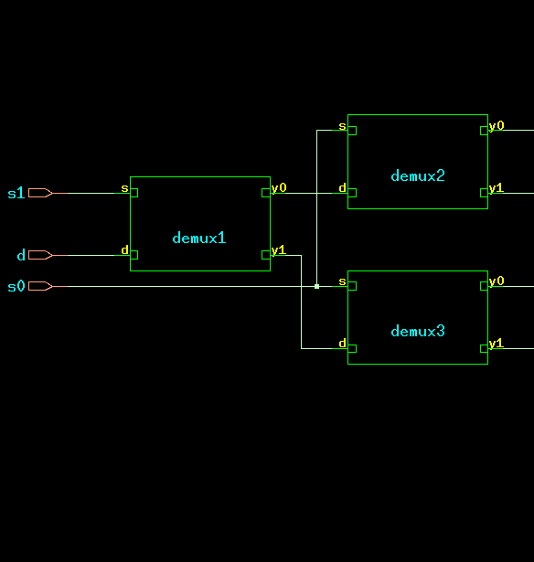

d. TIMING DIAGRAM:
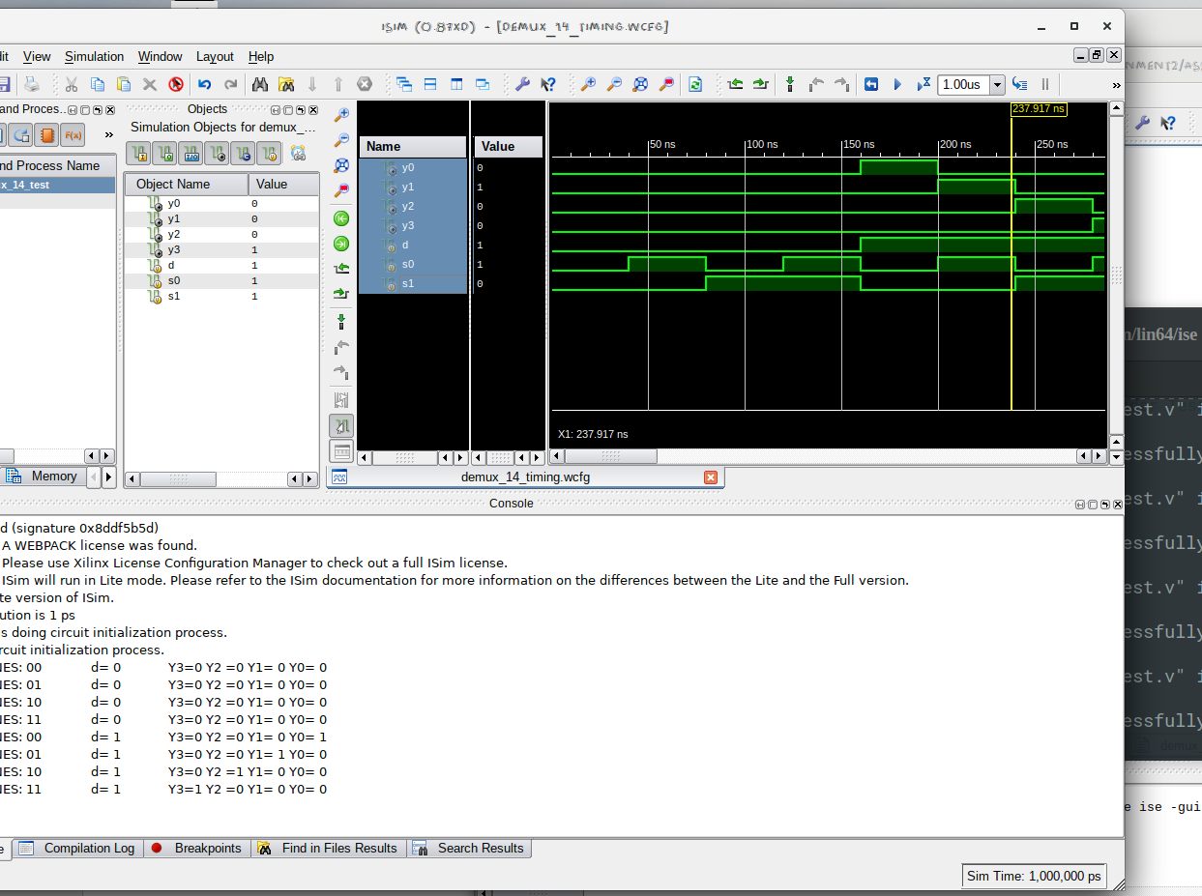

e. LAYOUT From Innovus:
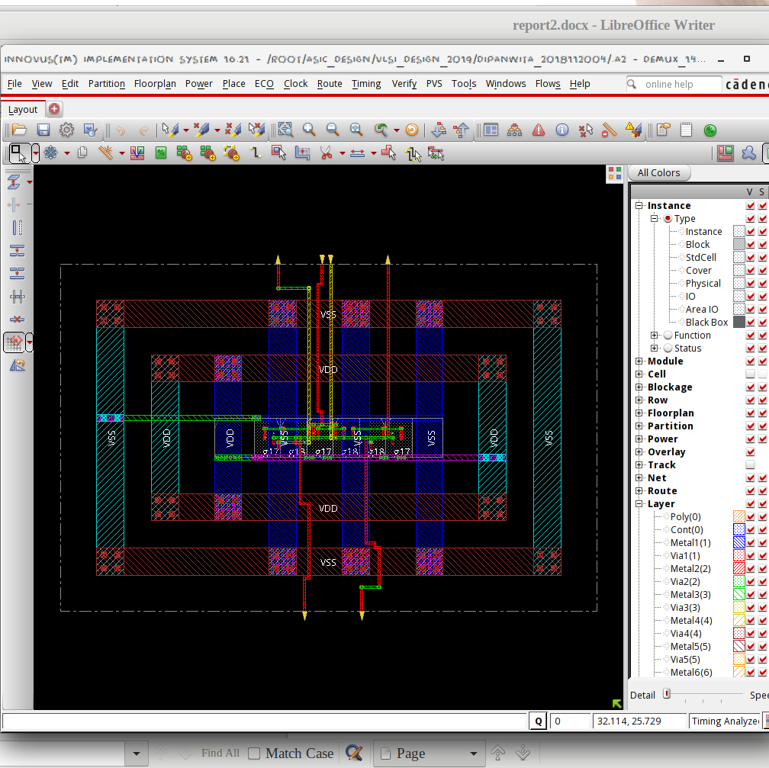

f. AREA STATISTICS:

(from Genus):

Gate Instances Area Library
-----------------------------------
AND2X1 1 4.541 slow
AND2XL 2 9.083 slow
NOR2BXL 3 13.624 slow
-----------------------------------
total 6 27.248

Type Instances Area Area %
---------------------------------------
logic 6 27.248 100.0
physical_cells 0 0.000 0.0
---------------------------------------
total 6 27.248 100.0

(from Innovus):

Depth Name #Inst Area (um^2)
-------------------------------------
0 demux_14 6 27.2484
1 demux3 2 9.0828
1 demux1 2 9.0828
1 demux2 2 9.0828

g. POWER STATISTICS:

(from Genus)

Leakage Dynamic Total
Instance Cells Power(nW) Power(nW) Power(nW)
---------------------------------------------
demux_14 6 126.371 569.555 695.927
demux1 2 43.796 227.444 271.240
demux2 2 41.288 101.094 142.382
demux3 2 41.288 123.736 165.024

(from Innovus)

#Power Units = 1mW

Total Power
-----------------------------------------------------------------------------------------
Total Internal Power: 0.00037386 61.8842%
Total Switching Power: 0.00010390 17.1978%
Total Leakage Power: 0.00012637 20.9180%
Total Power: 0.00060413

h. NETLIST STATISTICS: (from Innovus)

*** Statistics for net list demux_14 ***
Number of cells = 6
Number of nets = 9
Number of tri-nets = 0
Number of degen nets = 0
Number of pins = 25
Number of i/os = 7

Number of nets with 2 terms = 4 (44.4%)
Number of nets with 3 terms = 4 (44.4%)
Number of nets with 5 terms = 1 (11.1%)
Number of nets with >=10 terms = 0 (0.0%)

*** 3 Primitives used:
Primitive NOR2BXL (3 insts)
Primitive AND2XL (2 insts)
Primitive AND2X1 (1 insts)

i. TIMING REPORT: (from Xilinx_ISE)

Timing Details:
---------------
All values displayed in nanoseconds (ns)

=========================================================================
Timing constraint: Default path analysis
Total number of paths / destination ports: 12 / 4
-------------------------------------------------------------------------
Delay: 0.903ns (Levels of Logic = 3)
Source: s0 (PAD)
Destination: y0 (PAD)

Data Path: s0 to y0
Gate Net
Cell:in->out fanout Delay Delay Logical Name (Net Name)
---------------------------------------- ------------
IBUF:I->O 4 0.001 0.525 s0_IBUF (s0_IBUF)
LUT3:I0->O 1 0.097 0.279 demux3/y01 (y2_OBUF)
OBUF:I->O 0.000 y2_OBUF (y2)
----------------------------------------
Total 0.903ns (0.098ns logic, 0.805ns route)
(10.9% logic, 89.1% route)

j. ANALYSIS:

- The transistor-level design is expected to have 5 NMOS + 5 PMOS ((1 NMOS + 1 PMOS for inverter) + andgate) for each 1*2 DEMUX. 1*4 DEMUX has 3 such 1*2 DEMUXs. Hence the area is justified.
- The total power obtained from Genus is clearly higher than that from Innovus, which is justified by the fact that Innovus optimised the design.
- From the Timing Diagram and the Kmap it is clear that the DEMUX passes data through Y0 when the select line is 00, Y1 when 01 and so on.
- In the timingReports, the delays are listed due to the local and global buffers, but for WNS & TNS the time is 0 as it is a combinational circuit.

