REPORT FOR 2*1 MUX:

a. TRUTH TABLE:

SELECT LINE(S0) | INPUTS |  | OUTPUT(Y)
 | A | B
0 | 0 | 0 | 0
0 | 0 | 1 | 0
0 | 1 | 0 | 1
0 | 1 | 1 | 1
1 | 0 | 0 | 0
1 | 0 | 1 | 1
1 | 1 | 0 | 0
1 | 1 | 1 | 1

b. KMAP:

S0 \ BA | 00 | 01 | 11 | 10
0 | 0 | 1 | 1 | 0
1 | 0 | 0 | 1 | 1

So, Y = S0’.B’.A + S0’.A.B + S0.A.B + S0.B.A’
i.e, Y = S0’A + S0.B

c. RTL Schematic ( from genus & xilinx):

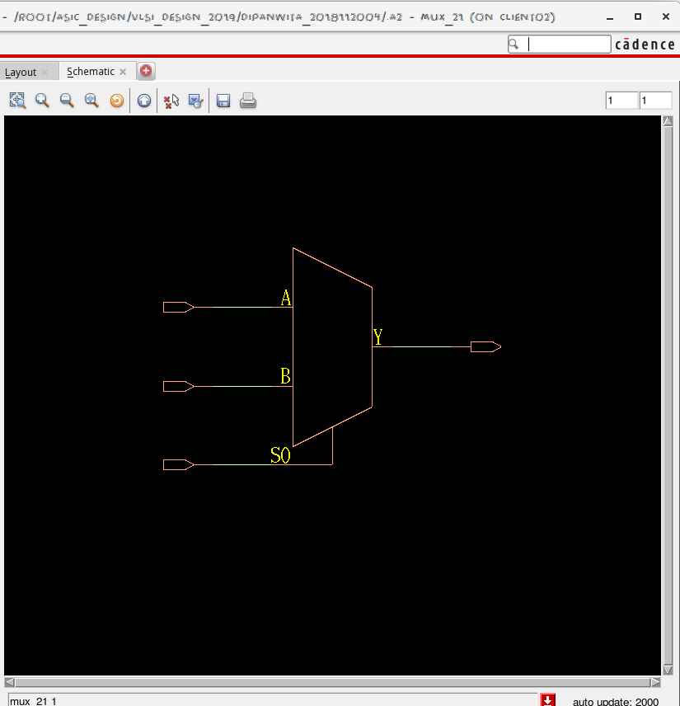

d. TIMING DIAGRAM:
(with C as select line)
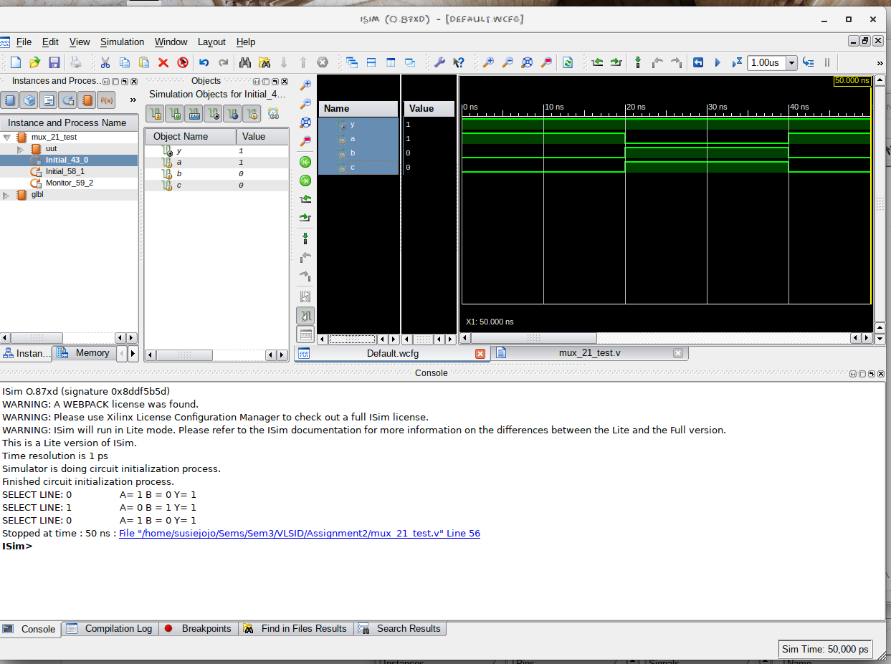

e. LAYOUT From Innovus:
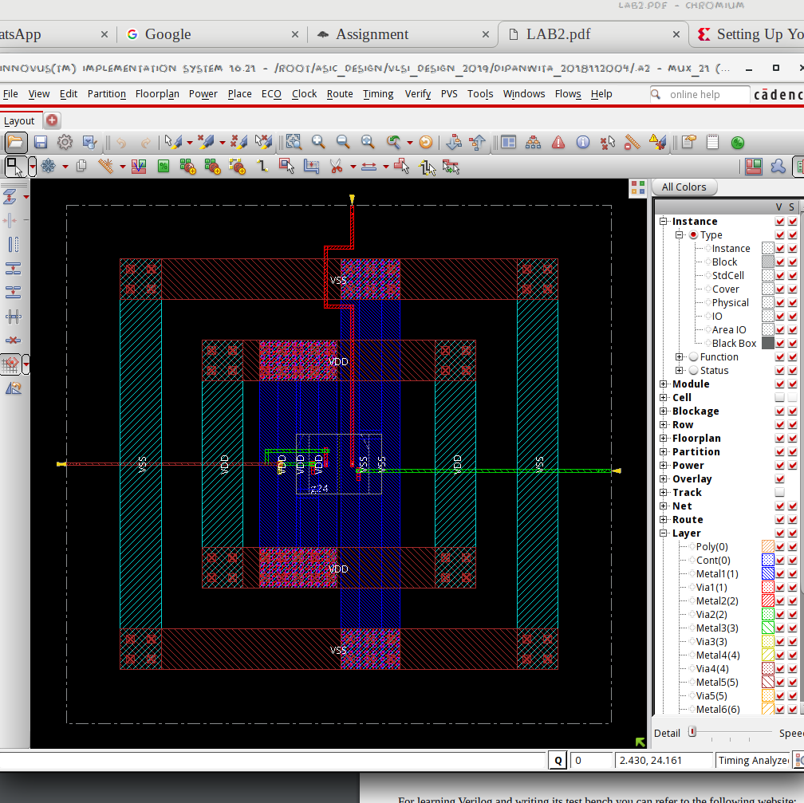

f. AREA STATISTICS:

(from Genus):

Gate Instances Area Library
--------------------------------
MX2X1 1 6.812 slow
--------------------------------
total 1 6.812

Type Instances Area Area %
--------------------------------------
logic 1 6.812 100.0
physical_cells 0 0.000 0.0
--------------------------------------
total 1 6.812 100.0

(from Innovus):

Depth Name #Inst Area (um^2)
-----------------------------------
0 mux_21 1 6.8121

g. POWER STATISTICS:

(from Genus)

Leakage Dynamic Total
Instance Cells Power(nW) Power(nW) Power(nW)
---------------------------------------------
mux_21 1 54.182 247.117 301.300

(from Innovus)

#Power Units = 1mW

Total Power
-----------------------------------------------------------------------------------------
Total Internal Power: 0.00012613 65.2889%
Total Switching Power: 0.00001288 6.6652%
Total Leakage Power: 0.00005418 28.0458%
Total Power: 0.00019319
-----------------------------------------------------------------------------------------

h. NETLIST STATISTICS: (from Innovus)

*** Statistics for net list mux_21 ***
Number of cells = 1
Number of nets = 4
Number of tri-nets = 0
Number of degen nets = 0
Number of pins = 8
Number of i/os = 4

Number of nets with 2 terms = 4 (100.0%)
Number of nets with >=10 terms = 0 (0.0%)

*** 1 Primitives used:
Primitive MX2X1 (1 insts)

i. TIMING REPORT: (from Xilinx_ISE)

Timing Details:
---------------
All values displayed in nanoseconds (ns)

=================================================================
Timing constraint: Default path analysis
Total number of paths / destination ports: 3 / 1
-------------------------------------------------------------------------
Delay: 0.889ns (Levels of Logic = 3)
Source: c (PAD)
Destination: y (PAD)

Data Path: c to y
Gate Net
Cell:in->out fanout Delay Delay Logical Name (Net Name)
---------------------------------------- ------------
IBUF:I->O 1 0.001 0.511 c_IBUF (c_IBUF)
LUT3:I0->O 1 0.097 0.279 y1 (y_OBUF)
OBUF:I->O 0.000 y_OBUF (y)
----------------------------------------
Total 0.889ns (0.098ns logic, 0.791ns route)
(11.0% logic, 89.0% route)

=================================================================

j. ANALYSIS:

- The transistor-level design is expected to have 4 NMOS + 4 PMOS and 1 NMOS + 1 PMOS for inverting the select line. Hence the area is justified.
- The total power obtained from Genus is clearly higher than that from Innovus, which is justified by the fact that Innovus optimised the design.
- From the Timing Diagram and the Kmap it is clear that the MUX passes A when the select line is off, and B when the select line is on.
- In the timingReports, the delays are listed due to the local and global buffers, but for WNS & TNS the time is 0 as it is a combinational circuit.

