REPORT FOR 4*1 MUX:(using 2*1 MUX)

a. TRUTH TABLE:

SELECT LINE |  | INPUTS |  |  |  | OUTPUT(Y)
S1 | S0 | I3 | I2 | I1 | I0
0 | 0 | X | X | X | 1 | 1
0 | 0 | X | X | X | 0 | 0
0 | 1 | X | X | 1 | X | 1
0 | 1 | X | X | 0 | X | 0
1 | 0 | X | 1 | X | X | 1
1 | 0 | X | 0 | X | X | 0
1 | 1 | 1 | X | X | X | 1
1 | 1 | 0 | X | X | X | 0

b. KMAP:

FOR S0 =0, S1 = 0
I3 I2 \I1 I0 | 00 | 01 | 10 | 11
00 | 0 | 1 | 0 | 1
01 | 0 | 1 | 0 | 1
10 | 0 | 1 | 0 | 1
11 | 0 | 1 | 0 | 1

FOR S0 =1, S1 = 0
I3 I2 \I1 I0 | 00 | 01 | 10 | 11
00 | 0 | 0 | 1 | 1
01 | 0 | 0 | 1 | 1
10 | 0 | 0 | 1 | 1
11 | 0 | 0 | 1 | 1

FOR S0 =0, S1 = 1
I3 I2 \I1 I0 | 00 | 01 | 10 | 11
00 | 0 | 0 | 0 | 0
01 | 1 | 1 | 1 | 1
10 | 0 | 0 | 0 | 0
11 | 1 | 1 | 1 | 1

FOR S0 =1, S1 = 1
I3 I2 \I1 I0 | 00 | 01 | 10 | 11
00 | 0 | 0 | 0 | 0
01 | 0 | 0 | 0 | 0
10 | 1 | 1 | 1 | 1
11 | 1 | 1 | 1 | 1

Y = S1’.S0’.I0 + S1’.S0.I1 + S1.S0’.I2 + S1.S0.I3

c. RTL Schematic ( from genus & xilinx):

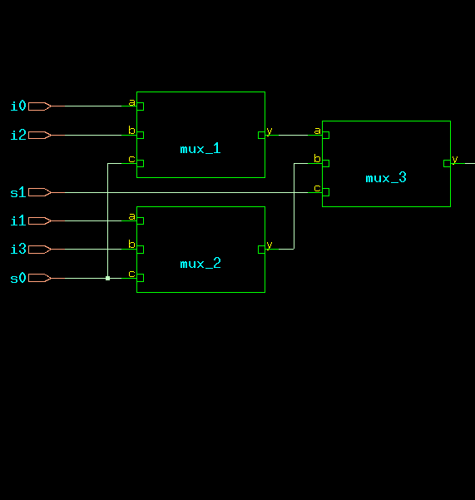

d. TIMING DIAGRAM:
(with C as select line)
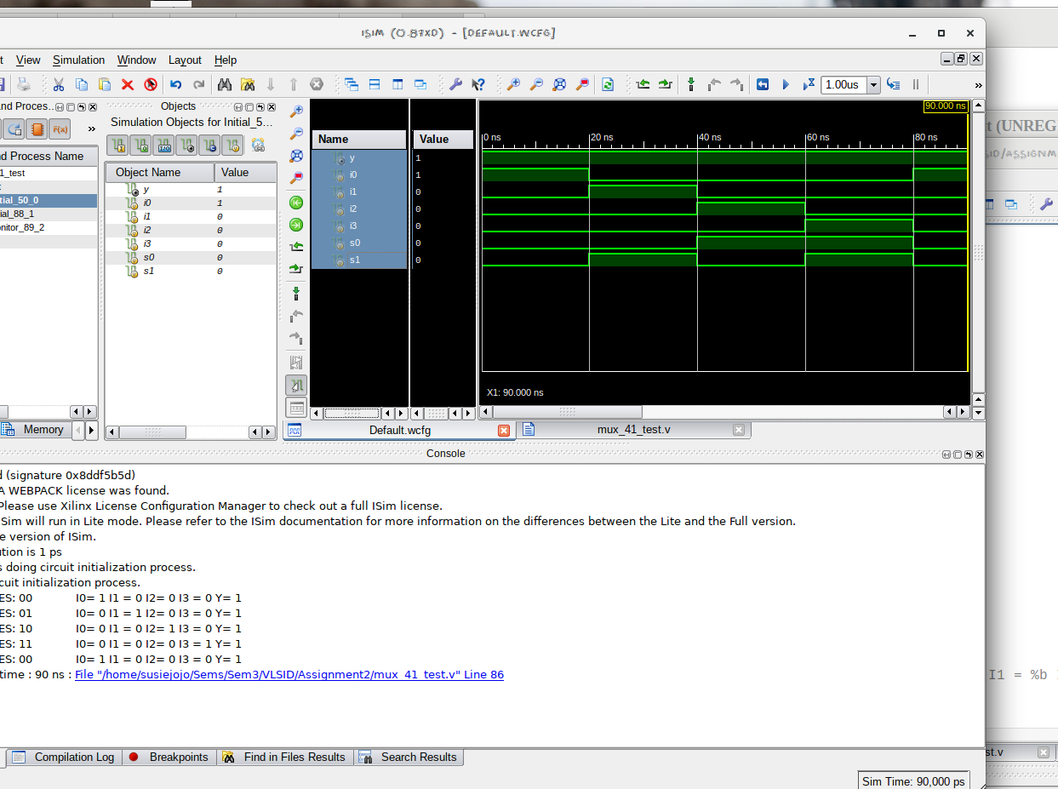

e. LAYOUT From Innovus:
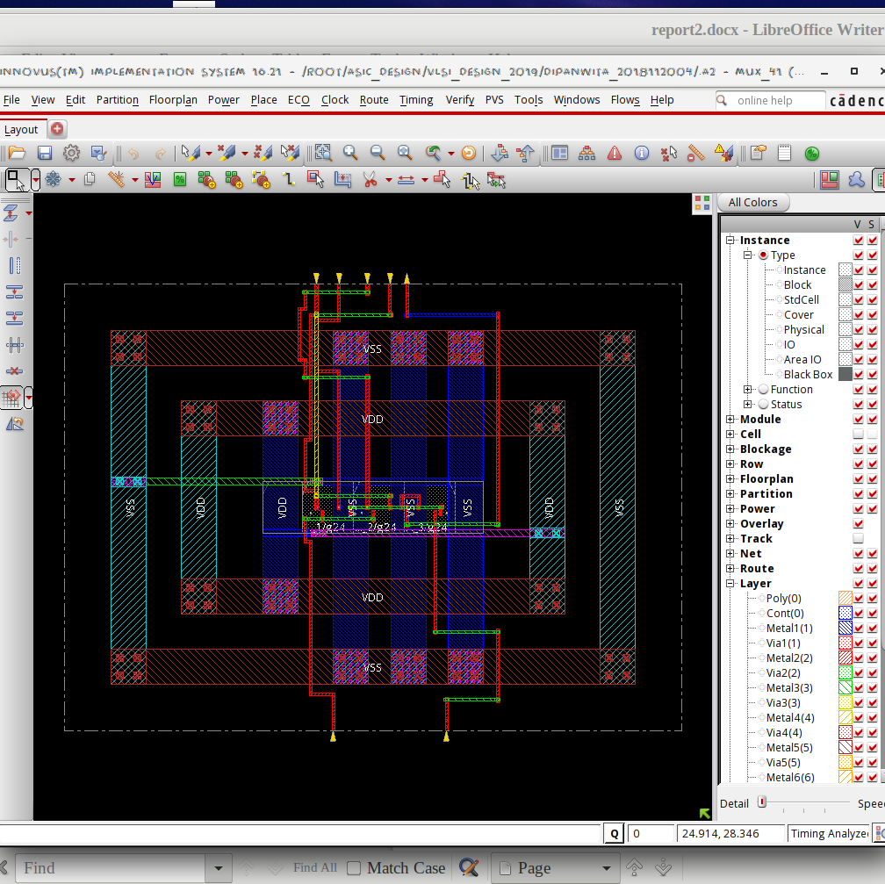

f. AREA STATISTICS:

(from Genus):

Gate Instances Area Library
---------------------------------
MX2X1 3 20.436 slow
---------------------------------
total 3 20.436

Type Instances Area Area %
---------------------------------------
logic 3 20.436 100.0
physical_cells 0 0.000 0.0
---------------------------------------
total 3 20.436 100.0

(from Innovus):

Depth Name #Inst Area (um^2)
-----------------------------------
0 mux_41 3 20.4363
1 mux_2 1 6.8121
1 mux_3 1 6.8121
1 mux_1 1 6.8121

g. POWER STATISTICS:

(from Genus)

Leakage Dynamic Total
Instance Cells Power(nW) Power(nW) Power(nW)
---------------------------------------------
mux_41 3 162.547 714.568 877.116
mux_1 1 54.182 238.251 292.433
mux_2 1 54.182 89.901 144.084
mux_3 1 54.182 233.697 287.880

(from Innovus)

#Power Units = 1mW

Total Power
-----------------------------------------------------------------------------------------
Total Internal Power: 0.00040352 62.5416%
Total Switching Power: 0.00007914 12.2653%
Total Leakage Power: 0.00016255 25.1930%
Total Power: 0.00064521
-----------------------------------------------------------------------------------------

h. NETLIST STATISTICS: (from Innovus)

*** Statistics for net list mux_41 ***
Number of cells = 3
Number of nets = 9
Number of tri-nets = 0
Number of degen nets = 0
Number of pins = 19
Number of i/os = 7

Number of nets with 2 terms = 8 (88.9%)
Number of nets with 3 terms = 1 (11.1%)
Number of nets with >=10 terms = 0 (0.0%)

*** 1 Primitives used:
Primitive MX2X1 (3 insts)

i. TIMING REPORT: (from Xilinx_ISE)

Timing Details:
---------------
All values displayed in nanoseconds (ns)

=======================================================================
Timing constraint: Default path analysis
Total number of paths / destination ports: 6 / 1
-------------------------------------------------------------------------
Delay: 1.071ns (Levels of Logic = 3)
Source: s0 (PAD)
Destination: y (PAD)

Data Path: s0 to y
Gate Net
Cell:in->out fanout Delay Delay Logical Name (Net Name)
---------------------------------------- ------------
IBUF:I->O 1 0.001 0.693 s0_IBUF (s0_IBUF)
LUT6:I0->O 1 0.097 0.279 mux_3/y1 (y_OBUF)
OBUF:I->O 0.000 y_OBUF (y)
----------------------------------------
Total 1.071ns (0.098ns logic, 0.973ns route)
(9.2% logic, 90.8% route)

=======================================================================

j. ANALYSIS:

- The transistor-level design is expected to have 4 NMOS + 4 PMOS and 1 NMOS + 1 PMOS for inverting the select line for each 2*1 MUX. A 4*1 MUX uses three such 2*1 MUXs as seen in the rtl. Since area of each 2*1 MUX is approximately 6 nm^2, the area is justified.
- The total power obtained from Genus is clearly higher than that from Innovus, which is justified by the fact that Innovus optimised the design.
- From the Timing Diagram and the Kmap it is clear that the MUX passes I0, I1, I2, I3 according to whether the select lines take binary values from 00 to 11.
- In the timingReports, the delays are listed due to the local and global buffers, but for WNS & TNS the time is 0 as it is a combinational circuit.

