REPORT FOR 8*1 MUX:(using 2*1 & 4*1 MUX)

a. TRUTH TABLE:

SELECT LINE |  |  | INPUTS |  |  |  |  |  |  |  | OUTPUT(Y)
S2 | S1 | S0 | I7 | I6 | I5 | I4 | I3 | I2 | I1 | I0
0 | 0 | 0 | X | X | X | X | X | X | X | 1 | 1
0 | 0 | 0 | X | X | X | X | X | X | X | 0 | 0
0 | 0 | 1 | X | X | X | X | X | X | 1 | X | 1
0 | 0 | 1 | X | X | X | X | X | X | 0 | X | 0
0 | 1 | 0 | X | X | X | X | X | 1 | X | X | 1
0 | 1 | 0 | X | X | X | X | X | 0 | X | X | 0
0 | 1 | 1 | X | X | X | X | 1 | X | X | X | 1
0 | 1 | 1 | X | X | X | X | 0 | X | X | X | 0
1 | 0 | 0 | X | X | X | 1 | X | X | X | X | 1
1 | 0 | 0 | X | X | X | 0 | X | X | X | X | 0
1 | 0 | 1 | X | X | 1 | X | X | X | X | X | 1
1 | 0 | 1 | X | X | 0 | X | X | X | X | X | 0
1 | 1 | 0 | X | 1 | X | X | X | X | X | X | 1
1 | 1 | 0 | X | 0 | X | X | X | X | X | X | 0
1 | 1 | 1 | 1 | X | X | X | X | X | X | X | 1
1 | 1 | 1 | 0 | X | X | X | X | X | X | X | 0

b. KMAP:

FOR S0 =0, S1 = 0 S2 = 0
I7 I6 I5 I4\I3 I2 I1 I0 | XXX1 | XX10 |  | X1X0 | 1XX0
XXX1 | 1 | 0 |  | 0 | 0
XX1X | 1 | 0 |  | 0 | 0
X1XX | 1 |  | 0 | 0 |  | 0
1XXX | 1 |  | 0 | 0 |  | 0

Similarly for S2,S1,S0 from 001 to 111 we have 7 more such Kmaps which yields:

Y = S2’.S1’.S0’.I0 + S2’.S1’.S0.I1 + S2’.S1.S0’.I2 + S2’.S1.S0.I3 + S2.S1’.S0’.I4 + S2.S1’.S0.I5 + S2.S1.S0’.I6 + S2.S1.S0.I7

c. RTL Schematic ( from genus & xilinx):

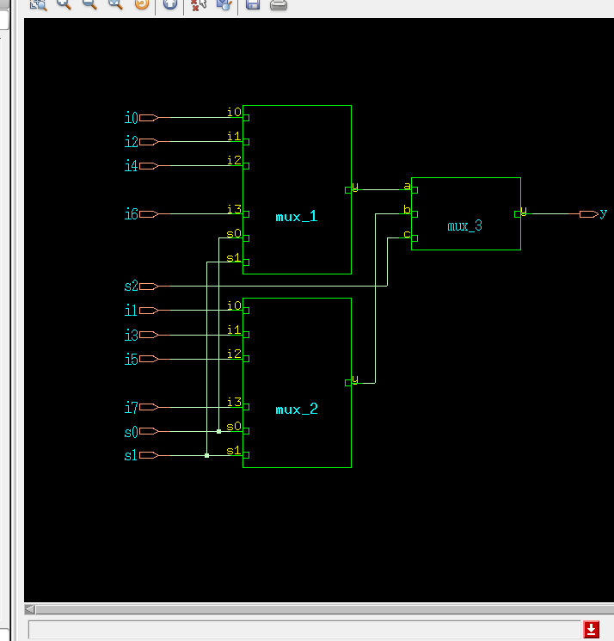

d. TIMING DIAGRAM:
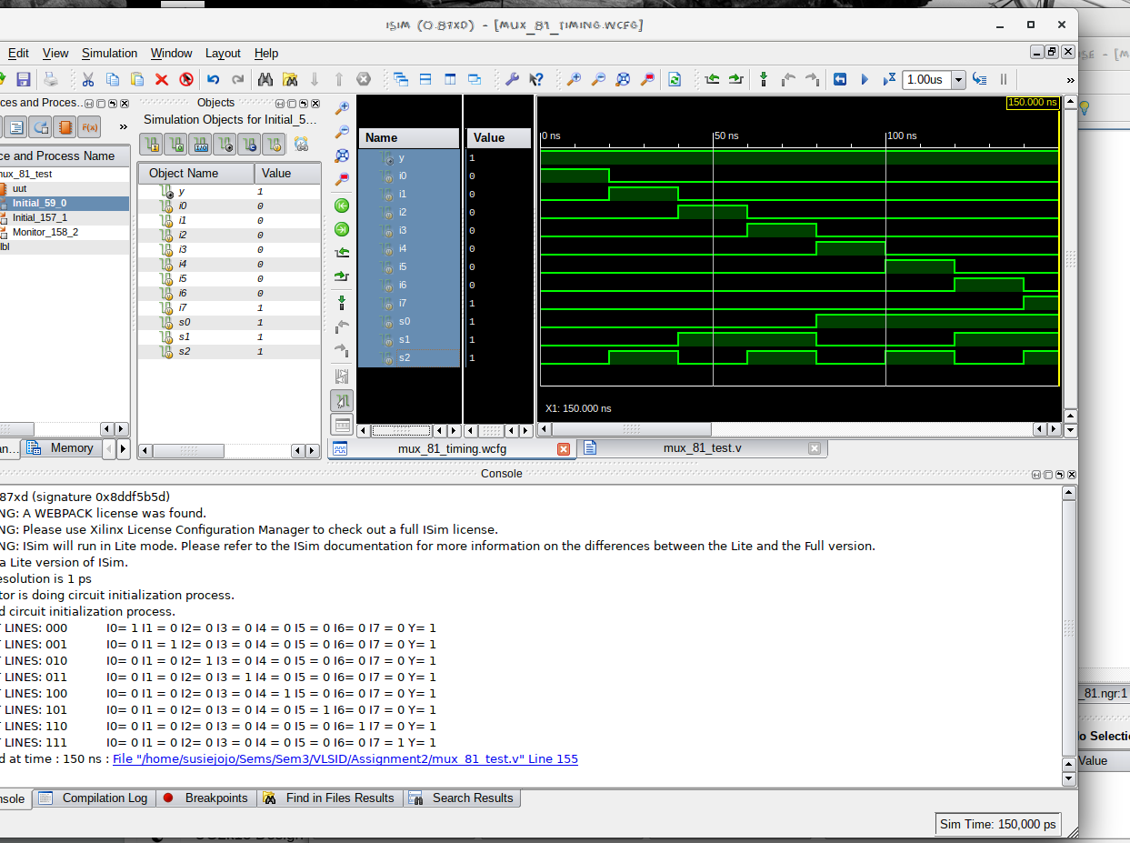

e. LAYOUT From Innovus:
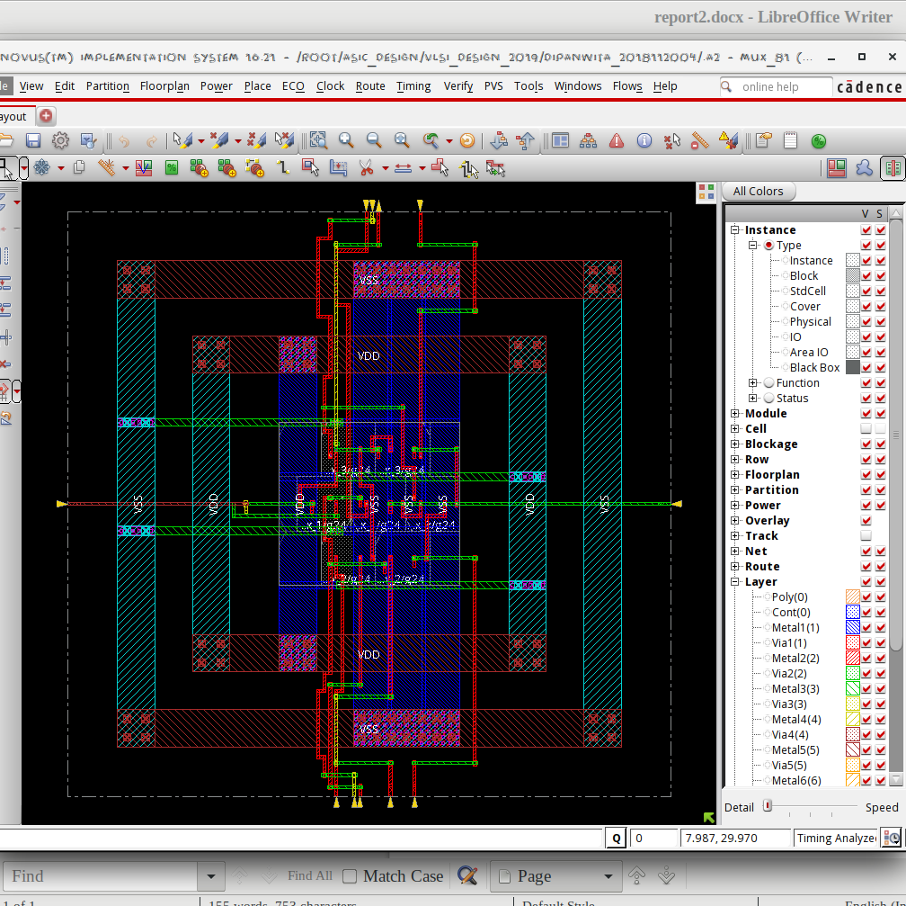

f. AREA STATISTICS:

(from Genus):
Gate Instances Area Library
---------------------------------
MX2X1 7 47.685 slow
---------------------------------
total 7 47.685

Type Instances Area Area %
---------------------------------------
logic 7 47.685 100.0
physical_cells 0 0.000 0.0
---------------------------------------
total 7 47.685 100.0

(from Innovus):

Depth Name #Inst Area (um^2)
----------------------------------------
0 mux_81 7 47.6847
1 mux_3 1 6.8121
1 mux_2 3 20.4363
1 mux_1 3 20.4363
2 mux_2/mux_2 1 6.8121
2 mux_1/mux_2 1 6.8121
2 mux_2/mux_3 1 6.8121
2 mux_2/mux_1 1 6.8121
2 mux_1/mux_3 1 6.8121
2 mux_1/mux_1 1 6.8121

g. POWER STATISTICS:

(from Genus)

Leakage Dynamic Total
Instance Cells Power(nW) Power(nW) Power(nW)
----------------------------------------------
mux_81 7 379.277 1609.126 1988.403
mux_1 3 162.547 591.367 753.914
mux_1 1 54.182 148.907 203.089
mux_2 1 54.182 179.802 233.985
mux_3 1 54.182 262.658 316.840
mux_2 3 162.547 475.550 638.098
mux_1 1 54.182 148.907 203.089
mux_2 1 54.182 179.802 233.985
mux_3 1 54.182 146.841 201.024
mux_3 1 54.182 205.552 259.735

(from Innovus)

#Power Units = 1mW

Total Power
-----------------------------------------------------------------------------------------
Total Internal Power: 0.00099762 64.0032%
Total Switching Power: 0.00018181 11.6639%
Total Leakage Power: 0.00037928 24.3328%
Total Power: 0.00155871
-----------------------------------------------------------------------------------------

h. NETLIST STATISTICS: (from Innovus)
*** Statistics for net list mux_81 ***
Number of cells = 7
Number of nets = 18
Number of tri-nets = 0
Number of degen nets = 0
Number of pins = 40
Number of i/os = 12

Number of nets with 2 terms = 16 (88.9%)
Number of nets with 3 terms = 1 (5.6%)
Number of nets with 5 terms = 1 (5.6%)
Number of nets with >=10 terms = 0 (0.0%)

*** 1 Primitives used:
Primitive MX2X1 (7 insts)

i. TIMING REPORT: (from Xilinx_ISE)

Timing Details:
---------------
All values displayed in nanoseconds (ns)

Timing constraint: Default path analysis
Total number of paths / destination ports: 13 / 1
-------------------------------------------------------------------------
Delay: 1.354ns (Levels of Logic = 4)
Source: s1 (PAD)
Destination: y (PAD)

Data Path: s1 to y
Gate Net
Cell:in->out fanout Delay Delay Logical Name (Net Name)
---------------------------------------- ------------
IBUF:I->O 2 0.001 0.697 s1_IBUF (s1_IBUF)
LUT6:I0->O 1 0.097 0.000 mux_3/y3_G (N3)
MUXF7:I1->O 1 0.279 0.279 mux_3/y3 (y_OBUF)
OBUF:I->O 0.000 y_OBUF (y)
----------------------------------------
Total 1.354ns (0.377ns logic, 0.977ns route)
(27.8% logic, 72.2% route)

j. ANALYSIS:

- The transistor-level design is expected to have 4 NMOS + 4 PMOS and 1 NMOS + 1 PMOS for inverting the select line for each 2*1 MUX. A 4*1 MUX uses three such 2*1 MUXs. A 8*1 MUX has 2 4*1 MUXs and 1 2*1 MUX. So a 8*1 MUX has a net of 7 2*1 MUXs. Since area of each 2*1 MUX is approximately 6 nm^2, the area is justified.
- The total power obtained from Genus is clearly higher than that from Innovus, which is justified by the fact that Innovus optimised the design.
- From the Timing Diagram and the Kmap it is clear that the MUX passes I0, I1, I2, I3,I4,I5,I6,I7 according to whether the select lines take binary values from 0000 to 1111.
- In the timingReports, the delays are listed due to the local and global buffers, but for WNS & TNS the time is 0 as it is a combinational circuit.

