SUMMARY REPORT FOR 16-BIT CARRY LOOKAHEAD ADDER:

TRUTH TABLE FOR 1 BIT FULL ADDER:

A | B | CIN | S | COUT
0 | 0 | 0 | 0 | 0
0 | 1 | 0 | 1 | 0
1 | 0 | 0 | 1 | 0
1 | 1 | 0 | 0 | 1
0 | 0 | 1 | 1 | 0
0 | 1 | 1 | 0 | 1
1 | 0 | 1 | 0 | 1
1 | 1 | 1 | 1 | 1

- KMAP:

FOR S:

A\B,CIN | 00 | 01 | 11 | 10
0 |  | 1 |  | 1
1 | 1 |  | 1

SO, S = A^B^CIN
FOR COUT:

A\B,CIN | 00 | 01 | 11 | 10
0 |  |  | 1
1 |  | 1 | 1 | 1

SO, COUT = CIN*(A^B) + A*B
- RTL Schematic:

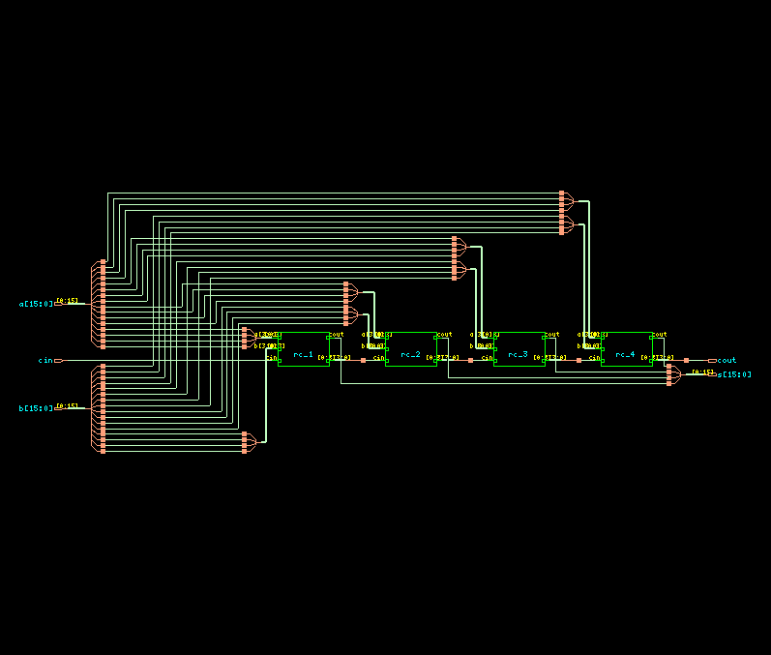

- TIMING DIAGRAM:
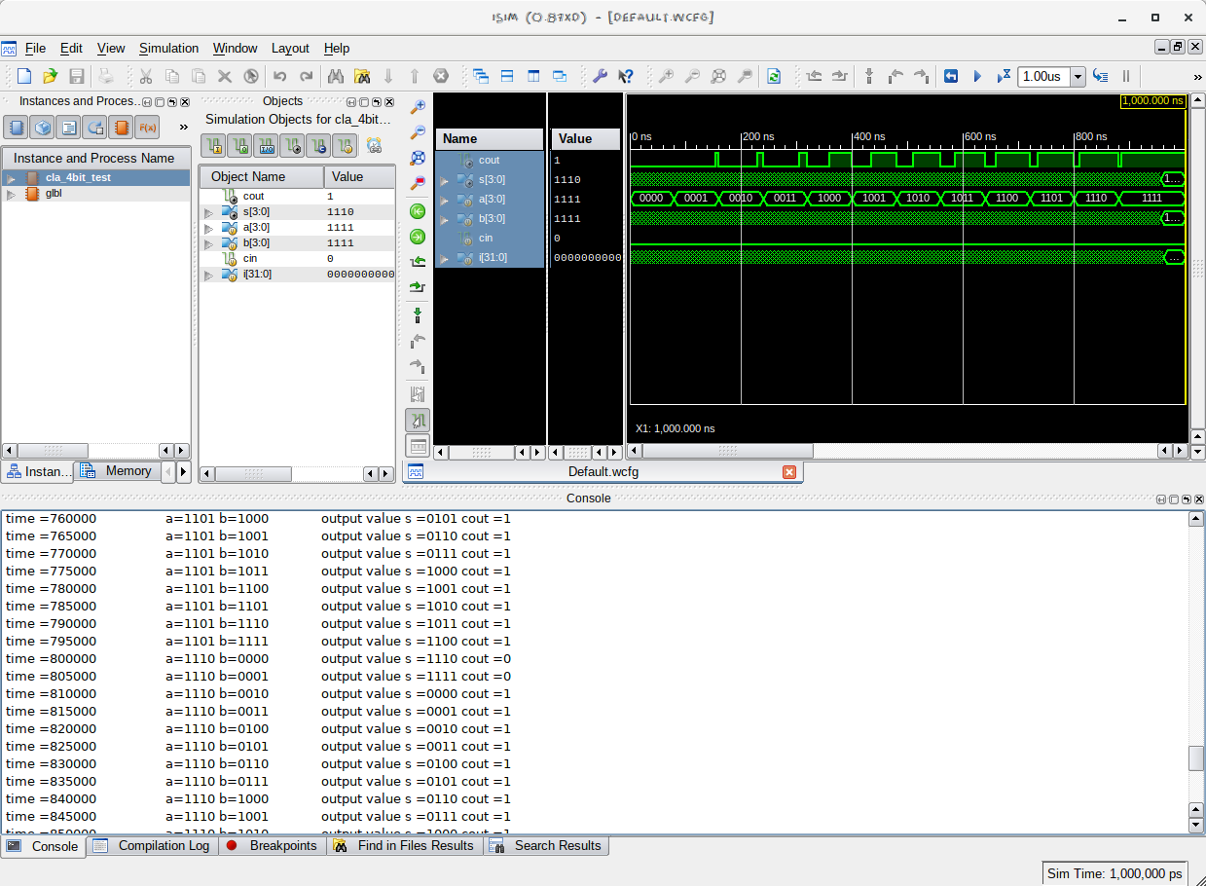
- LAYOUT FROM INNOVUS:

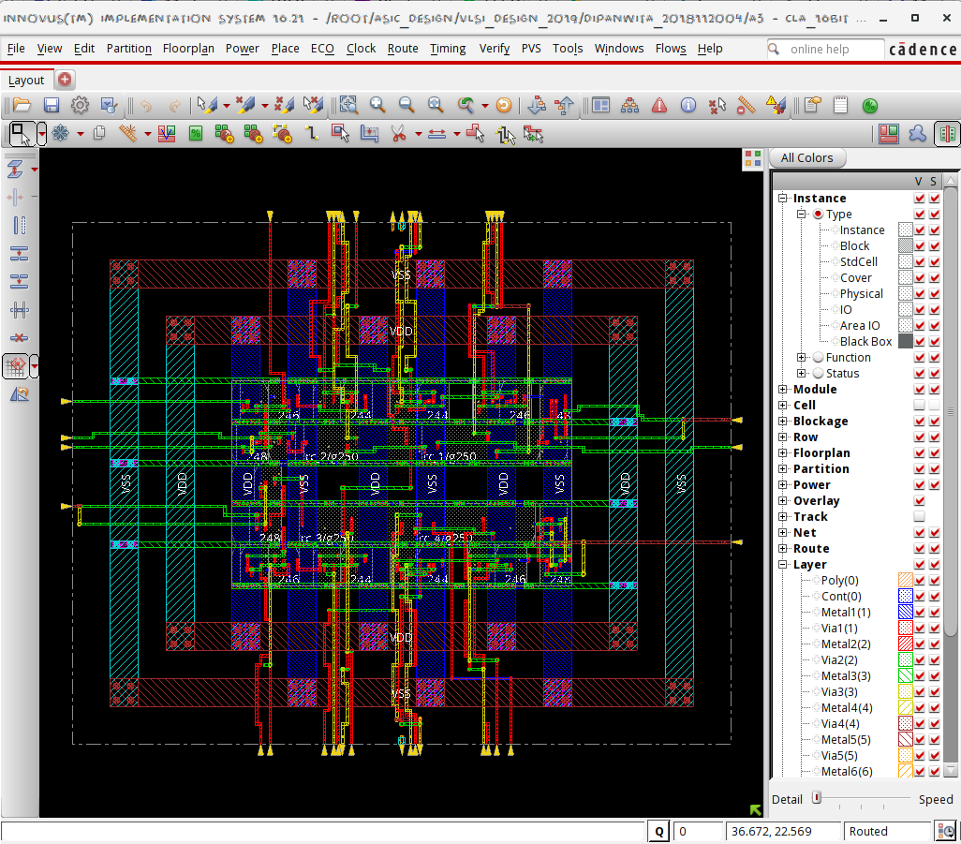
- AREA STATISTICS:

FROM GENUS:
============================================================
Generated by: Genus(TM) Synthesis Solution 16.21-s018_1
Generated on: Sep 26 2019 07:17:25 pm
Module: cla_16bit
Wireload mode: enclosed
Area mode: timing library
============================================================

Instance Module Cells Cell Area Net Area Total Area Wireload
----------------------------------------------------------------------------
cla_16bit 28 197 0 197 <none> (D)
rc_4 cla_4bit_3 7 49 0 49 <none> (D)
rc_3 cla_4bit_2 7 49 0 49 <none> (D)
rc_2 cla_4bit_1 7 49 0 49 <none> (D)
rc_1 cla_4bit 7 49 0 49 <none> (D)

(D) = wireload is default in technology library

FROM INNOVUS:

Depth Name #Inst Area (um^2)
--------------------------------------
0 cla_16bit 28 196.794
1 rc_4 7 49.1985
1 rc_2 7 49.1985
1 rc_3 7 49.1985
1 rc_1 7 49.1985

- POWER STATISTICS:

FROM GENUS:

Leakage Dynamic Total
Instance Cells Power(nW) Power(nW) Power(nW)
----------------------------------------------
cla_16bit 28 673.084 8725.172 9398.257
rc_1 7 168.271 1128.465 1296.736
rc_2 7 168.271 1706.295 1874.566
rc_3 7 168.271 2530.169 2698.440
rc_4 7 168.271 2313.150 2481.421

FROM INNOVUS:

Total Power
-----------------------------------------------------------------------------------------
Total Internal Power: 0.00337240 61.8420%
Total Switching Power: 0.00140777 25.8152%
Total Leakage Power: 0.00067308 12.3428%
Total Power: 0.00545325
-----------------------------------------------------------------------------------------

Group Internal Switching Leakage Total Percentage
Power Power Power Power (%)
-----------------------------------------------------------------------------------------
Sequential 0 0 0 0 0
Macro 0 0 0 0 0
IO 0 0 0 0 0
Combinational 0.003372 0.001408 0.0006731 0.005453 100
Clock (Combinational) 0 0 0 0 0
Clock (Sequential) 0 0 0 0 0
-----------------------------------------------------------------------------------------
Total 0.003372 0.001408 0.0006731 0.005453 100
-----------------------------------------------------------------------------------------

Rail Voltage Internal Switching Leakage Total Percentage
Power Power Power Power (%)
-----------------------------------------------------------------------------------------
VDD 0.9 0.003372 0.001408 0.0006731 0.005453 100

- TIMING REPORT: (from Xilinx_ISE)

Delay: 10.838ns (Levels of Logic = 8)
Source: a<0> (PAD)
Destination: s<12> (PAD)

Data Path: a<0> to s<12>
Gate Net
Cell:in->out fanout Delay Delay Logical Name (Net Name)
---------------------------------------- ------------
IBUF:I->O 2 1.106 0.532 a_0_IBUF (a_0_IBUF)
LUT3:I0->O 2 0.612 0.410 rc_1/Mxor_s<0>_Result1 (c1)
LUT3:I2->O 2 0.612 0.410 rc_2/Mxor_s<0>_Result1 (c2)
LUT3:I2->O 2 0.612 0.380 rc_3/Mxor_s<0>_Result1 (c3)
MUXF5:S->O 1 0.641 0.357 rc_4/carry_4_or000025_f5 (rc_4/carry_4_or000025)
MUXF5:S->O 1 0.641 0.387 rc_4/carry_4_or000053_SW0_f5 (N38)
LUT3:I2->O 1 0.612 0.357 rc_4/carry_4_or000053 (s_12_OBUF)
OBUF:I->O 3.169 s_12_OBUF (s<12>)
----------------------------------------
Total 10.838ns (8.005ns logic, 2.833ns route)
(73.9% logic, 26.1% route)

Total REAL time to Xst completion: 3.00 secs
Total CPU time to Xst completion: 3.14 secs

- INFERENCES:
- Clearly the Carry Lookahead Adder has lower delay (10.838ns) as compared to Ripple Carry Adder(21.690ns). This shows that we are able to optimize on the delays using Carry Lookahead Adder over Ripple Carry Adder.
- The total power obtained from Innovus is lower than that obtained from Genus. This is because Innovus optimises the design.
- The area(196.794 um^2) for Carry Lookahead Adder is lower than that of the Ripple Carry Adder (area: 314.8704 um^2). This is because 16-bit Ripple Carry Adder is implemented from 4-bit Ripple Carry Adder which is, in turn, made from 1-bit Full Adder. But in Carry Lookahead Adder we implement the whole logic in terms of gates which is highly efficient to save area.
- The power( 9398.257 nW) from Carry Lookahead Adder is also less than the power(14330.950 nW) for Ripple Carry Adder. This can also be explained in terms of the optimised gate-level implementation of the circuit.

