SUMMARY REPORT FOR 16-BIT RIPPLE CARRY ADDER:

- TRUTH TABLE FOR 1 BIT FULL ADDER:

A | B | CIN | S | COUT
0 | 0 | 0 | 0 | 0
0 | 1 | 0 | 1 | 0
1 | 0 | 0 | 1 | 0
1 | 1 | 0 | 0 | 1
0 | 0 | 1 | 1 | 0
0 | 1 | 1 | 0 | 1
1 | 0 | 1 | 0 | 1
1 | 1 | 1 | 1 | 1

- KMAP:

FOR S:

A\B,CIN | 00 | 01 | 11 | 10
0 |  | 1 |  | 1
1 | 1 |  | 1

SO, S = A^B^CIN
FOR COUT:

A\B,CIN | 00 | 01 | 11 | 10
0 |  |  | 1
1 |  | 1 | 1 | 1

SO, COUT = CIN*(A^B) + A*B
- RTL Schematic:

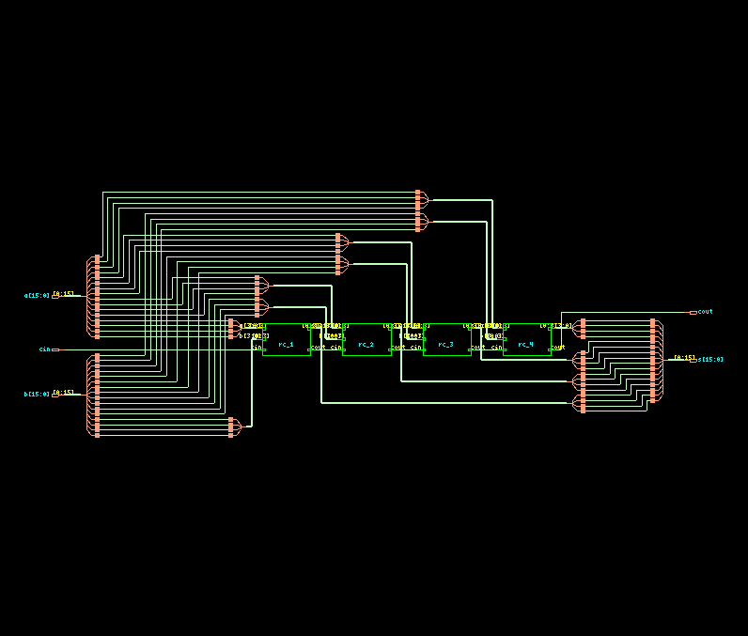

- TIMING DIAGRAM:
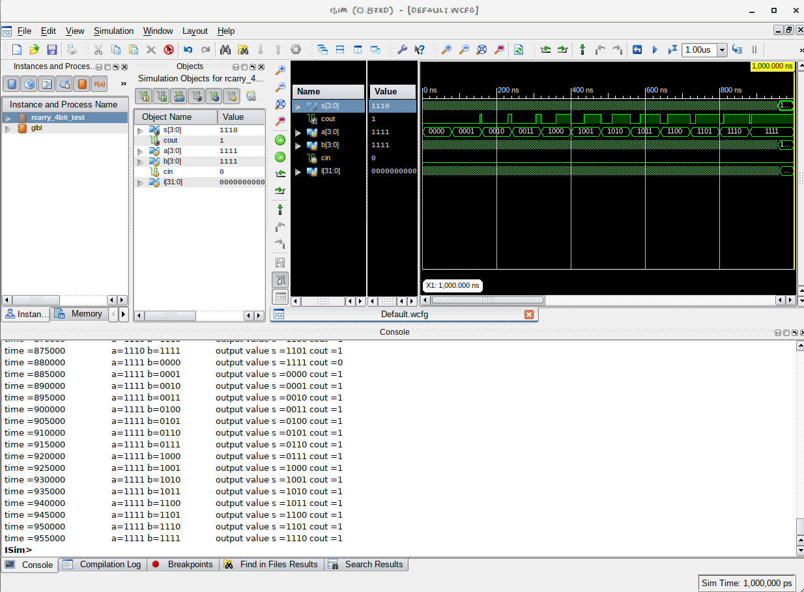
- LAYOUT FROM INNOVUS:

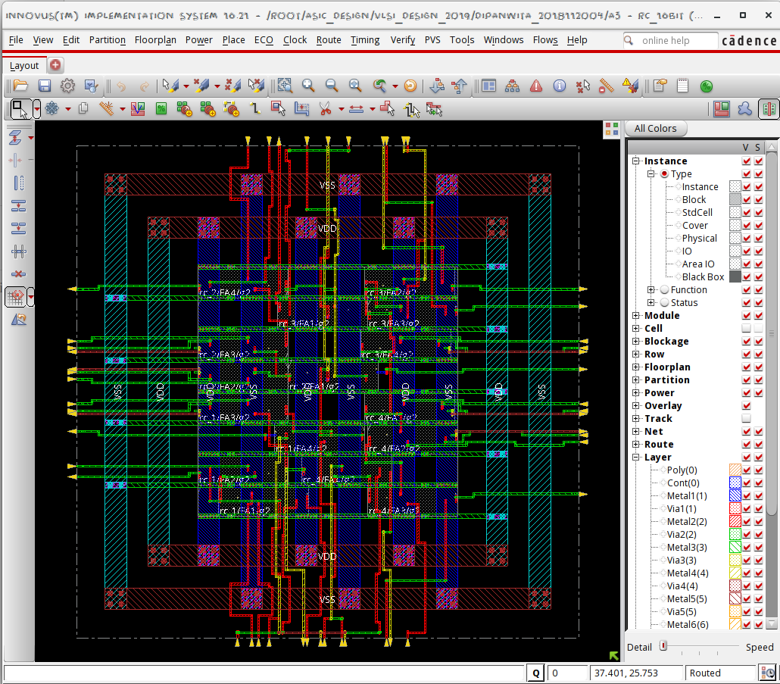
- AREA STATISTICS:

FROM GENUS:

Instance Module Cells Cell Area Net Area Total Area Wireload
------------------------------------------------------------------------------
rc_16bit 16 315 0 315 <none> (D)
rc_4 rcarry_4bit_3 4 79 0 79 <none> (D)
FA4 fa_1bit_15 1 20 0 20 <none> (D)
FA3 fa_1bit_14 1 20 0 20 <none> (D)
FA2 fa_1bit_13 1 20 0 20 <none> (D)
FA1 fa_1bit_12 1 20 0 20 <none> (D)
rc_3 rcarry_4bit_2 4 79 0 79 <none> (D)
FA4 fa_1bit_11 1 20 0 20 <none> (D)
FA3 fa_1bit_10 1 20 0 20 <none> (D)
FA2 fa_1bit_9 1 20 0 20 <none> (D)
FA1 fa_1bit_8 1 20 0 20 <none> (D)
rc_2 rcarry_4bit_1 4 79 0 79 <none> (D)
FA4 fa_1bit_7 1 20 0 20 <none> (D)
FA3 fa_1bit_6 1 20 0 20 <none> (D)
FA2 fa_1bit_5 1 20 0 20 <none> (D)
FA1 fa_1bit_4 1 20 0 20 <none> (D)
rc_1 rcarry_4bit 4 79 0 79 <none> (D)
FA4 fa_1bit_3 1 20 0 20 <none> (D)
FA3 fa_1bit_2 1 20 0 20 <none> (D)
FA2 fa_1bit_1 1 20 0 20 <none> (D)
FA1 fa_1bit 1 20 0 20 <none> (D)
FROM INNOVUS:

Depth Name #Inst Area (um^2)
-------------------------------------
0 rc_16bit 16 314.8704
1 rc_4 4 78.7176
1 rc_1 4 78.7176
1 rc_2 4 78.7176
1 rc_3 4 78.7176
2 rc_2/FA3 1 19.6794
2 rc_2/FA4 1 19.6794
2 rc_3/FA4 1 19.6794
2 rc_4/FA2 1 19.6794
2 rc_1/FA2 1 19.6794
2 rc_3/FA1 1 19.6794
2 rc_2/FA2 1 19.6794
2 rc_4/FA4 1 19.6794
2 rc_3/FA3 1 19.6794
2 rc_1/FA4 1 19.6794
2 rc_4/FA1 1 19.6794
2 rc_1/FA1 1 19.6794
2 rc_2/FA1 1 19.6794
2 rc_4/FA3 1 19.6794
2 rc_1/FA3 1 19.6794
2 rc_3/FA2 1 19.6794

- POWER STATISTICS:

FROM GENUS:

Leakage Dynamic Total
Instance Cells Power(nW) Power(nW) Power(nW)
---------------------------------------------
rc_16bit 16 1351.619 12979.331 14330.950
rc_1 4 337.905 2552.775 2890.680
FA1 1 84.476 562.004 646.480
FA2 1 84.476 630.482 714.959
FA3 1 84.476 660.543 745.019
FA4 1 84.476 699.747 784.223
rc_2 4 337.905 2828.424 3166.329
FA1 1 84.476 690.613 775.089
FA2 1 84.476 630.163 714.639
FA3 1 84.476 738.951 823.427
FA4 1 84.476 768.698 853.174
rc_3 4 337.905 3274.006 3611.911
FA1 1 84.476 877.405 961.881
FA2 1 84.476 868.022 952.499
FA3 1 84.476 789.951 874.427
FA4 1 84.476 738.628 823.104
rc_4 4 337.905 2541.282 2879.186
FA1 1 84.476 690.343 774.819
FA2 1 84.476 621.338 705.814
FA3 1 84.476 591.264 675.740
FA4 1 84.476 638.337 722.813
FROM INNOVUS:

Total Power
-----------------------------------------------------------------------------------------
Total Internal Power: 0.00755354 70.7850%
Total Switching Power: 0.00176595 16.5489%
Total Leakage Power: 0.00135162 12.6662%
Total Power: 0.01067111
-----------------------------------------------------------------------------------------

Group Internal Switching Leakage Total Percentage
Power Power Power Power (%)
-----------------------------------------------------------------------------------------
Sequential 0 0 0 0 0
Macro 0 0 0 0 0
IO 0 0 0 0 0
Combinational 0.007554 0.001766 0.001352 0.01067 100
Clock (Combinational) 0 0 0 0 0
Clock (Sequential) 0 0 0 0 0
-----------------------------------------------------------------------------------------
Total 0.007554 0.001766 0.001352 0.01067 100
-----------------------------------------------------------------------------------------

Rail Voltage Internal Switching Leakage Total Percentage
Power Power Power Power (%)
-----------------------------------------------------------------------------------------
VDD 0.9 0.007554 0.001766 0.001352 0.01067 100

- TIMING REPORT: (from Xilinx_ISE)

Delay: 21.690ns (Levels of Logic = 18)
Source: b<0> (PAD)
Destination: cout (PAD)

Data Path: b<0> to cout
Gate Net
Cell:in->out fanout Delay Delay Logical Name (Net Name)
---------------------------------------- ------------
IBUF:I->O 2 1.106 0.532 b_0_IBUF (b_0_IBUF)
LUT3:I0->O 2 0.612 0.449 rc_1/FA1/cout1 (rc_1/carry<1>)
LUT3:I1->O 2 0.612 0.449 rc_1/FA2/cout1 (rc_1/carry<2>)
LUT3:I1->O 2 0.612 0.449 rc_1/FA3/cout1 (rc_1/carry<3>)
LUT3:I1->O 2 0.612 0.449 rc_1/FA4/cout1 (c1)
LUT3:I1->O 2 0.612 0.449 rc_2/FA1/cout1 (rc_2/carry<1>)
LUT3:I1->O 2 0.612 0.449 rc_2/FA2/cout1 (rc_2/carry<2>)
LUT3:I1->O 2 0.612 0.449 rc_2/FA3/cout1 (rc_2/carry<3>)
LUT3:I1->O 2 0.612 0.449 rc_2/FA4/cout1 (c2)
LUT3:I1->O 2 0.612 0.449 rc_3/FA1/cout1 (rc_3/carry<1>)
LUT3:I1->O 2 0.612 0.449 rc_3/FA2/cout1 (rc_3/carry<2>)
LUT3:I1->O 2 0.612 0.449 rc_3/FA3/cout1 (rc_3/carry<3>)
LUT3:I1->O 2 0.612 0.449 rc_3/FA4/cout1 (c3)
LUT3:I1->O 2 0.612 0.449 rc_4/FA1/cout1 (rc_4/carry<1>)
LUT3:I1->O 2 0.612 0.449 rc_4/FA2/cout1 (rc_4/carry<2>)
LUT3:I1->O 2 0.612 0.449 rc_4/FA3/cout1 (rc_4/carry<3>)
LUT3:I1->O 1 0.612 0.357 rc_4/FA4/cout1 (cout_OBUF)
OBUF:I->O 3.169 cout_OBUF (cout)
----------------------------------------
Total 21.690ns (14.067ns logic, 7.623ns route)
(64.9% logic, 35.1% route)

Total REAL time to Xst completion: 4.00 secs
Total CPU time to Xst completion: 3.24 secs

- INFERENCES:
- Clearly the Carry Lookahead Adder has lower delay (10.838ns) as compared to Ripple Carry Adder(21.690ns). This shows that we are able to optimize on the delays using Carry Lookahead Adder over Ripple Carry Adder.
- The total power obtained from Innovus is lower than that obtained from Genus. This is because Innovus optimises the design.
- The area(196.794 um^2) for Carry Lookahead Adder is lower than that of the Ripple Carry Adder (area: 314.8704 um^2). This is because 16-bit Ripple Carry Adder is implemented from 4-bit Ripple Carry Adder which is, in turn, made from 1-bit Full Adder. But in Carry Lookahead Adder we implement the whole logic in terms of gates which is highly efficient to save area.
The power( 9398.257 nW) from Carry Lookahead Adder is also less than the power(14330.950 nW) for Ripple Carry Adder. This can also be explained in terms of the optimised gate-level implementation of the circuit.

