SUMMARY REPORT FOR 4 BIT WALLACE MULTIPLIER:

- TRUTH TABLE FOR 1 BIT FULL ADDER:

A | B | CIN | S | COUT
0 | 0 | 0 | 0 | 0
0 | 1 | 0 | 1 | 0
1 | 0 | 0 | 1 | 0
1 | 1 | 0 | 0 | 1
0 | 0 | 1 | 1 | 0
0 | 1 | 1 | 0 | 1
1 | 0 | 1 | 0 | 1
1 | 1 | 1 | 1 | 1

TRUTH TABLE FOR A 2 BIT MULTIPLIER:
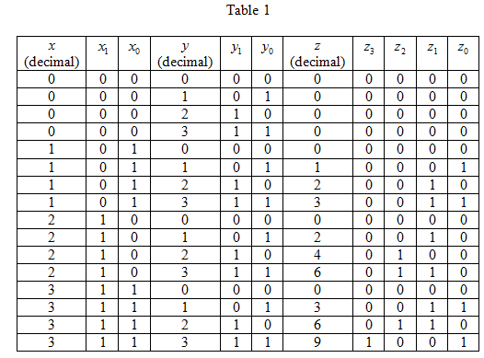

- ALGORITHM:
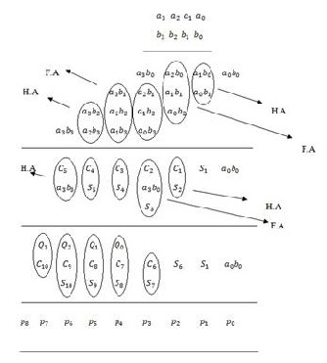

- RTL Schematic:

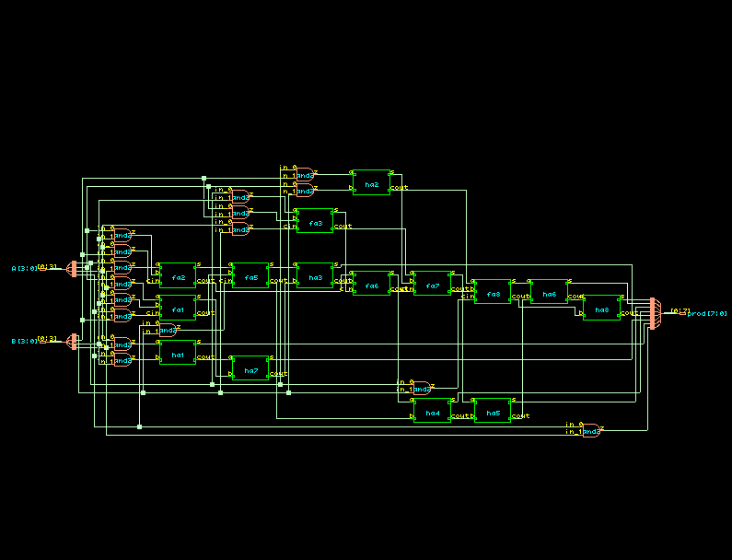

- TIMING DIAGRAM:
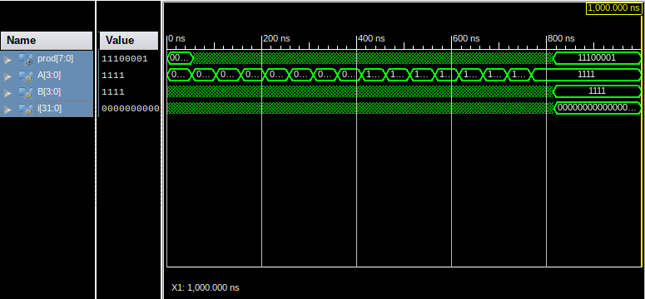
- LAYOUT FROM INNOVUS:
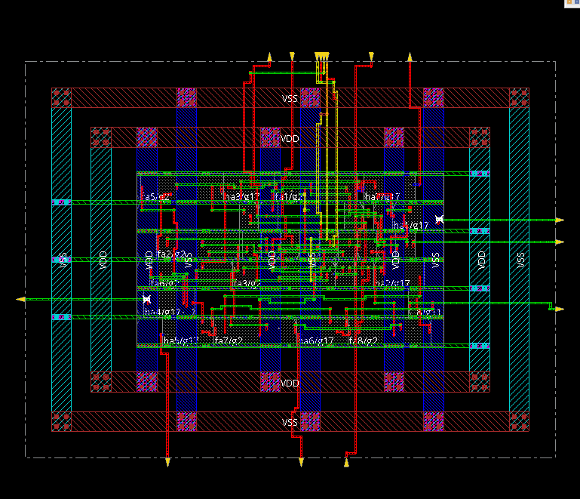
- AREA STATISTICS:

FROM GENUS:

Gate Instances Area Library
--------------------------------------
ADDFX1 7 137.756 slow
ADDHXL 7 84.773 slow
AND2X1 15 68.121 slow
AND2XL 1 4.541 slow
CLKXOR2X1 1 8.326 slow
--------------------------------------
total 31 283.517

Type Instances Area Area %
----------------------------------------
logic 31 283.517 100.0
physical_cells 0 0.000 0.0
----------------------------------------
total 31 283.517 100.0

FROM INNOVUS:

Depth Name #Inst Area (um^2)
------------------------------------
0 wallace 31 283.5169
1 fa8 1 19.6794
1 ha6 1 12.1104
1 fa5 1 19.6794
1 fa1 1 19.6794
1 ha2 1 12.1104
1 ha3 1 12.1104
1 ha8 1 12.1104
1 fa7 1 19.6794
1 fa3 1 19.6794
1 ha5 1 12.1104
1 ha1 1 12.1104
1 ha7 1 12.1104
1 fa6 1 19.6794
1 fa2 1 19.6794
1 ha4 1 12.1104

- POWER STATISTICS:

FROM GENUS:

Leakage Dynamic Total
Instance Cells Power(nW) Power(nW) Power(nW)
---------------------------------------------
wallace 31 1704.840 9416.049 11120.889
ha1 1 86.962 275.963 362.925
ha2 1 86.962 329.411 416.373
ha3 1 86.962 272.698 359.660
ha4 1 86.962 476.992 563.954
ha5 1 86.962 437.046 524.008
ha6 1 86.962 241.448 328.410
ha7 1 86.962 222.692 309.654
fa1 1 84.476 749.040 833.516
fa2 1 84.476 635.355 719.831
fa3 1 84.476 677.696 762.172
fa5 1 84.476 790.364 874.840
fa6 1 84.476 497.181 581.657
fa7 1 84.476 690.596 775.072
fa8 1 84.476 408.162 492.638
ha8 1 72.543 95.113 167.656

FROM INNOVUS:

Total Power
-----------------------------------------------------------------------------------------
Total Internal Power: 0.00429677 53.8903%
Total Switching Power: 0.00197156 24.7275%
Total Leakage Power: 0.00170484 21.3822%
Total Power: 0.00797318
-----------------------------------------------------------------------------------------
Group Internal Switching Leakage Total Percentage
Power Power Power Power (%)
-----------------------------------------------------------------------------------------
Sequential 0 0 0 0 0
Macro 0 0 0 0 0
IO 0 0 0 0 0
Combinational 0.004297 0.001972 0.001705 0.007973 100
Clock (Combinational) 0 0 0 0 0
Clock (Sequential) 0 0 0 0 0
-----------------------------------------------------------------------------------------
Total 0.004297 0.001972 0.001705 0.007973 100
-----------------------------------------------------------------------------------------

Rail Voltage Internal Switching Leakage Total Percentage
Power Power Power Power (%)
-----------------------------------------------------------------------------------------
VDD 0.9 0.004297 0.001972 0.001705 0.007973 100

-----------------------------------------------------------------------------------------
* Power Distribution Summary:
* Highest Average Power: fa5/g2 (ADDFX1): 0.0005353
* Highest Leakage Power: ha7/g17 (ADDHXL): 8.696e-05
* Total Cap: 2.40094e-13 F
* Total instances in design: 31
* Total instances in design with no power: 0
* Total instances in design with no activty: 0

* Total Fillers and Decap: 0

- TIMING REPORT: (from Xilinx_ISE)

All values displayed in nanoseconds (ns)

Timing constraint: Default path analysis
Total number of paths / destination ports: 686 / 8
Delay: 12.899ns (Levels of Logic = 10)
Source: A<0> (PAD)
Destination: prod<6> (PAD)

Data Path: A<0> to prod<6>
Gate Net
Cell:in->out fanout Delay Delay Logical Name (Net Name)
---------------------------------------- ------------
IBUF:I->O 6 1.106 0.721 A_0_IBUF (A_0_IBUF)
LUT2:I0->O 2 0.612 0.383 _and00041 (_and0004)
LUT4:I3->O 2 0.612 0.449 fa1/Mxor_s_Result1 (r2)
LUT2:I1->O 2 0.612 0.532 ha7/cout1 (c_2)
LUT4:I0->O 3 0.612 0.520 ha3/cout1 (C3)
LUT4:I1->O 2 0.612 0.532 ha4/cout1 (C4)
LUT4:I0->O 4 0.612 0.568 ha5/cout1 (C5)
LUT4:I1->O 1 0.612 0.000 ha6/Mxor_s_Result11 (ha6/Mxor_s_Result1)
MUXF5:I1->O 1 0.278 0.357 ha6/Mxor_s_Result1_f5 (prod_6_OBUF)
OBUF:I->O 3.169 prod_6_OBUF (prod<6>)
----------------------------------------
Total 12.899ns (8.837ns logic, 4.062ns route)
(68.5% logic, 31.5% route)

Total REAL time to Xst completion: 4.00 secs
Total CPU time to Xst completion: 3.36 secs

- INFERENCES:

- The total power obtained from Innovus is lower than that obtained from Genus. This is because Innovus optimises the design.
- The area(283.5169 um^2) for Genus is almost similar to that for Innovus.

