RADIX 2 FFT:

RTL SCHEMATIC:

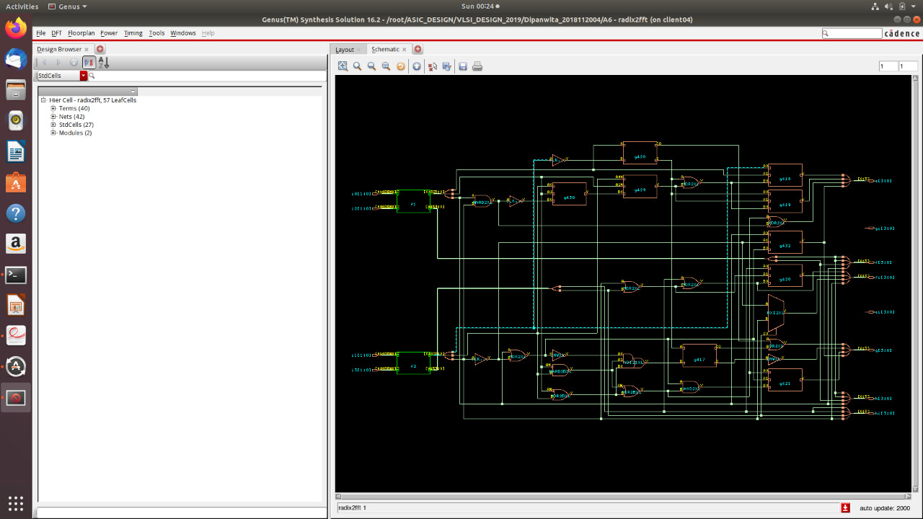
TIMING DIAGRAM:

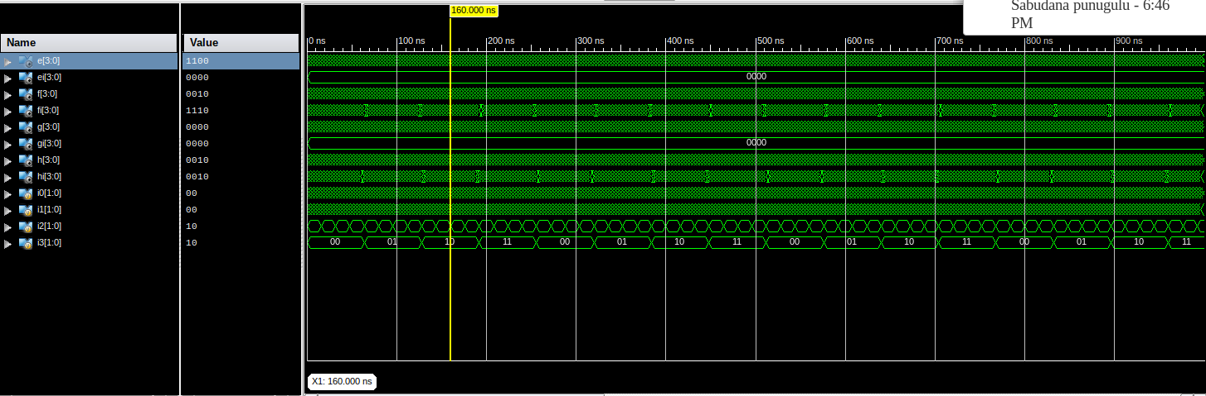

AREA REPORTS:

From Genus:

Gate Instances Area Library
--------------------------------------
ADDHXL 2 24.221 slow
AND2X1 2 9.083 slow
AO21X1 4 27.248 slow
AOI21XL 1 4.541 slow
CLKINVX1 7 15.895 slow
INVXL 2 4.541 slow
MXI2XL 1 6.055 slow
NAND2BXL 1 4.541 slow
NAND2XL 12 36.331 slow
NOR2BXL 4 18.166 slow
NOR2XL 4 12.110 slow
OAI21XL 8 36.331 slow
OAI22XL 2 12.110 slow
OAI2BB1XL 3 15.895 slow
OR2X1 3 13.624 slow
XOR2X1 1 8.326 slow
--------------------------------------
total 57 249.020

Type Instances Area Area %
----------------------------------------
inverter 9 20.436 8.2
logic 48 228.584 91.8
physical_cells 0 0.000 0.0
----------------------------------------
total 57 249.020 100.0

From Innovus:

Depth Name #Inst Area (um^2)
--------------------------------------
0 radix2fft 57 249.0201
1 f2 15 58.2813
1 f1 15 58.2813

POWER REPORTS:

From Genus:

Leakage Dynamic Total
Instance Cells Power(nW) Power(nW) Power(nW)
----------------------------------------------
radix2fft 57 1154.601 10699.801 11854.402
f1 15 216.266 1821.920 2038.186
f2 15 216.266 2101.126 2317.393

From Innovus:

Total Power

Total Internal Power: 0.00552666 56.9178%
Total Switching Power: 0.00302864 31.1912%
Total Leakage Power: 0.00115460 11.8910%
Total Power: 0.00970990

DELAY REPORTS:

Timing Detail:
--------------
All values displayed in nanoseconds (ns)

=========================================================================
Timing constraint: Default path analysis
Total number of paths / destination ports: 200 / 24
-------------------------------------------------------------------------
Delay: 8.301ns (Levels of Logic = 5)
Source: i0<1> (PAD)
Destination: g<3> (PAD)

Data Path: i0<1> to g<3>
Gate Net
Cell:in->out fanout Delay Delay Logical Name (Net Name)
---------------------------------------- ------------
IBUF:I->O 4 1.106 0.651 i0_1_IBUF (i0_1_IBUF)
LUT4:I0->O 8 0.612 0.795 f1/Madd_c_add0000_xor<1>11 (A<1>)
LUT4:I0->O 1 0.612 0.387 Msub_g_xor<3>1_SW0 (N0)
LUT3:I2->O 1 0.612 0.357 Msub_g_xor<3>1 (g_3_OBUF)
OBUF:I->O 3.169 g_3_OBUF (g<3>)
----------------------------------------
Total 8.301ns (6.111ns logic, 2.190ns route)
(73.6% logic, 26.4% route)

INFERENCES:

- Innovus power is lower than Genus power as Innovus optimises our design.

