RADIX 4 FFT:

RTL SCHEMATIC:

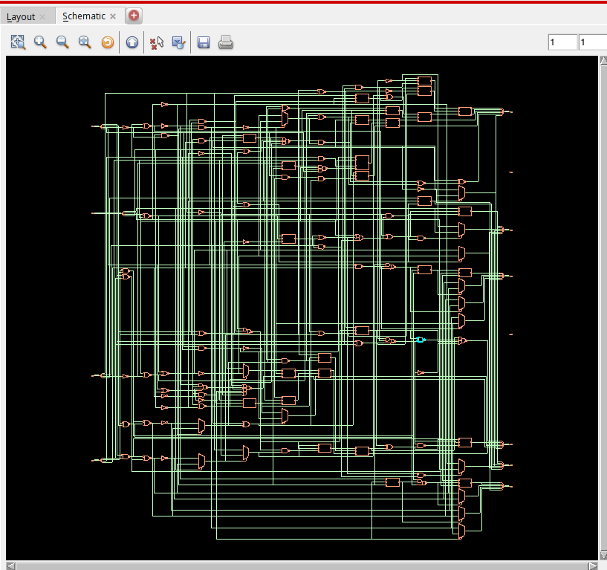
TIMING DIAGRAM:

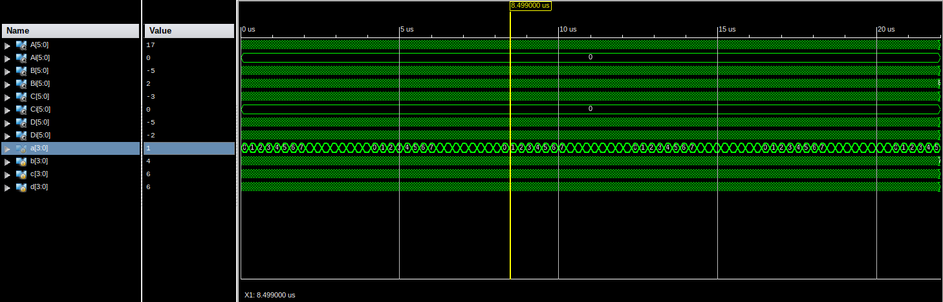

AREA REPORTS:

From Genus:

Gate Instances Area Library
--------------------------------------
ADDFX1 5 98.397 slow
ADDFXL 1 19.679 slow
AO21X1 2 13.624 slow
AOI211XL 1 5.298 slow
AOI21XL 4 18.166 slow
AOI22XL 1 6.055 slow
CLKXOR2X1 3 24.978 slow
INVXL 19 43.143 slow
MXI2XL 16 96.883 slow
NAND2BX1 1 4.541 slow
NAND2BXL 3 13.624 slow
NAND2XL 17 51.469 slow
NOR2BX1 1 4.541 slow
NOR2BXL 7 31.790 slow
NOR2XL 12 36.331 slow
OA21X1 1 6.812 slow
OAI211XL 1 5.298 slow
OAI21XL 15 68.121 slow
OAI222XL 1 8.326 slow
OAI22XL 2 12.110 slow
OAI2BB1XL 4 21.193 slow
OR2X1 2 9.083 slow
XNOR2XL 1 8.326 slow
--------------------------------------
total 120 607.791

Type Instances Area Area %
----------------------------------------
inverter 19 43.143 7.1
logic 101 564.647 92.9
physical_cells 0 0.000 0.0
----------------------------------------
total 120 607.791 100.0

From Innovus:

Depth Name #Inst Area (um^2)
------------------------------------
0 rad4fft 120 607.7907

POWER REPORTS:

From Genus:

Leakage Dynamic Total
Instance Cells Power(nW) Power(nW) Power(nW)
---------------------------------------------
rad4fft 120 2464.282 29303.507 31767.789

From Innovus:

Total Power
-----------------------------------------------------------------------------------------
Total Internal Power: 0.01350556 56.7783%
Total Switching Power: 0.00781664 32.8617%
Total Leakage Power: 0.00246428 10.3600%
Total Power: 0.02378648
-----------------------------------------------------------------------------------------

Group Internal Switching Leakage Total Percentage
Power Power Power Power (%)
-----------------------------------------------------------------------------------------
Sequential 0 0 0 0 0
Macro 0 0 0 0 0
IO 0 0 0 0 0
Combinational 0.01351 0.007817 0.002464 0.02379 100
Clock (Combinational) 0 0 0 0 0
Clock (Sequential) 0 0 0 0 0
-----------------------------------------------------------------------------------------
Total 0.01351 0.007817 0.002464 0.02379 100
-----------------------------------------------------------------------------------------

Rail Voltage Internal Switching Leakage Total Percentage
Power Power Power Power (%)
-----------------------------------------------------------------------------------------
VDD 0.9 0.01351 0.007817 0.002464 0.02379 100

-----------------------------------------------------------------------------------------
* Power Distribution Summary:
* Highest Average Power: g2551 (ADDFX1): 0.001087
* Highest Leakage Power: g2556 (ADDFX1): 8.448e-05
* Total Cap: 6.48932e-13 F
* Total instances in design: 120
* Total instances in design with no power: 0
* Total instances in design with no activty: 0

* Total Fillers and Decap: 0
-----------------------------------------------------------------------------------------

DELAY REPORTS:

Timing Detail:
--------------
All values displayed in nanoseconds (ns)

Timing constraint: Default path analysis
Total number of paths / destination ports: 1354 / 36
-------------------------------------------------------------------------
Delay: 11.550ns (Levels of Logic = 10)
Source: a<0> (PAD)
Destination: A_rnm0<5> (PAD)

Data Path: a<0> to A_rnm0<5>
Gate Net
Cell:in->out fanout Delay Delay Logical Name (Net Name)
---------------------------------------- ------------
IBUF:I->O 9 1.106 0.766 a_0_IBUF (a_0_IBUF)
LUT4:I1->O 3 0.612 0.451 Madd_A_rnm0_addsub0002_cy<1>11 (Madd_A_rnm0_addsub0002_cy<1>)
MUXF5:S->O 1 0.641 0.509 Madd_A_rnm0_addsub0002_xor<3>11_f5 (A_rnm0_addsub0002<3>)
LUT2:I0->O 1 0.612 0.000 Madd_A_rnm0_addsub0003_lut<3> (Madd_A_rnm0_addsub0003_lut<3>)
MUXCY:S->O 1 0.404 0.000 Madd_A_rnm0_addsub0003_cy<3> (Madd_A_rnm0_addsub0003_cy<3>)
XORCY:CI->O 1 0.699 0.509 Madd_A_rnm0_addsub0003_xor<4> (A_rnm0_addsub0003<4>)
LUT1:I0->O 1 0.612 0.000 Madd_A_rnm0_cy<4>_rt (Madd_A_rnm0_cy<4>_rt)
MUXCY:S->O 0 0.404 0.000 Madd_A_rnm0_cy<4> (Madd_A_rnm0_cy<4>)
XORCY:CI->O 1 0.699 0.357 Madd_A_rnm0_xor<5> (A_rnm0_5_OBUF)
OBUF:I->O 3.169 A_rnm0_5_OBUF (A_rnm0<5>)
----------------------------------------
Total 11.550ns (8.958ns logic, 2.592ns route)
(77.6% logic, 22.4% route)

INFERENCES:

- Innovus power is lower than Genus power as Innovus optimises our design.

