UNIVERSAL 4-BIT SHIFT REGISTER VS FINITE STATE MACHINE(FSM):

RTLs:

USR:

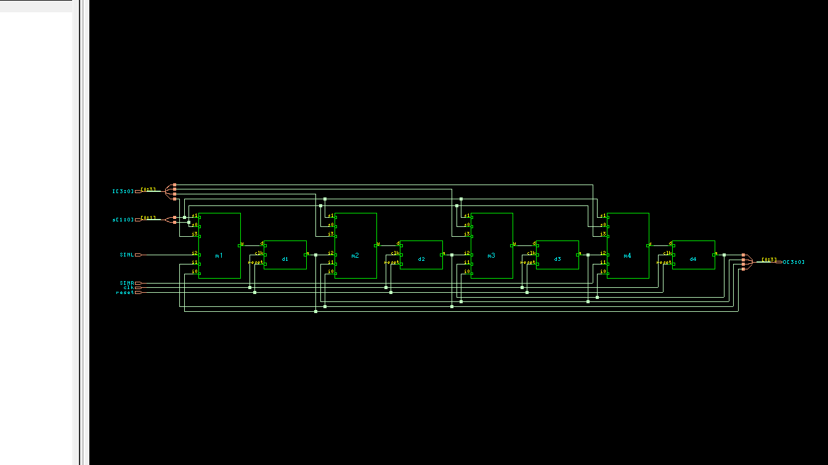

FSM:

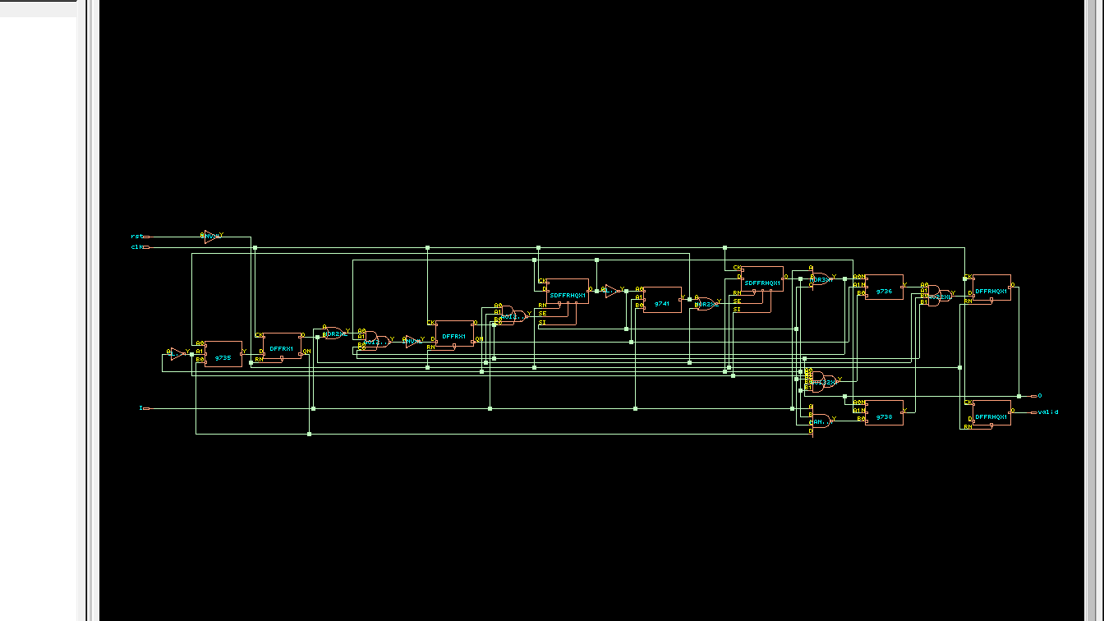

Innovus Designs:

USR:

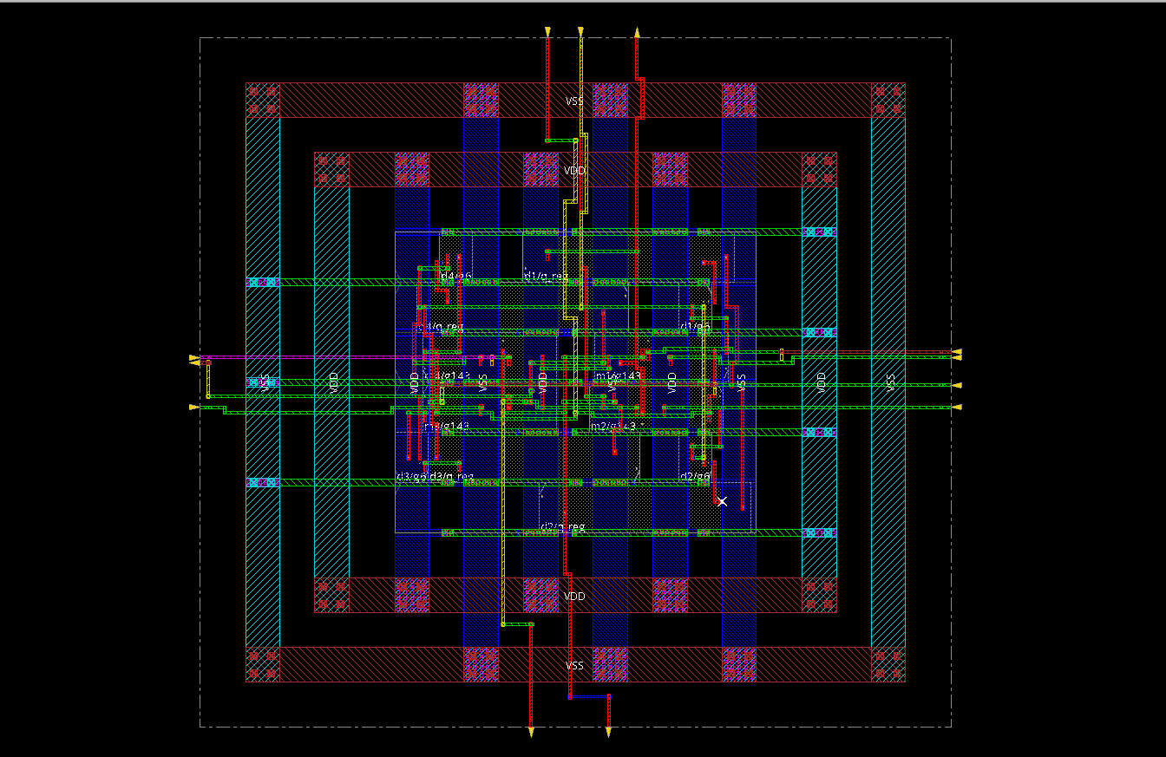

FSM:

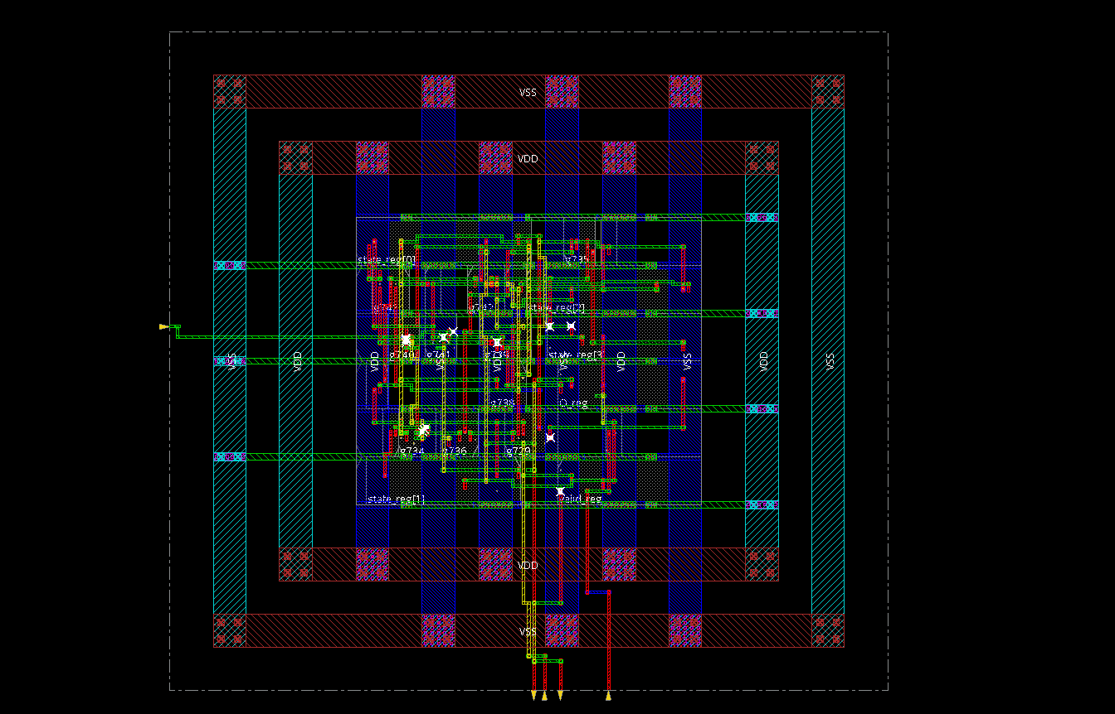

COMPARISON OF AREA & POWER:

DESIGN | AREA |  | POWER
 | GENUS | INNOVUS | GENUS | INNOVUS
D FLIPFLOP | 33 um^2 | 33um^2 | 7247.96 nW | 7033.7 nW
UNIVERSAL SHIFT REGISTER | 205.9 um^2 | 205.8768 um^2 | 24327.457 nW | 352345.7 nW
FSM | 200.67 um^2 | 200.665 um^2 | 48986.946nW | 42955.6nW

OBSERVATIONS & INFERENCE:

- The power is lower in Innovus than in Genus for all designs. This implies that Innovus optimises our design.
- D flipflop is a component in USR and FSM, and hence it is lower in area & power than both of them.

