REPORT FOR ASSIGNMENT 1:

BASIC GATES:

For 2-input AND Gate: A.B = Y

A | B | Y
0 | 0 | 0
0 | 1 | 0
1 | 0 | 0
1 | 1 | 1

GATE STATISTICS AND AREA:

Gate Instances Area Library
---------------------------------
AND2XL 1 4.541 slow
---------------------------------
total 1 4.541

Type Instances Area Area %
--------------------------------------
logic 1 4.541 100.0
physical_cells 0 0.000 0.0
--------------------------------------
total 1 4.541 100.0

INNOVUS LAYOUT :
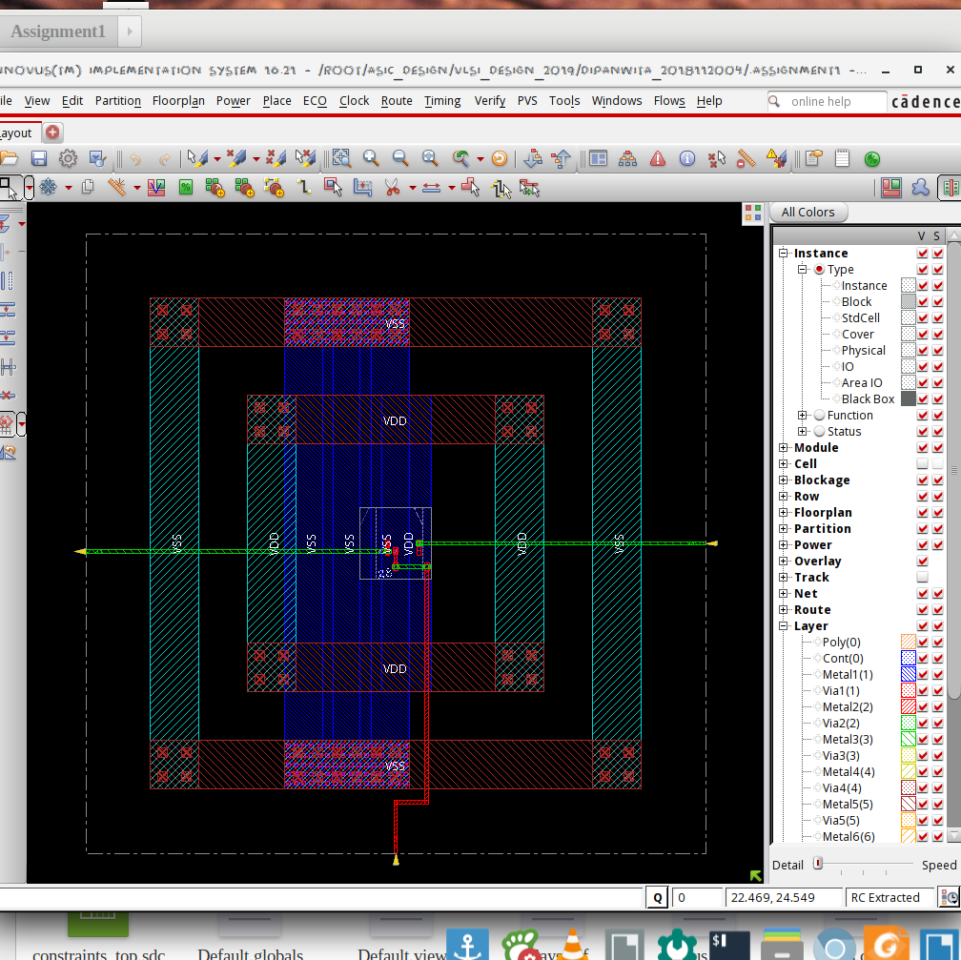
*** Innovus Statistics for net list andgate ***
Number of cells = 1
Number of nets = 3
Number of tri-nets = 0
Number of degen nets = 0
Number of pins = 6
Number of i/os = 3

Number of nets with 2 terms = 3 (100.0%)
Number of nets with >=10 terms = 0 (0.0%)

*** 1 Primitives used:
Primitive AND2XL (1 insts)

POWER:

Leakage Dynamic Total
Instance Cells Power(nW) Power(nW) Power(nW)
---------------------------------------------
andgate 1 24.663 88.320 112.983

GATE LEVEL DIAGRAM:

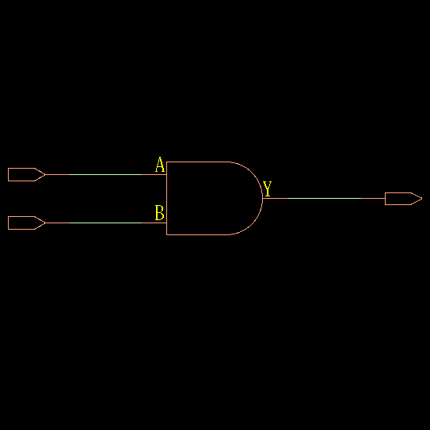

TIMING DIAGRAM:
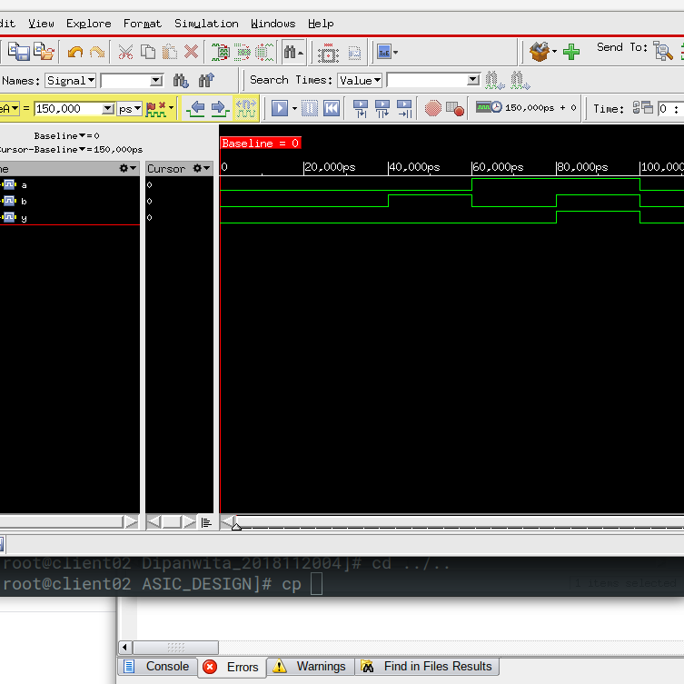

EXPLANATION OF TIMING DIAGRAM:

1. Till 40,000 us A = 0, B =0, so Y = A.B = 0
2. From 40,000 us to 60,000 us , A = 0, B=1, Y = 0
3. From 60,000 us to 80,000 us, A = 1, B = 0, Y = 0
4. From 80,000 us to 100,000 us, A = 1, B=1, Y = 1

For 2-input OR Gate: A + B = Y

A | B | Y
0 | 0 | 0
0 | 1 | 1
1 | 0 | 1
1 | 1 | 1

GATE STATISTICS & AREA:
Gate Instances Area Library
--------------------------------
OR2X1 1 4.541 slow
--------------------------------
total 1 4.541

Type Instances Area Area %
--------------------------------------
logic 1 4.541 100.0
physical_cells 0 0.000 0.0
--------------------------------------
total 1 4.541 100.0

*** Innovus Statistics for net list orgate ***
Number of cells = 1
Number of nets = 3
Number of tri-nets = 0
Number of degen nets = 0
Number of pins = 6
Number of i/os = 3

Number of nets with 2 terms = 3 (100.0%)
Number of nets with >=10 terms = 0 (0.0%)

*** 1 Primitives used:
Primitive OR2X1 (1 insts)

POWER:

Leakage Dynamic Total
Instance Cells Power(nW) Power(nW) Power(nW)
---------------------------------------------
orgate 1 42.556 93.213 135.769

GATE LEVEL DESIGN:
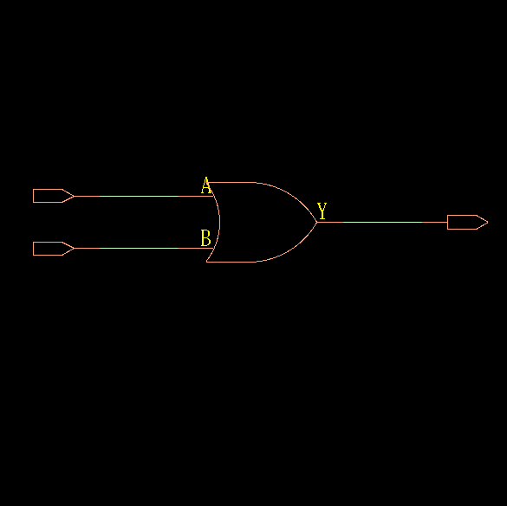

TIMING DIAGRAM:
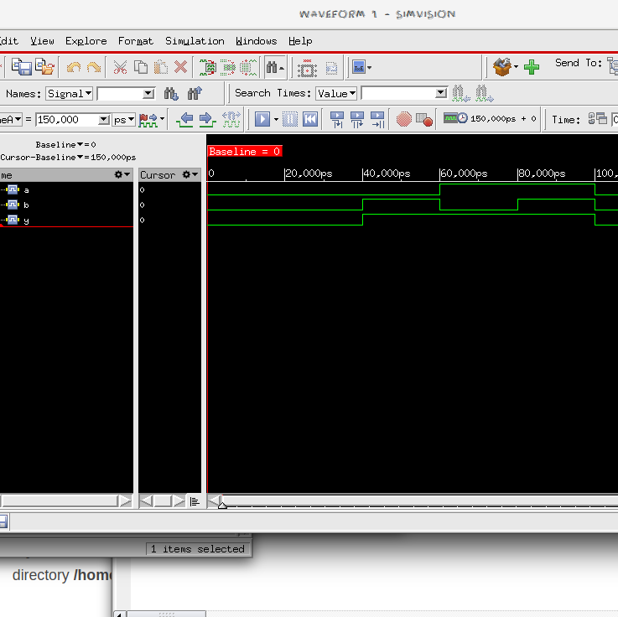

EXPLANATION OF TIMING DIAGRAM:

1. Till 40,000 us A = 0, B =0, so Y = 0
2. From 40,000 us to 60,000 us , A = 0, B=1, Y = 1
3. From 60,000 us to 80,000 us, A = 1, B = 0, Y = 1
4. From 80,000 us to 100,000 us, A = 1, B=1, Y = 1

For 2-input NOT Gate: Y = A’

A | Y
0 | 1
1 | 0

GATE STATISTICS & AREA:

Gate Instances Area Library
--------------------------------
INVXL 1 2.271 slow
--------------------------------
total 1 2.271

Type Instances Area Area %
--------------------------------------
inverter 1 2.271 100.0
physical_cells 0 0.000 0.0
--------------------------------------
total 1 2.271 100.0

*** Innovus Statistics for net list notgate ***

Number of cells = 1
Number of nets = 2
Number of tri-nets = 0
Number of degen nets = 0
Number of pins = 4
Number of i/os = 2

Number of nets with 2 terms = 2 (100.0%)
Number of nets with >=10 terms = 0 (0.0%)

*** 1 Primitives used:
Primitive INVXL (1 insts)

POWER:

Leakage Dynamic Total
Instance Cells Power(nW) Power(nW) Power(nW)
---------------------------------------------
notgate 1 8.757 44.417 53.174

TIMING DIAGRAM:
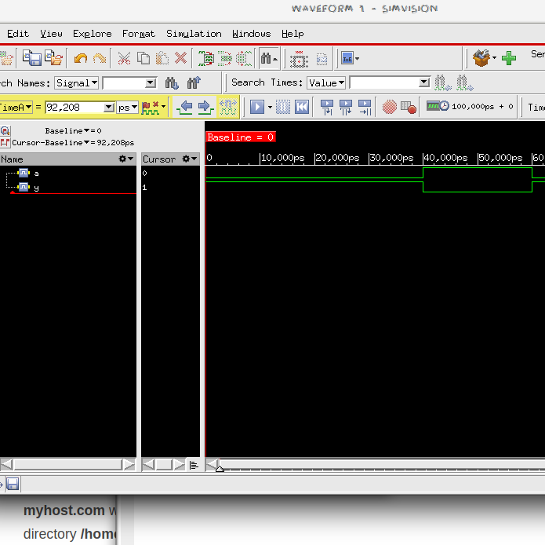

GATE LEVEL DESIGN:

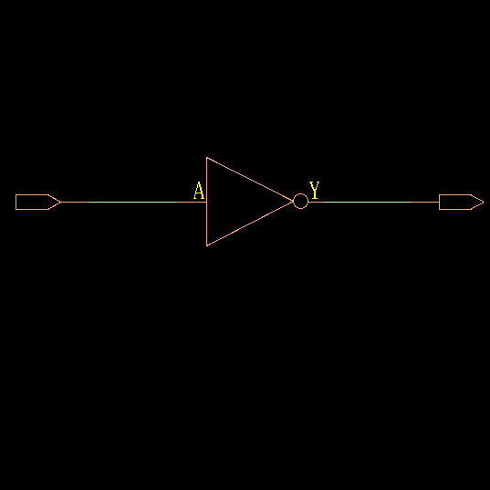

EXPLANATION OF TIMING DIAGRAM:

1. Till 40,000 us A = 0, Y = 1
2. From 40,000 us to 60,000 us , A = 1,Y = 0

For 2-input NOR Gate: Y = (A + B)’

A | B | Y
0 | 0 | 1
0 | 1 | 0
1 | 0 | 0
1 | 1 | 0

GATE LEVEL DESIGN & AREA:

Gate Instances Area Library
---------------------------------
NOR2XL 1 3.028 slow
---------------------------------
total 1 3.028

Type Instances Area Area %
--------------------------------------
logic 1 3.028 100.0
physical_cells 0 0.000 0.0
--------------------------------------
total 1 3.028 100.0

*** Innovus Statistics for net list norgate ***

Number of cells = 1
Number of nets = 3
Number of tri-nets = 0
Number of degen nets = 0
Number of pins = 6
Number of i/os = 3

Number of nets with 2 terms = 3 (100.0%)
Number of nets with >=10 terms = 0 (0.0%)

*** 1 Primitives used:
Primitive NOR2XL (1 insts)

POWER:

Leakage Dynamic Total
Instance Cells Power(nW) Power(nW) Power(nW)
---------------------------------------------
norgate 1 12.358 80.475 92.834

GATE LEVEL DIAGRAM:
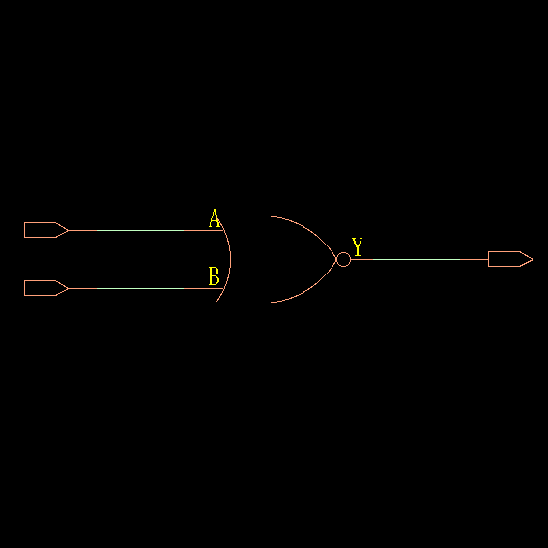

TIMING DIAGRAM:
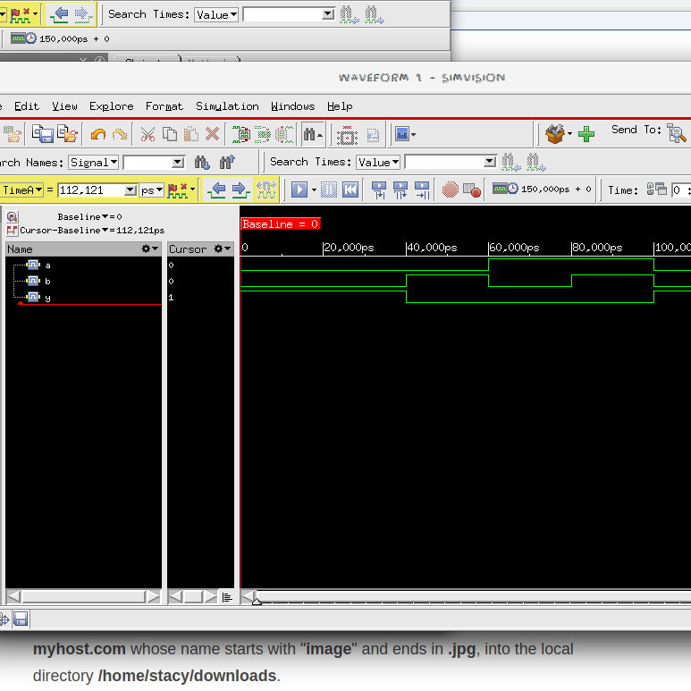

EXPLANATION OF TIMING DIAGRAM:

1. Till 40,000 us A = 0, B =0, so Y = 1
2. From 40,000 us to 60,000 us , A = 0, B=1, Y = 0
3. From 60,000 us to 80,000 us, A = 1, B = 0, Y = 0
4. From 80,000 us to 100,000 us, A = 1, B=1, Y = 0

For 2-input NAND Gate: Y = (A.B)’

A | B | Y
0 | 0 | 1
0 | 1 | 1
1 | 0 | 1
1 | 1 | 0

GATE STATISTICS:

Gate Instances Area Library
----------------------------------
NAND2XL 1 3.028 slow
----------------------------------
total 1 3.028

Type Instances Area Area %
--------------------------------------
logic 1 3.028 100.0
physical_cells 0 0.000 0.0
--------------------------------------
total 1 3.028 100.0

POWER:

Leakage Dynamic Total
Instance Cells Power(nW) Power(nW) Power(nW)
---------------------------------------------
nandgate 1 9.289 59.793 69.083

*** Innovus Statistics for net list nandgate ***
Number of cells = 1
Number of nets = 3
Number of tri-nets = 0
Number of degen nets = 0
Number of pins = 6
Number of i/os = 3

Number of nets with 2 terms = 3 (100.0%)
Number of nets with >=10 terms = 0 (0.0%)

TIMING DIAGRAM:

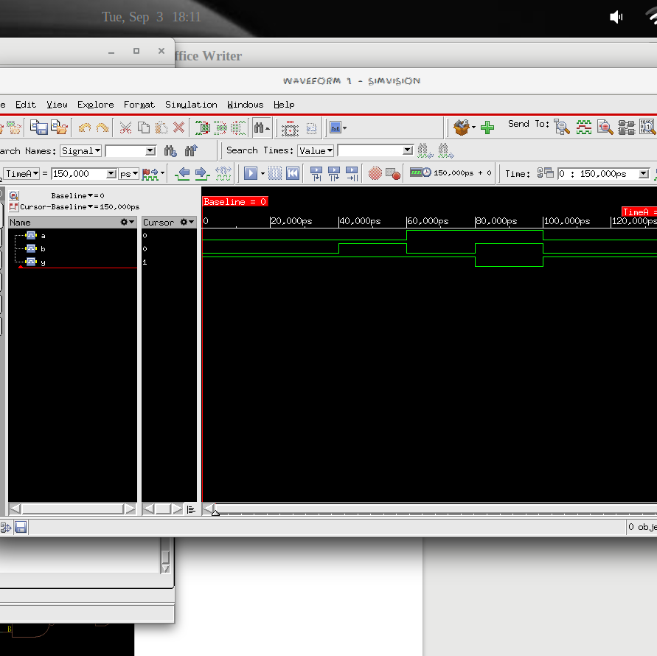

EXPLANATION OF TIMING DIAGRAM:

1. Till 40,000 us A = 0, B =0, so Y = (A.B)’ = 1
2. From 40,000 us to 60,000 us , A = 0, B=1, Y = 1
3. From 60,000 us to 80,000 us, A = 1, B = 0, Y = 1
4. From 80,000 us to 100,000 us, A = 1, B=1, Y = 0

GATE LEVEL DIAGRAM:

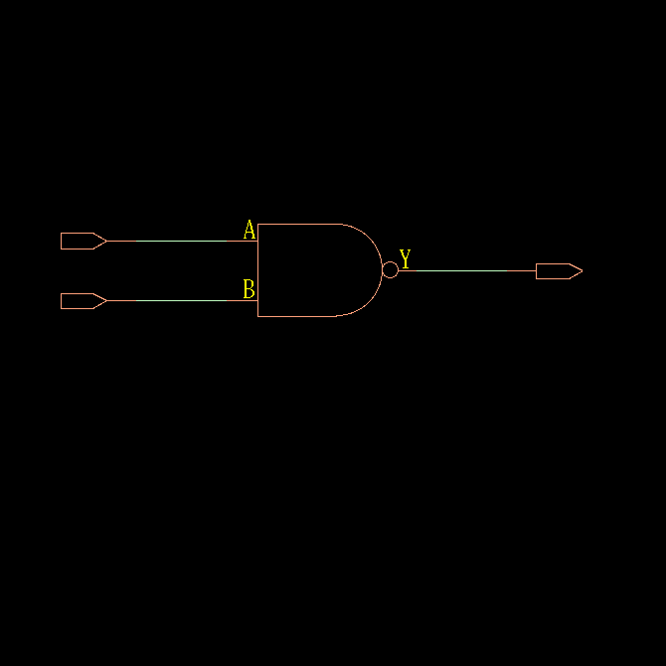

For 2-input XOR Gate: Y = A.B’ + A’.B

A | B | Y
0 | 0 | 0
0 | 1 | 1
1 | 0 | 1
1 | 1 | 0

GATE STATISTICS & AREA:

Gate Instances Area Library
------------------------------------
CLKXOR2X1 1 8.326 slow
------------------------------------
total 1 8.326

Type Instances Area Area %
--------------------------------------
logic 1 8.326 100.0
physical_cells 0 0.000 0.0
--------------------------------------
total 1 8.326 100.0

*** Statistics for net list xorgate ***
Number of cells = 1
Number of nets = 3
Number of tri-nets = 0
Number of degen nets = 0
Number of pins = 6
Number of i/os = 3
Number of nets with 2 terms = 3 (100.0%)
Number of nets with >=10 terms = 0 (0.0%)

*** 1 Primitives used:
Primitive CLKXOR2X1 (1 insts)

POWER:

Leakage Dynamic Total
Instance Cells Power(nW) Power(nW) Power(nW)
---------------------------------------------
xorgate 1 72.543 268.064 340.607

GATE LEVEL DESIGN:

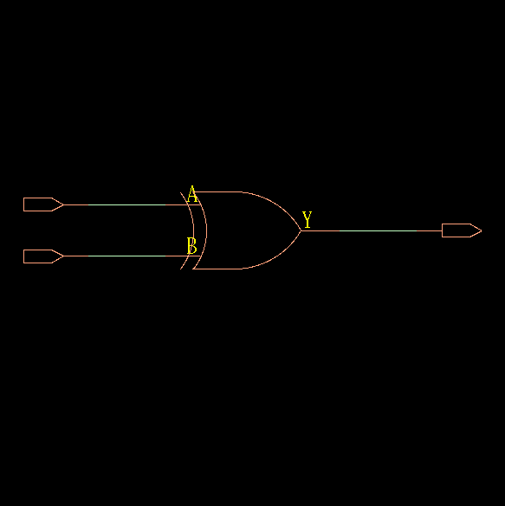

TIMING DIAGRAM:
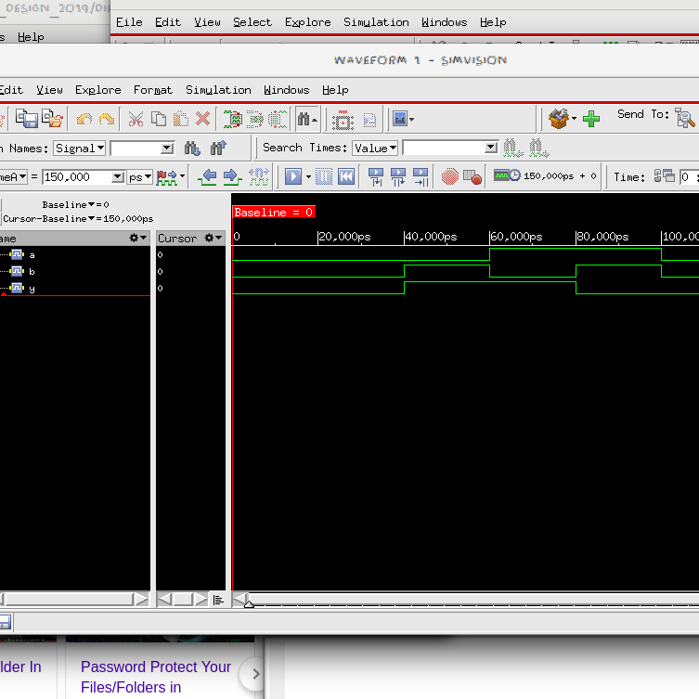

EXPLANATION OF TIMING DIAGRAM:
1. Till 40,000 us A = 0, B =0, so Y = 0
2. From 40,000 us to 60,000 us , A = 0, B=1, Y = 1
3. From 60,000 us to 80,000 us, A = 1, B = 0, Y = 1
4. From 80,000 us to 100,000 us, A = 1, B=1, Y = 0

For 2-input XNOR Gate: Y = A.B + A’.B’

A | B | Y
0 | 0 | 1
0 | 1 | 0
1 | 0 | 0
1 | 1 | 1

GATE STATISTICS & AREA:

Gate Instances Area Library
----------------------------------
NAND2XL 1 3.028 slow
OAI21XL 1 4.541 slow
----------------------------------
total 2 7.569

Type Instances Area Area %
--------------------------------------
logic 2 7.569 100.0
physical_cells 0 0.000 0.0
--------------------------------------
total 2 7.569 100.0

POWER :

Leakage Dynamic Total
Instance Cells Power(nW) Power(nW) Power(nW)
---------------------------------------------
xnorgate 2 18.018 186.241 204.259

*** Innovus Statistics for net list xnorgate ***

Number of cells = 2
Number of nets = 4
Number of tri-nets = 0
Number of degen nets = 0
Number of pins = 10
Number of i/os = 3

Number of nets with 2 terms = 2 (50.0%)
Number of nets with 3 terms = 2 (50.0%)
Number of nets with >=10 terms = 0 (0.0%)

*** 2 Primitives used:
Primitive OAI21XL (1 insts)
Primitive NAND2XL (1 insts)

GATE LEVEL DESIGN:

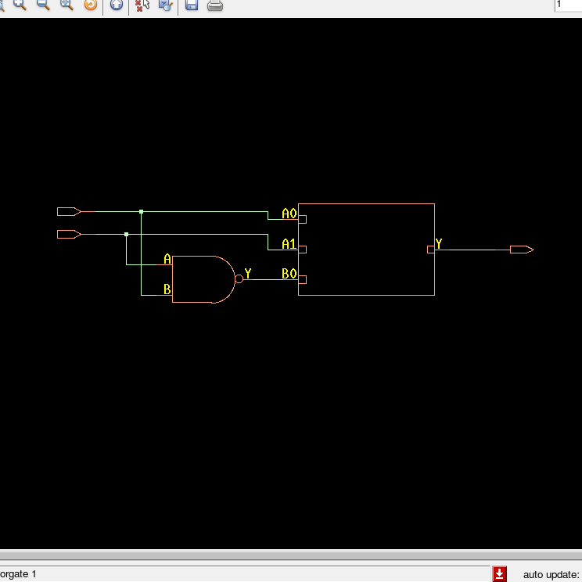

TIMING DIAGRAM:

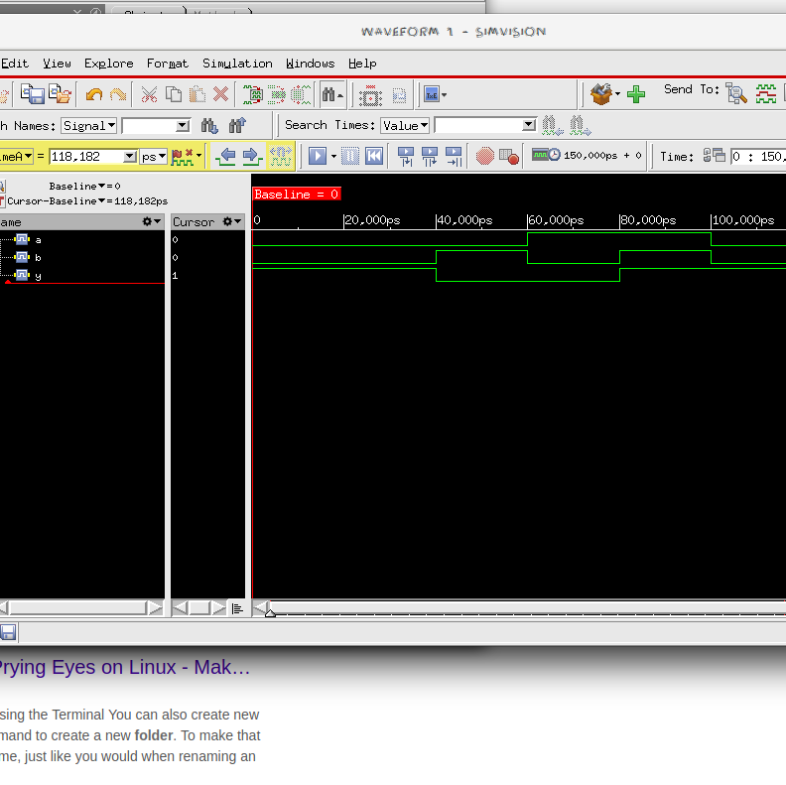

EXPLANATION OF TIMING DIAGRAM:

1. Till 40,000 us A = 0, B =0, so Y = 1
2. From 40,000 us to 60,000 us , A = 0, B=1, Y = 0
3. From 60,000 us to 80,000 us, A = 1, B = 0, Y = 0
4. From 80,000 us to 100,000 us, A = 1, B=1, Y = 1
COMBINATIONAL CIRCUITS:

QA.

GATE STATISTICS & AREA:

Gate Instances Area Library
---------------------------------
AO22X1 1 7.569 slow
---------------------------------
total 1 7.569

Type Instances Area Area %
--------------------------------------
logic 1 7.569 100.0
physical_cells 0 0.000 0.0
--------------------------------------
total 1 7.569 100.0

POWER:

Leakage Dynamic Total
Instance Cells Power(nW) Power(nW) Power(nW)
----------------------------------------------
comb_ckta 1 43.087 175.365 218.452

*** Statistics for net list comb_ckta ***
Number of cells = 1
Number of nets = 5
Number of tri-nets = 0
Number of degen nets = 0
Number of pins = 10
Number of i/os = 5

Number of nets with 2 terms = 5 (100.0%)
Number of nets with >=10 terms = 0 (0.0%)

*** 1 Primitives used:
Primitive AO22X1 (1 insts)

GATE LEVEL DIAGRAM:

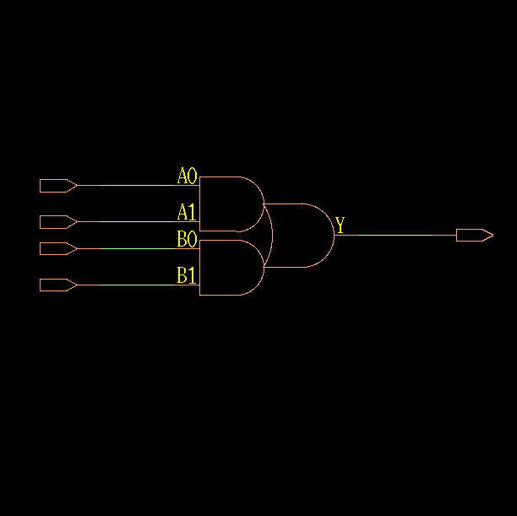

TIMING DIAGRAM:
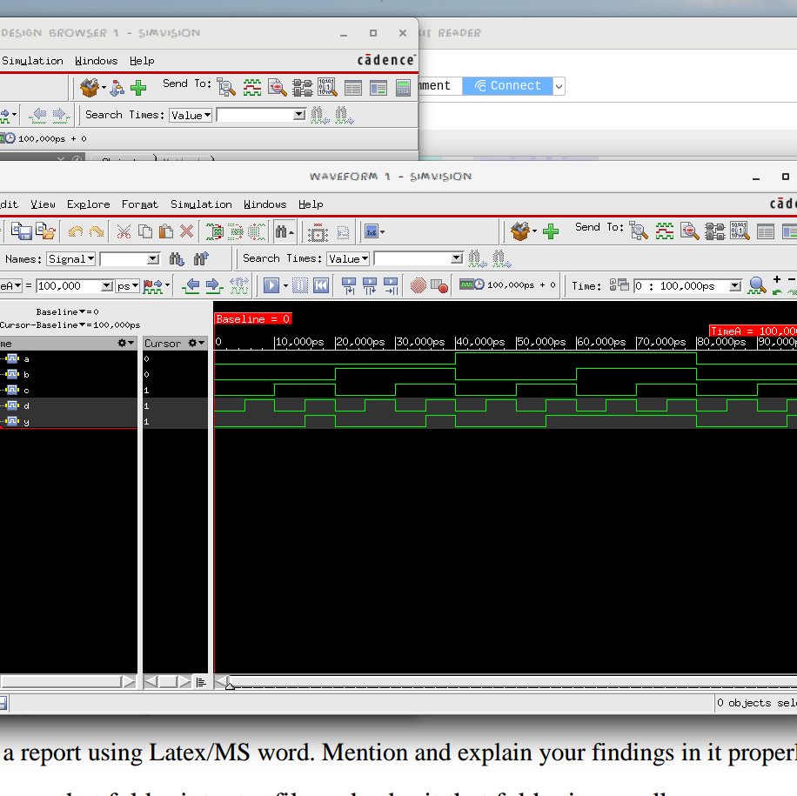

EXPLANATION FOR TIMING DIAGRAM:
We generate all 16 possible combinations of A,B,C,D by toggling D every 5,000 us, B every 10,000 us, C every 20,000 us and D every 40,000 us. Y toggles every 20,000 us.

The output Y is given as per the truth table:

A | B | C | D | Y
0 | 0 | 0 | 0 | 0
0 | 0 | 0 | 1 | 0
0 | 0 | 1 | 0 | 0
0 | 0 | 1 | 1 | 1
0 | 1 | 0 | 0 | 0
0 | 1 | 0 | 1 | 0
0 | 1 | 1 | 0 | 0
0 | 1 | 1 | 1 | 1
1 | 0 | 0 | 0 | 0
1 | 0 | 0 | 1 | 0
1 | 0 | 1 | 0 | 0
1 | 0 | 1 | 1 | 1
1 | 1 | 0 | 0 | 0
1 | 1 | 0 | 1 | 0
1 | 1 | 1 | 0 | 0
1 | 1 | 1 | 1 | 1

QB.

GATE STATISTICS AND AREA:

Gate Instances Area Library
-----------------------------------
AOI32XL 1 6.812 slow
NOR2BXL 1 4.541 slow
-----------------------------------
total 2 11.354

Type Instances Area Area %
---------------------------------------
logic 2 11.354 100.0
physical_cells 0 0.000 0.0
---------------------------------------
total 2 11.354 100.0

*** Statistics for net list comb_cktb ***

Number of cells = 2
Number of nets = 8
Number of tri-nets = 0
Number of degen nets = 0
Number of pins = 16
Number of i/os = 7

Number of nets with 2 terms = 8 (100.0%)
Number of nets with >=10 terms = 0 (0.0%)

*** 2 Primitives used:
Primitive NOR2BXL (1 insts)
Primitive AOI32XL (1 insts)

POWER:

Leakage Dynamic Total
Instance Cells Power(nW) Power(nW) Power(nW)
----------------------------------------------
comb_cktb 2 28.902 296.661 325.562

GATE LEVEL DESIGN:
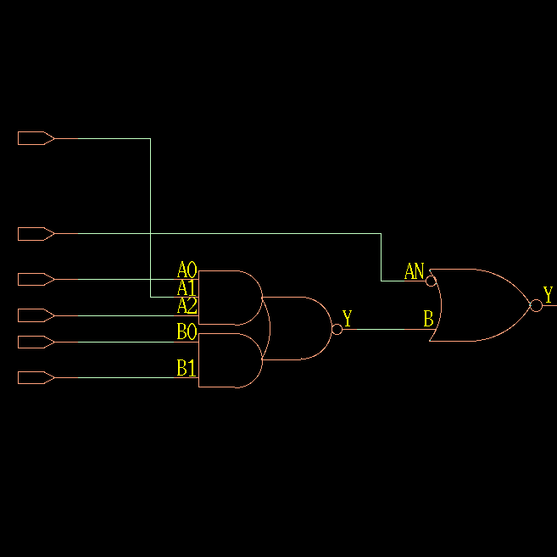

TIMING DIAGRAM:
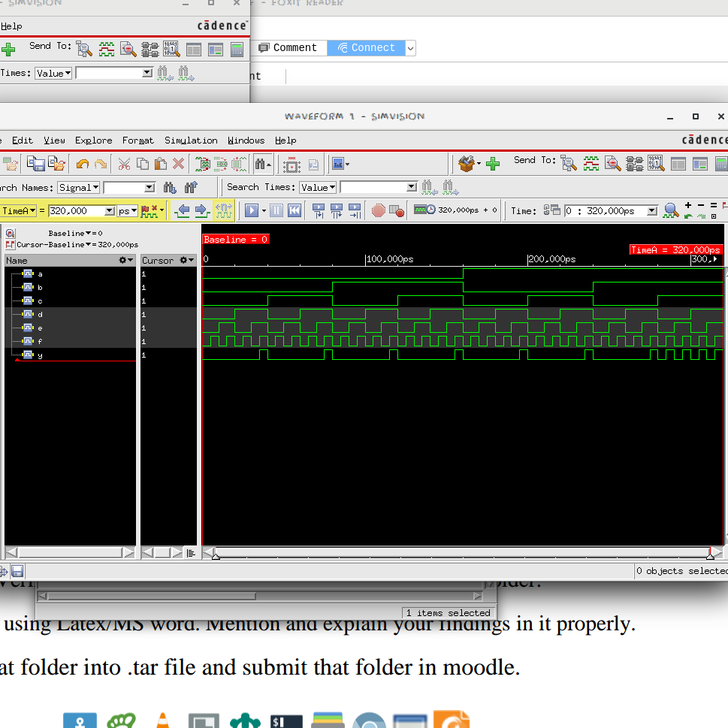
EXPLANATION OF TIMING DIAGRAM:

We generate all 64 possible combinations of A,B,C,D,E and F by toggling F every 5,000 us, E every 10,000 us, D every 20,000 us, C every 40,000 us, B every 80,000 us and A every 160,000 us.

A | B | C | D | E | F | Y
0 | 0 | 0 | 0 | 0 | 0 | 0
0 | 0 | 0 | 0 | 0 | 1 | 0
0 | 0 | 0 | 0 | 1 | 0 | 0
0 | 0 | 0 | 0 | 1 | 1 | 0
0 | 0 | 0 | 1 | 0 | 0 | 0
0 | 0 | 0 | 1 | 0 | 1 | 0
0 | 0 | 0 | 1 | 1 | 0 | 0
0 | 0 | 0 | 1 | 1 | 1 | 1
0 | 0 | 1 | 0 | 0 | 0 | 0
0 | 0 | 1 | 0 | 0 | 1 | 0
0 | 0 | 1 | 0 | 1 | 0 | 0
0 | 0 | 1 | 0 | 1 | 1 | 0
0 | 0 | 1 | 1 | 0 | 0 | 0
0 | 0 | 1 | 1 | 0 | 1 | 0
0 | 0 | 1 | 1 | 1 | 0 | 0
0 | 0 | 1 | 1 | 1 | 1 | 1
0 | 1 | 0 | 0 | 0 | 0 | 0
0 | 1 | 0 | 0 | 0 | 1 | 0
0 | 1 | 0 | 0 | 1 | 0 | 0
0 | 1 | 0 | 0 | 1 | 1 | 0
0 | 1 | 0 | 1 | 0 | 0 | 0
0 | 1 | 0 | 1 | 0 | 1 | 0
0 | 1 | 0 | 1 | 1 | 0 | 0
0 | 1 | 0 | 1 | 1 | 1 | 1
0 | 1 | 1 | 0 | 0 | 0 | 0
0 | 1 | 1 | 0 | 0 | 1 | 0
0 | 1 | 1 | 0 | 1 | 0 | 0
0 | 1 | 1 | 0 | 1 | 1 | 0
0 | 1 | 1 | 1 | 0 | 0 | 0
0 | 1 | 1 | 1 | 0 | 1 | 0
0 | 1 | 1 | 1 | 1 | 0 | 0
0 | 1 | 1 | 1 | 1 | 1 | 1
1 | 0 | 0 | 0 | 0 | 0 | 0
1 | 0 | 0 | 0 | 0 | 1 | 0
1 | 0 | 0 | 0 | 1 | 0 | 0
1 | 0 | 0 | 0 | 1 | 1 | 0
1 | 0 | 0 | 1 | 0 | 0 | 0
1 | 0 | 0 | 1 | 0 | 1 | 0
1 | 0 | 0 | 1 | 1 | 0 | 0
1 | 0 | 0 | 1 | 1 | 1 | 1
1 | 0 | 1 | 0 | 0 | 0 | 0
1 | 0 | 1 | 0 | 0 | 1 | 0
1 | 0 | 1 | 0 | 1 | 0 | 0
1 | 0 | 1 | 0 | 1 | 1 | 0
1 | 0 | 1 | 1 | 0 | 0 | 0
1 | 0 | 1 | 1 | 0 | 1 | 0
1 | 0 | 1 | 1 | 1 | 0 | 0
1 | 0 | 1 | 1 | 1 | 1 | 1
1 | 1 | 0 | 0 | 0 | 0 | 0
1 | 1 | 0 | 0 | 0 | 1 | 0
1 | 1 | 0 | 0 | 1 | 0 | 0
1 | 1 | 0 | 0 | 1 | 1 | 0
1 | 1 | 0 | 1 | 0 | 0 | 0
1 | 1 | 0 | 1 | 0 | 1 | 0
1 | 1 | 0 | 1 | 1 | 0 | 0
1 | 1 | 0 | 1 | 1 | 1 | 1
1 | 1 | 1 | 0 | 0 | 0 | 0
1 | 1 | 1 | 0 | 0 | 1 | 1
1 | 1 | 1 | 0 | 1 | 0 | 0
1 | 1 | 1 | 0 | 1 | 1 | 1
1 | 1 | 1 | 1 | 0 | 0 | 0
1 | 1 | 1 | 1 | 0 | 1 | 1
1 | 1 | 1 | 1 | 1 | 0 | 0
1 | 1 | 1 | 1 | 1 | 1 | 1

QC.

GATE STATISTICS AND AREA:

Gate Instances Area Library
-----------------------------------
AND2X1 1 4.541 slow
INVXL 1 2.271 slow
OAI22XL 1 6.055 slow
-----------------------------------
total 3 12.867

Type Instances Area Area %
---------------------------------------
inverter 1 2.271 17.6
logic 2 10.597 82.4
physical_cells 0 0.000 0.0
---------------------------------------
total 3 12.867 100.0

*** Statistics for net list comb_cktc ***
Number of cells = 3
Number of nets = 8
Number of tri-nets = 0
Number of degen nets = 0
Number of pins = 16
Number of i/os = 6

Number of nets with 2 terms = 8 (100.0%)
Number of nets with >=10 terms = 0 (0.0%)

*** 3 Primitives used:
Primitive OAI22XL (1 insts)
Primitive INVXL (1 insts)
Primitive AND2X1 (1 insts)

POWER:

Leakage Dynamic Total
Instance Cells Power(nW) Power(nW) Power(nW)
----------------------------------------------
comb_cktc 3 47.977 319.757 367.735

GATE LEVEL DESIGN:
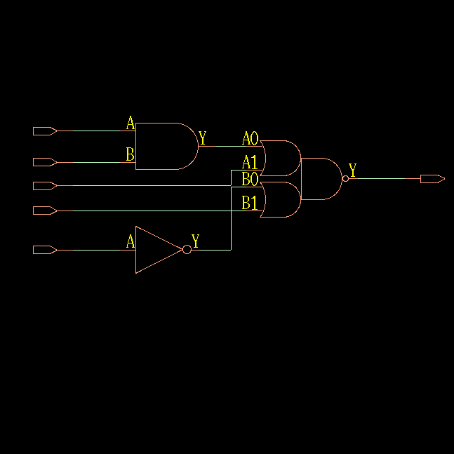

TIMING DIAGRAM:
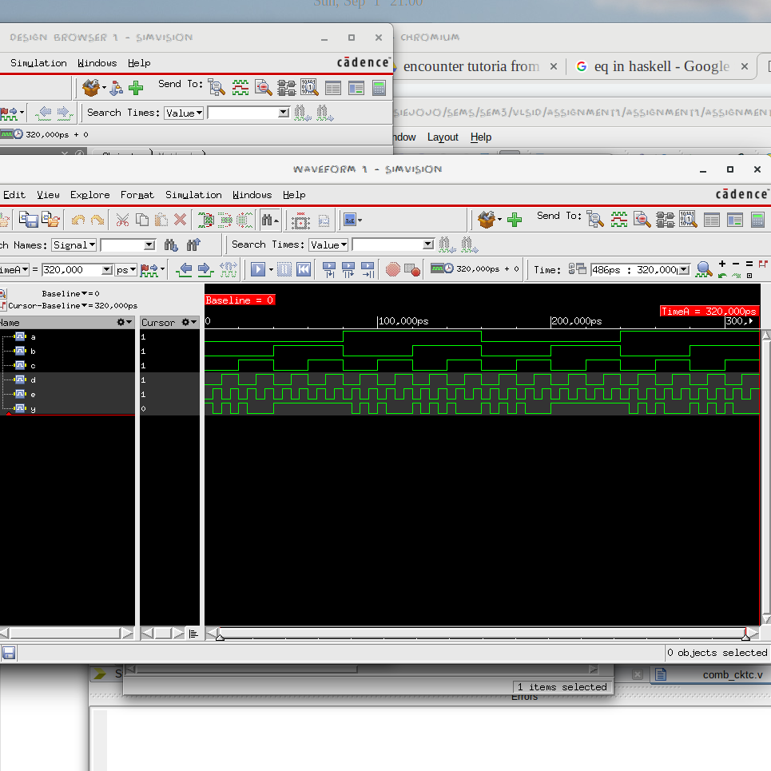
EXPLANATION OF TIMING DIAGRAM:

We generate all 32 possible combinations of A,B,C,D and E by toggling E every 5,000 us, D every 10,000 us, C every 20,000 us, B every 40,000 us and A every 80,000 us.

A | B | C | D | E | Y
0 | 0 | 0 | 0 | 0
0 | 0 | 0 | 0 | 1
0 | 0 | 0 | 1 | 0
0 | 0 | 0 | 1 | 1
0 | 0 | 1 | 0 | 0
0 | 0 | 1 | 0 | 1
0 | 0 | 1 | 1 | 0
0 | 0 | 1 | 1 | 1
0 | 1 | 0 | 0 | 0
0 | 1 | 0 | 0 | 1
0 | 1 | 0 | 1 | 0
0 | 1 | 0 | 1 | 1
0 | 1 | 1 | 0 | 0
0 | 1 | 1 | 0 | 1
0 | 1 | 1 | 1 | 0
0 | 1 | 1 | 1 | 1
1 | 0 | 0 | 0 | 0
1 | 0 | 0 | 0 | 1
1 | 0 | 0 | 1 | 0
1 | 0 | 0 | 1 | 1
1 | 0 | 1 | 0 | 0
1 | 0 | 1 | 0 | 1
1 | 0 | 1 | 1 | 0
1 | 0 | 1 | 1 | 1
1 | 1 | 0 | 0 | 0
1 | 1 | 0 | 0 | 1
1 | 1 | 0 | 1 | 0
1 | 1 | 0 | 1 | 1
1 | 1 | 1 | 0 | 0
1 | 1 | 1 | 0 | 1
1 | 1 | 1 | 1 | 0
1 | 1 | 1 | 1 | 1

