National Car Test (Ireland) - Analysis

Saumya Bhatnagar

16338296

_____________________________________________________________________________________

Abstract

The National Car Test (abbreviated NCT) is a roadworthiness test, which all cars in the Republic of Ireland must undergo, once every four years. Following a recent competitive tender process, the Road Safety Authority awarded the National Car Testing Service contract for the operation of the vehicle inspection service in the Republic of Ireland to Applause. In Northern Ireland, motor vehicles are subject to the M.o.T(Ministry of Transport Test)

_____________________________________________________________________________

1. Introduction

Regular car testing is compulsory in all states of Ireland. The test is called the National Car Test and is carried out on behalf of the Government by the National Car Testing Service Ltd (NCTS). The test is aimed at improving road safety and enhancing environmental protection. In this report, I’m sharing the analysis on the test results.

Data visualization is an interactive way in providing quick insights to the user/analyst. Visualization not only helps in exploring the hidden information and pattern, but also helps the business people in formulating various business strategies.

In this data visualization project, we are dealing the automobile data of Ireland Car Tests. We can derive many strategies on the pass and fail percentage of the model of the vehicle and testing center.

2. Background

The main intent of this project is to analyze and visualize the factors that lead to major test failures in NCTs.

We have considered the test center location to understand which test center has more testing count and which provides better efficiency in testing the automobiles, the model for various test failures to help the manufacture company in producing a better component in the future. We have also taken the customer review for visualizing what the customer needs on these vehicle manufacturing company. By visualizing the customer review data, we can find which vehicle manufacturing company has more choice of customer preference. This helps the respective vehicle manufacturers in the advertising and marketing campaigns.

3. Tools and Technique

3.1. Hardware Architecture:

OS: Windows 10

RAM: 8GB

3.2. Software Architecture:

Visualization Tool: Tableau

Data Cleaning Tool: Excel

3.3. Data Collation:

The dataset for this visualization is taken from data.gov.ie

The dataset for test pass/fail rate is downloaded in the form of CSV from Road Safety Authority dataset. The dataset for customer satisfaction is scraped. The two datasets are merged.

3.4. Data Cleaning

Null values are removed.

Special characters are removed

Data type for various the attributes are corrected.

3.5. Chart Types

3.5.1. Lollipop Chart

It is an amalgamation for bar and histogram chart, plus the same represents ease in viewing in case of high values

3.5.2. Box Treemap

It is used when a variable has plural non-numeric dimensions to be specified using another variable with a numeric dimension. There may not be links between various values of the variable. The advantage of the same over bubble chart is utilization of space.

3.5.3. Likert Scale

It is the most widely used approach to scaling responses in survey research, such that the term (or more accurately the Likert-type scale) is often used interchangeably with rating scale, although there are other types of rating scales.

3.5.4. Waffle Chart

Benefit over other charts is instant understanding. The charts are primarily used to present the percentage of a certain category.

4. Visualization

The infographic of the same is shown below:

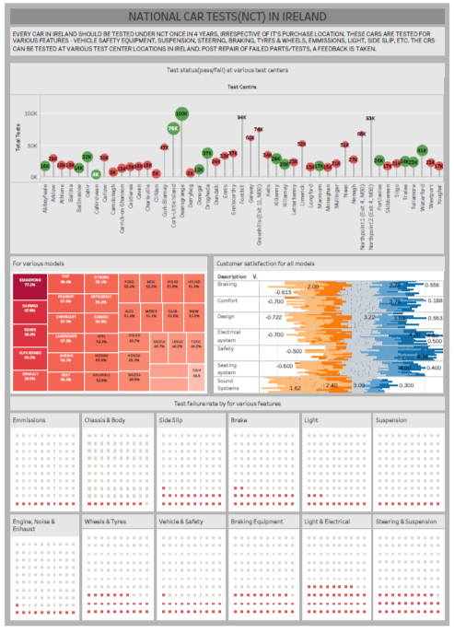

5. Analysis

5.1. Which centers are tested more?

The height in the lollipop chart shows – Deansgrange, Fonthill and Northpoint 2

5.2. Which test centers have higher rate of test passes?

Looking at the green lollipops, and comparing the sizes – Deansgrange, Cork Little Island

5.3. Which test centers have higher rate of test passes?

Looking at the red lollipops, and comparing the sizes – Clifden, Carndonagh

5.4. Which models are mostly used in Ireland?

The models shown in treemap are mostly used in Ireland

5.5. Which models are most prone to test failures?

Looking left most in the treemap: Ssangyong, Diawood, Rover, etc.

5.6. Where customers are mostly unsatified?

Looking at the likert Scale: Sound systems are mostly orange, which shows least satisfaction, followed by braking

5.7. Where customers are mostly satified?

Looking at the likert Scale: Safety

5.8. Which features fail mostly in car tests at NCTs?

Higher failures are in Light and Electrical, followed by Steering & suspension and braking equipment

6. Video Link

The visualization link can be found at the below link

<https://www.youtube.com/watch?v=l-2Zpmh5lSc>

7. Conclusions

The above analysis is done using the vehicle model, testing center, pass and failure rates. This helps in formulating the strategy for controlling the accident rate. This analysis can help the automobile industries in formulating a better business strategy using their failure rate. Likert scale data can help the companies to get profit.

8. References

[JOE 08] HARRY N. BOONE, DEBORAH A. BOONE. Analyzing Likert Data (April 2008), Volume 50 Number 2, Article Number 2TOT2 https://www.joe.org/joe/2012april/pdf/JOE_v50_2tt2.pdf

[IMT] ROMAIN BOULET, BERTRAND JOUVE, “The lollipop graph is determined by its spectrum” (Feb. 2008)