Spring

Spring is a framework that is powerful and flexible that is focused on building web applications in java

Spring regularly introduces features based on the needs of the Dev community – an example is spring boot

At the core of spring there is spring core:-

1. IOC inversion of control
2. DI dependency injection
3. Beans
4. Context
5. Spring expression language
6. IOC Container

IOC is the principle which states that instead of the programmer taking charge of the flow of the program, the framework takes control of the program flow

Dependency injection is the pattern thru which IOC is achieved.

Dependency injection shifts responsibility of object creation from the application to the IOC container.

Beans – object in java manged by the spring ioc container

Context – this is a memory location where we add the objects we want spring to manage

IOC Container is responsible for managing the beans that are placed in the spring context. It assembles the dependencies between the objects.

Heres an example

Here, we are telling spring that we want these 2 beans to be created and placed in the context

We also want this above bean of the Compo class to be placed in the context – it has to be assembled with a bean of type Integer – this assembly is done by the IOC container

In the above, ${xxx.yyy.xxx} is called spring expression language

NoUniqueBeanDefinition Exception

This exception occurs when we tell the context that we want a bean, but we are ambiguous – lets say there are 2 beans of type String , and we tell the context that we want a bean of type String, and spring is confused which bean it should return.

Ways to resolve this :

1. Give beans a name or use the @Primary annotation

There is another way to create beans and that is the Component annotation

Lets say we have 2 beans of type Byte

And we try to do this in the component below

This wont work.

This is again nonuniquebeandefiniteion exception

This will work – we use the @Qualifier to tell spring which bean we want exactly

Then we have stereotype annotations

@Component, @Service, @Reporisoty, @Controller, @RestController

These tell spring to create these beans automatically in the context

If you use @Bean, you can add many instances of the class to the context

If you use @Component, you can add only one instance of the class to the context

We can use the @PostConstruct annotation to configure our @Component beans

Output on the console is what we have specified using the @PostConstruct annotation

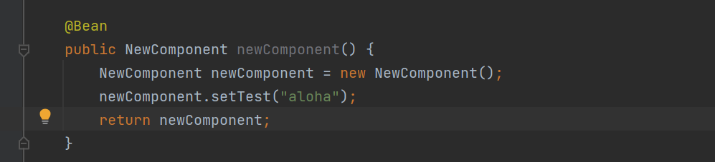

Autowired annotation is best used as constructor injection

In constructor injection for autowiring, you don’t need to use the @Autowired annotation.

Now we go on to bean scopes!

The bean scope is prototype .. each time this bean is needed, a new instance will be created.

This scope is suitable for repository layer beans

Now we go on to eager and lazy

Overview of a web app

