Peer Tutoring Session - 11 February 2025 (Week-5)

1-35 A **20-kg mass of iron** at **100°C** is brought into contact with **20 kg of aluminum** at **200°C** inside an **insulated enclosure**. The **specific heat of iron** is **0.45 kJ/kg·°C**, and the **specific heat of aluminum (at 473 K)** is **0.973 kJ/kg·°C**. Determine the **final equilibrium temperature** of the combined system.

1-62 The **inner and outer surfaces** of a **5-m × 6-m brick wall** with a **thickness of 30 cm** and a **thermal conductivity of 0.69 W/m·°C** are maintained at **temperatures of 20°C and 5°C**, respectively. Determine the **rate of heat transfer** through the wall, in **watts (W)**.

1-102 A **1.4-m-long**, **0.2-cm-diameter** electrical wire extends across a room that is maintained at **20°C**. Heat is generated in the wire due to **resistance heating**, and the **surface temperature** of the wire is measured to be **240°C** during steady operation. Additionally, the **voltage drop** and **electric current** through the wire are measured to be **110 V** and **3 A**, respectively. Disregarding any **heat transfer by radiation**, determine the **convection heat transfer coefficient** for heat transfer between the **outer surface of the wire** and the **air in the room**.

2-64 Consider a large plane wall of thickness **L = 0.3 m**, thermal conductivity **k = 2.5 W/m·°C**, and surface area **A = 12 m²**. The left side of the wall at **x = 0** is subjected to a net heat flux of **q̇₀ = 700 W/m²**, while the temperature at that surface is measured to be **T₁ = 80°C**.

Assuming constant thermal conductivity and no heat generation in the wall:  
(a) Express the **differential equation** and the **boundary conditions** for steady **one-dimensional heat conduction** through the wall.  
(b) Obtain a **relation** for the **variation of temperature** in the wall by solving the differential equation.  
(c) Evaluate the **temperature of the right surface** of the wall at **x = L**.

2-82 In a nuclear reactor, **1-cm-diameter** cylindrical uranium rods, cooled by water from the outside, serve as the fuel. Heat is generated uniformly in the rods (**k = 29.5 W/m·°C**) at a rate of **7 × 10⁷ W/m³**. If the **outer surface temperature** of the rods is **175°C**, determine the **temperature at their center**.

A long copper bar of **rectangular cross-section**, whose width (**w**) is much greater than its thickness (**L**), is maintained in contact with a **heat sink** at its lower surface, and the **temperature throughout the bar** is approximately equal to that of the sink (**T₀**). Suddenly, an **electric current** is passed through the bar, and an **airstream** of temperature (**T∞**) is passed over the top surface, while the **bottom surface** continues to be maintained at **T₀**. Obtain the **differential equation** and the **boundary and initial conditions** that could be solved to determine the **temperature as a function of position and time** in the bar.

Peer Tutoring Session - 18 February 2025 (Week-6)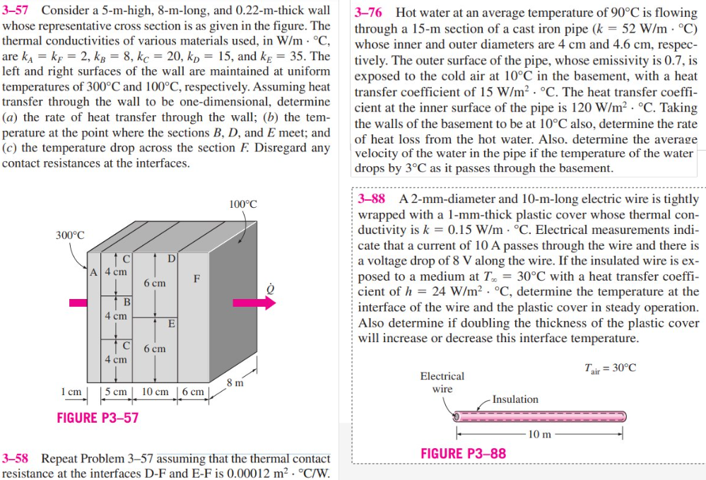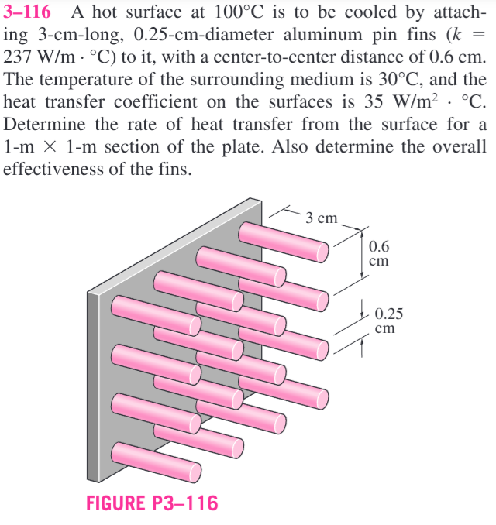

Peer Tutoring Session - 25 February 2025 (Week-7)

4-14 The temperature of a gas stream is to be measured by a thermocouple whose junction can be approximated as a 1.2-mm-diameter sphere. The properties of the junction are k = 35 W/m·°C, ρ = 8500 kg/m³, and Cp = 320 J/kg·°C, and t he heat transfer coefficient between the junction and the gas is h = 65 W/m²·°C. Determine how long it will take for the thermocouple to read 99 percent of the initial temperature difference. Answer: 38.5 s

4-23 Carbon steel balls (ρ = 7833 kg/m³, k = 54 W/m·°C, Cp = 0.465 kJ/kg·°C, and α = 1.474×10⁻⁶ m²/s) 8 mm in diameter are annealed by heating them first to 900°C in a furnace and then allowing them to cool slowly to 100°C in ambient air at 35°C. If the average heat transfer coefficient is 75 W/m²·°C, determine how long the annealing process will take. If 2500 balls are to be annealed per hour, determine the total rate of heat transfer from the balls to the ambient air.

4-34 An ordinary egg can be approximated as a 5.5-cm-diameter sphere whose properties are roughly k = 0.6 W/m·°C and α = 0.14×10⁻⁶ m²/s. The egg is initially at a uniform temperature of 8°C and is dropped into boiling water at 97°C. Taking the convection heat transfer coefficient to be h = 1400 W/m²·°C, determine how long it will take for the center of the egg to reach 70°C.

Peer Tutoring Session – 11th March 2025 (Week-9)

**Problem 1:** The experimental results for the local heat transfer coefficient, , for flow over a flat plate with an extremely rough surface were found to fit the relation where is a coefficient and represents the distance from the leading edge of the plate.

1. Develop an expression for the ratio of the average heat transfer coefficient, , for a plate of length to the local xheat transfer coefficient, , at .
2. Show qualitatively the variation of and as a function of .

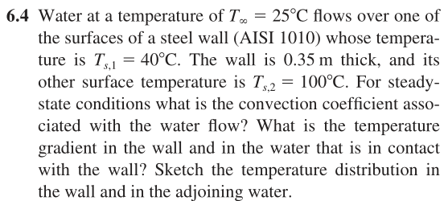**Problem 2:**

**Problem 3:**

**Problem 4:**

**Problem 5:**

Peer Tutoring Session – 18th March 2025 (Week-10)

**Problem 1:** 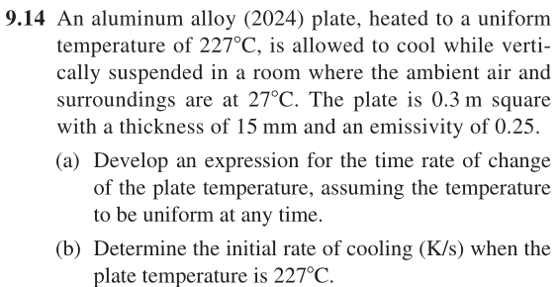



**Problem 2:**

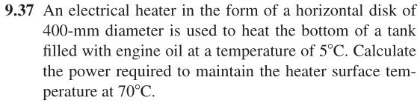



Problem 3:

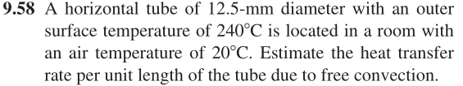



Peer Tutoring Session – 25th March 2025 (Week-10)

|  |  |
| --- | --- |
|  |  |