Knowledge Representation - Assignment 2

Contents

Answer 1.1.1 2

Answer 1.1.2 2

Assumptions made: 3

Explanation of Bayesian Networks 4

Answer 1.2.1 5

Prior Probabilities: 6

Probability of Evidence: 6

Likelihood of Evidence 7

Answer 1.2.2 8

# Answer 1.1.1

The prior probabilities for all the questions is as follows.

|  |  |  |  |  |  |  |  |
| --- | --- | --- | --- | --- | --- | --- | --- |
|  |  | never | rarely | sometimes | often | always | SUM |
| Tip 1 | STUDY | 0.021739 | 0.086957 | 0.130435 | 0.26087 | 0.5 | 1 |
| Tip 2 | REST | 0.352941 | 0.117647 | 0.352941 | 0.117647 | 0.058824 | 1 |
| Tip 3 | ALARM | 0.615385 | 0.051282 | 0.128205 | 0.102564 | 0.102564 | 1 |

It is not possible to compute the joint distribution as we do not have any data of how they occur together.

# Answer 1.1.2

With the supplied variables, the following Bayesian Network was created, conditional probability tables are represented in the diagram:

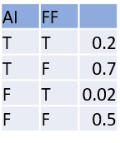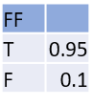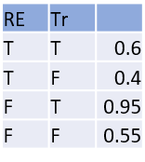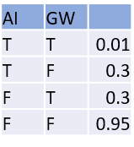

## Assumptions made:

1. Artificial intelligence can help boost renewable energy by offering smart ways to load balance between durations of high/low production and high/low demand
2. AI and automation does have an impact on jobs lost
3. Low Fossil Fuel prices results in lower usage of renewable energy and vice versa
4. Low Fossil Fuel prices also means that people will travel more and not use public transport, resulting in more traffic
5. High traffic causes more global warming
6. Not using renewable energy also has an impact on global warming
7. Global warming results in climate change which results in unemployment in various sectors (especially farm related)

Querying the Bayesian Network:

Inference is the process of getting the probability distribution of some variables given a set of assignments to to other variables. There are two methods – enumeration or elimination. Both the methods give same results but the latter is faster than the former. Below is the example of enumeration and elimination in practice with AIMA library:

bayes_net = BayesNet([

('AI', '', 0.8),

('FossilFuel', '', 0.4),

('RenewableEnergy', 'AI FossilFuel',

{(T, T):0.2, (T,F):0.7, (F,T):0.02, (F,F):0.5}),

('Traffic', 'FossilFuel',

{T:0.95, F:0.1}),

('GlobalWarming', 'RenewableEnergy Traffic',

{(T,T):0.6, (T,F):0.4, (F,T):0.95, (F,F):0.55}),

('Employed', 'AI GlobalWarming',

{(T,T):0.01, (T,F):0.03, (F,T):0.03, (F,F):0.95})

])

p_employed = enumeration_ask(X='Employed',

e={'AI': True,

'FossilFuel':True},

bn=bayes_net)

print(f"given AI=true and FossilFuel=True:",

f"\n\t\tP(Employed)\t\t=\t\t{p_employed.show_approx()}")

p_global_warming = elimination_ask(X='GlobalWarming',

e={'Employed':False,

'Traffic':False}, bn=bayes_net)

print(f"Given Employed=False and Traffic=False, \n\t\tP(GlobalWarming)\t=",

f"\t\t{p_global_warming.show_approx()}")

p_ai = elimination_ask(X='AI', e={'RenewableEnergy': True,

'GlobalWarming': True,

'Employed': True,

'Traffic':True,

'FossilFuel':True}, bn=bayes_net)

print(f"Given RenewableEnergy=T, GlobalWarming=T",

f"Employed=T, Traffic=T, FossilFuel=T, \n\t\tP(AI)\t\t\t=\t\t{p_ai.show_approx()}")

The results are as follows:

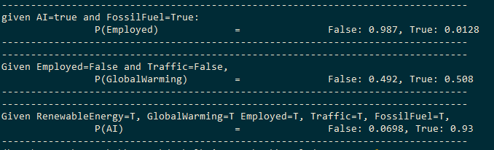

## Explanation of Bayesian Networks

The best prediction with Bayesian Learning is given by Bayes Optimal Classifier, but Bayes Optimal classifier quickly becomes intractable as it requires computing the full joint probability distribution table. Such a table has O(dN) entries if there are N variables with d values each. Naïve Bayes (NB) classifier gets around this problem by making a naïve assumption that all the N variables are independent. While NB works well for some classes of problems, in other classes of problems, NB’s assumption of independence is inadequate. Bayes Networks (BN) takes the middle path between Bayes Optimal and NB classifiers. A BN is a ***graphical model that efficiently represents the joint probability distribution table*.** A BN is a Directed Acyclic Graph comprises of:

1. Nodes that represent each Random Variable
2. Arcs that represent probabilistic dependence between nodes. Absence of an arc denotes independence or conditional independence
3. Every node has a Conditional Probability Table (CPT) where the conditional probability given its parents is stored. This conditional probability table only contains the conditional probability given its immediate parents and no other nodes.

Conditional dependence and independence can be leveraged for efficient inference.

***Each node is conditionally independent of its non-descendants given the value of its parents. 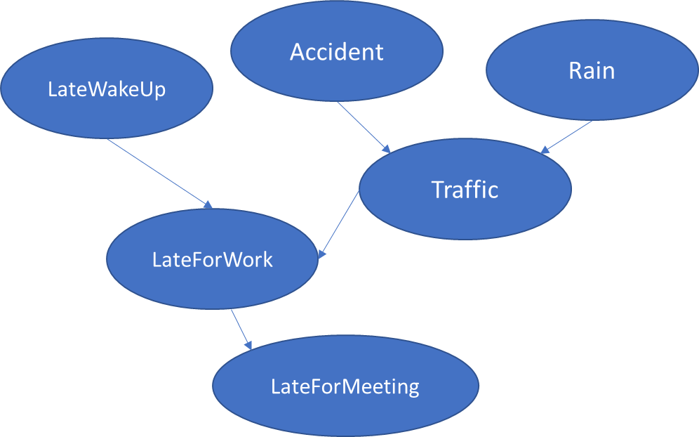Consider the given network***. Normally, LateForMeeting is related to LateWakeUp, but if one is given that LateForWork=T, then LateForMeeting becomes conditionally independent of LateWakeUp. These notions of conditional dependence and independence can be leveraged for efficient storage and retrieval.

In general, inference in a BN is also intractable, but for some special BNs it becomes tractable, and even for BNs where it is not tractable, there are efficient ways of approximating inference using sampling.

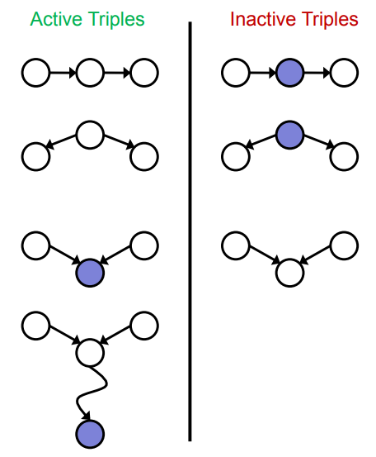D-Separation is the criteria to determine if X and Y are conditionally independent given the evidence; all undirected paths between X and Y are considered, and if all of them are inactive, then they are conditionally independent.

A path is active if all triplets in that path are active, so even if one of the triplets are inactive, then the entire path is inactive.

Active and inactive triplets can be recognized by the forms on the left, where the purple circles represent the evidence and white circles the hidden nodes.

Figure from CS188 Slides

Another advantage of BN is that it allows humans to create the graphical representation of the network using domain knowledge. It also allows an intuitive representation of the relationships between RVs, and it is easy to judge what influences another at a glance.

One model is where humans give the graph structure, and the CPTs can be learned from the data. This is often used in practice. Another variant used is where the graph structure itself can be learned from the data, but that often produces graphs that are not intuitive to humans.

# Answer 1.2.1

The general form of multivariate Baye’s theorem is given by

$$P(C|X_{1},X_{2}, ...,X_{n}) = \frac{P(X_{1},X_{2}, ...,X_{n}|C)∙P(C)}{P(X_{1},X_{2}, ...,X_{n})}$$

Baye’s theorem is helpful because given labeled training samples, it is easy to calculate the probabilities of Xi given the class C, and then Baye’s theorem allows us to reverse the conditionality, and for test-samples predict the class given the evidence.

However, the above formula means that the entire joint distribution table must be learnt and stored in the training phase, and that is exponential, and the problem becomes intractable.

A *naïve assumption* is made that all the X­is are independent. This assumption is never strictly true, but in many problems, it still give good results. With the naïve assumption, the above formula is reduced to:

$$P(C|X_{1},X_{2}, ...,X_{n}) = \frac{P(X_{1}|C) ∙P(X_{2}|C)∙ ...{ ∙P(X}_{n}|C)∙P(C)}{P(X_{1},X_{2}, ...,X_{n})}$$

This formula is evaluated for all class $c_{i}∈C$ and the $c_{i}$ that has the highest probability is chosen as the predicted class.

Now since $P(X_{1},X_{2}, ...,X_{n})$ is common to all $c_{i}$ s, the denominator can be dropped, and the above formula simply becomes: $P(C|X_{1},X_{2}, ...,X_{n}) ∝ P(X_{1}|C) ∙P(X_{2}|C) ∙ ... {∙ P(X}_{n}|C)∙P(C)$.

If there are a lot of variables, then each $P(X_{1}|C)$ is very small and multiplying them together will result in hitting the limits of floating point precision as the products become smaller. To avoid this problem, the logarithm is taken and that allows us to avoid the multiplication.

$$log P(C|X_{1},X_{2}, ...,X_{n}) ∝ log P(X_{1}|C) +log P(X_{2}|C) + ...{ + log P(X}_{n}|C)+ log P(C)$$

The dataset chosen was SMS spam classification. The Multinomial method was used, along with Laplace Smoothing to avoid 0 probabilities.

$$P(C) = \frac{n(Documents of class C)}{n(Documents)}$$

And for every word:

$$P(w|C) = \frac{n(Occurences of w in documents of class C)}{n(Occurences of w) + |V|}$$

Where |V| = number of words in the vocabulary.

The process of training is simply to calculate all the conditional probabilities and the prior probabilities of the classes.

In this classification, first the strings were converted to lowercase, punctuations were removed, numbers changed to ###. The string was tokenized, stop-words removed and then n-grams taken.

***In this problem, the number of random variables X­I is the same as the number of words and n-grams. With such a high number of variables, a Bayesian Network is not practical, and only a Naïve Bayes is possible.***

The full probability tables are too big (there are 136403 variables with 5-grams), so only a few probabilities from each table are tabulated below.

### Prior Probabilities:

|  |  |
| --- | --- |
| SPAM | HAM |
| 0.725 | 0.275 |

### Probability of Evidence:

The probability of evidence would involve multiplying the probabilities of each of the words in the evidence, but that would be too large. Hence only the probabilities of each of the words is presented, and a small number of them. Here n-gram are included, and they are seen as joined words.



### Likelihood of Evidence

Again, since the table is too big, only a small set of conditional probabilities have been presented. Here n-gram are included, and are seen as joined words.



## Answer 1.2.2

Naïve Bayes classification was implemented from a scratch. The strings were converted to lowercase, punctuations were removed, numbers changed to ###. The string was tokenized, stop-words removed and then n-grams added.

The Implementation was evaluated on four datasets, and the results are as below:

|  |  |  |
| --- | --- | --- |
| Data Set | Classification  Accuracy | F1 Score |
| [SMS Spam Collection Classification](https://archive.ics.uci.edu/ml/datasets/sms+spam+collection) | 0.9835 | 0.933 |
| [Clinc 150](https://archive.ics.uci.edu/ml/datasets/CLINC150) | 0.8241 | 0.824 |
| [Youtube Spam](https://archive.ics.uci.edu/ml/machine-learning-databases/00380/) | 0.8912 | 0.897 |
| [Sentiment Labelled Sentences](https://archive.ics.uci.edu/ml/datasets/Sentiment+Labelled+Sentences) | 0.8419 | 0.809 |