**भारत सरकार पृथ्वीववज्ञान मंत्रालय**

**भारत मौसम ववज्ञान ववभाग मौसम ववज्ञान कें देहरादून्र**

**GOVERNMENT OF INDIA**



**MINISTRY OF EARTH SCIENCES**

**INDIA METEOROLOGICAL DEPARTMENT**

**METEOROLOGICAL CENTRE DEHRADUN**

**13th Oct 2019 Time: 13:30 Hours IST**

**District-wise Weather Warning for Uttarakhand**

|  |  |  |  |  |  |  |  |  |  |  |  |  |  |  |  |  |  |  |
| --- | --- | --- | --- | --- | --- | --- | --- | --- | --- | --- | --- | --- | --- | --- | --- | --- | --- | --- |
|  | **District** |  |  | **Day-1** |  |  | **Day-2** |  |  | **Day-3** |  |  | **Day-4** |  |  | **Day-5** |  |  |
|  |  |  |  |  |  |  |  |  |  |  |  |  |
|  |  |  |  |  |  |  |  |  |  |  |  |  |  |  |  |  |  |  |
|  | Almora |  |  | **NIL** |  |  | **NIL** |  |  | **NIL** |  |  | **NIL** |  |  | **NIL** |  |  |
|  |  |  |  |  |  |  |  |
|  |  |  |  |  |  |  |  |  |  |  |  |  |  |  |  |  |  |
|  |  |  |  |  |  |  |  |  |  |  |  |  |  |  |  |  |  |  |
|  |  |  |  |  | |  |  | |  |  | |  |  | |  |  | |  |
|  | Bageshwar |  |  | **NIL** |  |  | **NIL** |  |  | **NIL** |  |  | **NIL** |  |  | **NIL** |  |  |
|  |  |  |  |  |  |  |  |
|  |  |  |  |  |  |  |  |  |  |  |  |  |  |  |  |  |  |
|  |  |  |  |  |  |  |  |  |  |  |  |  |  |  |  |  |  |  |
|  |  |  |  |  | |  |  | |  |  | |  |  | |  |  | |  |
|  |  |  |  | **NIL** |  |  | **NIL** |  |  | **NIL** |  |  | **NIL** |  |  | **NIL** |  |  |
|  | Chamoli |  |  |  |  |  |  |  |
|  |  |  |  |  |  |  |  |  |  |  |  |  |  |  |  |  |  |
|  |  |  |  |  |  |  |  |  |  |  |  |  |  |  |  |  |  |  |
|  |  |  |  |  | |  |  | |  |  | |  |  | |  |  | |  |
|  | Champawat |  |  | **NIL** |  |  | **NIL** |  |  | **NIL** |  |  | **NIL** |  |  | **NIL** |  |  |
|  |  |  |  |  |  |  |  |
|  |  |  |  |  |  |  |  |  |  |  |  |  |  |  |  |  |  |
|  |  |  |  |  |  |  |  |  |  |  |  |  |  |  |  |  |  |  |
|  |  |  |  |  | |  |  | |  |  | |  |  | |  |  | |  |
|  | Dehradun |  |  | **NIL** |  |  | **NIL** |  |  | **NIL** |  |  | **NIL** |  |  | **NIL** |  |  |
|  |  |  |  |  |  |  |  |
|  |  |  |  |  |  |  |  |  |  |  |  |  |  |  |  |  |  |
|  |  |  |  |  |  |  |  |  |  |  |  |  |  |  |  |  |  |  |
|  |  |  |  |  | |  |  | |  |  | |  |  | |  |  | |  |
|  | Haridwar |  |  | **NIL** |  |  | **NIL** |  |  | **NIL** |  |  | **NIL** |  |  | **NIL** |  |  |
|  |  |  |  |  |  |  |  |
|  |  |  |  |  |  |  |  |  |  |  |  |  |  |  |  |  |  |
|  |  |  |  |  |  |  |  |  |  |  |  |  |  |  |  |  |  |  |
|  |  |  |  |  |  |  |  |  |  |  |  |  |  |  |  |  |  |  |
|  |  |  |  |  | |  |  | |  |  | |  |  | |  |  | |  |
|  | Nainital |  |  | **NIL** |  |  | **NIL** |  |  | **NIL** |  |  | **NIL** |  |  | **NIL** |  |  |
|  |  |  |  |  |  |  |  |
|  |  |  |  |  |  |  |  |  |  |  |  |  |  |  |  |  |  |
|  |  |  |  |  |  |  |  |  |  |  |  |  |  |  |  |  |  |  |
|  |  |  |  |  | |  |  | |  |  | |  |  | |  |  | |  |
|  | Pauri Garhwal |  |  | **NIL** |  |  | **NIL** |  |  | **NIL** |  |  | **NIL** |  |  | **NIL** |  |  |
|  |  |  |  |  |  |  |  |
|  |  |  |  |  |  |  |  |  |  |  |  |  |  |  |  |  |  |
|  |  |  |  |  |  |  |  |  |  |  |  |  |  |  |  |  |  |  |
|  |  |  |  |  | |  |  | |  |  | |  |  | |  |  | |  |
|  | Pithoragarh |  |  | **NIL** |  |  | **NIL** |  |  | **NIL** |  |  | **NIL** |  |  | **NIL** |  |  |
|  |  |  |  |  |  |  |  |  |  |  |  |  |
|  |  |  |  |  |  |  |  |
|  |  |  |  |  |  |  |  |  |  |  |  |  |  |  |  |  |  |
|  |  |  |  |  |  |  |  |  |  |  |  |  |  |  |  |  |  |  |
|  |  |  |  |  | |  |  | |  |  | |  |  | |  |  | |  |
|  | Rudraprayag |  |  | **NIL** |  |  | **NIL** |  |  | **NIL** |  |  | **NIL** |  |  | **NIL** |  |  |
|  |  |  |  |  |  |  |  |
|  |  |  |  |  |  |  |  |  |  |  |  |  |  |  |  |  |  |
|  |  |  |  |  |  |  |  |  |  |  |  |  |  |  |  |  |  |  |
|  |  |  |  |  |  |  |  |  |  |  |  |  |  |  |  |  |  |  |
|  |  |  |  |  | |  |  | |  |  | |  |  | |  |  | |  |
|  | Tehri Garhwal |  |  | **NIL** |  |  | **NIL** |  |  | **NIL** |  |  | **NIL** |  |  | **NIL** |  |  |
|  |  |  |  |  |  |  |  |
|  |  |  |  |  |  |  |  |  |  |  |  |  |  |  |  |  |  |
|  |  | |  |  |  |  |  |  |  |  |  |  |  |  |  |  |  |  |
|  |  | |  |  | |  |  | |  |  | |  |  | |  |  | |  |
|  | Udham Singh |  |  | **NIL** |  |  | **NIL** |  |  | **NIL** |  |  | **NIL** |  |  | **NIL** |  |  |
|  |  |  |  |  |  |  |  |  |  |  |  |  |
|  | Nagar |  |  |  |  |  |  |  |  |  |  |  |  |  |  |  |  |  |
|  |  |  |  |  |  |  |  |  |  |  |  |  |  |  |  |  |  |  |
|  |  |  |  |  | |  |  | |  |  | |  |  | |  |  | |  |
|  | Uttarkashi |  |  | **NIL** |  |  | **NIL** |  |  | **NIL** |  |  | **NIL** |  |  | **NIL** |  |  |
|  |  |  |  |  |  |  |  |
|  |  |  |  |  |  |  |  |  |  |  |  |  |  |  |  |  |  |
|  |  |  |  |  |  |  |  |  |  |  |  |  |  |  |  |  |  |  |
|  |  |  |  |  |  |  |  |  |  |  |  |  |  |  |  |  |  |  |

**LEGEND:**

|  |  |
| --- | --- |
| **WARNING (TAKE ACTION)** | **WATCH(BE UPDATED)** |
| **ALERT(BE PREPARED)** | **NO WARNING (NO ACTION)** |



**1 |** P a g e

**भारत सरकार पृथ्वीववज्ञान मंत्रालय**

**भारत मौसम ववज्ञान ववभाग मौसम ववज्ञान कें देहरादून्र**

**GOVERNMENT OF INDIA**



**MINISTRY OF EARTH SCIENCES**

**INDIA METEOROLOGICAL DEPARTMENT**

**METEOROLOGICAL CENTRE DEHRADUN**

**WEATHER WARNING | DAY 1 | 13 OCT 2019**

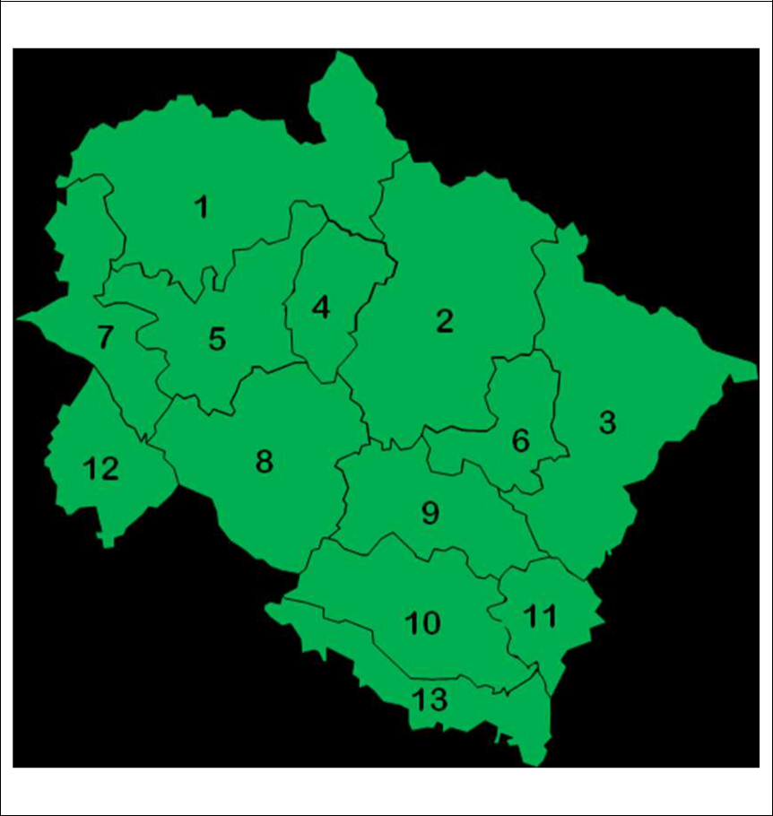

**Index**

|  |  |  |  |
| --- | --- | --- | --- |
| S.No | District | S.No | District |
| 1 | Uttarkashi | 8 | Pauri Garhwal |
| 2 | Chamoli | 9 | Almora |
| 3 | Pithoragarh | 10 | Nainital |
| 4 | Rudraprayag | 11 | Champawat |
| 5 | Tehri Garhwal | 12 | Haridwar |
| 6 | Bageshwar | 13 | Udham Singh Nagar |
| 7 | Dehradun |  |  |

**LEGEND:**

|  |  |
| --- | --- |
| **WARNING (TAKE ACTION)** | **WATCH(BE UPDATED)** |
| **ALERT(BE PREPARED)** | **NO WARNING (NO ACTION)** |



**2 |** P a g e

**भारत सरकार पृथ्वीववज्ञान मंत्रालय**

**भारत मौसम ववज्ञान ववभाग मौसम ववज्ञान कें देहरादून्र**

**GOVERNMENT OF INDIA**



**MINISTRY OF EARTH SCIENCES**

**INDIA METEOROLOGICAL DEPARTMENT**

**METEOROLOGICAL CENTRE DEHRADUN**

**WEATHER WARNING | DAY 2 | 14 OCT 2019**

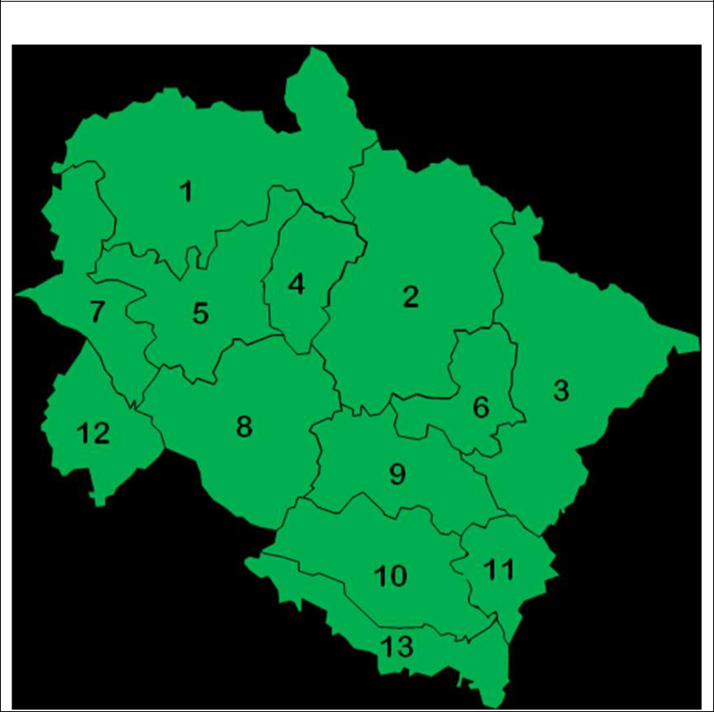

**Index**

|  |  |  |  |
| --- | --- | --- | --- |
| S.No | District | S.No | District |
| 1 | Uttarkashi | 8 | Pauri Garhwal |
| 2 | Chamoli | 9 | Almora |
| 3 | Pithoragarh | 10 | Nainital |
| 4 | Rudraprayag | 11 | Champawat |
| 5 | Tehri Garhwal | 12 | Haridwar |
| 6 | Bageshwar | 13 | Udham Singh Nagar |
| 7 | Dehradun |  |  |

**LEGEND:**

|  |  |
| --- | --- |
| **WARNING (TAKE ACTION)** | **WATCH(BE UPDATED)** |
| **ALERT(BE PREPARED)** | **NO WARNING (NO ACTION)** |



**3 |** P a g e

**भारत सरकार पृथ्वीववज्ञान मंत्रालय**

**भारत मौसम ववज्ञान ववभाग मौसम ववज्ञान कें देहरादून्र**

**GOVERNMENT OF INDIA**



**MINISTRY OF EARTH SCIENCES**

**INDIA METEOROLOGICAL DEPARTMENT**

**METEOROLOGICAL CENTRE DEHRADUN**

**WEATHER WARNING | DAY 3 | 15 OCT 2019**



**Index**

|  |  |  |  |
| --- | --- | --- | --- |
| S.No | District | S.No | District |
| 1 | Uttarkashi | 8 | Pauri Garhwal |
| 2 | Chamoli | 9 | Almora |
| 3 | Pithoragarh | 10 | Nainital |
| 4 | Rudraprayag | 11 | Champawat |
| 5 | Tehri Garhwal | 12 | Haridwar |
| 6 | Bageshwar | 13 | Udham Singh Nagar |
| 7 | Dehradun |  |  |

**LEGEND:**

|  |  |
| --- | --- |
| **WARNING (TAKE ACTION)** | **WATCH(BE UPDATED)** |
| **ALERT(BE PREPARED)** | **NO WARNING (NO ACTION)** |



**4 |** P a g e

**भारत सरकार पृथ्वीववज्ञान मंत्रालय**

**भारत मौसम ववज्ञान ववभाग मौसम ववज्ञान कें देहरादून्र**

**GOVERNMENT OF INDIA**



**MINISTRY OF EARTH SCIENCES**

**INDIA METEOROLOGICAL DEPARTMENT**

**METEOROLOGICAL CENTRE DEHRADUN**

**WEATHER WARNING | DAY 4 | 16 OCT 2019**



**Index**

|  |  |  |  |
| --- | --- | --- | --- |
| S.No | District | S.No | District |
| 1 | Uttarkashi | 8 | Pauri Garhwal |
| 2 | Chamoli | 9 | Almora |
| 3 | Pithoragarh | 10 | Nainital |
| 4 | Rudraprayag | 11 | Champawat |
| 5 | Tehri Garhwal | 12 | Haridwar |
| 6 | Bageshwar | 13 | Udham Singh Nagar |
| 7 | Dehradun |  |  |

**LEGEND:**

|  |  |
| --- | --- |
| **WARNING (TAKE ACTION)** | **WATCH(BE UPDATED)** |
| **ALERT(BE PREPARED)** | **NO WARNING (NO ACTION)** |



**5 |** P a g e

**भारत सरकार पृथ्वीववज्ञान मंत्रालय**

**भारत मौसम ववज्ञान ववभाग मौसम ववज्ञान कें देहरादून्र**

**GOVERNMENT OF INDIA**



**MINISTRY OF EARTH SCIENCES**

**INDIA METEOROLOGICAL DEPARTMENT**

**METEOROLOGICAL CENTRE DEHRADUN**

**WEATHER WARNING | DAY 5 | 17 OCT 2019**



**Index**

|  |  |  |  |
| --- | --- | --- | --- |
| S.No | District | S.No | District |
| 1 | Uttarkashi | 8 | Pauri Garhwal |
| 2 | Chamoli | 9 | Almora |
| 3 | Pithoragarh | 10 | Nainital |
| 4 | Rudraprayag | 11 | Champawat |
| 5 | Tehri Garhwal | 12 | Haridwar |
| 6 | Bageshwar | 13 | Udham Singh Nagar |
| 7 | Dehradun |  |  |

**LEGEND:**

|  |  |
| --- | --- |
| **WARNING (TAKE ACTION)** | **WATCH(BE UPDATED)** |
| **ALERT(BE PREPARED)** | **NO WARNING (NO ACTION)** |



**6 |** P a g e