Final Report
Team-11 Customer Churn Analysis
Predicting customer churn with an ANN
TEAM 11
Pratham
Muhammad Awais
Shaffan Chaudhary
Shahmeer Aamir
Abhishek Singh
PY Internship IT Project
October 2026

Table of Contents
1. Summary of Key Findings 3
1.1 Project overview 3
1.2 Data preprocessing and modelling methodology 3
1.3 Model summary 3
1.4 Model performance (1,349 test customers) 4
1.5 Customer segments and churn 5
1.6 Headline findings 5
2. Factors Contributing to Churn and Retention 6
2.1 Method 6
2.2 Churn rate by factor 6
2.3 Factors contributing to churn 7
2.4 Factors contributing to retention 7
2.5 Factors with little or no effect 7
3. Recommendations for Targeted Retention Strategies 8
3.1 Targeted actions by customer attribute 8
3.2 Strategy by segment 8
3.3 Putting the model to work 8
4. Limitations and Proposed Solutions 9
5. Conclusion 9
6. Glossary of Key Terms 10
Appendix A. Model Configuration and Evaluation Summary 12
Appendix B. Reported Test-Set Performance 12
Appendix C. Reproducibility and Interpretation Notes 12

1. Summary of Key Findings
The model is good at ranking customers by risk (ROC-AUC 0.817), but at the default 0.50 cut-off, it finds only 44% of the customers who actually left.

1.1 Project overview
For this stage, we built an Artificial Neural Network (ANN) to predict which customers are likely to leave. The cleaned dataset holds 6,741 customer records with 9 attributes plus the target column Churn: gender, SeniorCitizen, Dependents, tenure, PhoneService, MultipleLines, InternetService, Contract, and MonthlyCharges. It has no missing values and no duplicate rows. 1,791 customers (26.6%) churned, and 4,950 (73.4%) were retained, so the classes are imbalanced.

1.2 Data preprocessing and modeling methodology
The cleaned dataset contains 6,741 customer records and nine predictor attributes: gender, SeniorCitizen, Dependents, tenure, PhoneService, MultipleLines, InternetService, Contract, and MonthlyCharges. The target variable is Churn. The project summary reports no missing values or duplicate rows. The target distribution is 1,791 churners (26.6%) and 4,950 retained customers (73.4%), indicating a class imbalance.
For model training, the predictive-modeling script loads separate preprocessed training and testing CSV files. It separates the Churn target from the predictor columns and converts the target labels “No” and “Yes” to binary values 0 and 1. The script reports 10 processed input features, which are passed to the ANN. The model is fitted on the training set and evaluated on a separate test set of 1,349 customers; the test predictions are not used to fit the model.
Scope of the available documentation: the supplied predictive modeling script begins after preprocessing is complete. It does not show the exact categorical encoding, any numerical scaling, the train/test split ratio, or whether the split was stratified. These details should be confirmed against the earlier preprocessing script or project notes before the methodology is treated as fully reproducible. To avoid data leakage, any encoding or scaling should be fitted on the training data only and then applied unchanged to the test data.

1.3 Model summary
The model is a feed-forward ANN built with scikit-learn's MLPClassifier. It has 10 pre-processed inputs, two ReLU hidden layers (32 and 16 neurons), and a single output neuron that gives the probability of churn. Training used the Adam optimizer with a learning rate of 0.001, up to 300 iterations, and early stopping (20% of the training data held out for validation, stopping after 20 iterations without improvement). The random seed was 42. Customers with a predicted probability of 0.50 or higher are classified as churners. The model was trained on the pre-processed training file and evaluated on a separate pre-processed testing file of 1,349 customers. It is saved as ANN_Model.pkl.

1.4 Model performance (1,349 test customers)
Metric | Result | What it tells us
Accuracy | 78.65% | Share of all test customers classified correctly (1,061 of 1,349)
Precision | 64.23% | Of the customers flagged as churners, the share who really left (158 of 246)
Recall | 44.13% | Of the customers who really left, the share the model caught (158 of 358)
F1-score | 52.32% | Balance of precision and recall
ROC-AUC | 0.8171 | How well the probability scores rank churners above non-churners (0.5 = random, 1.0 = perfect)

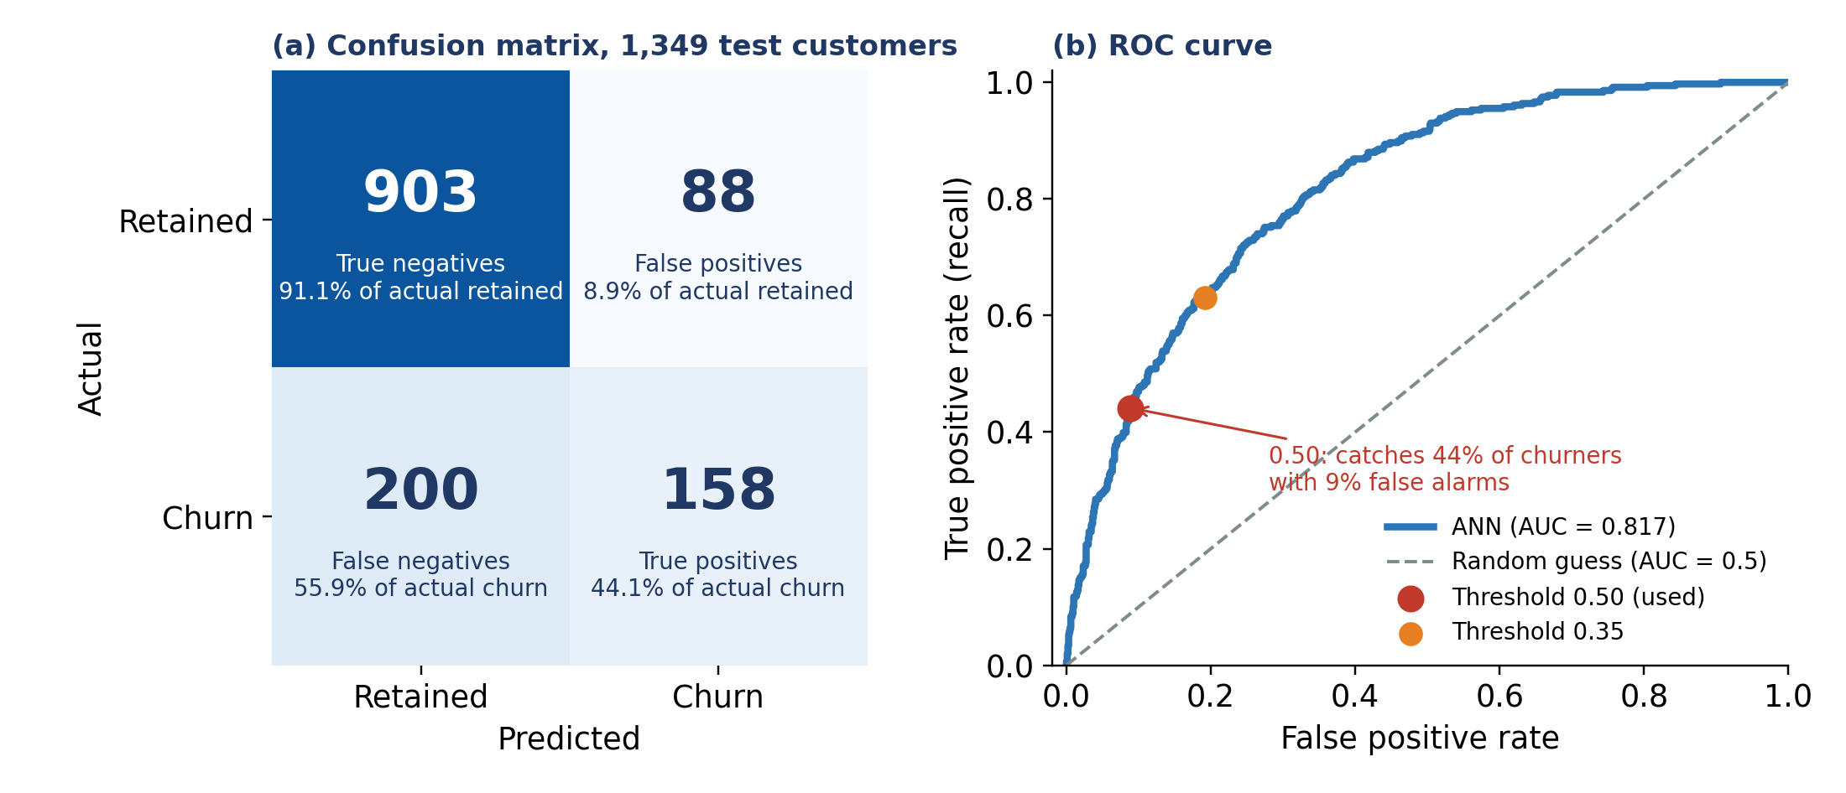
Figure 1: Confusion matrix (a) and ROC curve (b) on the 1,349 test customers; 0.50 is the threshold used
A few things stand out in these numbers:
- Accuracy looks better than it is. 991 of the 1,349 test customers (73.5%) are retained, so predicting "no churn" for everyone would already score about 73.5%. The model's 78.65% is an improvement of roughly 5 percentage points.
- Recall is the weak point. Of 358 customers who actually churned, the model found 158 and missed 200 (55.9%). It flagged 246 customers as churners (18.2%) compared with an actual churn rate of 26.5%, so it underpredicts churn.
- Precision is better. When the model flags a customer, it is right 64% of the time (158 of 246).
An AUC of 0.817 means the scores do separate churners from non-churners fairly well, so the low recall comes mostly from where the cut-off sits, not from the model finding nothing. Re-scoring the saved test predictions at other thresholds shows the trade-off:
Threshold | Precision | Recall | F1-score | Accuracy
0.50 (used) | 64.2% | 44.1% | 52.3% | 78.7%
0.40 | 57.8% | 57.0% | 57.4% | 77.5%
0.35 | 54.7% | 63.1% | 58.6% | 76.4%
0.30 | 51.6% | 67.9% | 58.6% | 74.6%

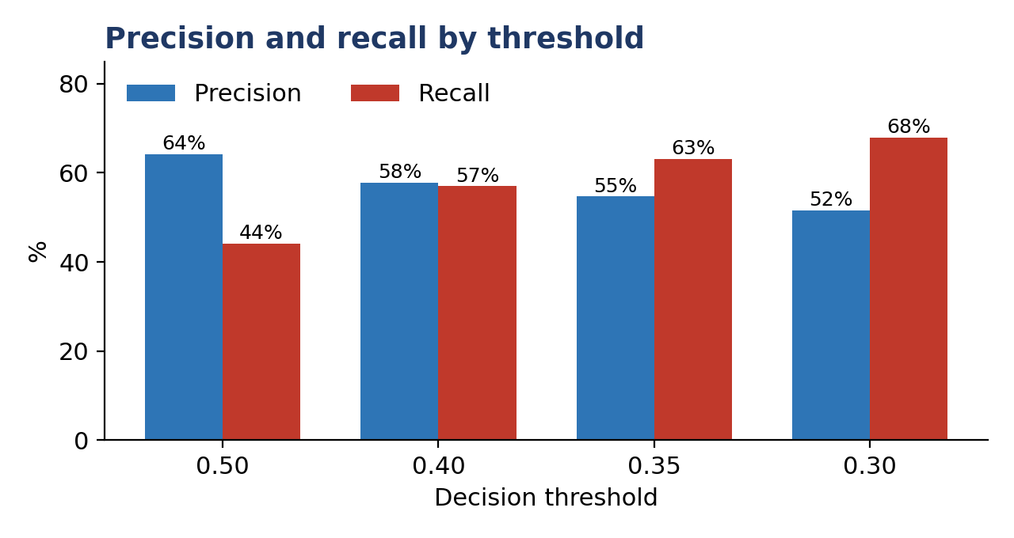
Figure 2: Lowering the threshold trades precision for recall
Lowering the threshold to 0.40 lifts recall from 44% to 57% and F1 from 52.3% to 57.4%, for a loss of about one point of accuracy.

1.5 Customer segments and churn
The segments below are simple risk groups defined from the two strongest drivers in the data: tenure (new = 12 months or less) and monthly charges (high = above 70). The churn rates are what actually happened across all 6,741 customers.
Segment | Customers | Share of base | Churn rate | Share of all churners
New, high charges | 795 | 11.8% | 68.3% | 30.3%
New, lower charges | 1,201 | 17.8% | 35.1% | 23.6%
Established, high charges | 2,636 | 39.1% | 25.0% | 36.7%
Established, lower charges | 2,109 | 31.3% | 8.0% | 9.4%

The first group is where retention effort should start. New customers on high monthly charges make up 11.8% of the base, but 30.3% of all churners, and more than two in three of them leave. The established, high-charge segment has a lower rate but is large, so it contributes the most churners in absolute terms.

1.6 Headline findings
- The overall churn rate is 26.6%, and the ANN reaches ROC-AUC 0.817, accuracy 78.65%, and recall 44.13% at the 0.50 threshold.
- Short tenure, high monthly charges, senior-citizen status, and having no dependents are the clearest markers of churn (Section 2).
- Customers with 4 or more years of tenure, low monthly charges, or dependents are the most likely to stay.
- Gender, phone service, multiple lines, and internet type show almost no relationship with churn.
- Contract type shows only a small difference in this dataset (27.5% churn for month-to-month versus 25.2% for two-year), which is unusual and worth verifying with the data owner.

2. Factors Contributing to Churn and Retention
Tenure and monthly charges are the strongest churn markers, followed by senior-citizen status and dependents.

2.1 Method
Feature importance has not been calculated for the ANN because the supplied project files do not include permutation-importance or SHAP results. The figures in this section therefore show observed churn rates within the cleaned dataset (6,741 customers), not a ranking of the features used by the trained ANN. They describe associations rather than causes. The ANN's predictive performance is evaluated separately using the held-out test set and metrics such as ROC-AUC, precision and recall. To identify which inputs the ANN relies on most, permutation importance or SHAP should be calculated using the saved model and an appropriate held-out dataset. Until that analysis is completed, factors discussed here should be described as customer characteristics associated with churn, not confirmed model-specific drivers.
Interpretation note: the segment-level churn rates in Sections 1 and 3 are descriptive summaries of what happened in the dataset. The ANN supplies customer-level predicted probabilities; combining those scores with observed segment patterns can guide outreach, but the segment rates alone do not prove that the ANN uses those attributes most strongly or that the attributes cause churn.

2.2 Churn rate by factor
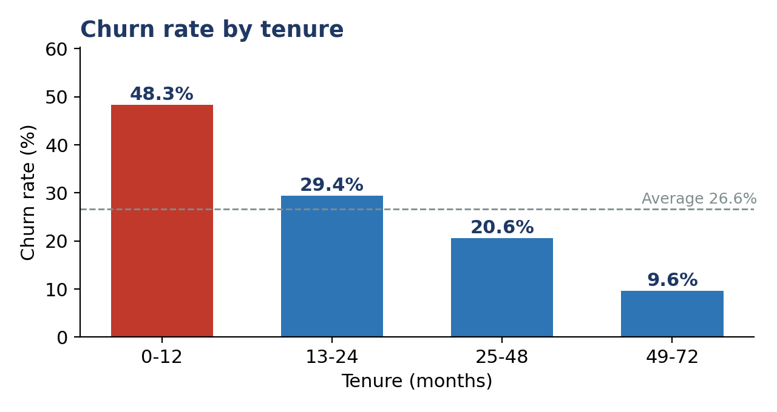
Figure 3: Churn rate by tenure band
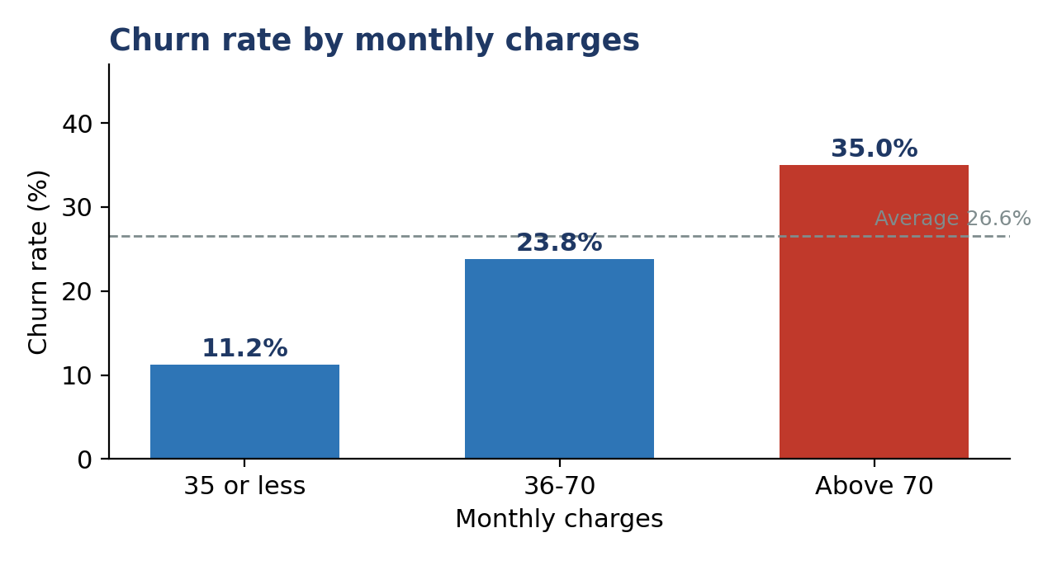
Figure 4: Churn rate by monthly charges band
Factor | Group | Customers | Churn rate
Tenure | 0–12 months | 1,996 | 48.3%
Tenure | 13–24 months | 993 | 29.4%
Tenure | 25–48 months | 1,570 | 20.6%
Tenure | 49–72 months | 2,182 | 9.6%
Monthly charges | 35 or less | 1,568 | 11.2%
Monthly charges | 36–70 | 1,742 | 23.8%
Monthly charges | Above 70 | 3,431 | 35.0%
Senior citizen | Yes | 1,130 | 41.2%
Senior citizen | No | 5,611 | 23.6%
Dependents | No | 4,690 | 31.3%
Dependents | Yes | 2,051 | 15.8%
Contract | Month-to-month | 3,653 | 27.5%
Contract | One year | 1,439 | 25.9%
Contract | Two year | 1,649 | 25.2%

2.3 Factors contributing to churn
- Short tenure. Nearly half of customers in their first year leave (48.3%), against 9.6% for those past four years. No other factor moves the churn rate as much.
- High monthly charges. Churn rises steadily with price, from 11.2% at 35 or less to 35.0% at 70 or above. Customers above 70 are also the largest group (51% of the base).
- Senior citizens. Seniors churn at 41.2%, about 1.7 times the rate of other customers. The effect is stronger early on: senior customers in their first year churn at 67.0%.
- No dependents. Customers without dependents churn at 31.3%, twice the rate of those with dependents.

2.4 Factors contributing to retention
- Long tenure. Customers with 49 or more months of service churn at only 9.6%, and those with 25–48 months at 20.6%.
- Low monthly charges. Customers paying 35 or less churn at 11.2%. Established customers on lower charges are the most stable segment, at 8.0%.
- Having dependents. Households with dependents churn at 15.8%. Established customers with dependents churn at 11.0%.

2.5 Factors with little or no effect
Gender (27.1% vs 26.1%), phone service (24.7% without vs 26.8% with), multiple lines (26.8% vs 26.2%), and internet type (DSL 27.5%, fibre 25.4%) all sit close to the 26.6% average, so they are weak predictors here.
Contract type is the surprise. In most subscription businesses, longer contracts reduce churn sharply, but here, month-to-month customers (27.5%) churn only slightly more than two-year customers (25.2%). The pattern holds within each tenure band as well. This may be a genuine feature of this customer base or an artifact of how the data was collected or cleaned, so it should be confirmed with the data owner before building a strategy around contracts.

3. Recommendations for Targeted Retention Strategies
Retention effort should go first to new customers on high monthly charges, who churn at 68.3%, and the ANN's risk scores should be used to find them before they leave.

3.1 Targeted actions by customer attribute
- Senior customers. They churn at 41.2% and 67.0% in their first year. Offer a dedicated support line, simpler plans, and assisted setup.
- Customers without dependents. They churn at 31.3%. Test household or family-style bundles and referral rewards that give single-person accounts a reason to stay.
- Customers above 70 per month. Review pricing for this group, since churn keeps climbing as monthly charges go up.
- Tenure milestones. Churn falls from 48.3% in year one to 29.4% in year two, so the first 24 months are the critical window. Time contact to months 3, 6, 12, and 18.

3.2 Strategy by segment
Segment | Churn rate | Main risk drivers | Recommended action
New, high charges (795) | 68.3% | First-year tenure, price above 70 | Priority group. Contact within the first 90 days, check the plan fits their usage, and offer a cheaper plan or a time-limited discount before they cancel.
New, lower charges (1,201) | 35.1% | First-year tenure | Strengthen onboarding: welcome check-in, usage tips, and follow-ups at months 3 and 6. Low-cost automated contact is enough.
Established, high charges (2,636) | 25.0% | Price | Largest source of churners in total numbers. Annual plan review, loyalty pricing or bundles, and tenure rewards.
Established, lower charges (2,109) | 8.0% | Few | Maintain. Avoid unnecessary offers and use these customers for referral or upgrade campaigns.

3.3 Putting the model to work
- Score customers regularly. Run the saved ANN on the active base on a fixed schedule (for example, monthly) and rank customers by churn probability.
- Use a lower threshold for outreach. At 0.50, the model finds only 44% of churners. At 0.40, it finds 57% with a precision of 57.8%, and at 0.30, it finds 67.9% with a precision of 51.6%. If a retention call is cheaper than losing a customer, 0.30 to 0.40 is the better operating point.
- Combine risk with value. Prioritize customers who are both likely to leave and valuable (for example, high monthly charges).
- Test before scaling. Run each offer as an A/B test, with a treated group and a comparison group, and track retention rate and cost per saved customer.
- Verify the contract finding. Confirm with the data owner why contract length has so little effect before funding contract-upgrade campaigns.

4. Limitations and Proposed Solutions
Limitation or challenge | Impact | Proposed solution
Low recall at the default threshold (44.1%) | The model misses 200 of 358 churners in the test set | Tune the decision threshold (0.30 to 0.40) using the cost of a missed churner versus an unneeded offer
Class imbalance (26.6% churners); no resampling or class weighting was applied | The model leans towards predicting "no churn" and under-predicts it (18.2% flagged vs 26.5% actual) | Apply class weights or oversampling, such as SMOTE, on the training data, and judge results by recall, F1, and ROC-AUC rather than accuracy alone
Single train/test split | Results may depend on which customers landed in the test set; robustness is not shown | Add stratified k-fold cross-validation and report the mean and spread of ROC-AUC and recall
No feature importance from the ANN | Section 2 relies on observed churn rates rather than the model's own reasoning; ANNs are hard to interpret | Run permutation importance or SHAP on the saved model and test set, and compare with a logistic regression baseline
Limited feature set (9 raw attributes, 10 model inputs) | No usage, billing history, complaint, or satisfaction data, which likely caps performance | Collect behavioral and service-interaction data and retest
Contract type shows almost no effect | Unusual for subscription data and may reflect a data collection or cleaning issue | Check the source and cleaning steps with the data owner
Modest regularisation and tuning | The model has two small hidden layers with early stopping, but no dropout and no hyperparameter search | Try tuning layer sizes, learning rate, and L2 regularisation with grid or random search, and compare with random forest or gradient boosting
Static snapshot | Customer behaviour and pricing change over time | Retrain on fresh data on a regular schedule and monitor performance for drift
Correlation, not causation | A factor linked to churn may not be its cause | Validate retention actions through controlled experiments

5. Conclusion
The ANN (10-32-16-1, ReLU, Adam) reached an ROC-AUC of 0.817 and an accuracy of 78.65% on 1,349 test customers, but it identifies only 44% of churners at the default threshold. Churn is concentrated among new customers, high-paying customers, senior citizens, and customers without dependents, with new customers paying above 70 per month, leaving at 68.3%. Lowering the decision threshold to about 0.30 to 0.40 and targeting the high-risk segments with the actions in Section 3 would give the business the most practical benefit from the model, while class weighting, cross-validation, and feature importance analysis would make the next version more reliable and easier to explain.

6. Glossary of Key Terms
This glossary defines the main technical terms used in the report for readers who may not have a machine-learning background.
Term | Definition
Artificial Neural Network (ANN) | A machine-learning model with connected processing units arranged in layers. Here, it predicts customer churn probability.
Churn | The event in which a customer stops using the service is the model's target variable.
Target variable | The outcome the model is trained to predict. In this project, Churn is encoded as 0 = No Churn and 1 = Churn.
Feature/predictor | An input attribute supplied to the model, such as tenure or MonthlyCharges.
Preprocessing | Preparing data for modeling. The supplied modeling script loads already-preprocessed data; the exact encoding and scaling steps should be confirmed from the team's preprocessing workflow.
Training set | The portion of the dataset used to fit the model.
Test set | A separate portion of data is used to evaluate model performance after training.
Hidden layer | A layer of neurons between the input and output layers. This ANN uses hidden layers of 32 and 16 neurons.
ReLU | Rectified Linear Unit, an activation function used in the ANN's hidden layers.
Adam | An optimisation algorithm used to update model parameters during training.
Early stopping | A technique that stops training when validation performance stops improving.
Prediction threshold | The probability cut-off is used to assign a predicted class. The main reported results use 0.50.
Accuracy | The proportion of all predictions that are correct.
Precision | Among customers predicted to churn, the proportion who actually churned.
Recall | Among customers who actually churned, the proportion correctly identified by the model.
F1-score | The harmonic mean of precision and recall.
ROC-AUC | Area under the Receiver Operating Characteristic curve; measures how well the model ranks churners above non-churners across thresholds.
Class imbalance | A difference in the frequency of target classes. Churners represent approximately 26.6% of this dataset.
Feature importance | An estimate of how much a model relies on each input. ANN-specific feature importance was not calculated in the supplied outputs.
Data leakage | When information that would not legitimately be available during training influences model fitting or evaluation.
A/B test | A controlled comparison between a group receiving a retention action and a comparison group.
Note: Project-specific statements reflect the supplied report and modelling script. Preprocessing details not documented in those files should be confirmed against the complete workflow.

Appendix A. Model Configuration and Evaluation Summary
This appendix consolidates the model settings and test-set results reported in the main body. It is a quick reference and does not replace the methodology or results sections.
Configuration | Value
Model type | Feed-forward Artificial Neural Network implemented with scikit-learn MLPClassifier
Input features | 10 processed input features, as reported by the modelling script
Hidden layers | 32 and 16 neurons
Hidden-layer activation | ReLU
Solver / optimizer | Adam
Initial learning rate | 0.001
Maximum iterations | 300
Early stopping | Enabled
Validation fraction | 20%
Iterations without improvement | 20
Random state | 42
Classification threshold | 0.50 for the main reported test metrics
Test-set size | 1,349 customers
Saved model filename | ANN_Model.pkl

Appendix B. Reported Test-Set Performance
Metric | Reported result
Accuracy | 78.65%
Precision | 64.23%
Recall | 44.13%
F1-score | 52.32%
ROC-AUC | 0.8171

Appendix C. Reproducibility and Interpretation Notes
The supplied modelling script reads preprocessed training and testing CSV files, fits the ANN on the training data, and evaluates predictions on the separate test set.
The supplied modelling script reads preprocessed training and testing CSV files, fits the ANN on the training data, and evaluates predictions on the separate test set.
The supplied script converts target labels “No” and “Yes” to numeric values 0 and 1. It does not document the complete predictor encoding or scaling procedure.
The exact train/test split ratio, split strategy, and whether stratification was used should be confirmed from the earlier data-preparation workflow.
Churn rates by segment are descriptive observations from the cleaned dataset. They are not ANN-specific feature importance and do not establish causation.
The threshold comparison demonstrates a precision-recall trade-off. The operating threshold should be selected based on retention costs, customer value, and the cost of missed churners.

