# Note Hash Bcryte of 123456

$2y$12$z//IhiDZ5N4QCswGNmtJEuU1sto.sLTbvOYLM0Gf6wP.SEvolc.P6

# GITLAB Command

## Command line instructions

-------------------------------------------------------------------------------------------------------------

### Git global setup (sabia bhanda pahila yo step garne tespachi aaru garne ok )

git config --global user.name "Madhu Sudan Bhattarai"

git config --global user.email [bhattaraimadhu56@gmail.com](mailto:bhattaraimadhu56@gmail.com)

-----------------------------------------------------------------------------

### Create a new repository (gitlab bata computer ma file launa download garna)

git clone https://gitlab.com/bhattaraimadhu56/madhularavelgeneralsite.git

cd madhularavelgeneralsite

touch README.md

git add README.md

git commit -m "add README"

git push -u origin master

necessary screen shot

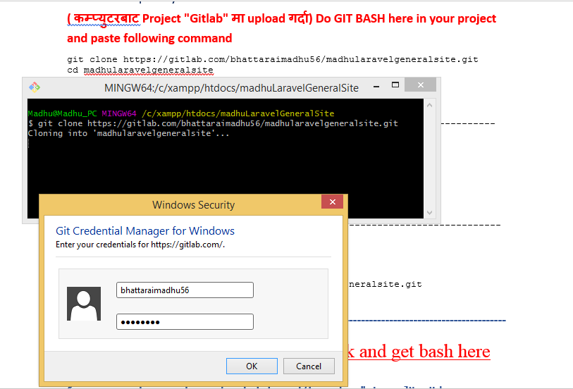

----------------------------------------------------------------------------

Existing folder ( कम्प्युटरबाट Project "Gitlab" मा upload गर्दा)

Do GIT BASH here in your project and paste following command

1. cd existing folder (project भित्र "git bash here" गरे पछी यो नगरे पनि हुन्छ )
2. git init
3. git remote add origin https://gitlab.com/bhattaraimadhu56/madhularavelgeneralsite.git
4. git add .
5. git commit -m "Initial commit"
6. git push -u origin master

-----------------------------------------------------------------------------

### Existing Git repository

cd existing_repo

git remote rename origin old-origin

git remote add origin https://gitlab.com/bhattaraimadhu56/madhularavelgeneralsite.git

git push -u origin --all

git push -u origin --tags

-------------------------------------------------------------------------------------------------------------

# First go to c:/xampp/htdocs right click and get bash here then write command

$composer create-project --prefer-dist laravel/laravel madhuLaravelNewsHub

# Go to c:/xampp/htdocs/madhuLaravelNewsHub by following command

$cd madhularavelNewshub

# For creating tables

Madhu@Madhu_PC MINGW64 /c/xampp/htdocs/madhularavelNewshub

$ php artisan make:migration create_users_table --create=users

Madhu@Madhu_PC MINGW64 /c/xampp/htdocs/madhularavelNewshub

$ php artisan make:migration create_categories_table --create=categories

Created Migration: 2018_10_12_073136_create_categories_table

Madhu@Madhu_PC MINGW64 /c/xampp/htdocs/madhularavelNewshub

$ php artisan make:migration create_news_table --create=news

Created Migration: 2018_10_12_073258_create_news_table

Madhu@Madhu_PC MINGW64 /c/xampp/htdocs/madhularavelNewshub

$ php artisan make:migration create_news_images_table --create=news_images

Created Migration: 2018_10_12_073347_create_news_images_table

Madhu@Madhu_PC MINGW64 /c/xampp/htdocs/madhularavelNewshub

$ php artisan make:migration create_site_profiles_table --create=site_profiles

Created Migration: 2018_10_12_073604_create_site_profiles_table

# For creating login and registration

Madhu@Madhu_PC MINGW64 /c/xampp/htdocs/madhularavelNewshub

$ php artisan make:auth

Authentication scaffolding generated successfully.

Madhu@Madhu_PC MINGW64 /c/xampp/htdocs/madhularavelNewshub

# If any error comes wile migrating the data

Then go to: app/ providers/AppServiceProvider.php

Write following code mainly use at top

//(at top)

use Carbon\Carbon;

use Illuminate\Support\Facades\Schema;

then write function for default length in function boot()

public function boot()

{

//Added manually later

Schema::defaultStringLength(191);

setlocale(LC_TIME, app()->getLocale());

Carbon::setLocale(app()->getLocale());

}

# For migrating data to database mysql from Laravel

Madhu@Madhu_PC MINGW64 /c/xampp/htdocs/madhularavelNewshub

$ php artisan migrate

Migrating: 2014_10_12_000000_create_users_table

Migrated: 2014_10_12_000000_create_users_table

Migrating: 2014_10_12_100000_create_password_resets_table

Migrated: 2014_10_12_100000_create_password_resets_table

Migrating: 2018_10_12_073136_create_catagories_table

Migrated: 2018_10_12_073136_create_catagories_table

Migrating: 2018_10_12_073258_create_news_table

Migrated: 2018_10_12_073258_create_news_table

Migrating: 2018_10_12_073347_create_news_images_table

Migrated: 2018_10_12_073347_create_news_images_table

Migrating: 2018_10_12_073604_create_site_profiles_table

Migrated: 2018_10_12_073604_create_site_profiles_table

// if any changes occur in database to do roll back (to destroy tables from database)

Madhu@Madhu_PC MINGW64 /c/xampp/htdocs/madhularavelNewshub

$ php artisan migrate:rollback

Rolling back: 2018_10_12_073604_create_site_profiles_table

Rolled back: 2018_10_12_073604_create_site_profiles_table

Rolling back: 2018_10_12_073347_create_news_images_table

Rolled back: 2018_10_12_073347_create_news_images_table

Rolling back: 2018_10_12_073258_create_news_table

Rolled back: 2018_10_12_073258_create_news_table

Rolling back: 2018_10_12_073136_create_catagories_table

Rolled back: 2018_10_12_073136_create_catagories_table

Rolling back: 2014_10_12_100000_create_password_resets_table

Rolled back: 2014_10_12_100000_create_password_resets_table

Rolling back: 2014_10_12_000000_create_users_table

Rolled back: 2014_10_12_000000_create_users_table

# After roll back we need to migrate

# one step to rollback and migrate all data at a time

Madhu@Madhu_PC MINGW64 /c/xampp/htdocs/madhularavelNewshub

$ php artisan migrate:refresh

Rolling back: 2018_10_12_073604_create_site_profiles_table

Rolled back: 2018_10_12_073604_create_site_profiles_table

Rolling back: 2018_10_12_073347_create_news_images_table

Rolled back: 2018_10_12_073347_create_news_images_table

Rolling back: 2018_10_12_073258_create_news_table

Rolled back: 2018_10_12_073258_create_news_table

Rolling back: 2018_10_12_073136_create_catagories_table

Rolled back: 2018_10_12_073136_create_catagories_table

Rolling back: 2014_10_12_100000_create_password_resets_table

Rolled back: 2014_10_12_100000_create_password_resets_table

Rolling back: 2014_10_12_000000_create_users_table

Rolled back: 2014_10_12_000000_create_users_table

Migrating: 2014_10_12_000000_create_users_table

Migrated: 2014_10_12_000000_create_users_table

Migrating: 2014_10_12_100000_create_password_resets_table

Migrated: 2014_10_12_100000_create_password_resets_table

Migrating: 2018_10_12_073136_create_catagories_table

Migrated: 2018_10_12_073136_create_catagories_table

Migrating: 2018_10_12_073258_create_news_table

Migrated: 2018_10_12_073258_create_news_table

Migrating: 2018_10_12_073347_create_news_images_table

Migrated: 2018_10_12_073347_create_news_images_table

Migrating: 2018_10_12_073604_create_site_profiles_table

Migrated: 2018_10_12_073604_create_site_profiles_table

// For creating Controller

For making controller with all functions

Madhu@Madhu_PC MINGW64 /c/xampp/htdocs/madhuLaravelNewsHub

$ php artisan make:controller UserController --resource

Controller created successfully.

For making controller only

Madhu@Madhu_PC MINGW64 /c/xampp/htdocs/madhuLaravelNewsHub

$ php artisan make:controller UserController

Controller created successfully.

# For creating Models

Madhu@Madhu_PC MINGW64 /c/xampp/htdocs/madhuLaravelNewsHub

Here -m means --migration

$ php artisan make:model user -m

Model already exists!

Madhu@Madhu_PC MINGW64 /c/xampp/htdocs/madhuLaravelNewsHub

Or we can simply create without using -m as below

$ php artisan make:model user

Model already exists!

## To make model category inside folder Models ok

$ php artisan make:model Models/Category

Or

$ php artisan make:model Models/Category -m

# To see all the route used in the project

Madhu@Madhu_PC MINGW64 /c/xampp/htdocs/madhuLaravelNewsHub

$ php artisan route:list

+--------+----------+------------------------+---------------------+------------------------------------------------------------------------+--------------+

| Domain | Method | URI | Name | Action | Middleware |

+--------+----------+------------------------+---------------------+------------------------------------------------------------------------+--------------+

| | GET|HEAD | / | | Closure | web |

| | GET|HEAD | admin | | Closure | web |

| | GET|HEAD | admin/user/addUser | admin.user.addUser | App\Http\Controllers\UserController@addUser | web |

| | GET|HEAD | admin/user/listUser | admin.user.listUser | App\Http\Controllers\UserController@listUser | web |

| | GET|HEAD | api/user | | Closure | api,auth:api |

| | GET|HEAD | home | home | App\Http\Controllers\HomeController@index | web,auth |

| | GET|HEAD | kkkkkaby | | App\Http\Controllers\HomeController@showadmin | web,auth |

| | GET|HEAD | login | login | App\Http\Controllers\Auth\LoginController@showLoginForm | web,guest |

| | POST | login | | App\Http\Controllers\Auth\LoginController@login | web,guest |

| | POST | logout | logout | App\Http\Controllers\Auth\LoginController@logout | web |

| | POST | password/email | password.email | App\Http\Controllers\Auth\ForgotPasswordController@sendResetLinkEmail | web,guest |

| | GET|HEAD | password/reset | password.request | App\Http\Controllers\Auth\ForgotPasswordController@showLinkRequestForm | web,guest |

| | POST | password/reset | password.update | App\Http\Controllers\Auth\ResetPasswordController@reset | web,guest |

| | GET|HEAD | password/reset/{token} | password.reset | App\Http\Controllers\Auth\ResetPasswordController@showResetForm | web,guest |

| | GET|HEAD | register | register | App\Http\Controllers\Auth\RegisterController@showRegistrationForm | web,guest |

| | POST | register | | App\Http\Controllers\Auth\RegisterController@register | web,guest |

+--------+----------+------------------------+---------------------+------------------------------------------------------------------------+--------------+

# Backend Validation in Laravel [Form Request Validation](https://laravel.com/docs/5.7/validation#form-request-validation)

(<https://laravel.com/docs/5.7/validation#form-request-validation> )

php artisan make:request Category

this will be inside “app/Http/Requests”

-------------------------------------------------------------------------------------------------------------

Madhu@Madhu_PC MINGW64 /c/xampp/htdocs/madhuLaravelGeneralSite (master)

$ php artisan make:request Category/AddFormValidation

Request created successfully.

Here category is folder name and AddFormValidation.php is file

You will see folder in (app\Http\Requests/Category/ AddFormValidation.php)

Madhu@Madhu_PC MINGW64 /c/xampp/htdocs/madhuLaravelGeneralSite (master)

$ php artisan make:request User/AddFormValidation

Request created successfully.

You will see folder in (app\Http\Requests/User/ AddFormValidation.php)