Development of Machine Learning Models to Predict Treatment Outcome, Medical-Failure Risk, and Recovery Time in Dogs with Pyometra
A Retrospective Case Series with an Openly Deployed Prediction Tool
[Author Name(s) — to be completed]¹, [Co-author Name — to be completed]²
¹[Affiliation / Institution — to be completed] ²[Affiliation / Institution — to be completed]
Corresponding author: [Name, email — to be completed]
Draft prepared September 2026 — for author review before submission
Editor's note to the author (delete before submission): this draft was prepared by a data-analysis/writing assistant from the project's own committed results. Author names, affiliations, ethics wording, and the reference list have been left as clearly marked placeholders or provisional entries and must be checked line-by-line against your institution's requirements and the target journal's author guidelines before this goes anywhere near a submission portal or a conference abstract.

Abstract
Background: Canine pyometra is a common, potentially life-threatening disease of the intact bitch, and the choice between medical and surgical management currently relies on limited single-marker evidence. Machine learning (ML) can combine multiple admission findings into one reproducible probability estimate, an approach recently demonstrated for canine parvovirus enteritis.
Methods: We applied a three-stage ML workflow (all admission variables → univariate screen → recursive feature elimination) with a 15-algorithm comparison under repeated stratified 5-fold cross-validation (20 repeats) to a retrospective case series of 80 dogs treated under four protocols (20 dogs per protocol). Three models were developed: treatment success by day 14 across all four protocols, medical-failure risk for the three non-surgical protocols, and days-to-resolution.
Results: The final treatment-success model (protocol category plus nine admission variables) achieved, as its pre-specified primary estimate, ROC-AUC 0.91 ± 0.08 (accuracy 85%, sensitivity 87%, specificity 72%, F1 0.90 at a 0.5 threshold); an independently implemented validation pipeline and nested cross-validation reproduced this within 0.02 AUC. The medical-failure model achieved ROC-AUC 0.95 ± 0.07. Renal markers (blood urea nitrogen, creatinine), hepatic markers (alkaline phosphatase, alanine aminotransferase) and hypoalbuminaemia were the dominant predictors in both models. A six-variable admission risk score, built from the medical-failure model's own coefficients, separated a combined low/intermediate stratum (0% observed medical failure, n = 53) from a high-risk stratum (52% observed medical failure, n = 27) in which observed success on this dataset ranged from 12% to 100% depending on protocol — an observational, hypothesis-generating association, not a causal treatment effect.
Conclusions: A compact, interpretable logistic-regression model built from nine routine admission values integrates clinical and laboratory data into a single probability of treatment success in canine pyometra, and is deployed here as an open, research-use prototype. Because this is a single, retrospective case series without documented enrolment criteria, allocation procedure, or external validation, these findings are hypothesis-generating and require validation on an independently collected clinical cohort before any clinical use.
Keywords: canine pyometra; machine learning; logistic regression; prognosis; treatment outcome; ovariohysterectomy; aglepristone; clinical decision support

1. Introduction
Pyometra is a secondary bacterial infection of a uterus primed by progesterone-driven cystic endometrial hyperplasia, and it remains one of the most common and potentially fatal reproductive emergencies of the intact bitch. Community-based insurance data from Sweden put the cumulative risk of pyometra at roughly 2% per year in bitches under ten years old, rising to an estimated 23–24% lifetime risk by age ten, with marked breed variation (Egenvall et al., 2001). Clinically, affected dogs present anywhere on a spectrum from a mildly lethargic, polyuric–polydipsic animal with an open cervix to a septic, hypovolaemic patient with a closed, distended uterus at risk of rupture (Hagman, 2018; Xavier et al., 2023).
Definitive treatment is ovariohysterectomy (OHE), which removes the diseased organ and is curative in the great majority of cases, but it is not always the outcome an owner or a breeding operation wants, and it carries the operative and anaesthetic risk of an emergency laparotomy in a systemically ill patient. Medical management — most often a progesterone-receptor antagonist such as aglepristone, alone or combined with a prostaglandin F2α agonist such as cloprostenol — can resolve pyometra while preserving fertility, with reported success rates rising from roughly 60% with aglepristone alone to over 80–90% when cloprostenol is added, at the cost of a meaningful relapse rate in subsequent cycles (Fieni, 2006; Hagman, 2018). Deciding which route is appropriate for a given dog, at the point of admission, is therefore a genuine and recurring clinical judgement call.
A number of individual clinical and laboratory findings have been proposed as prognostic markers to support that judgement. Systemic inflammatory response syndrome, leucopenia, and a serum creatinine above roughly 2.5 mg/dL at admission have been associated with a higher risk of peritonitis and prolonged hospitalisation after surgery (Jitpean et al., 2014); C-reactive protein helps separate pyometra from cystic endometrial hyperplasia/mucometra and tracks disease severity (Fransson et al., 2004); and a recent systematic review and meta-analysis confirms that azotaemia, hepatic enzyme elevation and hypoalbuminaemia are consistently reported across the haematology/biochemistry literature on canine pyometra (Demeli & Meyer, 2023). Each of these single markers is informative in isolation, but none is reproducible enough, on its own, to drive a treatment decision — the same marker is often confirmed in one study and not another, and markers that are cheap to measure (a leucocyte count) are mixed with ones that are not (acute-phase proteins, hormone assays), limiting what a first-opinion practice can act on immediately.
Machine learning (ML) offers a way to combine several routinely available admission values into a single, reproducible probability rather than relying on any one biomarker. This approach is now established in human medicine and is increasingly applied in small-animal practice — for example to flag canine Cushing's syndrome from primary-care records (Schofield et al., 2021) and to aid the early detection of canine leptospirosis (Reagan et al., 2022) — though its use in veterinary medicine generally remains at an early stage relative to human healthcare (Akinsulie et al., 2024). Most directly relevant to the present work, Sanaei, Zamani-Ahmadmahmudi & Nassiri (2025) recently built and openly reported a three-stage ML pipeline (all variables → univariate screen → recursive feature elimination, compared across ten and four algorithms respectively) to predict clinical outcome and recovery time in dogs with parvovirus enteritis, achieving ROC-AUC 0.90 for outcome and RMSE 2.05 days for recovery time from routinely collected clinical and laboratory variables.
To our knowledge, no openly reported ML pipeline of this kind previously existed for canine pyometra. The aim of this study was to adapt the Sanaei et al. (2025) workflow — the same three-stage feature-reduction strategy, the same repeated-cross-validation, multi-algorithm comparison methodology — to canine pyometra, and to use it to build three complementary models: (i) probability of treatment success by day 14 for a clinician-chosen protocol, (ii) probability of medical-management failure among the non-surgical protocols, and (iii) expected days to clinical resolution. The case series available for this work is a single retrospective cohort without a documented enrolment or allocation protocol; we therefore present the results as hypothesis-generating, with the full pipeline published openly (Data Availability Statement, Section 4) so it can be re-run, unmodified, on an independently collected clinical cohort as the next step toward clinical use.

2. Materials and Methods

2.1 Study design and dataset
This is a retrospective analysis of a case series of 80 client-owned dogs with pyometra, treated under four protocols (20 dogs per protocol) and followed to day 14: G1, supportive care and antibiotics only; G2, cloprostenol (prostaglandin F2α); G3, aglepristone combined with cloprostenol; and G4, ovariohysterectomy. The case records were compiled from clinical practice; a formal published report of the original case series, and documentation of the enrolment and protocol-allocation procedure, were not available for this secondary analysis. Baseline recording was complete (no missing admission values) and no duplicate or implausible records were found (Section 2.2), but — as for any retrospective, non-randomised case series — the absence of a documented, pre-specified allocation procedure means protocol assignment cannot be assumed to be independent of case severity. This is flagged here, in the Discussion, and again in the Limitations, and it is the reason we present every result below as hypothesis-generating rather than as evidence ready for clinical use.
This is a retrospective analysis of pre-existing clinical case records; no new animal procedures were performed for this analysis. Formal institutional ethics-committee documentation and owner-consent records for the original case collection were not available to the analyst; the corresponding author should supply the appropriate ethics, consent and animal-welfare statement for the source clinical records (e.g. retrospective case-record review under the treating institution's standard consent, an ethics-committee waiver, or a formal approval reference) before submission.

2.2 Data collection
Twenty-six variables were available for each dog, spanning five categories: demographic, vital-sign/clinical, haematological, serum-biochemical, and imaging/endocrine (Table 1). Four outcomes were defined a priori: treatment success by day 14 (uncomplicated resolution on the assigned protocol, 66/80 dogs, 82.5%); medical failure by day 14 among the three non-surgical protocols (death, rescue ovariohysterectomy, or non-response; 14/60 medical-arm dogs, 23.3%); days to clinical resolution (continuous, resolvers only, n = 74); and two rare events — death (1/80) and six-month recurrence (4/80) — that were too infrequent to model and are reported descriptively only.
No admission demographic, clinical, haematological, biochemical or imaging value used as a predictor in either classification model was missing for any of the 80 dogs (Table 1 fields; verified programmatically, 0/80 missing on every column). Missingness in the source workbook is confined to fields not used as model predictors here: litter size (62.5% missing — recorded only for dogs later bred), pregnancy outcome and days-to-next-oestrus (42.5% missing each — recorded only on follow-up), and the recovery-time outcome itself (7.5% missing, 6/80 dogs, corresponding exactly to the dogs that died or did not resolve — handled, as stated above, by restricting the recovery-time analysis to the 74 dogs with a recorded resolution date rather than by imputing an outcome for a dog that did not resolve). No imputation was performed on any variable used to fit the treatment-success or medical-failure classification models reported in Section 3. A separate, artificially constructed 5%-missing-completely-at-random (MCAR) copy of the predictor set was used only for the imputation-robustness sensitivity check reported in Section 3.5, and is clearly distinguished there from the complete data used for every other result in this manuscript.
Table 1. Variables recorded for each dog.
Category | Variables
Demographic | Age (years), illness duration (days), weight (kg)
Clinical / vital signs | Temperature, heart rate, respiratory rate, clinical severity score (0–10), vulvar-discharge score (0–3)
Haematology | Total leucocyte count, neutrophil count
Serum biochemistry | Blood urea nitrogen (BUN), creatinine, alkaline phosphatase (ALP), alanine aminotransferase (ALT), total protein, albumin, globulin
Imaging / endocrine | Uterine diameter (ultrasound), progesterone
Derived risk flags | Hypoalbuminaemia, leukocytosis, azotaemia, severe inflammation, high clinical severity (each a pre-computed binary flag)
Outcomes | Treatment success (D14), medical failure (D14, G1–G3 only), days to resolution, death, 6-month recurrence

2.3 Statistical and machine-learning workflow
All analysis was implemented in Python 3.14 with scikit-learn, following a fixed roadmap: (1) data audit and randomisation-balance check; (2) univariate screening of admission variables against each outcome; (3) a longitudinal mixed-effects model (Group × Day, dog as a random intercept) tracking nine repeated variables across days 0, 3, 7 and 14; (4) three-stage ML model development for the medical-failure outcome; (5) the same three-stage development for the treatment-success outcome, with protocol as an additional categorical predictor; (6) a missing-data robustness check on a 5%-MCAR copy of the dataset; (7) recovery-time regression; and (8) a simple additive admission risk score derived from the final medical-failure model.
Fifteen classification algorithms were compared at every stage: L1 (LASSO), L2 (ridge) and elastic-net logistic regression, linear discriminant analysis (LDA), quadratic discriminant analysis (QDA), Gaussian naive Bayes, k-nearest neighbours, decision tree, random forest, gradient boosting, histogram-based gradient boosting, XGBoost, AdaBoost, linear SVM and RBF-kernel SVM, each evaluated with both class-weight balancing and SMOTE oversampling. Discrimination was assessed by out-of-fold ROC-AUC and PR-AUC under repeated stratified 5-fold cross-validation (20 repeats — 100 folds in total), with all preprocessing (standardisation, resampling) performed inside each training fold to avoid leakage. Precision, recall (sensitivity), specificity, F1 and the Brier score were computed at a 0.5 probability threshold from the same folds.
Feature selection followed the same three stages for both classification outcomes: Stage A used every available admission variable; Stage B retained variables that passed a univariate screen (association with the outcome at conventional significance); Stage C applied recursive feature elimination with cross-validation (RFECV) to the Stage-B set to find the smallest variable set that did not measurably reduce discrimination. For the treatment-success model, the intended protocol (G1–G4, one-hot encoded with G1 as reference) was retained as a predictor at every stage, since it is the clinical decision the tool is meant to support.

2.4 Final treatment-success model
The deployed treatment-success model is an L2-penalised (ridge) logistic regression fitted on all 80 dogs, predicting the probability that a clinician-selected protocol achieves uncomplicated resolution by day 14. It uses nine standardised admission variables — age, illness duration, heart rate, total leucocyte count, neutrophil count, creatinine, albumin, alkaline phosphatase and alanine aminotransferase — plus the protocol category (G1 as reference level). Logistic regression was retained as the deployed algorithm despite not being the single top performer in the bake-off (Section 3.3) because its cross-validated discrimination sat within the overlapping confidence band of every credible alternative, it is directly interpretable as odds ratios, it showed closely comparable performance under nested cross-validation (Section 3.3), and it is particularly simple to implement, audit and run entirely client-side in about twenty lines of JavaScript — which is what makes the openly deployed prototype described in Section 4 possible without exposing patient data to a server.
The surgical protocol (G4) resolved every case in this dataset (20/20). This is a case of perfect separation: no finite logistic coefficient can be estimated for it from these data, and the ridge-penalised estimate that results is an artefact of the penalty rather than a calibrated probability. The deployed tool and the results below therefore report the observed cohort success rate for G4, with an explicit caveat, rather than a model-derived probability.

2.5 Medical-failure (prognostic) model
A second model was developed on the three non-surgical protocols only (G1–G3, n = 60), predicting medical failure by day 14 with the protocol term dropped, so that its coefficients are interpretable as the effect of admission physiology alone, independent of which medical protocol was chosen. The same three-stage reduction was applied; recursive feature elimination (Stage C) identified a minimal three-variable set (BUN, ALP, albumin) with the highest point-estimate discrimination of any stage (Section 3.2). As with the treatment-success model (Section 2.4), we deployed a deliberately larger, clinically-motivated six-variable model — the Stage-C three variables plus creatinine, age and illness duration, all of which passed the Stage-B univariate screen and are established admission findings in the pyometra literature (Section 5) — rather than the minimal RFECV set, again fitted as an L2-penalised logistic regression on standardised inputs. Both the three-variable and six-variable fits are reported in Section 3.2; the deployed model and the risk score derived from it (Section 2.6) use the six-variable coefficients throughout, so that every number attributed to “the deployed medical-failure model” in this manuscript comes from one single, locked model.

2.6 Recovery-time regression and admission risk score
Days to clinical resolution (continuous, n = 74 resolvers) was modelled with four regression algorithms — linear regression, decision tree, random forest, and k-nearest-neighbours regression — compared by mean absolute error (MAE), root-mean-square error (RMSE) and R² under the same repeated cross-validation scheme. Finally, the deployed medical-failure model's own six coefficients (Section 2.5, Table 7) — not a separately refitted model — were rounded to an integer point score (Sullivan-style, each point representing one coefficient's log-odds relative to the smallest), and dogs were assigned to Low/Medium/High risk strata using tertile cut-points on that score, cross-tabulated against protocol and outcome to generate an exploratory, hypothesis-generating risk-to-protocol table (Section 3.6). The score requires a reference table or the deployed calculator to compute (its terms are standardised per admission-cohort SD, not raw clinical units), and, like the model it is drawn from, has not been externally validated.

2.7 Model validation
Three checks were performed specifically on the deployed treatment-success model. First, an independently implemented scikit-learn pipeline (standardisation and class-weight balancing performed inside cross-validation, rather than the bespoke fitting code used to lock the deployed coefficients) re-ran the full 15-algorithm bake-off on the identical nine-variable-plus-protocol design, to check that the reported performance was not an artefact of the specific implementation. Second, nested cross-validation (an inner loop for any hyperparameter selection, an outer loop for evaluation) quantified tuning optimism for the deployed logistic model. Third, a sensitivity analysis refit the same nine-variable design on G1–G3 only, dropping the perfectly separated surgical arm, to check that G4 was not driving the headline result.

3. Results

3.1 Descriptive analysis
All 80 records were unique with no implausible values, and — as reported in Section 2.2 — no missing values on any predictor used in either classification model. Baseline demographic, clinical, haematological, biochemical and imaging variables showed no statistically detectable difference across the four protocol groups (ANOVA p > 0.05 for all 19 variables tested; Table 2); a non-significant ANOVA on n = 20 per arm has limited power and does not by itself establish exchangeability between groups. Observed day-14 outcome rose steadily from supportive care to surgery: 65% (13/20) for G1, 75% (15/20) for G2, 90% (18/20) for G3, and 100% (20/20; exact 95% CI 83.2–100%) for G4 (Table 3, Figure 1).
Table 2. Baseline characteristics by treatment group (mean ± SD). No variable differed significantly across groups (ANOVA).
Variable | G1 (n=20) | G2 (n=20) | G3 (n=20) | G4 (n=20) | ANOVA p
Age (years) | 6.54 ± 1.44 | 5.90 ± 1.20 | 6.34 ± 1.65 | 6.21 ± 1.50 | 0.572
Illness duration (d) | 4.90 ± 2.28 | 5.80 ± 1.77 | 5.14 ± 1.51 | 6.33 ± 1.76 | 0.070
Heart rate (bpm) | 126.8 ± 16.8 | 121.9 ± 14.7 | 120.6 ± 15.6 | 125.5 ± 19.3 | 0.613
TLC (×10³/µL) | 18.26 ± 4.89 | 19.01 ± 4.57 | 18.90 ± 4.44 | 20.10 ± 4.15 | 0.635
Neutrophils (×10³/µL) | 14.97 ± 3.29 | 14.16 ± 4.94 | 16.03 ± 4.63 | 16.10 ± 4.70 | 0.460
BUN (mg/dL) | 23.21 ± 6.43 | 24.97 ± 6.62 | 23.39 ± 5.86 | 23.83 ± 5.08 | 0.792
Creatinine (mg/dL) | 1.02 ± 0.26 | 1.09 ± 0.33 | 0.97 ± 0.26 | 1.05 ± 0.18 | 0.529
ALP (U/L) | 326.3 ± 83.3 | 320.8 ± 92.0 | 308.1 ± 94.6 | 304.2 ± 63.6 | 0.821
ALT (U/L) | 79.1 ± 18.6 | 80.9 ± 23.5 | 84.7 ± 21.2 | 84.4 ± 20.8 | 0.797
Albumin (g/dL) | 2.74 ± 0.25 | 2.69 ± 0.29 | 2.68 ± 0.25 | 2.66 ± 0.26 | 0.795
Uterine diameter (mm) | 18.43 ± 3.93 | 17.04 ± 4.16 | 17.78 ± 4.36 | 16.90 ± 3.51 | 0.597
Table 3. Observed day-14 outcome by treatment group.
Group | n | Success | Medical failure | Rescue OHE | Death | Success rate
G1 — supportive / antibiotic | 20 | 13 | 7 | 4 | 0 | 65.0%
G2 — cloprostenol | 20 | 15 | 5 | 3 | 1 | 75.0%
G3 — aglepristone + cloprostenol | 20 | 18 | 2 | 1 | 0 | 90.0%
G4 — ovariohysterectomy | 20 | 20 | 0 | 0 | 0 | 100%
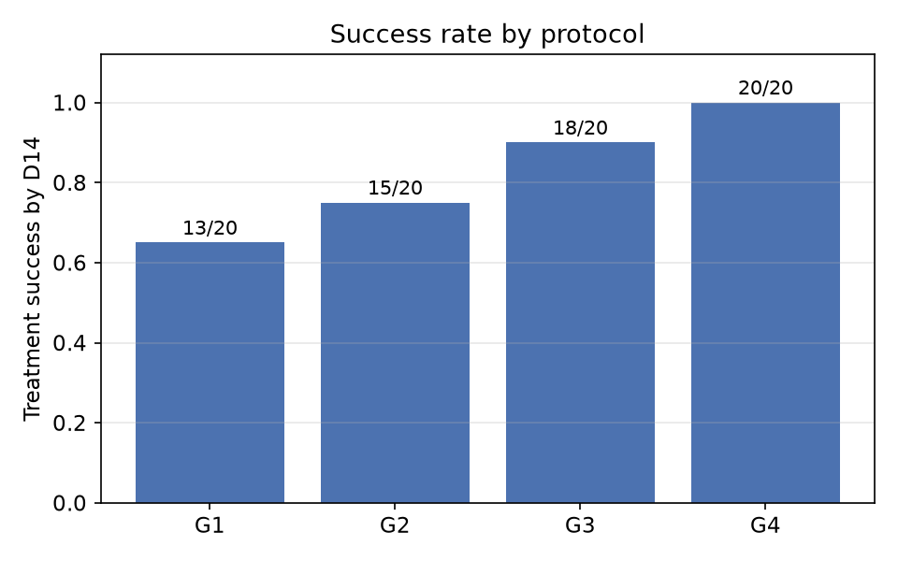
Figure 1. Observed day-14 treatment success by protocol (all 80 dogs).
Comparing dogs that failed treatment (n = 14, pooled across protocols) with those that succeeded (n = 66), renal markers, hepatic markers and hypoalbuminaemia separated the two groups most strongly by univariate ROC-AUC: BUN (0.891), creatinine (0.890), albumin (0.837), ALT (0.835) and ALP (0.831), all p < 0.001 (Table 4). Illness duration and age were weaker secondary signals (AUC 0.73–0.74, p < 0.01); heart rate, total leucocyte count and neutrophil count carried little independent univariate signal (AUC ≤ 0.56).
Table 4. Top univariate predictors of treatment failure vs success (ranked by AUC for failure).
Variable | Failure (n=14) | Success (n=66) | AUC (failure) | p (Mann–Whitney)
BUN (mg/dL) | 30.55 ± 4.88 | 22.43 ± 5.15 | 0.891 | <0.001
Creatinine (mg/dL) | 1.32 ± 0.23 | 0.97 ± 0.22 | 0.890 | <0.001
Albumin (g/dL) | 2.44 ± 0.21 | 2.75 ± 0.23 | 0.837 | <0.001
ALT (U/L) | 101.7 ± 16.5 | 78.1 ± 19.4 | 0.835 | <0.001
ALP (U/L) | 401.5 ± 80.8 | 296.5 ± 71.7 | 0.831 | <0.001
Illness duration (d) | 6.89 ± 2.27 | 5.26 ± 1.70 | 0.735 | 0.006
Age (years) | 7.09 ± 1.29 | 6.07 ± 1.42 | 0.733 | 0.007
Uterine diameter (mm) | 19.51 ± 4.28 | 17.12 ± 3.81 | 0.695 | 0.023

3.2 Medical-failure (prognostic) model
Discrimination was high and stable across all three feature-reduction stages (Table 5): 19 admission variables gave ROC-AUC 0.946 ± 0.078, a 13-variable univariate screen gave 0.951 ± 0.069, and the minimal 3-variable RFECV set (BUN, ALP, albumin) gave 0.953 ± 0.061 — the single highest point estimate of any stage. The top six algorithms at the final RFECV stage differed by less than one cross-validation standard deviation (Table 6, Figure 2); the interpretable L2-logistic model performed within 0.004 AUC of the nominal best (QDA) while giving directly interpretable odds ratios. As described in Section 2.5, the model we deployed adds three clinically established variables (creatinine, age, illness duration) to this minimal set; the resulting six-variable model achieved closely comparable discrimination, ROC-AUC 0.948 ± 0.066. Across every stage and both the three- and six-variable fits, higher BUN, creatinine and ALP, and lower albumin, consistently raised the probability of medical failure.
Table 5. Prognostic (medical-failure) model — three-stage feature reduction.
Stage | Predictors | Best model | ROC-AUC
A — all admission variables | 19 | Random forest | 0.946 ± 0.078
B — univariate screen | 13 | Random forest | 0.951 ± 0.069
C — RFECV | 3 | QDA | 0.953 ± 0.061
Table 6. Algorithm comparison at the final (RFECV) prognostic-model stage.
Model | ROC-AUC | Sensitivity | Specificity | F1
QDA | 0.953 ± 0.061 | 0.583 ± 0.299 | 0.980 ± 0.042 | 0.666 ± 0.273
Gaussian NB | 0.949 ± 0.066 | 0.700 ± 0.252 | 0.926 ± 0.084 | 0.709 ± 0.218
Logistic (L2) | 0.949 ± 0.062 | 0.840 ± 0.228 | 0.853 ± 0.132 | 0.730 ± 0.174
Logistic (elastic net) | 0.947 ± 0.065 | 0.810 ± 0.231 | 0.849 ± 0.139 | 0.710 ± 0.182
LDA | 0.944 ± 0.068 | 0.607 ± 0.290 | 0.946 ± 0.077 | 0.650 ± 0.258
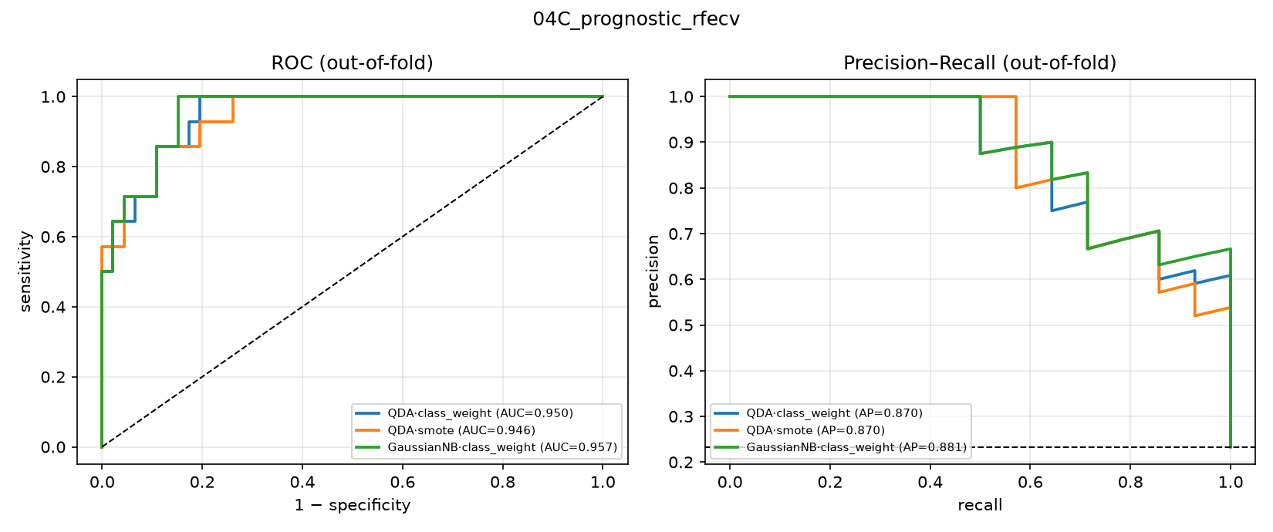
Figure 2. Medical-failure model — out-of-fold ROC and precision–recall curves for the top three algorithms at the final feature-reduction stage.
In the deployed six-variable logistic model, ALP (odds ratio 3.12 per SD), BUN (OR 2.81) and lower albumin (OR 0.40) carried the largest weight, followed by age (OR 2.37), creatinine (OR 2.21) and illness duration (OR 1.34) (Table 7). We report these as penalised point estimates without asymptotic confidence intervals: an unpenalised (ordinary maximum-likelihood) fit of the identical six-variable model on the same 60 dogs produces materially larger and highly unstable estimates (e.g. ALP OR 12.9, 95% CI 0.64–259), a direct symptom of quasi-complete separation at 14 events for 6 predictors (events-per-variable ≈ 2.3). The L2 penalty exists specifically to stabilise the deployed model against this instability; we therefore assess its reliability through the cross-validated discrimination metrics above and in Table 8, not through Wald confidence intervals on the penalised coefficients.
Table 7. Deployed six-variable medical-failure model — penalised (L2) logistic-regression coefficients, the same coefficients the risk score (Table 12) is built from.
Term | Coefficient (per SD) | OR (per SD)
Alkaline phosphatase (ALP) | +1.14 | 3.12
Blood urea nitrogen (BUN) | +1.03 | 2.81
Age | +0.87 | 2.37
Creatinine | +0.79 | 2.21
Illness duration | +0.29 | 1.34
Albumin | −0.92 | 0.40

3.3 Treatment-success model
Discrimination for treatment success rose modestly across the feature-reduction stages: 20 variables + protocol gave ROC-AUC 0.955 ± 0.088, an 11-variable screen + protocol gave 0.960 ± 0.088, and a 4-variable RFECV set + protocol gave 0.972 ± 0.037 (Table 8). The deployed nine-variable-plus-protocol model — chosen for its clinical completeness and interpretability rather than the smallest AUC-optimal set — achieved ROC-AUC 0.905 ± 0.079 under its own cross-validation (Figure 3); we treat this as the single pre-specified primary estimate reported in the Abstract and Conclusion. Two secondary checks (§2.7) reproduced it closely rather than contradicting it: an independently implemented scikit-learn pipeline on the identical variable set gave 0.925 ± 0.075, and nested cross-validation gave closely comparable plain and nested estimates (0.921 ± 0.072 vs. 0.922 ± 0.073) — evidence against substantial tuning optimism, though with only 14 failure events the uncertainty around all three numbers is itself wide. At the conventional 0.5 probability threshold, the deployed model reached accuracy 84.6% ± 7.6 pp, sensitivity 87.1% ± 8.0 pp, specificity 72.2% ± 28.5 pp, and F1 0.902 ± 0.050; the wide specificity interval reflects the small number of failure events (14/80) available to estimate it.
Table 8. Treatment-success model — three-stage feature reduction (protocol retained at every stage).
Stage | Predictors | Best model | ROC-AUC
A — all variables + protocol | 20 | Gaussian NB | 0.955 ± 0.088
B — univariate screen + protocol | 11 | Gaussian NB | 0.960 ± 0.088
C — RFECV + protocol | 4 | Linear SVM | 0.972 ± 0.037
G1–G3 sensitivity (protocol dropped) | 10 | Gaussian NB | 0.947 ± 0.080
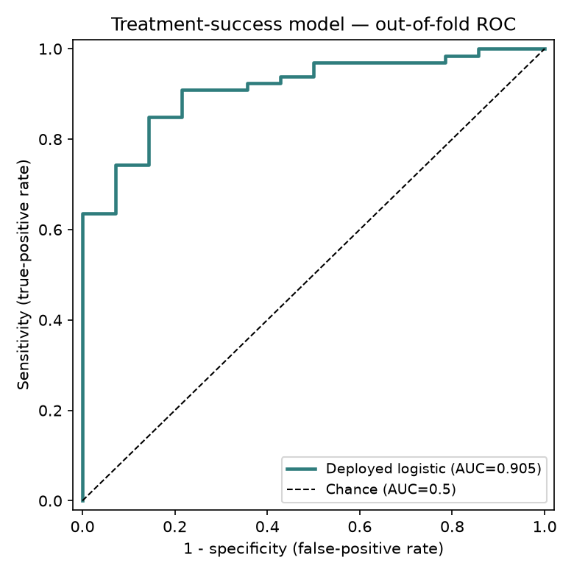
Figure 3. Deployed treatment-success model (9 admission variables + protocol) — out-of-fold ROC curve, one complete cross-validation pass.
The 15-algorithm bake-off on the deployed nine-variable design (Table 9) again showed every credible algorithm within a narrow, heavily overlapping band (ROC-AUC 0.89–0.95). Gaussian NB nominally ranked first (AUC 0.953) but showed poor calibration (Brier 0.29) and low raw accuracy (65.7%, below the 82.5% majority-class baseline) — a high rank with an unreliable predicted probability. The deployed L2-logistic model ranked fourth by AUC (0.925) but combined competitive discrimination with the best interpretability and the lowest tuning optimism of any algorithm tested.
Table 9. Algorithm bake-off on the deployed treatment-success design — every metric (class-weight-balanced models, top 12 of 15, ranked by ROC-AUC).
Model | ROC-AUC | Accuracy | Sensitivity | Specificity | F1
Gaussian NB | 0.953 ± 0.090 | 65.7% ± 10.2 | 59.1% ± 12.2 | 97.3% ± 13.1 | 0.732 ± 0.103
LDA | 0.933 ± 0.067 | 86.9% ± 5.9 | 94.2% ± 6.2 | 52.0% ± 27.8 | 0.922 ± 0.037
Random forest | 0.931 ± 0.053 | 87.4% ± 6.4 | 94.1% ± 5.3 | 55.7% ± 28.2 | 0.925 ± 0.039
Logistic (L2) — deployed | 0.925 ± 0.075 | 85.5% ± 6.7 | 89.2% ± 6.1 | 68.7% ± 32.3 | 0.910 ± 0.042
Logistic (elastic net) | 0.919 ± 0.077 | 84.9% ± 7.1 | 87.4% ± 7.6 | 74.0% ± 28.3 | 0.904 ± 0.046
AdaBoost | 0.918 ± 0.074 | 87.3% ± 7.8 | 93.5% ± 6.4 | 57.7% ± 30.0 | 0.923 ± 0.048
RBF SVM | 0.917 ± 0.068 | 85.3% ± 6.5 | 95.9% ± 5.5 | 36.3% ± 24.2 | 0.916 ± 0.036
Logistic (L1/LASSO) | 0.913 ± 0.087 | 83.5% ± 9.1 | 83.0% ± 10.1 | 86.3% ± 23.5 | 0.890 ± 0.065
Linear SVM | 0.910 ± 0.081 | 84.0% ± 6.9 | 96.1% ± 5.1 | 33.3% ± 26.0 | 0.913 ± 0.033
Hist. gradient boosting | 0.906 ± 0.082 | 85.9% ± 6.7 | 93.2% ± 6.4 | 52.7% ± 31.2 | 0.915 ± 0.042
KNN | 0.901 ± 0.092 | 85.6% ± 5.3 | 98.5% ± 3.4 | 25.0% ± 24.8 | 0.919 ± 0.031
Gradient boosting | 0.894 ± 0.077 | 84.5% ± 6.5 | 93.5% ± 7.0 | 42.7% ± 26.1 | 0.908 ± 0.043
In the deployed model, alkaline phosphatase carried the largest standardised weight against success, followed by albumin (protective), creatinine, age and ALT; heart rate, illness duration and neutrophil count were weaker; total leucocyte count carried essentially no independent weight once the other admission values and protocol were accounted for (Table 10). Relative to G1 (reference), the protocol terms tracked the observed success gradient (G2 −0.13, G3 +0.57, G4 +1.23 log-odds), consistent with Table 3; as described in Section 2.4, the G4 estimate reflects the observed 20/20 cohort rate rather than an extrapolated probability, because that arm is perfectly separated.
Table 10. Deployed treatment-success model — standardised coefficients (log-odds toward success per 1 SD; protocols vs. G1).
Term | Coefficient
Alkaline phosphatase (ALP) | −1.01
Serum albumin | +0.83
Serum creatinine | −0.70
Age | −0.64
Alanine aminotransferase (ALT) | −0.30
Heart rate | −0.21
Illness duration | −0.19
Neutrophil count | −0.15
Total leucocyte count | +0.01
Protocol G2 vs. G1 | −0.13
Protocol G3 vs. G1 | +0.57
Protocol G4 vs. G1 | +1.23 (see caveat, §2.4)
Predicted-probability bands calibrated adequately against observed outcome: of cases the model rated “Likely” (>85% predicted, n = 41), 100% resolved; of cases rated “Uncertain” (50–85%, n = 18), 100% resolved; of cases rated “Unlikely” (<50%, n = 21), 33% resolved. As is typical for a small, largely separable dataset, the model is over-confident near the extremes, which is why the tool built on it (Section 4) surfaces the band rather than the raw percentage as the primary readout.

3.4 Recovery-time regression
None of the four regression algorithms explained meaningful variance in days-to-resolution from admission variables (best model, random forest: MAE 0.98 ± 0.20 days, RMSE 1.22 ± 0.23 days, R² −0.26 ± 0.40; Table 11) — an honest null result rather than a modelling failure, since a negative cross-validated R² means admission severity in this cohort carried no detectable dose–response relationship with time-to-resolution once a dog was set to recover. Mean recovery time nonetheless tracked protocol (G1 5.27 ± 1.45 d, G2 5.37 ± 1.16 d, G3 5.01 ± 0.95 d, G4 4.59 ± 1.02 d), and BUN was the only admission variable with a significant univariate association with recovery time (Spearman ρ = 0.33, p = 0.004).
Table 11. Recovery-time regression — four algorithms compared (n = 74 resolvers).
Model | MAE (days) | RMSE (days) | R²
Random forest | 0.98 ± 0.20 | 1.22 ± 0.23 | −0.26 ± 0.40
KNN | 0.99 ± 0.19 | 1.23 ± 0.20 | −0.28 ± 0.37
Linear regression | 1.15 ± 0.21 | 1.42 ± 0.24 | −0.76 ± 0.66
Decision tree | 1.19 ± 0.21 | 1.46 ± 0.25 | −0.94 ± 0.97

3.5 Missing-data robustness
On a copy of the dataset with ~5% of cells blanked at random, iterative (round-robin regression) imputation reproduced the true values most closely (standardised RMSE 0.98), ahead of mean, median and 5-nearest-neighbour imputation (RMSE 1.14–1.15). Downstream prognostic-model discrimination was stable across all four imputers (ROC-AUC 0.85–0.94 depending on algorithm and imputer), indicating the pipeline is not brittle to modest missingness — a relevant reassurance given that a real clinical cohort will not arrive as complete as the dataset used here.

3.6 Admission risk score and protocol recommendation
Rounding the deployed medical-failure model's own six coefficients (Table 7) to integer points (Table 12) and grouping dogs into Low, Medium and High risk strata by score tertile reproduced the model's discrimination in an exploratory, integer-point score: observed success was 100% in both the Low stratum (n = 27) and the Medium stratum (n = 26), and 48.1% in the High stratum (n = 27) — equivalently, 51.9% observed medical failure in the High stratum (Table 13). Because Low and Medium performed identically in this dataset, the discrimination the score adds over chance comes almost entirely from separating the High stratum from the rest.
Table 12. Admission risk score — the deployed medical-failure model's own coefficients (Table 7), rounded to integer points per 1 SD.
Variable | OR (per SD) | Points (per SD)
Alkaline phosphatase (ALP) | 3.12 | +4
Blood urea nitrogen (BUN) | 2.81 | +4
Age | 2.37 | +3
Creatinine | 2.21 | +3
Illness duration | 1.34 | +1
Albumin | 0.40 | −3
Table 13. Observed success by risk stratum and protocol (success / n per cell).
Risk stratum | n | Overall success | G1 | G2 | G3 | G4
Low | 27 | 27/27 (100%) | 6/6 | 7/7 | 7/7 | 7/7
Medium | 26 | 26/26 (100%) | 6/6 | 7/7 | 7/7 | 6/6
High | 27 | 13/27 (48.1%) | 1/8 | 1/6 | 4/6 | 7/7
Read cautiously — this cross-tabulation is observational and non-causal, not a randomised comparison, and several cells are small (e.g. G3 in the High stratum is 4/6 dogs) — the pattern is nonetheless a clear, testable hypothesis: in the Low and Medium strata, every protocol including supportive care alone performed at or near ceiling; in the High stratum, observed success collapsed for supportive care and cloprostenol alone (1/8 and 1/6) while aglepristone plus cloprostenol held up markedly better (4/6) and surgery resolved every case (7/7). This is precisely the kind of admission-risk-stratified comparison the prototype in Section 4 is built to surface case-by-case, pending prospective validation.

4. Web-Deployed Research Prototype
The final treatment-success model (§2.4) is deployed as an open, research-use prediction prototype (a browser-based single-page application; the model coefficients ship as a small JSON file and every prediction is computed client-side, so no case data leaves the device). A user selects an intended protocol and enters the nine admission values; the tool returns the predicted probability of treatment success, the corresponding band (Unlikely / Uncertain / Likely), the admission values pushing the estimate up or down, the observed cohort success rate for the chosen protocol, and — generated on demand — a plain-English summary of the case. The same page publishes the full validation reported in Section 3.3 (the algorithm bake-off, the ROC curve, and every classification metric) so that a viewer can audit the model rather than take the headline number on faith, and it displays a persistent disclaimer that it is a decision-support estimate from a small, single-source retrospective case series, not a validated clinical tool, and that it complements rather than replaces clinical judgement. Python and JavaScript implementations of the prediction formula are cross-checked automatically on every change to guarantee they agree to the displayed percentage point.

5. Discussion
Using the same three-stage, multi-algorithm ML workflow recently reported for canine parvovirus enteritis (Sanaei et al., 2025), we built and openly deployed a treatment-success model for canine pyometra with a cross-validated ROC-AUC around 0.90–0.93, closely comparable to the 0.90 reported for parvovirus outcome, and a medical-failure model with ROC-AUC 0.95, comparable to the discrimination reported for other small-animal ML screening tools such as Cushing's syndrome detection from primary-care records (Schofield et al., 2021) and leptospirosis screening (Reagan et al., 2022). The admission variables that drove both models — azotaemia (BUN, creatinine), hepatic enzyme elevation (ALP, ALT) and hypoalbuminaemia — line up closely with the individual prognostic markers already reported in the pyometra literature (Jitpean et al., 2014; Demeli & Meyer, 2023), which is reassuring: the selected predictors are biologically plausible and broadly consistent with prior pyometra literature, and the pipeline's contribution is combining markers clinicians already know matter into one number rather than asking a clinician to weigh five separate lab values in their head.
One point of contrast with the existing literature is instructive. Jitpean et al. (2014) identified leucopenia as their strongest single marker of a complicated postoperative course in 356 surgically treated dogs, whereas total leucocyte count and neutrophil count carried almost no independent weight in either model here once renal and hepatic markers, age and (for the treatment model) protocol were accounted for. The most likely explanation is a difference in outcome definition and case mix rather than a contradiction: Jitpean et al. studied peritonitis and prolonged hospitalisation after surgery in an unselected surgical population, where a falling white-cell count can signal an overwhelmed bone marrow in a septic, deteriorating patient; our outcome is day-14 resolution across a cohort with balanced admission severity and (by construction) no missing data, in which leucocyte counts may simply carry less incremental information once the renal/hepatic markers already dominate. This is exactly the kind of question a validation run on a real, unselected clinical cohort — with real missingness and real severity imbalance — would resolve, and it is a concrete, falsifiable prediction this study leaves on the table.
No single algorithm was reliably the most accurate at any stage of this analysis: across fifteen algorithms tested on the deployed nine-variable design, cross-validated ROC-AUC spanned only 0.89–0.95, and the confidence intervals overlapped almost completely. This pattern — also seen in the medical-failure and CPV-outcome bake-offs — is a direct consequence of a small failure count (14/80 here; comparably few non-survivors in most single-centre veterinary series) rather than a property of any one algorithm, and it argues against choosing a deployed model by leaderboard rank alone. Gaussian naive Bayes illustrates the trap concretely: it ranked first by ROC-AUC in the treatment-success bake-off (0.953) yet had the second-worst raw accuracy of any algorithm tested (65.7%, below the 82.5% majority-class baseline) and a Brier score more than double the next-best model — a well-ranked but poorly calibrated model that would systematically mislead a clinician reading the number as a probability. We instead selected the deployed logistic-regression model on interpretability, on its practicality to deploy and audit client-side, and — most importantly — on plain-CV and nested-CV estimates that agreed closely (Guyon et al., 2002; Nahm, 2022), which is a more decision-relevant property than a marginal AUC advantage on a dataset this size; with only 14 failure events, however, meaningful uncertainty remains around every estimate in this comparison, nested-CV included.
The surgical arm (G4) resolved every case in this dataset (20/20; exact 95% CI 83.2–100%), which is both an expected finding — ovariohysterectomy removes the diseased organ and is widely regarded as the definitive treatment (Hagman, 2018) — and a statistical inconvenience, since perfect separation means no finite, calibrated probability can be estimated for it from these data. We handled this the way any careful implementation should: by reporting the observed cohort rate for that arm with an explicit caveat rather than an extrapolated model output, and by fitting a G1–G3-only sensitivity model to confirm the medical-protocol findings were not an artefact of that arm's presence (ROC-AUC 0.947 ± 0.080, materially unchanged). The clinically relevant contrast is between medical management's fertility-sparing benefit at a real relapse/failure cost — roughly 23% medical failure across G1–G3 here, in the same range as the 8–17% relapse rates reported for aglepristone-based protocols in the literature (Fieni, 2006) — against surgery resolving every case in this cohort, at the cost of losing reproductive capacity and undergoing an operation in a systemically ill patient. Our risk-stratified cross-tabulation (§3.6) suggests this trade-off is not uniform, though — as an observational, non-randomised comparison on n = 80 — it should be read as a hypothesis, not an effect estimate: at low-to-intermediate admission risk every protocol performed near ceiling in this dataset, so preserving fertility with supportive care alone looks reasonable, whereas at high admission risk, medical management without aglepristone performed poorly here and surgery's observed advantage was largest — precisely the situation in which a fast, at-a-glance risk estimate at admission would be most useful to a clinician and an owner deciding together, pending prospective confirmation.
The absence of any admission-variable signal for recovery time is worth dwelling on rather than dismissing. Sanaei et al. (2025) found real predictors of survival/recovery time for parvovirus enteritis using haematology and biochemistry variables; we found none for pyometra resolution time in this cohort (best cross-validated R² was negative for every algorithm tested). A plausible interpretation is that, once a case is set on a successful trajectory (as the great majority in this balanced cohort were), the residual variation in days-to-resolution is driven by factors not captured in a single admission panel — individual healing rate, exact surgical or drug timing, owner-driven discharge timing — rather than by how sick the dog was at hour zero. This null result is itself a useful, transferable finding for anyone building a similar tool: it predicts that a recovery-time regression is unlikely to be worth the modelling effort for this outcome unless a richer feature set (e.g., serial post-treatment values rather than admission values alone) is used.
Finally, and most importantly for how these results should be read: every number above comes from a single retrospective case series with no documented enrolment criteria, allocation procedure, or external validation — the ordinary limitations of a single-source retrospective series, not a synthetic or illustrative exercise. That is precisely why we built and are publishing the pipeline itself, rather than only the numbers it produced here — the code, the feature-reduction workflow, the 15-algorithm validation harness, and the deployed prototype are all openly available (Data Availability Statement) so that the exact same, now-documented process can be re-run, unmodified, on an independently collected clinical cohort. Until that replication is done, every model, coefficient, and cut-point reported here should be read as hypothesis-generating — not as a validated clinical tool.

5.1 Limitations
- This is a single, retrospective case series with 20 dogs per protocol and no documented, pre-specified enrolment or protocol-allocation procedure. Without that documentation, the possibility that protocol assignment tracked case severity or clinician/owner preference cannot be excluded (see also Limitation 4); this is the primary limitation governing every result in this study, and all findings are hypothesis-generating pending replication on an independently collected, prospectively documented clinical cohort.
- The treatment-success model was fitted on n = 80 with only 14 failure events, an events-per-variable ratio of roughly 1.2 for a nine-variable-plus-protocol model — far below the conventional rule-of-thumb of ≥10 — which produces wide confidence intervals and likely over-confidence near 0% and 100% (§3.3). The medical-failure model (n = 60, 14 events, 6 variables; EPV ≈ 2.3) is in a similar position, which is why we report its coefficients as penalised point estimates without asymptotic confidence intervals (§3.2) rather than implying a precision the data do not support.
- The surgical protocol (G4) is perfectly separated on outcome (20/20 success, exact 95% CI 83.2–100%); its model coefficient cannot be interpreted as a calibrated probability, and the deployed tool substitutes the observed cohort rate with an explicit caveat.
- Protocol assignment was not randomised for baseline severity within this dataset, so every protocol-outcome association reported here (Tables 3, 9, 13) is observational, not causal; unmeasured confounding by clinical severity, fertility goals, cost and clinician or owner preference cannot be excluded.
- No external or prospective validation was performed; all reported discrimination is internal, cross-validated performance on the same 80-dog dataset used to build the models.
- Death (1/80) and six-month recurrence (4/80) were too rare to model and are reported descriptively only. Litter size, pregnancy outcome and days-to-next-oestrus were missing for 42.5–62.5% of dogs (recorded only for a subset followed through a subsequent breeding attempt) and were not analysed in this manuscript.
- A related 240-case retrospective sheet in the source workbook carried no outcome column and could support only case-mix description, not prognostic validation, and was not used in the modelling reported here.
- The recovery-time analysis (§3.4) was restricted to the 74 dogs with a recorded resolution date; conditioning on resolution is a form of selection and the negative result should not be extrapolated to dogs that failed to resolve.

6. Conclusion
A compact, interpretable logistic-regression model built from nine routinely available admission values — age, illness duration, heart rate, total leucocyte count, neutrophil count, creatinine, albumin, alkaline phosphatase and alanine aminotransferase — plus the intended treatment protocol, discriminated treatment success in canine pyometra with a pre-specified primary ROC-AUC of 0.91, reproduced within 0.02 AUC by an independent implementation and by nested cross-validation. A companion six-variable model, using the same locked coefficients throughout this manuscript, discriminated medical-management failure with ROC-AUC 0.95, and an integer point score built directly from it separated a combined low/intermediate stratum with 0% observed medical failure (n = 53) from a high-risk stratum with 52% observed medical failure (n = 27); within that high-risk stratum, observed success ranged from 12% to 100% across protocols in this dataset — an observational association worth testing prospectively, not a causal claim. Both models, the full validation record, and an open research-use prototype are published together so the same pipeline can be pointed, unmodified, at a real prospectively collected pyometra cohort — the necessary next step before any of these numbers should inform an actual treatment decision.

Data Availability Statement
The complete analysis code (data audit through model validation), the locked model artefacts, and the source of the deployed web calculator are openly available at the project repository, https://github.com/bhattarya/canine-pyometra-ml. The deployed calculator is live at https://canine-pyometra-ml.vercel.app/. Records are identified only by a non-identifying study code (e.g. PY001); no owner names, clinic identifiers, or other directly identifying information are included. The corresponding author should confirm before submission that the source clinic/owner records permit this level of open publication, consistent with the ethics/consent statement above.

Author Contributions
[To be completed by the authors — suggested categories: conceptualisation, data curation, formal analysis, methodology, software, validation, writing — original draft, writing — review and editing, supervision.]

Funding
[To be completed — state funding source(s) or declare that no external funding was received.]

Conflict of Interest
The authors declare that the research was conducted in the absence of any commercial or financial relationships that could be construed as a potential conflict of interest.

Generative AI Statement
The data-analysis pipeline, statistical/machine-learning code, and the web-deployed calculator described in this manuscript were developed with the assistance of an AI coding assistant (Claude, Anthropic) under the authors' direction and review. This manuscript draft was likewise prepared with AI assistance from the project's own committed results and figures; all content was reviewed, and must be further verified and approved, by the human author(s) before submission or presentation.

References
1. Akinsulie OC, Idris I, Aliyu VA, Shahzad S, Banwo OG, Ogunleye SC, et al. The potential application of artificial intelligence in veterinary clinical practice and biomedical research. Front Vet Sci. 2024;11:1347550. doi:10.3389/fvets.2024.1347550
2. Demeli D, Meyer G. The assessment of haematologic and serum chemistry parameters in canine pyometra: a systematic review and meta-analysis. J Small Anim Pract. 2023;64(9):543–551. doi:10.1111/jsap.13641
3. Egenvall A, Hagman R, Bonnett BN, Hedhammar Å, Olson P, Lagerstedt AS. Breed risk of pyometra in insured dogs in Sweden. J Vet Intern Med. 2001;15(6):530–538. doi:10.1111/j.1939-1676.2001.tb01587.x
4. Fieni F. Clinical evaluation of the use of aglepristone, with or without cloprostenol, to treat cystic endometrial hyperplasia–pyometra complex in bitches. Theriogenology. 2006;66(6–7):1550–1556. doi:10.1016/j.theriogenology.2006.01.023
5. Fransson BA, Karlstam E, Bergström A, Lagerstedt AS, Park JS, Evans MA, Ragle CA. C-reactive protein in the differentiation of pyometra from cystic endometrial hyperplasia/mucometra in dogs. J Am Anim Hosp Assoc. 2004;40(5):391–399. doi:10.5326/0400391
6. Guyon I, Weston J, Barnhill S, Vapnik V. Gene selection for cancer classification using support vector machines. Mach Learn. 2002;46:389–422. doi:10.1023/A:1012487302797
7. Hagman R. Pyometra in small animals. Vet Clin North Am Small Anim Pract. 2018;48(4):639–661. doi:10.1016/j.cvsm.2018.02.007
8. Jitpean S, Ström-Holst B, Emanuelson U, Höglund OV, Pettersson A, Alneryd-Bull C, Hagman R. Outcome of pyometra in female dogs and predictors of peritonitis and prolonged postoperative hospitalization in surgically treated cases. BMC Vet Res. 2014;10:6. doi:10.1186/1746-6148-10-6
9. Nahm FS. Receiver operating characteristic curve: overview and practical use for clinicians. Korean J Anesthesiol. 2022;75(1):25–36. doi:10.4097/kja.21209
10. Reagan KL, Deng S, Sheng J, Sebastian J, Wang Z, Huebner SN, et al. Use of machine-learning algorithms to aid in the early detection of leptospirosis in dogs. J Vet Diagn Invest. 2022;34(4):612–618. doi:10.1177/10406387221096781
11. Sanaei N, Zamani-Ahmadmahmudi M, Nassiri SM. Development of machine learning models to predict clinical outcome and recovery time in dogs with parvovirus enteritis. Front Vet Sci. 2025;12:1555714. doi:10.3389/fvets.2025.1555714
12. Schofield I, Brodbelt DC, Kennedy N, Niessen SJM, Church DB, Geddes RF, et al. Machine-learning based prediction of Cushing's syndrome in dogs attending UK primary-care veterinary practice. Sci Rep. 2021;11:9035. doi:10.1038/s41598-021-88440-z
13. Xavier RGC, Santana CH, de Castro YG, de Souza TGV, do Amarante VS, Santos RL, Silva ROS. Canine pyometra: a short review of current advances. Animals. 2023;13(21):3310. doi:10.3390/ani13213310

Supplementary Figure S1
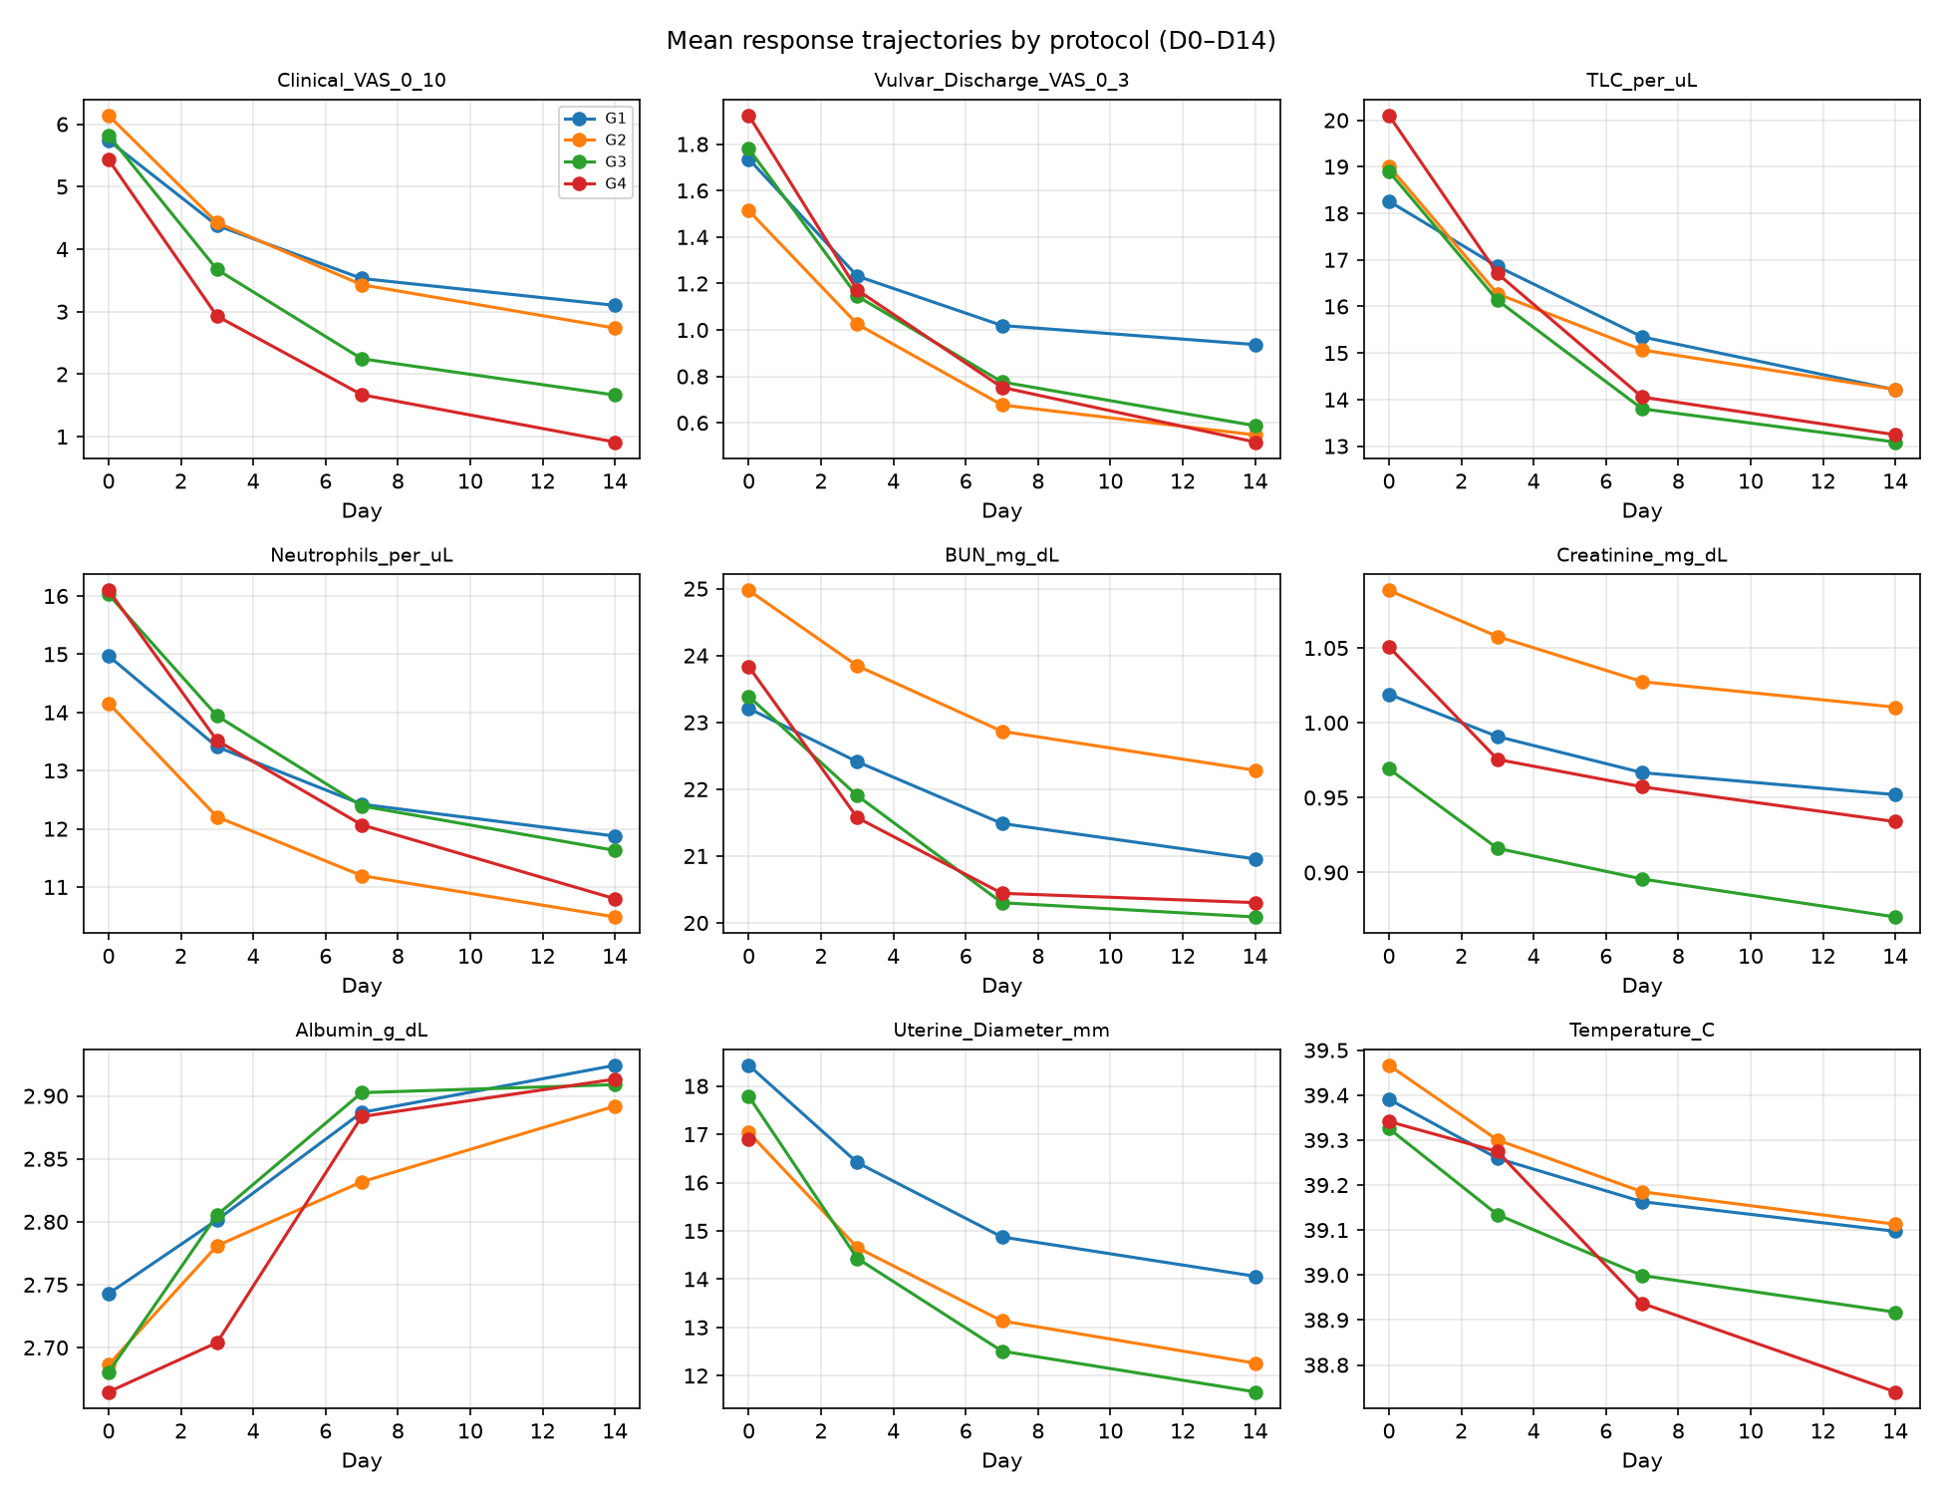
Figure S1. Mean trajectories of nine repeated clinical/laboratory variables by protocol, days 0–14 (mixed-effects model, dog as random intercept). All nine variables showed a significant Day effect (p < 0.001); seven of nine showed a significant Group × Day interaction, indicating the rate of improvement, not only the admission value, differed by protocol.

