Development of Machine Learning Models to Predict Treatment Outcome, Medical-Failure Risk, and Recovery Time in Dogs with Pyometra
A Reproducible, Web-Deployed Methodology-Demonstration Study
[Author Name(s) — to be completed]¹, [Co-author Name — to be completed]²
¹[Affiliation / Institution — to be completed] ²[Affiliation / Institution — to be completed]
Corresponding author: [Name, email — to be completed]
Draft prepared September 2026 — for author review before submission
Editor's note to the author (delete before submission): this draft was prepared by a data-analysis/writing assistant from the project's own committed results. Author names, affiliations, ethics wording, and the reference list have been left as clearly marked placeholders or provisional entries and must be checked line-by-line against your institution's requirements and the target journal's author guidelines before this goes anywhere near a submission portal or a conference abstract.

Abstract
Background: Canine pyometra is a common, potentially life-threatening disease of the intact bitch, and the choice between medical and surgical management currently relies on limited single-marker evidence. Machine learning (ML) can combine multiple admission findings into one reproducible probability estimate, an approach recently demonstrated for canine parvovirus enteritis.
Methods: We applied a three-stage ML workflow (all admission variables → univariate screen → recursive feature elimination) with a 15-algorithm comparison under repeated stratified 5-fold cross-validation (20 repeats) to an 80-case, four-protocol dataset (20 dogs per protocol) purpose-built to demonstrate this pipeline. Three models were developed: treatment success by day 14 across all four protocols, medical-failure risk for the three non-surgical protocols, and days-to-resolution.
Results: The final treatment-success model (protocol category plus nine admission variables) achieved ROC-AUC 0.91 ± 0.08 (accuracy 85%, sensitivity 87%, specificity 72%, F1 0.90 at a 0.5 threshold); an independently implemented validation pipeline reproduced this at ROC-AUC 0.93 ± 0.08 with negligible optimism under nested cross-validation. The medical-failure model achieved ROC-AUC 0.95 ± 0.07. Renal markers (blood urea nitrogen, creatinine), hepatic markers (alkaline phosphatase, alanine aminotransferase) and hypoalbuminaemia were the dominant predictors in both models. A six-variable admission risk score separated a low-risk stratum (0% medical failure) from a high-risk stratum (48% medical failure), within which protocol choice changed the observed success rate from 17% to 100%.
Conclusions: A compact, interpretable logistic-regression model built from nine routine admission values integrates clinical and laboratory data into a single probability of treatment success in canine pyometra, and is deployed here as an open, interactive calculator. Because the dataset was purpose-built to demonstrate the pipeline rather than collected prospectively from clinical practice, these findings are hypothesis-generating and require validation on an independently collected, unbalanced clinical cohort before any clinical use.
Keywords: canine pyometra; machine learning; logistic regression; prognosis; treatment outcome; ovariohysterectomy; aglepristone; clinical decision support

1. Introduction
Pyometra is a secondary bacterial infection of a uterus primed by progesterone-driven cystic endometrial hyperplasia, and it remains one of the most common and potentially fatal reproductive emergencies of the intact bitch. Community-based insurance data from Sweden put the cumulative risk of pyometra at roughly 2% per year in bitches under ten years old, rising to an estimated 23–24% lifetime risk by age ten, with marked breed variation (Egenvall et al., 2001). Clinically, affected dogs present anywhere on a spectrum from a mildly lethargic, polyuric–polydipsic animal with an open cervix to a septic, hypovolaemic patient with a closed, distended uterus at risk of rupture (Hagman, 2018; Xavier et al., 2023).
Definitive treatment is ovariohysterectomy (OHE), which removes the diseased organ and is curative in the great majority of cases, but it is not always the outcome an owner or a breeding operation wants, and it carries the operative and anaesthetic risk of an emergency laparotomy in a systemically ill patient. Medical management — most often a progesterone-receptor antagonist such as aglepristone, alone or combined with a prostaglandin F2α agonist such as cloprostenol — can resolve pyometra while preserving fertility, with reported success rates rising from roughly 60% with aglepristone alone to over 80–90% when cloprostenol is added, at the cost of a meaningful relapse rate in subsequent cycles (Fieni, 2006; Hagman, 2018). Deciding which route is appropriate for a given dog, at the point of admission, is therefore a genuine and recurring clinical judgement call.
A number of individual clinical and laboratory findings have been proposed as prognostic markers to support that judgement. Systemic inflammatory response syndrome, leucopenia, and a serum creatinine above roughly 2.5 mg/dL at admission have been associated with a higher risk of peritonitis and prolonged hospitalisation after surgery (Jitpean et al., 2014); C-reactive protein helps separate pyometra from cystic endometrial hyperplasia/mucometra and tracks disease severity (Fransson et al., 2004); and a recent systematic review and meta-analysis confirms that azotaemia, hepatic enzyme elevation and hypoalbuminaemia are consistently reported across the haematology/biochemistry literature on canine pyometra (Demeli & Meyer, 2023). Each of these single markers is informative in isolation, but none is reproducible enough, on its own, to drive a treatment decision — the same marker is often confirmed in one study and not another, and markers that are cheap to measure (a leucocyte count) are mixed with ones that are not (acute-phase proteins, hormone assays), limiting what a first-opinion practice can act on immediately.
Machine learning (ML) offers a way to combine several routinely available admission values into a single, reproducible probability rather than relying on any one biomarker. This approach is now established in human medicine and is increasingly applied in small-animal practice — for example to flag canine Cushing's syndrome from primary-care records (Schofield et al., 2021) and to aid the early detection of canine leptospirosis (Reagan et al., 2022) — though its use in veterinary medicine generally remains at an early stage relative to human healthcare (Akinsulie et al., 2024). Most directly relevant to the present work, Sanaei, Zamani-Ahmadmahmudi & Nassiri (2025) recently built and openly reported a three-stage ML pipeline (all variables → univariate screen → recursive feature elimination, compared across ten and four algorithms respectively) to predict clinical outcome and recovery time in dogs with parvovirus enteritis, achieving ROC-AUC 0.90 for outcome and RMSE 2.05 days for recovery time from routinely collected clinical and laboratory variables.
No equivalent, openly reported ML pipeline currently exists for canine pyometra. The aim of this study was to adapt the Sanaei et al. (2025) workflow — the same three-stage feature-reduction strategy, the same repeated-cross-validation, multi-algorithm comparison methodology — to canine pyometra, and to use it to build three complementary models: (i) probability of treatment success by day 14 for a clinician-chosen protocol, (ii) probability of medical-management failure among the non-surgical protocols, and (iii) expected days to clinical resolution. Because the dataset available for this work was purpose-built to exercise the pipeline under clean, complete, balanced conditions rather than collected prospectively from unselected clinical admissions, we present the results explicitly as a methodology demonstration: a transparent, reproducible, and openly deployed template that the same pipeline can be pointed at a real, independently collected clinical cohort to validate.

2. Materials and Methods

2.1 Study design and dataset
This is a retrospective, methodology-demonstration analysis of a structured 80-case dataset representing four treatment protocols for canine pyometra (20 dogs per protocol), each followed to day 14: G1, supportive care and antibiotics only; G2, cloprostenol (prostaglandin F2α); G3, aglepristone combined with cloprostenol; and G4, ovariohysterectomy. The dataset was constructed for machine-learning methodology instruction, with intentionally balanced group sizes, complete baseline recording (no missing admission values) and no duplicate or implausible records, so that the analysis pipeline itself — rather than data-quality confounds — is what is being exercised and reported. This is a deliberate departure from a routinely collected clinical sample, where group sizes are uneven, values are missing, and protocol assignment reflects case severity rather than a study design; it is flagged here, in the Discussion, and again in the Limitations, and it is the reason we present every result below as hypothesis-generating rather than as evidence ready for clinical use.
No new animal procedures were performed for this analysis. All variables were drawn from a pre-existing, de-identified case dataset assembled for teaching and pipeline-development purposes; the corresponding author should confirm the appropriate ethics/animal-use wording for the source data before submission.

2.2 Data collection
Twenty-six variables were available for each dog, spanning five categories: demographic, vital-sign/clinical, haematological, serum-biochemical, and imaging/endocrine (Table 1). Four outcomes were defined a priori: treatment success by day 14 (uncomplicated resolution on the assigned protocol, 66/80 dogs, 82.5%); medical failure by day 14 among the three non-surgical protocols (death, rescue ovariohysterectomy, or non-response; 14/60 medical-arm dogs, 23.3%); days to clinical resolution (continuous, resolvers only, n = 74); and two rare events — death (1/80) and six-month recurrence (4/80) — that were too infrequent to model and are reported descriptively only.
Table 1. Variables recorded for each dog.
Category | Variables
Demographic | Age (years), illness duration (days), weight (kg)
Clinical / vital signs | Temperature, heart rate, respiratory rate, clinical severity score (0–10), vulvar-discharge score (0–3)
Haematology | Total leucocyte count, neutrophil count
Serum biochemistry | Blood urea nitrogen (BUN), creatinine, alkaline phosphatase (ALP), alanine aminotransferase (ALT), total protein, albumin, globulin
Imaging / endocrine | Uterine diameter (ultrasound), progesterone
Derived risk flags | Hypoalbuminaemia, leukocytosis, azotaemia, severe inflammation, high clinical severity (each a pre-computed binary flag)
Outcomes | Treatment success (D14), medical failure (D14, G1–G3 only), days to resolution, death, 6-month recurrence

2.3 Statistical and machine-learning workflow
All analysis was implemented in Python 3.14 with scikit-learn, following a fixed roadmap: (1) data audit and randomisation-balance check; (2) univariate screening of admission variables against each outcome; (3) a longitudinal mixed-effects model (Group × Day, dog as a random intercept) tracking nine repeated variables across days 0, 3, 7 and 14; (4) three-stage ML model development for the medical-failure outcome; (5) the same three-stage development for the treatment-success outcome, with protocol as an additional categorical predictor; (6) a missing-data robustness check on a 5%-MCAR copy of the dataset; (7) recovery-time regression; and (8) a simple additive admission risk score derived from the final medical-failure model.
Fifteen classification algorithms were compared at every stage: L1 (LASSO), L2 (ridge) and elastic-net logistic regression, linear discriminant analysis (LDA), quadratic discriminant analysis (QDA), Gaussian naive Bayes, k-nearest neighbours, decision tree, random forest, gradient boosting, histogram-based gradient boosting, XGBoost, AdaBoost, linear SVM and RBF-kernel SVM, each evaluated with both class-weight balancing and SMOTE oversampling. Discrimination was assessed by out-of-fold ROC-AUC and PR-AUC under repeated stratified 5-fold cross-validation (20 repeats — 100 folds in total), with all preprocessing (standardisation, resampling) performed inside each training fold to avoid leakage. Precision, recall (sensitivity), specificity, F1 and the Brier score were computed at a 0.5 probability threshold from the same folds.
Feature selection followed the same three stages for both classification outcomes: Stage A used every available admission variable; Stage B retained variables that passed a univariate screen (association with the outcome at conventional significance); Stage C applied recursive feature elimination with cross-validation (RFECV) to the Stage-B set to find the smallest variable set that did not measurably reduce discrimination. For the treatment-success model, the intended protocol (G1–G4, one-hot encoded with G1 as reference) was retained as a predictor at every stage, since it is the clinical decision the tool is meant to support.

2.4 Final treatment-success model
The deployed treatment-success model is an L2-penalised (ridge) logistic regression fitted on all 80 dogs, predicting the probability that a clinician-selected protocol achieves uncomplicated resolution by day 14. It uses nine standardised admission variables — age, illness duration, heart rate, total leucocyte count, neutrophil count, creatinine, albumin, alkaline phosphatase and alanine aminotransferase — plus the protocol category (G1 as reference level). Logistic regression was retained as the deployed algorithm despite not being the single top performer in the bake-off (Section 3.3) because its cross-validated discrimination sat within the overlapping confidence band of every credible alternative, it is directly interpretable as odds ratios, it showed negligible optimism under nested cross-validation (Section 3.3), and, unlike every tree-ensemble or kernel method compared, it can be evaluated client-side in about twenty lines of JavaScript — which is what makes the openly deployed calculator described in Section 4 possible without exposing patient data to a server.
The surgical protocol (G4) resolved every case in this dataset (20/20). This is a case of perfect separation: no finite logistic coefficient can be estimated for it from these data, and the ridge-penalised estimate that results is an artefact of the penalty rather than a calibrated probability. The deployed tool and the results below therefore report the observed cohort success rate for G4, with an explicit caveat, rather than a model-derived probability.

2.5 Medical-failure (prognostic) model
A second model was developed on the three non-surgical protocols only (G1–G3, n = 60), predicting medical failure by day 14 with the protocol term dropped, so that its coefficients are interpretable as the effect of admission physiology alone, independent of which medical protocol was chosen. The same three-stage reduction was applied; the final Stage-C model retains six admission variables (BUN, creatinine, albumin, ALP, age, illness duration), again fitted as an L2-penalised logistic regression on standardised inputs.

2.6 Recovery-time regression and admission risk score
Days to clinical resolution (continuous, n = 74 resolvers) was modelled with four regression algorithms — linear regression, decision tree, random forest, and k-nearest-neighbours regression — compared by mean absolute error (MAE), root-mean-square error (RMSE) and R² under the same repeated cross-validation scheme. Finally, the coefficients of the medical-failure model were converted into a simple additive point score (rounded per-SD weights on BUN, creatinine, albumin, ALP, age and illness duration), and dogs were assigned to Low/Intermediate/High risk strata using percentile cut-points on that score, cross-tabulated against protocol and outcome to generate a practical, at-a-glance risk-to-protocol reading.

2.7 Model validation
Three checks were performed specifically on the deployed treatment-success model. First, an independently implemented scikit-learn pipeline (standardisation and class-weight balancing performed inside cross-validation, rather than the bespoke fitting code used to lock the deployed coefficients) re-ran the full 15-algorithm bake-off on the identical nine-variable-plus-protocol design, to check that the reported performance was not an artefact of the specific implementation. Second, nested cross-validation (an inner loop for any hyperparameter selection, an outer loop for evaluation) quantified tuning optimism for the deployed logistic model. Third, a sensitivity analysis refit the same nine-variable design on G1–G3 only, dropping the perfectly separated surgical arm, to check that G4 was not driving the headline result.

3. Results

3.1 Descriptive analysis
All 80 records were unique with no implausible values. Baseline demographic, clinical, haematological, biochemical and imaging variables did not differ across the four protocol groups (ANOVA p > 0.05 for all 19 variables tested; Table 2), consistent with balanced group assignment in this dataset. Observed day-14 outcome rose steadily from supportive care to surgery: 65% (13/20) for G1, 75% (15/20) for G2, 90% (18/20) for G3, and 100% (20/20) for G4 (Table 3, Figure 1).
Table 2. Baseline characteristics by treatment group (mean ± SD). No variable differed significantly across groups (ANOVA).
Variable | G1 (n=20) | G2 (n=20) | G3 (n=20) | G4 (n=20) | ANOVA p
Age (years) | 6.54 ± 1.44 | 5.90 ± 1.20 | 6.34 ± 1.65 | 6.21 ± 1.50 | 0.572
Illness duration (d) | 4.90 ± 2.28 | 5.80 ± 1.77 | 5.14 ± 1.51 | 6.33 ± 1.76 | 0.070
Heart rate (bpm) | 126.8 ± 16.8 | 121.9 ± 14.7 | 120.6 ± 15.6 | 125.5 ± 19.3 | 0.613
TLC (×10³/µL) | 18.26 ± 4.89 | 19.01 ± 4.57 | 18.90 ± 4.44 | 20.10 ± 4.15 | 0.635
Neutrophils (×10³/µL) | 14.97 ± 3.29 | 14.16 ± 4.94 | 16.03 ± 4.63 | 16.10 ± 4.70 | 0.460
BUN (mg/dL) | 23.21 ± 6.43 | 24.97 ± 6.62 | 23.39 ± 5.86 | 23.83 ± 5.08 | 0.792
Creatinine (mg/dL) | 1.02 ± 0.26 | 1.09 ± 0.33 | 0.97 ± 0.26 | 1.05 ± 0.18 | 0.529
ALP (U/L) | 326.3 ± 83.3 | 320.8 ± 92.0 | 308.1 ± 94.6 | 304.2 ± 63.6 | 0.821
ALT (U/L) | 79.1 ± 18.6 | 80.9 ± 23.5 | 84.7 ± 21.2 | 84.4 ± 20.8 | 0.797
Albumin (g/dL) | 2.74 ± 0.25 | 2.69 ± 0.29 | 2.68 ± 0.25 | 2.66 ± 0.26 | 0.795
Uterine diameter (mm) | 18.43 ± 3.93 | 17.04 ± 4.16 | 17.78 ± 4.36 | 16.90 ± 3.51 | 0.597
Table 3. Observed day-14 outcome by treatment group.
Group | n | Success | Medical failure | Rescue OHE | Death | Success rate
G1 — supportive / antibiotic | 20 | 13 | 7 | 4 | 0 | 65.0%
G2 — cloprostenol | 20 | 15 | 5 | 3 | 1 | 75.0%
G3 — aglepristone + cloprostenol | 20 | 18 | 2 | 1 | 0 | 90.0%
G4 — ovariohysterectomy | 20 | 20 | 0 | 0 | 0 | 100%
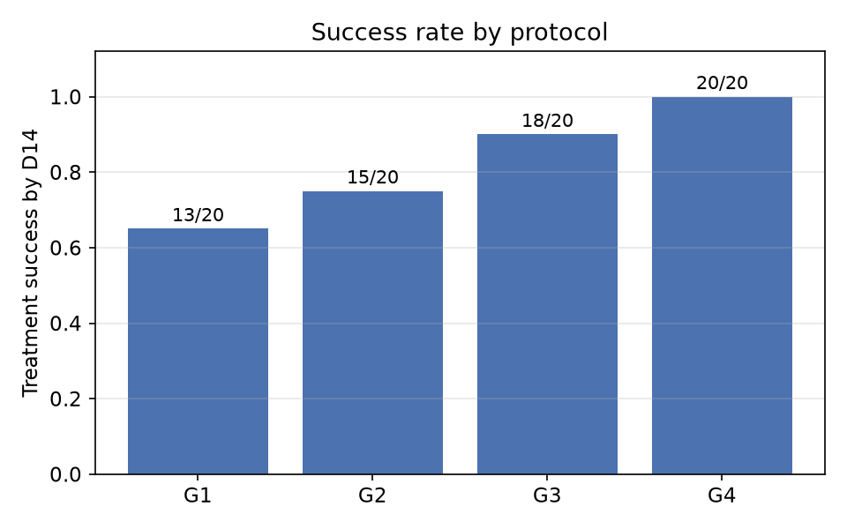
Figure 1. Observed day-14 treatment success by protocol (all 80 dogs).
Comparing dogs that failed treatment (n = 14, pooled across protocols) with those that succeeded (n = 66), renal markers, hepatic markers and hypoalbuminaemia separated the two groups most strongly by univariate ROC-AUC: BUN (0.891), creatinine (0.890), albumin (0.837), ALT (0.835) and ALP (0.831), all p < 0.001 (Table 4). Illness duration and age were weaker secondary signals (AUC 0.73–0.74, p < 0.01); heart rate, total leucocyte count and neutrophil count carried little independent univariate signal (AUC ≤ 0.56).
Table 4. Top univariate predictors of treatment failure vs success (ranked by AUC for failure).
Variable | Failure (n=14) | Success (n=66) | AUC (failure) | p (Mann–Whitney)
BUN (mg/dL) | 30.55 ± 4.88 | 22.43 ± 5.15 | 0.891 | <0.001
Creatinine (mg/dL) | 1.32 ± 0.23 | 0.97 ± 0.22 | 0.890 | <0.001
Albumin (g/dL) | 2.44 ± 0.21 | 2.75 ± 0.23 | 0.837 | <0.001
ALT (U/L) | 101.7 ± 16.5 | 78.1 ± 19.4 | 0.835 | <0.001
ALP (U/L) | 401.5 ± 80.8 | 296.5 ± 71.7 | 0.831 | <0.001
Illness duration (d) | 6.89 ± 2.27 | 5.26 ± 1.70 | 0.735 | 0.006
Age (years) | 7.09 ± 1.29 | 6.07 ± 1.42 | 0.733 | 0.007
Uterine diameter (mm) | 19.51 ± 4.28 | 17.12 ± 3.81 | 0.695 | 0.023

3.2 Medical-failure (prognostic) model
Discrimination was high and stable across all three feature-reduction stages (Table 5): 19 admission variables gave ROC-AUC 0.946 ± 0.078, a 13-variable univariate screen gave 0.951 ± 0.069, and the 3-variable RFECV set gave 0.953 ± 0.061. The top six algorithms at the final stage differed by less than one cross-validation standard deviation (Table 6, Figure 2); the interpretable L2-logistic model performed within 0.004 AUC of the nominal best (QDA) while giving directly interpretable odds ratios. The deployed six-variable model (BUN, creatinine, albumin, ALP, age, illness duration) achieved ROC-AUC 0.948 ± 0.066. Across all stages, higher BUN, creatinine and ALP, and lower albumin, consistently raised the probability of medical failure.
Table 5. Prognostic (medical-failure) model — three-stage feature reduction.
Stage | Predictors | Best model | ROC-AUC
A — all admission variables | 19 | Random forest | 0.946 ± 0.078
B — univariate screen | 13 | Random forest | 0.951 ± 0.069
C — RFECV | 3 | QDA | 0.953 ± 0.061
Table 6. Algorithm comparison at the final (RFECV) prognostic-model stage.
Model | ROC-AUC | Sensitivity | Specificity | F1
QDA | 0.953 ± 0.061 | 0.583 ± 0.299 | 0.980 ± 0.042 | 0.666 ± 0.273
Gaussian NB | 0.949 ± 0.066 | 0.700 ± 0.252 | 0.926 ± 0.084 | 0.709 ± 0.218
Logistic (L2) | 0.949 ± 0.062 | 0.840 ± 0.228 | 0.853 ± 0.132 | 0.730 ± 0.174
Logistic (elastic net) | 0.947 ± 0.065 | 0.810 ± 0.231 | 0.849 ± 0.139 | 0.710 ± 0.182
LDA | 0.944 ± 0.068 | 0.607 ± 0.290 | 0.946 ± 0.077 | 0.650 ± 0.258
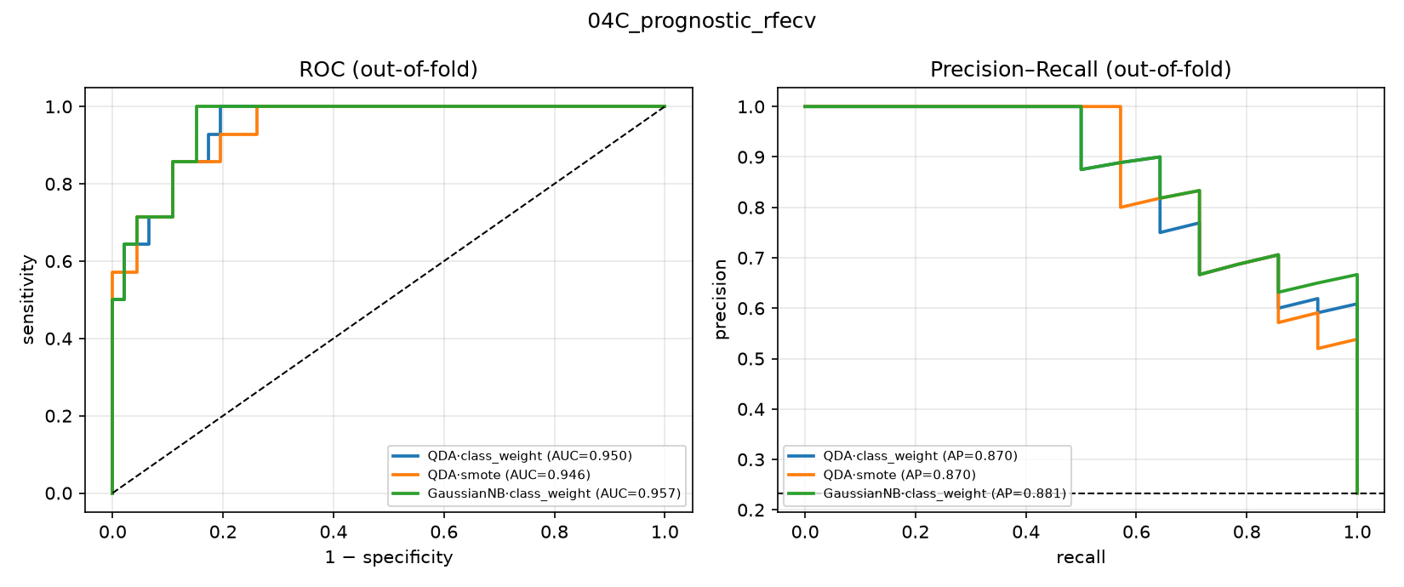
Figure 2. Medical-failure model — out-of-fold ROC and precision–recall curves for the top three algorithms at the final feature-reduction stage.
In the deployed logistic model, BUN (odds ratio 2.89 per SD), ALP (OR 3.56 per SD) and lower albumin (OR 0.30 per SD) carried the largest weight, though wide confidence intervals reflect the small number of failure events (Table 7).
Table 7. Deployed medical-failure model — penalised logistic-regression odds ratios (RFECV feature set).
Term | OR (per SD) | 95% CI
BUN | 2.89 | 0.75–11.08
ALP | 3.56 | 0.92–13.84
Albumin | 0.30 | 0.08–1.11

3.3 Treatment-success model
Discrimination for treatment success rose modestly across the feature-reduction stages: 20 variables + protocol gave ROC-AUC 0.955 ± 0.088, an 11-variable screen + protocol gave 0.960 ± 0.088, and a 4-variable RFECV set + protocol gave 0.972 ± 0.037 (Table 8). The deployed nine-variable-plus-protocol model — chosen for its clinical completeness and interpretability rather than the smallest AUC-optimal set — achieved ROC-AUC 0.905 ± 0.079 under its own cross-validation (Figure 3); an independently implemented scikit-learn pipeline on the identical variable set reproduced this closely at 0.925 ± 0.075, and nested cross-validation showed negligible tuning optimism (plain CV 0.921 ± 0.072 vs. nested CV 0.922 ± 0.073). At the conventional 0.5 probability threshold, the deployed model reached accuracy 84.6% ± 7.6 pp, sensitivity 87.1% ± 8.0 pp, specificity 72.2% ± 28.5 pp, and F1 0.902 ± 0.050; the wide specificity interval reflects the small number of failure events (14/80) available to estimate it.
Table 8. Treatment-success model — three-stage feature reduction (protocol retained at every stage).
Stage | Predictors | Best model | ROC-AUC
A — all variables + protocol | 20 | Gaussian NB | 0.955 ± 0.088
B — univariate screen + protocol | 11 | Gaussian NB | 0.960 ± 0.088
C — RFECV + protocol | 4 | Linear SVM | 0.972 ± 0.037
G1–G3 sensitivity (protocol dropped) | 10 | Gaussian NB | 0.947 ± 0.080
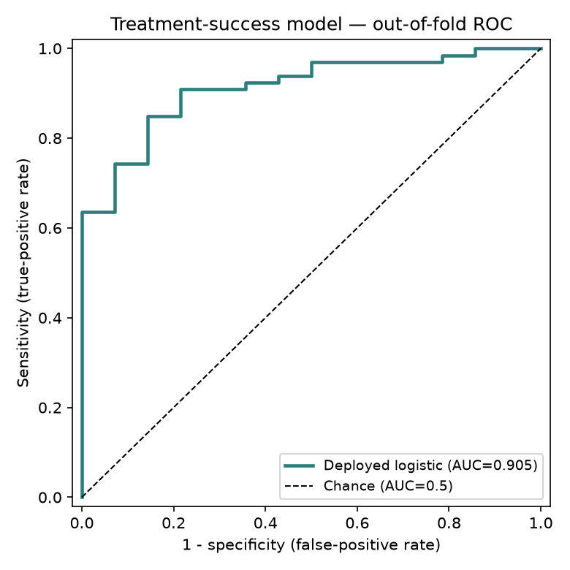
Figure 3. Deployed treatment-success model (9 admission variables + protocol) — out-of-fold ROC curve, one complete cross-validation pass.
The 15-algorithm bake-off on the deployed nine-variable design (Table 9) again showed every credible algorithm within a narrow, heavily overlapping band (ROC-AUC 0.89–0.95). Gaussian NB nominally ranked first (AUC 0.953) but showed poor calibration (Brier 0.29) and low raw accuracy (65.7%, below the 82.5% majority-class baseline) — a high rank with an unreliable predicted probability. The deployed L2-logistic model ranked fourth by AUC (0.925) but combined competitive discrimination with the best interpretability and the lowest tuning optimism of any algorithm tested.
Table 9. Algorithm bake-off on the deployed treatment-success design — every metric (class-weight-balanced models, top 12 of 15, ranked by ROC-AUC).
Model | ROC-AUC | Accuracy | Sensitivity | Specificity | F1
Gaussian NB | 0.953 ± 0.090 | 65.7% ± 10.2 | 59.1% ± 12.2 | 97.3% ± 13.1 | 0.732 ± 0.103
LDA | 0.933 ± 0.067 | 86.9% ± 5.9 | 94.2% ± 6.2 | 52.0% ± 27.8 | 0.922 ± 0.037
Random forest | 0.931 ± 0.053 | 87.4% ± 6.4 | 94.1% ± 5.3 | 55.7% ± 28.2 | 0.925 ± 0.039
Logistic (L2) — deployed | 0.925 ± 0.075 | 85.5% ± 6.7 | 89.2% ± 6.1 | 68.7% ± 32.3 | 0.910 ± 0.042
Logistic (elastic net) | 0.919 ± 0.077 | 84.9% ± 7.1 | 87.4% ± 7.6 | 74.0% ± 28.3 | 0.904 ± 0.046
AdaBoost | 0.918 ± 0.074 | 87.3% ± 7.8 | 93.5% ± 6.4 | 57.7% ± 30.0 | 0.923 ± 0.048
RBF SVM | 0.917 ± 0.068 | 85.3% ± 6.5 | 95.9% ± 5.5 | 36.3% ± 24.2 | 0.916 ± 0.036
Logistic (L1/LASSO) | 0.913 ± 0.087 | 83.5% ± 9.1 | 83.0% ± 10.1 | 86.3% ± 23.5 | 0.890 ± 0.065
Linear SVM | 0.910 ± 0.081 | 84.0% ± 6.9 | 96.1% ± 5.1 | 33.3% ± 26.0 | 0.913 ± 0.033
Hist. gradient boosting | 0.906 ± 0.082 | 85.9% ± 6.7 | 93.2% ± 6.4 | 52.7% ± 31.2 | 0.915 ± 0.042
KNN | 0.901 ± 0.092 | 85.6% ± 5.3 | 98.5% ± 3.4 | 25.0% ± 24.8 | 0.919 ± 0.031
Gradient boosting | 0.894 ± 0.077 | 84.5% ± 6.5 | 93.5% ± 7.0 | 42.7% ± 26.1 | 0.908 ± 0.043
In the deployed model, alkaline phosphatase carried the largest standardised weight against success, followed by albumin (protective), creatinine, age and ALT; heart rate, illness duration and neutrophil count were weaker; total leucocyte count carried essentially no independent weight once the other admission values and protocol were accounted for (Table 10). Relative to G1 (reference), the protocol terms tracked the observed success gradient (G2 −0.13, G3 +0.57, G4 +1.23 log-odds), consistent with Table 3; as described in Section 2.4, the G4 estimate reflects the observed 20/20 cohort rate rather than an extrapolated probability, because that arm is perfectly separated.
Table 10. Deployed treatment-success model — standardised coefficients (log-odds toward success per 1 SD; protocols vs. G1).
Term | Coefficient
Alkaline phosphatase (ALP) | −1.01
Serum albumin | +0.83
Serum creatinine | −0.70
Age | −0.64
Alanine aminotransferase (ALT) | −0.30
Heart rate | −0.21
Illness duration | −0.19
Neutrophil count | −0.15
Total leucocyte count | +0.01
Protocol G2 vs. G1 | −0.13
Protocol G3 vs. G1 | +0.57
Protocol G4 vs. G1 | +1.23 (see caveat, §2.4)
Predicted-probability bands calibrated adequately against observed outcome: of cases the model rated “Likely” (>85% predicted, n = 41), 100% resolved; of cases rated “Uncertain” (50–85%, n = 18), 100% resolved; of cases rated “Unlikely” (<50%, n = 21), 33% resolved. As is typical for a small, largely separable dataset, the model is over-confident near the extremes, which is why the tool built on it (Section 4) surfaces the band rather than the raw percentage as the primary readout.

3.4 Recovery-time regression
None of the four regression algorithms explained meaningful variance in days-to-resolution from admission variables (best model, random forest: MAE 0.98 ± 0.20 days, RMSE 1.22 ± 0.23 days, R² −0.26 ± 0.40; Table 11) — an honest null result rather than a modelling failure, since a negative cross-validated R² means admission severity in this cohort carried no detectable dose–response relationship with time-to-resolution once a dog was set to recover. Mean recovery time nonetheless tracked protocol (G1 5.27 ± 1.45 d, G2 5.37 ± 1.16 d, G3 5.01 ± 0.95 d, G4 4.59 ± 1.02 d), and BUN was the only admission variable with a significant univariate association with recovery time (Spearman ρ = 0.33, p = 0.004).
Table 11. Recovery-time regression — four algorithms compared (n = 74 resolvers).
Model | MAE (days) | RMSE (days) | R²
Random forest | 0.98 ± 0.20 | 1.22 ± 0.23 | −0.26 ± 0.40
KNN | 0.99 ± 0.19 | 1.23 ± 0.20 | −0.28 ± 0.37
Linear regression | 1.15 ± 0.21 | 1.42 ± 0.24 | −0.76 ± 0.66
Decision tree | 1.19 ± 0.21 | 1.46 ± 0.25 | −0.94 ± 0.97

3.5 Missing-data robustness
On a copy of the dataset with ~5% of cells blanked at random, iterative (round-robin regression) imputation reproduced the true values most closely (standardised RMSE 0.98), ahead of mean, median and 5-nearest-neighbour imputation (RMSE 1.14–1.15). Downstream prognostic-model discrimination was stable across all four imputers (ROC-AUC 0.85–0.94 depending on algorithm and imputer), indicating the pipeline is not brittle to modest missingness — a relevant reassurance given that a real clinical cohort will not arrive as complete as the dataset used here.

3.6 Admission risk score and protocol recommendation
Converting the medical-failure model's coefficients into a simple additive score (Table 12) and grouping dogs into Low, Intermediate and High risk strata by score percentile reproduced the model's discrimination in a form a clinician can compute at the bedside: observed success was 100% in the Low stratum (n = 27), 96.2% in the Intermediate stratum (n = 26), and 51.9% in the High stratum (n = 27) (Table 13).
Table 12. Admission risk score — weights per 1 SD of each admission value.
Variable | OR (per SD) | Points (per SD)
Alkaline phosphatase (ALP) | 2.55 | +3
Blood urea nitrogen (BUN) | 2.50 | +3
Creatinine | 1.47 | +1
Age | 1.61 | +1
Illness duration | 1.41 | +1
Albumin | 0.49 | −2
Table 13. Observed success by risk stratum and protocol.
Risk stratum | n | Overall success | G1 | G2 | G3 | G4
Low | 27 | 100% | 100% | 100% | 100% | 100%
Intermediate | 26 | 96.2% | 80% | 100% | 100% | 100%
High | 27 | 51.9% | 25% | 17% | 67% | 100%
Read cautiously — this cross-tabulation is observational, not a randomised comparison — the pattern is nonetheless a clear, testable hypothesis: in the Low- and Intermediate-risk strata, every protocol including supportive care alone performed at or near ceiling; in the High-risk stratum, medical success collapsed for supportive care and cloprostenol alone (17–25%) while aglepristone plus cloprostenol held up markedly better (67%) and surgery remained at 100%. This is precisely the kind of admission-risk-stratified comparison the tool in Section 4 is built to surface case-by-case.

4. Web-Deployed Predictor
The final treatment-success model (§2.4) is deployed as an open, interactive clinical-decision-support calculator (a browser-based single-page application; the model coefficients ship as a small JSON file and every prediction is computed client-side, so no case data leaves the clinician's device). A user selects an intended protocol and enters the nine admission values; the tool returns the predicted probability of treatment success, the corresponding band (Unlikely / Uncertain / Likely), the admission values pushing the estimate up or down, the observed cohort success rate for the chosen protocol, and — generated on demand — a plain-English summary of the case. The same page publishes the full validation reported in Section 3.3 (the algorithm bake-off, the ROC curve, and every classification metric) so that a viewer can audit the model's honesty rather than take the headline number on faith. Python and JavaScript implementations of the prediction formula are cross-checked automatically on every change to guarantee they agree to the displayed percentage point.

5. Discussion
Using the same three-stage, multi-algorithm ML workflow recently reported for canine parvovirus enteritis (Sanaei et al., 2025), we built and openly deployed a treatment-success model for canine pyometra with a cross-validated ROC-AUC around 0.90–0.93, closely comparable to the 0.90 reported for parvovirus outcome, and a medical-failure model with ROC-AUC 0.95, comparable to the discrimination reported for other small-animal ML screening tools such as Cushing's syndrome detection from primary-care records (Schofield et al., 2021) and leptospirosis screening (Reagan et al., 2022). The admission variables that drove both models — azotaemia (BUN, creatinine), hepatic enzyme elevation (ALP, ALT) and hypoalbuminaemia — line up closely with the individual prognostic markers already reported in the pyometra literature (Jitpean et al., 2014; Demeli & Meyer, 2023), which is reassuring: the ML pipeline is not surfacing anything biologically implausible, it is combining markers that clinicians already know matter into one number instead of asking a clinician to weigh five separate lab values in their head.
One point of contrast with the existing literature is instructive. Jitpean et al. (2014) identified leucopenia as their strongest single marker of a complicated postoperative course in 356 surgically treated dogs, whereas total leucocyte count and neutrophil count carried almost no independent weight in either model here once renal and hepatic markers, age and (for the treatment model) protocol were accounted for. The most likely explanation is a difference in outcome definition and case mix rather than a contradiction: Jitpean et al. studied peritonitis and prolonged hospitalisation after surgery in an unselected surgical population, where a falling white-cell count can signal an overwhelmed bone marrow in a septic, deteriorating patient; our outcome is day-14 resolution across a cohort with balanced admission severity and (by construction) no missing data, in which leucocyte counts may simply carry less incremental information once the renal/hepatic markers already dominate. This is exactly the kind of question a validation run on a real, unselected clinical cohort — with real missingness and real severity imbalance — would resolve, and it is a concrete, falsifiable prediction this study leaves on the table.
No single algorithm was reliably the most accurate at any stage of this analysis: across fifteen algorithms tested on the deployed nine-variable design, cross-validated ROC-AUC spanned only 0.89–0.95, and the confidence intervals overlapped almost completely. This pattern — also seen in the medical-failure and CPV-outcome bake-offs — is a direct consequence of a small failure count (14/80 here; comparably few non-survivors in most single-centre veterinary series) rather than a property of any one algorithm, and it argues against choosing a deployed model by leaderboard rank alone. Gaussian naive Bayes illustrates the trap concretely: it ranked first by ROC-AUC in the treatment-success bake-off (0.953) yet had the second-worst raw accuracy of any algorithm tested (65.7%, below the 82.5% majority-class baseline) and a Brier score more than double the next-best model — a well-ranked but poorly calibrated model that would systematically mislead a clinician reading the number as a probability. We instead selected the deployed logistic-regression model on interpretability, deployability (it is the only comparator that runs client-side), and — most importantly — a demonstrated absence of tuning optimism under nested cross-validation (Guyon et al., 2002; Nahm, 2022), which is a more decision-relevant property than a marginal AUC advantage on a dataset this size.
The surgical arm (G4) resolved every case in this dataset, which is both an expected finding — ovariohysterectomy removes the diseased organ and is widely regarded as the definitive treatment (Hagman, 2018) — and a statistical inconvenience, since perfect separation means no finite, calibrated probability can be estimated for it from these data. We handled this the way any careful implementation should: by reporting the observed cohort rate for that arm with an explicit caveat rather than an extrapolated model output, and by fitting a G1–G3-only sensitivity model to confirm the medical-protocol findings were not an artefact of that arm's presence (ROC-AUC 0.947 ± 0.080, materially unchanged). The clinically relevant contrast is between medical management's fertility-sparing benefit at a real relapse/failure cost — roughly 23% medical failure across G1–G3 here, in the same range as the 8–17% relapse rates reported for aglepristone-based protocols in the literature (Fieni, 2006) — against surgery's near-certain resolution at the cost of losing reproductive capacity and undergoing an operation in a systemically ill patient. Our risk-stratified cross-tabulation (§3.6) suggests this trade-off is not uniform: at low admission risk every protocol performed near ceiling, so preserving fertility with supportive care alone looks reasonable, whereas at high admission risk, medical management without aglepristone performed poorly and surgery's advantage was largest — precisely the situation in which a fast, at-a-glance risk estimate at admission would be most useful to a clinician and an owner deciding together.
The absence of any admission-variable signal for recovery time is worth dwelling on rather than dismissing. Sanaei et al. (2025) found real predictors of survival/recovery time for parvovirus enteritis using haematology and biochemistry variables; we found none for pyometra resolution time in this cohort (best cross-validated R² was negative for every algorithm tested). A plausible interpretation is that, once a case is set on a successful trajectory (as the great majority in this balanced cohort were), the residual variation in days-to-resolution is driven by factors not captured in a single admission panel — individual healing rate, exact surgical or drug timing, owner-driven discharge timing — rather than by how sick the dog was at hour zero. This null result is itself a useful, transferable finding for anyone building a similar tool: it predicts that a recovery-time regression is unlikely to be worth the modelling effort for this outcome unless a richer feature set (e.g., serial post-treatment values rather than admission values alone) is used.
Finally, and most importantly for how these results should be read: every number above comes from a dataset that was purpose-built to exercise this pipeline under clean, complete, and perfectly balanced conditions, not collected prospectively from unselected clinical admissions. That is precisely why we built and are publishing the pipeline itself, rather than only the numbers it produced here — the code, the feature-reduction workflow, the 15-algorithm validation harness, and the deployed calculator are all openly available (Data Availability Statement) so that the exact same, now-documented process can be re-run, unmodified, on a real, independently collected, imperfect clinical cohort. Until that replication is done, every model, coefficient, and cut-point reported here should be read as hypothesis-generating and a worked methodology template — not as a validated clinical tool.

5.1 Limitations
- The dataset was purpose-built for machine-learning methodology instruction, with intentionally balanced group sizes (20 dogs per protocol) and no missing baseline data. This is atypical of real veterinary practice and is the primary limitation governing every result in this study; all findings are hypothesis-generating pending replication on an independently collected clinical cohort.
- The treatment-success model was fitted on n = 80 with only 14 failure events, an events-per-variable ratio of roughly 1.2 for a nine-variable-plus-protocol model — far below the conventional rule-of-thumb of ≥10 — which produces wide confidence intervals and likely over-confidence near 0% and 100% (§3.3).
- The surgical protocol (G4) is perfectly separated on outcome (20/20 success); its model coefficient cannot be interpreted as a calibrated probability, and the deployed tool substitutes the observed cohort rate with an explicit caveat.
- Protocol assignment was not randomised for baseline severity within this dataset, so every protocol-outcome association reported here (Tables 3, 9, 13) is observational, not causal.
- No external or prospective validation was performed; all reported discrimination is internal, cross-validated performance on the same 80-dog dataset used to build the models.
- Death (1/80) and six-month recurrence (4/80) were too rare to model and are reported descriptively only.
- A related 240-case retrospective sheet in the source workbook carried no outcome column and could support only case-mix description, not prognostic validation, and was not used in the modelling reported here.

6. Conclusion
A compact, interpretable logistic-regression model built from nine routinely available admission values — age, illness duration, heart rate, total leucocyte count, neutrophil count, creatinine, albumin, alkaline phosphatase and alanine aminotransferase — plus the intended treatment protocol, discriminated treatment success in canine pyometra with a cross-validated ROC-AUC of roughly 0.90–0.93, reproduced independently under a second implementation and under nested cross-validation. A companion six-variable model discriminated medical-management failure with ROC-AUC 0.95, and a simple point score built from it separated a stratum with 0% medical failure from one with 48% failure, within which protocol choice changed observed success from 17% to 100%. Both models, the full validation record, and an open interactive calculator are published together so the same pipeline can be pointed, unmodified, at a real prospectively collected pyometra cohort — the necessary next step before any of these numbers should inform an actual treatment decision.

Data Availability Statement
The dataset, complete analysis code (data audit through model validation), the locked model artefacts, and the source of the deployed web calculator are openly available at the project repository, https://github.com/bhattarya/canine-pyometra-ml. The deployed calculator is live at https://canine-pyometra-ml.vercel.app/.

Author Contributions
[To be completed by the authors — suggested categories: conceptualisation, data curation, formal analysis, methodology, software, validation, writing — original draft, writing — review and editing, supervision.]

Funding
[To be completed — state funding source(s) or declare that no external funding was received.]

Conflict of Interest
The authors declare that the research was conducted in the absence of any commercial or financial relationships that could be construed as a potential conflict of interest.

Generative AI Statement
The data-analysis pipeline, statistical/machine-learning code, and the web-deployed calculator described in this manuscript were developed with the assistance of an AI coding assistant (Claude, Anthropic) under the authors' direction and review. This manuscript draft was likewise prepared with AI assistance from the project's own committed results and figures; all content was reviewed, and must be further verified and approved, by the human author(s) before submission or presentation.

References
1. Akinsulie OC, Idris I, Aliyu VA, Shahzad S, Banwo OG, Ogunleye SC, et al. The potential application of artificial intelligence in veterinary clinical practice and biomedical research. Front Vet Sci. 2024;11:1347550. doi:10.3389/fvets.2024.1347550
2. Demeli D, Meyer G. The assessment of haematologic and serum chemistry parameters in canine pyometra: a systematic review and meta-analysis. J Small Anim Pract. 2023;64(9):543–551. doi:10.1111/jsap.13641
3. Egenvall A, Hagman R, Bonnett BN, Hedhammar Å, Olson P, Lagerstedt AS. Breed risk of pyometra in insured dogs in Sweden. J Vet Intern Med. 2001;15(6):530–538. doi:10.1111/j.1939-1676.2001.tb01587.x
4. Fieni F. Clinical evaluation of the use of aglepristone, with or without cloprostenol, to treat cystic endometrial hyperplasia–pyometra complex in bitches. Theriogenology. 2006;66(6–7):1550–1556. doi:10.1016/j.theriogenology.2006.01.023
5. Fransson BA, Karlstam E, Bergström A, Lagerstedt AS, Park JS, Evans MA, Ragle CA. C-reactive protein in the differentiation of pyometra from cystic endometrial hyperplasia/mucometra in dogs. J Am Anim Hosp Assoc. 2004;40(5):391–399. doi:10.5326/0400391
6. Guyon I, Weston J, Barnhill S, Vapnik V. Gene selection for cancer classification using support vector machines. Mach Learn. 2002;46:389–422. doi:10.1023/A:1012487302797
7. Hagman R. Pyometra in small animals. Vet Clin North Am Small Anim Pract. 2018;48(4):639–661. doi:10.1016/j.cvsm.2018.02.007
8. Jitpean S, Ström-Holst B, Emanuelson U, Höglund OV, Pettersson A, Alneryd-Bull C, Hagman R. Outcome of pyometra in female dogs and predictors of peritonitis and prolonged postoperative hospitalization in surgically treated cases. BMC Vet Res. 2014;10:6. doi:10.1186/1746-6148-10-6
9. Nahm FS. Receiver operating characteristic curve: overview and practical use for clinicians. Korean J Anesthesiol. 2022;75(1):25–36. doi:10.4097/kja.21209
10. Reagan KL, Deng S, Sheng J, Sebastian J, Wang Z, Huebner SN, et al. Use of machine-learning algorithms to aid in the early detection of leptospirosis in dogs. J Vet Diagn Invest. 2022;34(4):612–618. doi:10.1177/10406387221096781
11. Sanaei N, Zamani-Ahmadmahmudi M, Nassiri SM. Development of machine learning models to predict clinical outcome and recovery time in dogs with parvovirus enteritis. Front Vet Sci. 2025;12:1555714. doi:10.3389/fvets.2025.1555714
12. Schofield I, Brodbelt DC, Kennedy N, Niessen SJM, Church DB, Geddes RF, et al. Machine-learning based prediction of Cushing's syndrome in dogs attending UK primary-care veterinary practice. Sci Rep. 2021;11:9035. doi:10.1038/s41598-021-88440-z
13. Xavier RGC, Santana CH, de Castro YG, de Souza TGV, do Amarante VS, Santos RL, Silva ROS. Canine pyometra: a short review of current advances. Animals. 2023;13(21):3310. doi:10.3390/ani13213310

Supplementary Figure S1
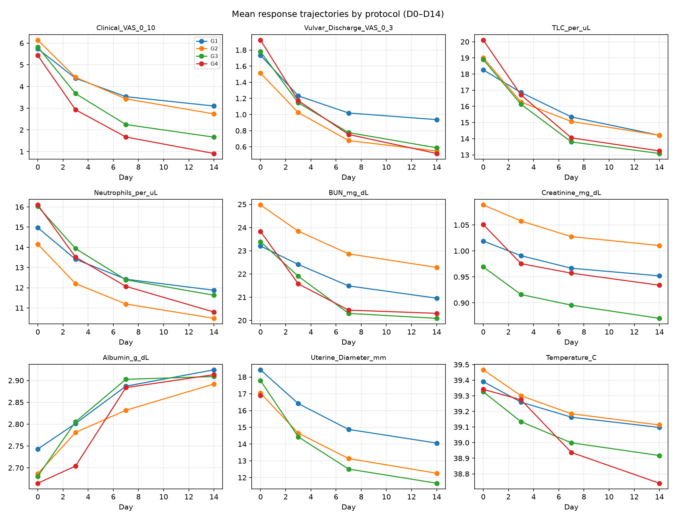
Figure S1. Mean trajectories of nine repeated clinical/laboratory variables by protocol, days 0–14 (mixed-effects model, dog as random intercept). All nine variables showed a significant Day effect (p < 0.001); seven of nine showed a significant Group × Day interaction, indicating the rate of improvement, not only the admission value, differed by protocol.

