 | 

CAG × DIGITAL INDIA BHASHINI · हिंदी पखवाड़ा
हिंदी शराड्स
Hindi Charades
Technical concept note
Build specification for the game: rules, screens, scoring, सहायिका and data

Version 2 · 22 October 2026 · For the developers, and for any AI tool used to build the game

How to use this document
This note is the brief for building हिंदी शराड्स. Give it, whole, to the developer or AI tool that builds the game. Every rule, number and on-screen word the game needs is written here.
· Exact values win. Where a number, name or label appears in a table, use it exactly as written. The same values are in Hindi_Charades_Game_Config.json; keep that file and the game in step.
· Must and should. "Must" is a rule the game cannot break. "Should" is the preferred way, which can change if there is a good technical reason.
· All settings in one place. Round names, titles, times, credits, chances, pass mark and scoring weights must live in one settings block (or file), never hard-coded on screens, so they can be changed later without touching the screens.
· Old names. Earlier files used तरकश / Tarkash / अनुवाद समर for the game and गुरु / Guru for the guide, with bow, arrow and quiver pictures. None of these may appear anywhere in the game. Section 12 lists the replacements.
· Sample content. Report pages, passages and names in this note are samples. Real CAG pages replace them through the game manager console (section 10).

Scope of this build
Item | What it means
Working prototype | Due 27 October 2026. The full player journey working end to end: registration, all four rounds, BHASHINI drafts, voice typing in परख, सहायिका with voice, report cards, best-of-three credits and certificate download. Scale (thousands of players) is not part of this build.
Who plays | Officers of the Indian Audit & Accounts Department only.
Devices | Any modern browser, nothing to install: Chrome and Edge on Windows, Safari on Mac, iPhone and iPad. Must work with a mouse, a touch screen and a physical keyboard.
Language on screen | All player-facing text in simple, warm, spoken Hindi (see section 11). सहायिका speaks in English and her words are also shown in Hindi.

1. The game in one page
हिंदी शराड्स is a short, staged translation game for Hindi Pakhwada. Officers translate real CAG audit report pages from English into Hindi. The pages get harder in each round, from a plain passage to a full page with tables and charts. Each answer is compared with CAG's own published Hindi version of the same page, and the officer gets a report card, a title and credits.
Who plays | Officers of the Indian Audit & Accounts Department. Each registers once with name, mobile number, email ID, office and office address. The email ID is the player's unique ID.
What they do | Translate audit report pages from English into Hindi. In परख they translate on their own. In the other three rounds they check and correct BHASHINI's Hindi draft.
Why play | It counts toward their appraisal, builds real translation skill, and earns credits for the Hindi Pakhwada contest.
Who guides them | सहायिका (Sahayika), an on-screen guide with a warm female voice. She welcomes the player, explains, cheers them on, answers questions and announces each title.
Rounds | Four rounds in a fixed order: परख, प्राथमिक, माध्यमिक, वृत्तिक. Each can be played up to 3 times (3 मौके); the best score counts.
Rewards | A title for each round scored 33 / 100 or more, credits (up to 50 in all), and a downloadable certificate.

Four rounds, four titles
Round | Title earned | Time | What is translated | BHASHINI draft | Typing | Credits
Trial (परख) | अनुवाद पथिक | 20 min | A short passage of about 300 words (20 sentences) | No: the officer translates from scratch | Voice or keyboard | 3
Primary (प्राथमिक) | अनुवाद निपुण | 1 hr | One report page: body text, page number, header, footer, footnotes | Yes, to check and improve | Keyboard | 5
Secondary (माध्यमिक) | अनुवाद विद्वान | 1.5 hr | All of the above, plus headnotes, tables and annexure references | Yes | Keyboard | 15
Pro (वृत्तिक) | अनुवाद विशेषज्ञ | 2 hr | A full report page, including charts and graphs | Yes | Keyboard | 25

Registration adds 2 credits, so an officer can earn up to 50 credits in all. Numbers and figures on a page are never changed; officers translate only the words.

2. What the player does: participant SOP
This is the game from the player's side, step by step. Every step must work exactly as written here. The same text can be sent to officers by email, printed, or used in the game's own help screen.
Getting started with हिंदी शराड्स. Every step is short and simple, and सहायिका (Sahayika), the game guide, stays with you all the way.

Before you start
What you need | Why
A computer or laptop with Chrome or Edge | The game runs on these.
A good internet connection | So your work keeps saving as you go.
Your email ID | It is your ID in the game. All your credits are saved against it.
A microphone (optional) | For voice typing in the Trial round.
Some quiet time | Each round has a fixed time, from 20 min to 2 hr. Once a round starts, you cannot leave the page until you submit.

Step by step
1. Open the game. Open the link and press शुरू करें. सहायिका will welcome you.
2. Register (only once). Fill in your name, mobile number, email ID, office and office address. All fields are required. Registering earns you your first 2 credits.
3. Read "How to play". Eight short points: who the game is for, what you gain, credits, the BHASHINI draft and the ways to type.
4. Read the rules. The time for each round, and three rules: no copy-paste, 3 chances per round, and voice typing in the Trial only.
5. Play the Trial round (20 min). A short passage of about 300 words. You translate it on your own, by voice or keyboard. There is no BHASHINI draft here.
6. Check your report card. You see your score, the five measures and one tip. A score of 33 / 100 or more earns you the round's title. Then replay, or move on.
7. Play the main rounds: Primary, Secondary and Pro. Before each round, a pop-up shows the time, your chance number and the rules. BHASHINI's Hindi draft is already in the box: check it and improve it, paragraph by paragraph. From now on you type; voice typing is off.
8. See your total score. The best score and credits for every round are shown together. Download your certificate from here.

The four rounds at a glance
Round | Time | What you do | How you write | Credits | Title
Trial / परख | 20 min | Translate a short passage of about 300 words on your own | Voice or keyboard | Up to 3 | अनुवाद पथिक
Primary / प्राथमिक | 1 hr | Improve BHASHINI's draft: body text, page number, header, footer, footnotes | Keyboard | Up to 5 | अनुवाद निपुण
Secondary / माध्यमिक | 1.5 hr | All of the above, plus headnotes, tables and annexure references | Keyboard | Up to 15 | अनुवाद विद्वान
Pro / वृत्तिक | 2 hr | A full report page, with charts and graphs | Keyboard | Up to 25 | अनुवाद विशेषज्ञ

Three chances in every round
· You can play each round up to 3 times. The screen shows मौका 1 / 3, मौका 2 / 3, मौका 3 / 3.
· Your best score of the three counts for credits. A lower score never takes anything away.
· You can use the chances left later too: press स्कोर बढ़ाइए on the total-score screen.

How you earn credits
You can earn up to 50 credits in all: registration 2, Trial 3, Primary 5, Secondary 15 and Pro 25.
· Each round's credits depend on your best score. For example, 84 / 100 in the Trial gives 3 × 84/100 = 2.5 credits.
· Credits are saved against your email ID and go to the Hindi Pakhwada credit list.
· This formula is a proposal for now and may change once CAG confirms it.

At least 33 / 100 for a title
· To earn a round's title, you need at least 33 / 100.
· Your score is made of five measures: translation, time, completion, glossary and sentence construction. The report card shows each as a count, for example 9 / 12 शब्द.
· Scored below 33? Don't worry. Read सहायिका's tip and try again with your next chance.

Getting help from सहायिका
· सहायिका is with you on every screen. Everything she says is shown as text, and you can press 🔊 सुनें to hear it.
· During a round, press the सहायिका button to ask anything about the game: the rules, the time left, your chances or credits.
· सहायिका will not translate for you, but she will always point you the right way. After each round, she announces your new title.
· Need CAG's standard Hindi term for a word? Press the शब्दावली button, for example Annexure → अनुलग्नक. Using the right term earns marks.

Keep in mind
· When a round starts, the game opens full screen. You cannot leave the page until you press जमा करें.
· Copy-paste is off. Write it yourself; you can do it!
· The timer keeps running even if you refresh the page. When time is up, your work is submitted automatically.
· Do not change the numbers and figures on the page. Translate only the words.
· Voice typing is for the Trial only. In the other rounds, type using phonetic typing (type sarkar and pick सरकार) or the InScript keyboard.
Ready? Let's begin. A new title is waiting for you in every round!

3. Game settings
These are the exact settings. They must sit in one settings block (as CONFIG in the prototype, or a settings file on the server) and every screen, the report card, the credit maths and सहायिका's answers must read from it.
Setting | Value | Notes
Game name | हिंदी शराड्स (Hindi Charades) | Shown on the title screen, the header of every screen and the certificate
Guide | सहायिका (Sahayika) | Female voice; see section 9
Registration credits | 2 | Given once, when registration is complete
Chances per round (मौके) | 3 | The server must refuse a 4th attempt
Which chance counts | The best score of the chances played | A lower later score never lowers credits
Title pass mark | 33 / 100 | The best score must be at least 33 to earn the round's title
Score shown as | out of 100, whole number | For example 84 / 100
Maximum credits | 50 | 2 + 3 + 5 + 15 + 25
Credit rounding | 1 decimal place | For example 2.5
Round order | परख → प्राथमिक → माध्यमिक → वृत्तिक | A round opens after the previous round has been played at least once

Rounds
Key | Name on screen | Title | Time limit | Credit cap | BHASHINI draft | Voice typing | Completion by
trial | परख राउंड (Trial) | अनुवाद पथिक | 20 min | 3 | No | Yes | Sentences
primary | प्राथमिक राउंड (Primary) | अनुवाद निपुण | 60 min | 5 | Yes | No | Paragraphs
secondary | माध्यमिक राउंड (Secondary) | अनुवाद विद्वान | 90 min | 15 | Yes | No | Paragraphs
pro | वृत्तिक राउंड (Pro) | अनुवाद विशेषज्ञ | 120 min | 25 | Yes | No | Paragraphs

Settings file
The same values, as they are saved in /mnt/project-files/tarkash/game/Hindi_Charades_Game_Config.json:
{
"game": { "name": "हिंदी शराड्स", "nameEn": "Hindi Charades",
"guide": "सहायिका", "guideEn": "Sahayika" },
"registration": { "credits": 2 },
"rounds": [
{ "key": "trial", "name": "परख राउंड", "title": "अनुवाद पथिक",
"timeLimitMinutes": 20, "creditCap": 3, "bhashiniDraft": false,
"voiceTyping": true, "completionCountedBy": "sentence" },
{ "key": "primary", "name": "प्राथमिक राउंड", "title": "अनुवाद निपुण",
"timeLimitMinutes": 60, "creditCap": 5, "bhashiniDraft": true,
"voiceTyping": false, "completionCountedBy": "paragraph" },
{ "key": "secondary", "name": "माध्यमिक राउंड", "title": "अनुवाद विद्वान",
"timeLimitMinutes": 90, "creditCap": 15, "bhashiniDraft": true,
"voiceTyping": false, "completionCountedBy": "paragraph" },
{ "key": "pro", "name": "वृत्तिक राउंड", "title": "अनुवाद विशेषज्ञ",
"timeLimitMinutes": 120, "creditCap": 25, "bhashiniDraft": true,
"voiceTyping": false, "completionCountedBy": "paragraph" }
],
"maxCredits": 50, "maxChancesPerRound": 3, "bestOfChancesCounts": true,
"titlePassMark": 33, "scoreOutOf": 100,
"scoringWeights": { "translation": 30, "completion": 20,
"sentenceConstruction": 20, "glossary": 20, "time": 10 },
"timeMarks": { "fullMarksIfFinishedWithinShareOfLimit": 0.5,
"marksAtTimeLimit": 0.6 },
"creditFormula": "round credits = best score / 100 x round credit cap",
"creditDecimals": 1
}

4. Player journey and screens
The game has eight kinds of screen. The first four are seen once (the player can reopen how to play and rules any time). Then every round follows the same three screens: pop-up, round, report card. The total score screen closes the game.
शीर्षक (title) → पंजीकरण (registration) → कैसे खेलें (how to play) → खेल के नियम (rules)
→ for each round, in order परख, प्राथमिक, माध्यमिक, वृत्तिक:
राउंड से पहले (pop-up) → राउंड (the round) → रिपोर्ट कार्ड (report card)
report card → फिर खेलें (replay, if chances are left) or आगे (next round)
→ आपका कुल स्कोर (total score) → certificate download / स्कोर बढ़ाइए (replay a round)

# | Screen | Must show | Player actions
1 | शीर्षक · Title | Game name हिंदी शराड्स, CAG logo on the left and BHASHINI logo on the right, the line "हर राउंड में एक नई उपाधि · क्रेडिट्स का उपयोग करें हिंदी पखवाड़ा कॉन्टेस्ट में". | शुरू करें
2 | पंजीकरण · Registration | Fields, all required: नाम, मोबाइल नंबर (+91, 10 digits), ईमेल आईडी, कार्यालय (drop-down from the CAG office list), कार्यालय का पता (fills in from the office, can be edited). "+2 क्रेडिट" badge. सहायिका welcome card. Note: "केवल कैग अधिकारियों के लिए". | पंजीकरण करें (validates, saves, gives 2 credits). A returning player (same email) is taken to where they left off.
3 | कैसे खेलें · How to play | Eight short points: who the game is for; what they gain (appraisal, practice, Hindi Pakhwada credits); the credits per round; BHASHINI's draft; परख is done on your own; the शब्दावली button; the five scoring measures; ways to write Hindi. A small panel to try each typing method. सहायिका introduces herself. | आगे
4 | खेल के नियम · Rules | One card per round with its name, title, time, typing mode, completion unit and credits. Three rule cards: कॉपी-पेस्ट नहीं चलेगा · हर राउंड के तीन मौके · परख के बाद सिर्फ़ टाइपिंग. | समझ गया, शुरू करें
5 | राउंड से पहले · Pop-up | Round name, the title it gives, मौका n / 3, the time, the rules in short, and (before प्राथमिक) that typing only is allowed from now on. सहायिका line. | शुरू करें (enters full screen and starts the clock)
6 | राउंड · Round | Header with round, मौका n / 3, time left and credits up to. English source on the left, Hindi box(es) on the right. Bottom bar: typing mode, शब्दावली, सहायिका, कॉपी-पेस्ट बंद badge, live count (वाक्य 6 / 20 पूरे or पैराग्राफ 3 / 6 पूरे), progress bar, जमा करें. | Type, speak (परख only), tick ✓ a part as done (main rounds), open शब्दावली, ask सहायिका, जमा करें
7 | रिपोर्ट कार्ड · Report card | सहायिका panel announcing the title (or encouragement below 33); credits earned and running total out of 50; progress stars; the five measures as counts; score / 100; all three chances with the best starred; one tip; times the player left the page. | फिर खेलें (if chances are left) or आगे
8 | आपका कुल स्कोर · Total score | Every round's best score, chances used, title earned and credits; total credits out of 50; congratulations line. | प्रमाणपत्र डाउनलोड करें, स्कोर बढ़ाइए (replay a round with chances left)

5. Screen designs
These designs show the layout, colours and wording to follow. Names, scores and report text are samples. Build from these, using the rules in sections 3 to 9 where a picture and the text differ.
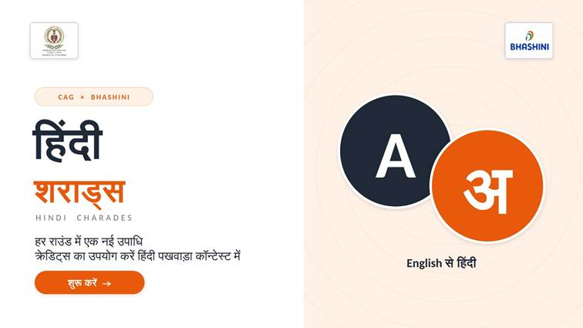
1. Title screen. Screen 1. Name हिंदी शराड्स, CAG logo left and BHASHINI logo right, the A / अ design, and one शुरू करें button.
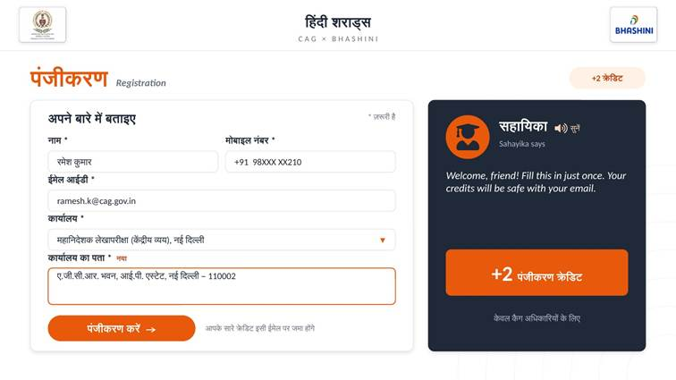
2. Registration. Screen 2. Five required fields including the office address. +2 क्रेडिट badge. सहायिका welcome card with 🔊 सुनें.

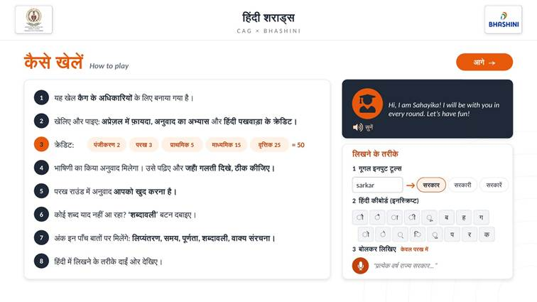
3. How to play. Screen 3. Eight numbered points on the left. On the right, सहायिका's greeting and a panel to try the three ways to write (voice marked केवल परख में).
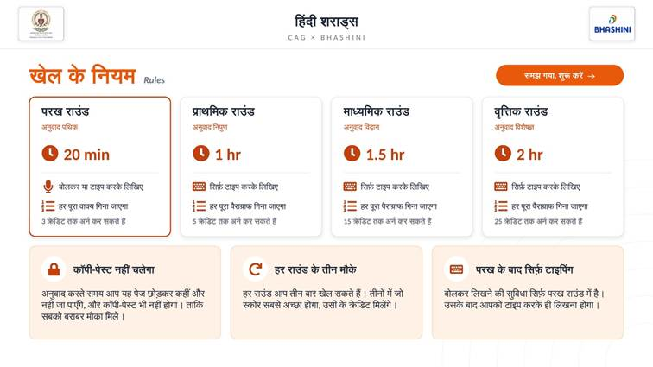
4. Rules. Screen 4. One card per round with name, title, time, typing and credits, then the three rules.

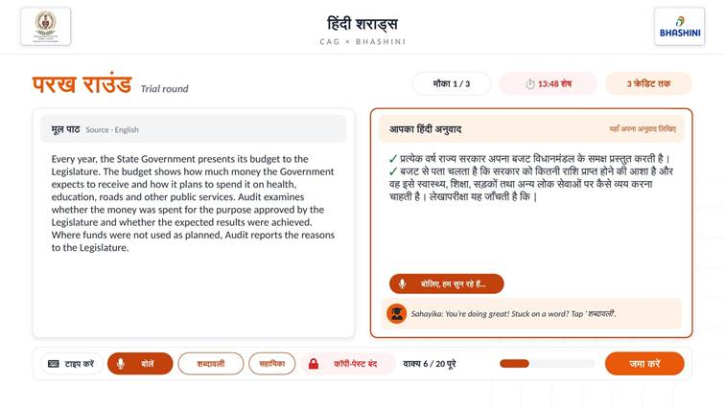
5. परख round. Screen 6, trial. No BHASHINI draft: the player writes the whole passage. Voice and keyboard both on. Each finished sentence gets a green tick; live count वाक्य 6 / 20 पूरे.
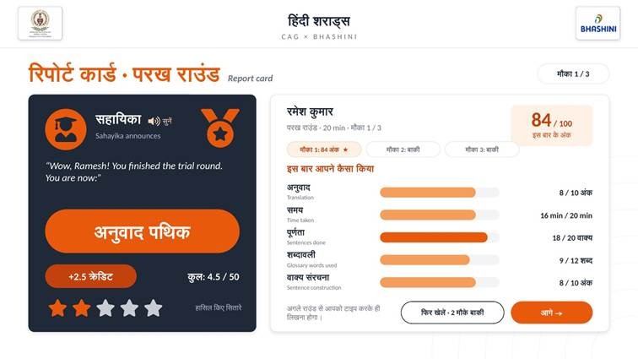
6. परख report card. Screen 7. सहायिका announces अनुवाद पथिक. Five measures as counts, score 84 / 100, three chances with the best starred, one tip, and the note that typing only is allowed from the next round.

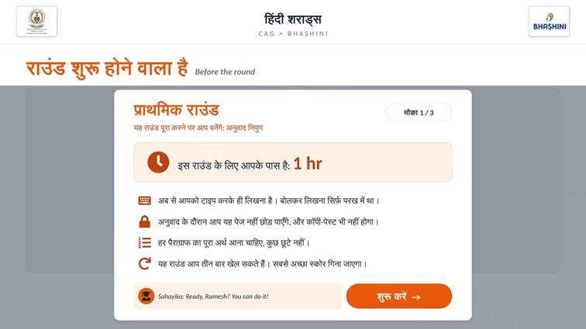
7. Before every round. Screen 5. Pop-up with round, title, मौका 1 / 3, time and rules. Before प्राथमिक it says voice typing has ended.
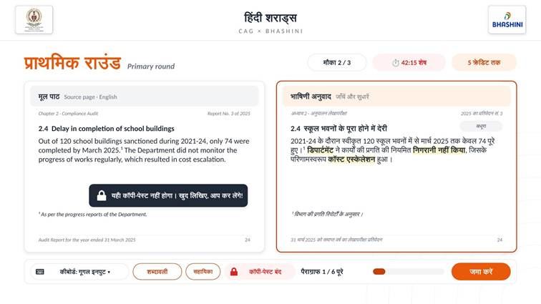
8. प्राथमिक round · BHASHINI draft. Screen 6, main round. English page left; BHASHINI draft right, marked “भाषिणी अनुवाद · जाँचें और सुधारें”, editable part by part with a ✓ per paragraph. The copy-paste message is shown as a friendly toast.

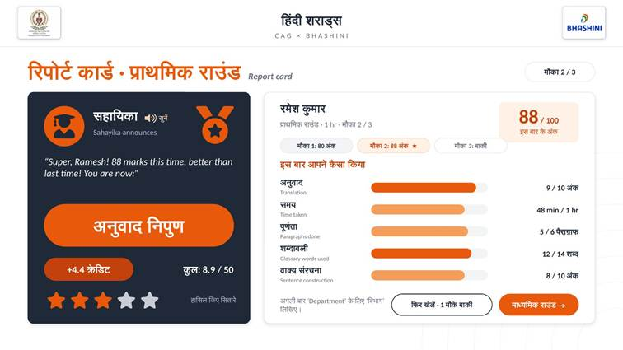
9. प्राथमिक report card. Screen 7, second chance. Title अनुवाद निपुण. Chance 2 scored better and is starred; credits use the best.
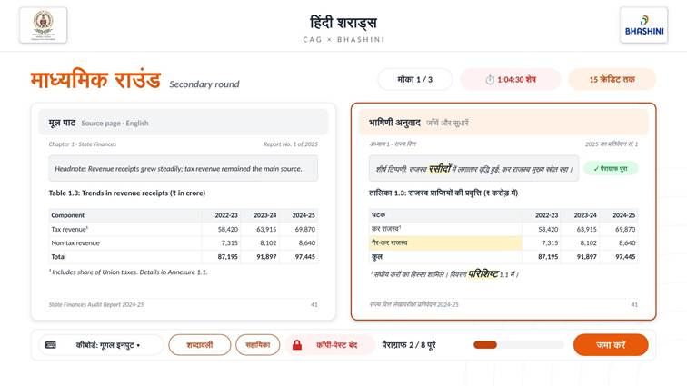
10. माध्यमिक round. Screen 6 with a headnote, a table, footnotes and an annexure reference. Numbers in the table are locked and cannot be edited.

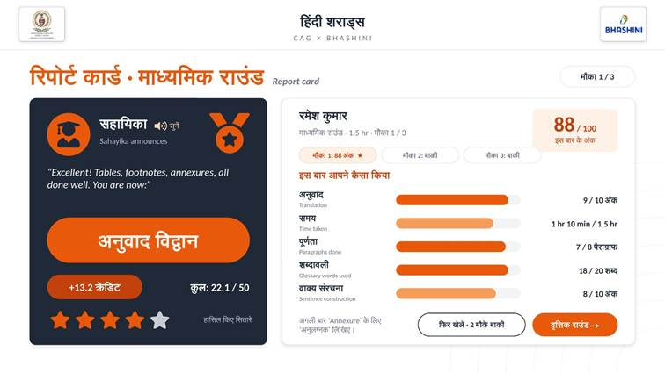
11. माध्यमिक report card. Screen 7. Title अनुवाद विद्वान, with a tip on the annexure term (अनुलग्नक).
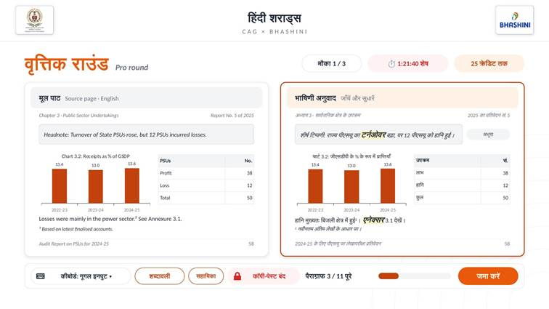
12. वृत्तिक round. Screen 6 with a chart (title, labels, source line), a table and body text. Only words are edited; chart numbers stay locked.

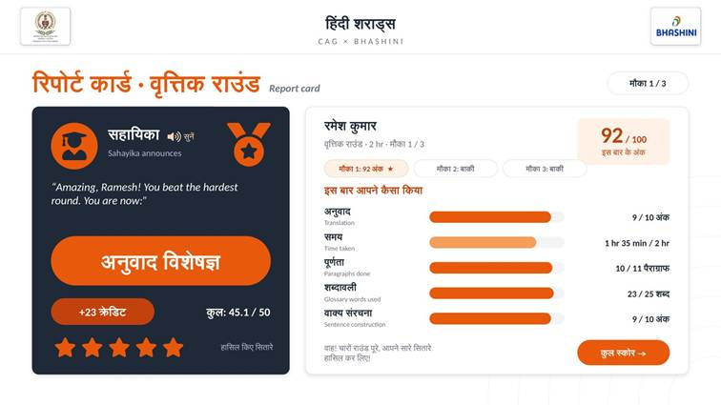
13. वृत्तिक report card. Screen 7. The top title, अनुवाद विशेषज्ञ, announced by सहायिका.
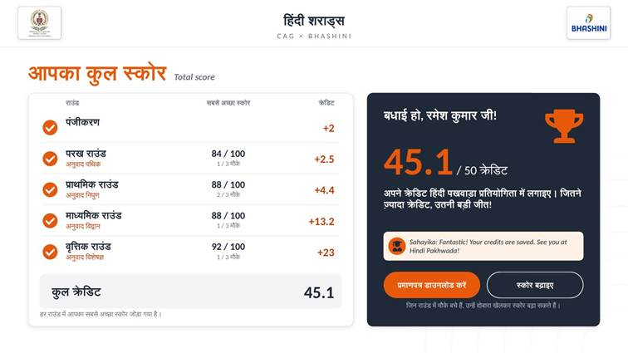
14. Total score. Screen 8. Best score, chances used, title and credits for every round; total out of 50; certificate download; स्कोर बढ़ाइए for rounds with chances left.

6. What each round contains
Round | Page parts | How the player works | Completion
परख | One plain passage, about 300 words, 20 sentences. | Writes the full Hindi translation alone, in one box, by voice or keyboard. No BHASHINI draft. | A sentence counts when it is written and ends with ।
प्राथमिक | One report page: header, heading, body paragraphs, footnote, footer, page number. | Each part has its own Hindi box, already filled with BHASHINI's draft. The player corrects it and taps ✓ when the part is right. | A paragraph (page part) counts when it is ticked ✓ and not empty
माध्यमिक | All of the above, plus a headnote, a table, footnotes and an annexure reference. | As प्राथमिक. Table cells with numbers are locked; only words are edited. | As above
वृत्तिक | A full page: headnote, chart (title, labels, source), table, body text, footnote, footer. | As प्राथमिक. Chart and table numbers are locked. | As above

· Different page for each chance. Each round should have at least 3 pages (or passages), so each मौका gets a different one. If only one exists, the same page is used again.
· Report sector is never shown. The player must not see whether a page is from the social, public works or commercial sector.
· Numbers never change. Numbers, years and rupee amounts are copied into the Hindi side as they are and cannot be edited.
· Content per page (stored by the game manager): English text of each part, BHASHINI draft of each part, the published CAG Hindi of each part (the reference for scoring), and the glossary terms that appear on the page.

7. Ways to write Hindi
Method | How it works | Where
Phonetic typing (Google Input style) | The player types in Roman letters and presses space; the word turns into Hindi, with suggestions to pick from (sarkar → सरकार / सरकारी / सरकारें). | All rounds; the default
Hindi keyboard (InScript) | The standard InScript layout, with an on-screen key panel that can be tapped. | All rounds
Device keyboard | The phone, tablet or computer's own Hindi keyboard must also work. | All rounds
Voice typing | The player taps the mic and speaks Hindi; words appear in the box. While listening the button reads "बोलिए, हम सुन रहे हैं…". Saying "पूर्ण विराम" (poorn viraam) adds ।. Needs internet; if the browser cannot listen, a friendly message says so. | परख only. From प्राथमिक the mic is hidden.
शब्दावली (glossary) | A button opens CAG's standard terms. Search in English or Hindi. With the cursor in the translation, tapping जोड़ें inserts the term. | All rounds

8. Fair play rules (freeze screen)
From शुरू करें on the pop-up until the round is submitted, the round is "frozen". These rules must hold on every device.
· Full screen. The round opens full screen where the device allows it.
· No copy, cut, paste or right-click in the round. If the player tries, show the friendly line "यहाँ कॉपी-पेस्ट नहीं होगा। खुद लिखिए, आप कर लेंगे!" (not an error). A "कॉपी-पेस्ट बंद" badge stays visible.
· Leaving the page. Switching tab or app, or leaving full screen, shows a warning card: the round is still running and the clock too. Each time is counted ("पेज छोड़ा: n बार") and shown on the report card.
· The clock keeps running. The start time is saved on the server, so a refresh, a closed tab or a lost connection does not stop or reset the timer. The work typed so far is saved as the player goes and comes back after a refresh.
· Warnings. A toast at 5 minutes left: "बस 5 मिनट बचे हैं!".
· Auto-submit. When time is up the work is submitted automatically: "समय पूरा: आपका अनुवाद जमा हो गया".
· Submitting early. If parts are not done, the first press of जमा करें changes it to "पक्का जमा करें?" and says how many are left; a second press within 4 seconds submits.
· When a chance is used. A मौका is used once the round starts. If the player leaves and does not come back, the work is submitted automatically when time runs out.

9. Scoring, titles and credits
Every round is scored on the same five measures. Each measure is worked out as a value from 0 to 1, then the weighted total gives the score out of 100. The report card shows each measure as a simple count, not a percentage.
Measure | What it checks | How it is measured | Weight | Shown as
अनुवाद (Translation) | How close the meaning is to CAG's published Hindi | Anuvad evaluation API (prototype: character similarity with the reference), averaged over parts by length | 30 | 8 / 10 अंक
पूर्णता (Completion) | How much is done | Sentences done / total (परख); paragraphs done / total (main rounds) | 20 | 18 / 20 वाक्य · 5 / 6 पैराग्राफ
वाक्य संरचना (Sentence construction) | Grammar and flow | Anuvad API (prototype: deductions for grammar slips, English words left in Latin script, and missing ।) | 20 | 8 / 10 अंक
शब्दावली (Glossary) | CAG terms used correctly, and no English words written in Hindi letters | Glossary terms on the page used correctly / glossary terms on the page | 20 | 9 / 12 शब्द
समय (Time) | Time used out of the time allowed | Full marks up to half the time limit, then falling evenly to 60% at the limit | 10 | 16 min / 20 min

score = round(translation×30 + completion×20 + sentence×20
+ glossary×20 + time×10)
(each measure is a value from 0 to 1)
f = time used / time limit
time = 1 if f ≤ 0.5
= 1 − (f − 0.5) / 0.5 × 0.4 if f > 0.5 (0.6 at the limit)
empty answer → score 0

Titles, chances and credits
· Report card tip. One short tip, from the first thing still wrong. For a term: "अगली बार 'Department' के लिए 'विभाग' लिखिए।" For grammar: "अगली बार ध्यान दीजिए: …". If nothing is wrong: a word of praise.
· Title. If the round's best score is 33 or more, the player earns its title. Below 33, सहायिका encourages them to use their next chance.
· Best of three. The report card lists all three chances (मौका 1: 80 अंक · मौका 2: 88 अंक ★ · मौका 3: बाकी). The best is starred and is the one that counts.
· Credits per round = best score / 100 × the round's credit cap, rounded to 1 decimal. Example: 84 / 100 in परख gives 3 × 84/100 = 2.5 credits. Total = 2 for registration + the four rounds, out of 50.
· Below 33. For now the player still earns credits by the formula, but no title (to be confirmed, section 14).
· Credits are worked out on the server, saved against the email ID, and exported to the Hindi Pakhwada credit list.
· Certificate. Downloaded from the total score screen as PNG or PDF. It shows the player's name, the titles earned (only rounds with 33 or more) and total credits, with the CAG logo on the left and the BHASHINI logo on the right.

10. सहायिका, the game guide
सहायिका is a friendly female guide who appears on every screen as a card or a line with her picture. She has two jobs: fixed lines at fixed moments (the script), and answering the player's questions (the chatbot).
Rule | Detail
Voice | A clear, warm female voice. She speaks in English: simple, cheerful, as you would speak to a child of 6 to 9, at most 3 short sentences.
On screen | Every line is shown as text, in simple Hindi, with a 🔊 सुनें button that reads it aloud.
Answer format | Every answer has two parts: en (what she says aloud) and hi (the same meaning in natural Hindi, shown on screen).
Never translates for the player | She never writes out the translation of the passage or a whole sentence. She gives hints, single terms or a grammar tip.
Words | She gives the CAG standard Hindi term from the glossary and says which word to avoid (Annexure = अनुलग्नक, not एनेक्सर).
Never reveals | The report's sector or department, or the mistakes planted in BHASHINI's draft. She may hint where to look.
Unknown questions | Dates, prizes, appraisal rules, technical faults: she kindly says the organisers will tell them, and suggests they keep playing.
Always encouraging | Never discouraging. After a low score she reminds them the best score counts and they have more chances.
Knows the round | She uses the facts of the round the player is in first (time, title, what is on the page, common slips).

When सहायिका speaks (the script)
Screen | Moment | Example line (spoken English)
Registration | Screen opens | "Hello, friend! I'm so happy you're here! Fill this in just once, and I'll keep your credits safe with your email."
Registration | Form submitted | "Yay, you're in! You just earned your first 2 credits."
How to play | New player / returning player | "Hi, I'm Sahayika! I'll be right beside you in every round." · "Welcome back, {name}! Your {total_credits} credits are safe with me."
Rules | Screen opens | "There are four rounds, and you get 3 chances in each one."
Pop-up | Before each round | "Ready, {name}? You can do it!" plus a rotating tip
Round | Halfway, 5 minutes left, stuck | "You're doing great! Stuck on a word? Tap शब्दावली."
Report card | Title earned / below 33 / so close / first pass on a retry | "Wow, {name}! You finished the trial round. You are now: अनुवाद पथिक"
Total score | All rounds done | "Fantastic! Your credits are saved. See you at Hindi Pakhwada!"

The full script (80 lines, by round and moment, with line IDs, English and Hindi) is in Tarkash_Guru_Script.json, and the chatbot's instructions, game facts, ready answers per round and glossary are in Tarkash_Guru_Knowledge.json (system_prompt and system_prompt_by_round). Both files were written before the renaming: apply the name changes in section 12 to them, and drop any line that talks about a quiver (तरकश) or arrows (तीर).

11. Technology, data and services

BHASHINI services
Service | Where it is used | How
Translation (English → Hindi) | Draft in प्राथमिक, माध्यमिक, वृत्तिक | Made once, before the game opens, for every part of every page, checked by a game manager and stored with the page. Every player gets the same draft. Never called live during play.
Speech to text (Hindi ASR) | Voice typing in परख | BHASHINI ASR; the browser's own speech service is the fallback for the prototype.
Text to speech | सहायिका's 🔊 सुनें | A female voice (BHASHINI TTS, or the device voice as fallback), the same on every device where possible.
Anuvad evaluation | Report card marks | Takes the player's Hindi and the reference Hindi; returns translation, glossary, transliteration and sentence-construction scores. Replaces the simulated scoring of the prototype.

If any service is slow or down, the game must show a friendly message and let the player carry on (for example keep typing), never lose their work.

Data to store (server)
Record | Fields
Player | email ID (unique key), name, mobile, office, office address, registered at, registration credits
Attempt (one per मौका) | player, round, chance number (1 to 3), page used, start time, submit time, auto-submitted or not, times the page was left, answer text per part, the five measure values, score out of 100
Round result | player, round, best score, chances used, title earned (yes / no), credits
Page (content) | round, English part texts, BHASHINI draft per part, reference Hindi per part, locked numbers, glossary terms on the page, active or not
Glossary | English term, Hindi term, wrong forms to avoid
Office | office name (Hindi and English), postal address with PIN, state

· The server must enforce the 3 chances, the round order and the timer, and compute scores and credits itself. Nothing that decides credits may be trusted from the browser.
· Login by the officer's email ID (with OTP or CAG single sign-on when available). One officer, one player.
· Personal data stays in India, with a short privacy notice at registration.

Game manager console
A separate set of screens (see Tarkash_Manager_Screen_Mockups.pptx) for the game managers: upload a report page and its published Hindi, generate and check the BHASHINI draft part by part, mark glossary terms, lock numbers, publish a page to a round, see results, and export credits to Excel.

Platform
· A web app over https (needed for the microphone and full screen). Works in Chrome and Edge on Windows, and Safari on Mac, iPhone and iPad.
· Devanagari must display correctly everywhere (use a web font such as Noto Sans Devanagari or Mukta).
· Layouts must work on a phone held upright, a tablet and a desktop.
· The prototype source (Tarkash_Game_Source_Code.zip: plain HTML, CSS and JavaScript) is the starting point. Its CONFIG block, rounds, glossary and scoring are described in its README.

12. Names and wording

Names to use, and the old names to replace
Use | Replace | Where
हिंदी शराड्स (Hindi Charades) | तरकश, Tarkash, अनुवाद समर, Anuvad Samar | Everywhere: screens, header, certificate, सहायिका's lines, file and page titles
सहायिका (Sahayika) | गुरु, Guru | Everywhere. She is female: use feminine verbs (मैं आपके साथ रहूँगी).
परख राउंड (Trial) | ट्रायल राउंड | Round name
वृत्तिक राउंड (Pro) | प्रो राउंड | Round name
अनुवाद निपुण | अनुवाद प्रवीण | Title of प्राथमिक
अनुवाद विद्वान | अनुवाद विशेषज्ञ (as the माध्यमिक title) | Title of माध्यमिक
अनुवाद विशेषज्ञ | अनुवाद आचार्य | Title of वृत्तिक (the top title)
Stars, medal, trophy, ticks | Bow, arrows, quiver, arrow in the target | All pictures and icons. No archery images or words anywhere.

How the game speaks
What we aim for | We write | Instead of
Sound human, not official | अनुवाद करते समय आप यह पेज छोड़कर कहीं और नहीं जा पाएँगे | स्क्रीन रुकी रहेगी
Use familiar words | पैराग्राफ, मौका, अर्न कर सकते हैं, हासिल किए | अनुच्छेद, प्रयास, कमा सकते हैं
Write times as numbers | 20 min, 1 hr, 1.5 hr, 2 hr | डेढ़ घंटा
Show results as counts | 16 min / 20 min, 9 / 12 शब्द | 80%
Encourage, never scold | खुद लिखिए, आप कर लेंगे! | Error messages and warnings

Official CAG terms appear only inside the audit pages themselves, never in the game's own instructions.

13. Ready-for-review checklist
The prototype is ready for review when all of these are true:
1. No old name, no Guru and no archery picture appears anywhere.
2. A new player can register, and a returning player (same email) continues where they left off, with credits intact.
3. All four rounds play in order with the exact names, titles, times and credit caps of section 3.
4. परख has voice and keyboard and no draft; the other rounds show BHASHINI's draft, keyboard only, with numbers locked.
5. Copy, cut, paste and right-click are blocked in a round; leaving the page is warned and counted; the timer survives a refresh; time-out auto-submits.
6. The report card shows the five measures as counts, the score out of 100, all chances with the best starred, one tip, and the title only at 33 or more.
7. A 4th attempt at a round is refused; credits use the best score with 1 decimal; the total never passes 50.
8. सहायिका's lines appear in Hindi with 🔊 सुनें speaking English in a female voice, and her chatbot follows the rules of section 10.
9. The certificate downloads with the titles earned.
10. The game works on Windows (Chrome, Edge), Mac (Safari), iPhone and iPad (Safari).

