Project Documentation: Hosting a Static Website on Amazon S3

Prepared by: Hassan Jamil

Date: 22-09-2025

Email hassanjamil.b123gmail.com

# Table of Contents

1. 1. Introduction
2. 2. Project Objectives
3. 3. Prerequisites
4. 4. Step 1 – Create an S3 Bucket
5. 5. Step 2 – Enable Bucket Versioning
6. 6. Step 3 – Upload Website Files
7. 7. Step 4 – Enable Static Website Hosting
8. 8. Step 5 – Configure Bucket Policy (Public Access)
9. 9. Step 6 – Test Accessibility
10. 10. Final Output (Live Website URL)
11. 11. Conclusion

# 1. Introduction

Amazon S3 (Simple Storage Service) can be used to host static websites (HTML, CSS, JavaScript). This project demonstrates creating, configuring, and deploying a simple static website on S3.

# 2. Project Objectives

- Create an Amazon S3 bucket for website hosting.  
- Upload static website files (HTML/CSS).  
- Configure public access and bucket policy.  
- Enable versioning for file management.  
- Test accessibility through a live website URL.

# 3. Prerequisites

- AWS account with S3 access.  
- Basic HTML and CSS files (index.html, style.css).  
- Internet browser to test the website.

# 4. Step 1 – Create an S3 Bucket

1. Open AWS Console → Go to S3 Service.  
2. Click Create bucket.  
3. Enter a unique bucket name (example:my-static-website-hassan ).  
4. Select a region (e.g., us-east-1).  
5. Keep Block Public Access unchecked for website hosting.  
  
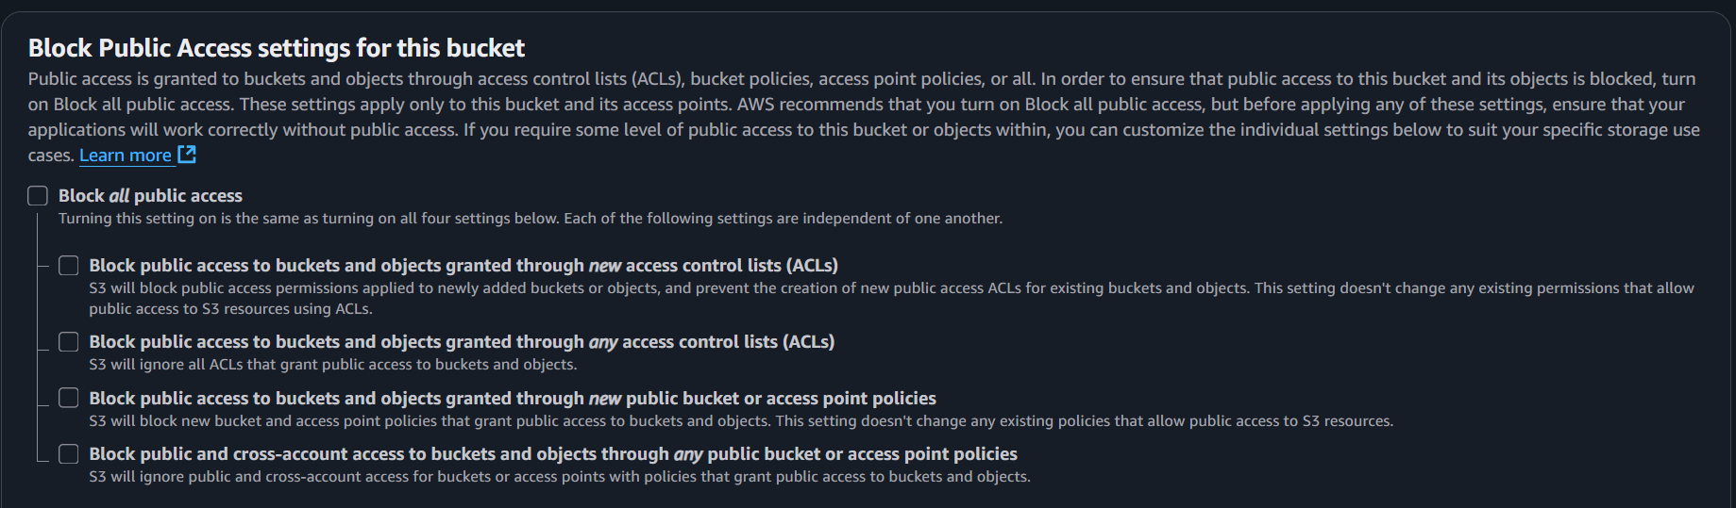

# 5. Step 2 – Enable Bucket Versioning

1. Go to your created bucket → Properties tab.  
2. Scroll down to Bucket Versioning.  
3. Enable versioning to keep multiple versions of uploaded files.  
  
 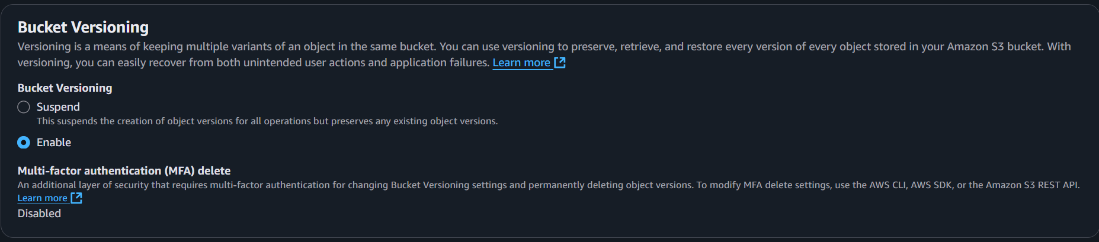

# 6. Step 3 – Upload Website Files

1. Open the bucket → Upload.  
2. Upload index.html and style.css.  
3. Keep files in the root directory (not inside a folder).

# 7. Step 4 – Enable Static Website Hosting

1. In bucket Properties → scroll to Static website hosting.  
2. Choose Enable.  
3. Specify index document: index.html.  
4. Save changes.  
  
 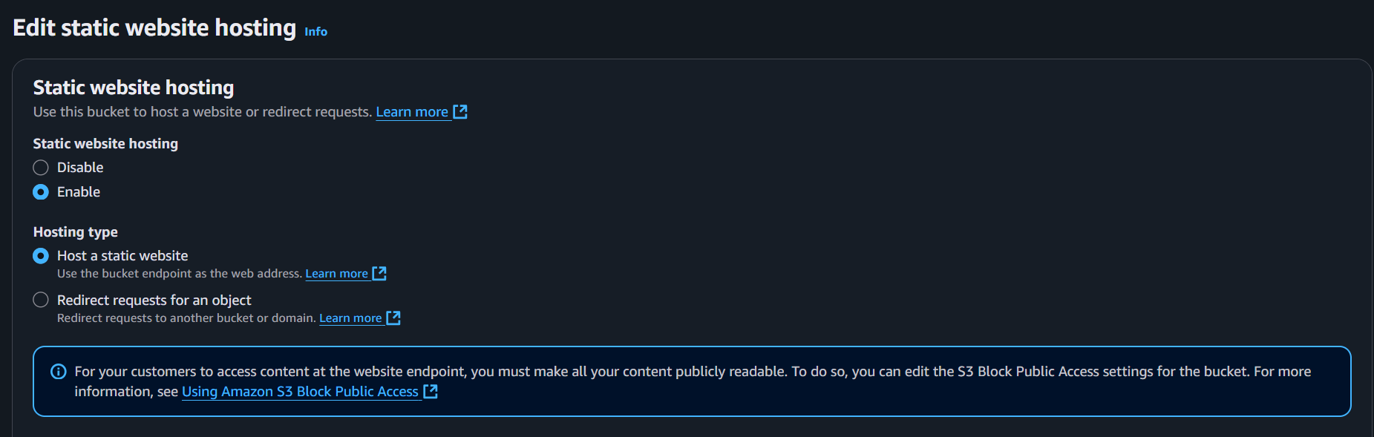

# 8. Step 5 – Configure Bucket Policy (Public Access)

By default, S3 denies public access. To fix this:

1. Go to the bucket Permissions tab → Bucket Policy.  
   2. Add the following policy

{  
 "Version": "2012-10-17",  
 "Statement": [  
 {  
 "Sid": "PublicReadGetObject",  
 "Effect": "Allow",  
 "Principal": "*",  
 "Action": "s3:GetObject",  
 "Resource": "arn:aws:s3::::my-static-website-hassan /*"  
 }  
 ]  
}

3. Save policy → Confirm.

# 9. Step 6 – Test Accessibility

1. Copy the Bucket Website Endpoint (shown in Static Website Hosting).  
2. Paste it into the browser.  
3. If configured correctly → your website should load.  
  
 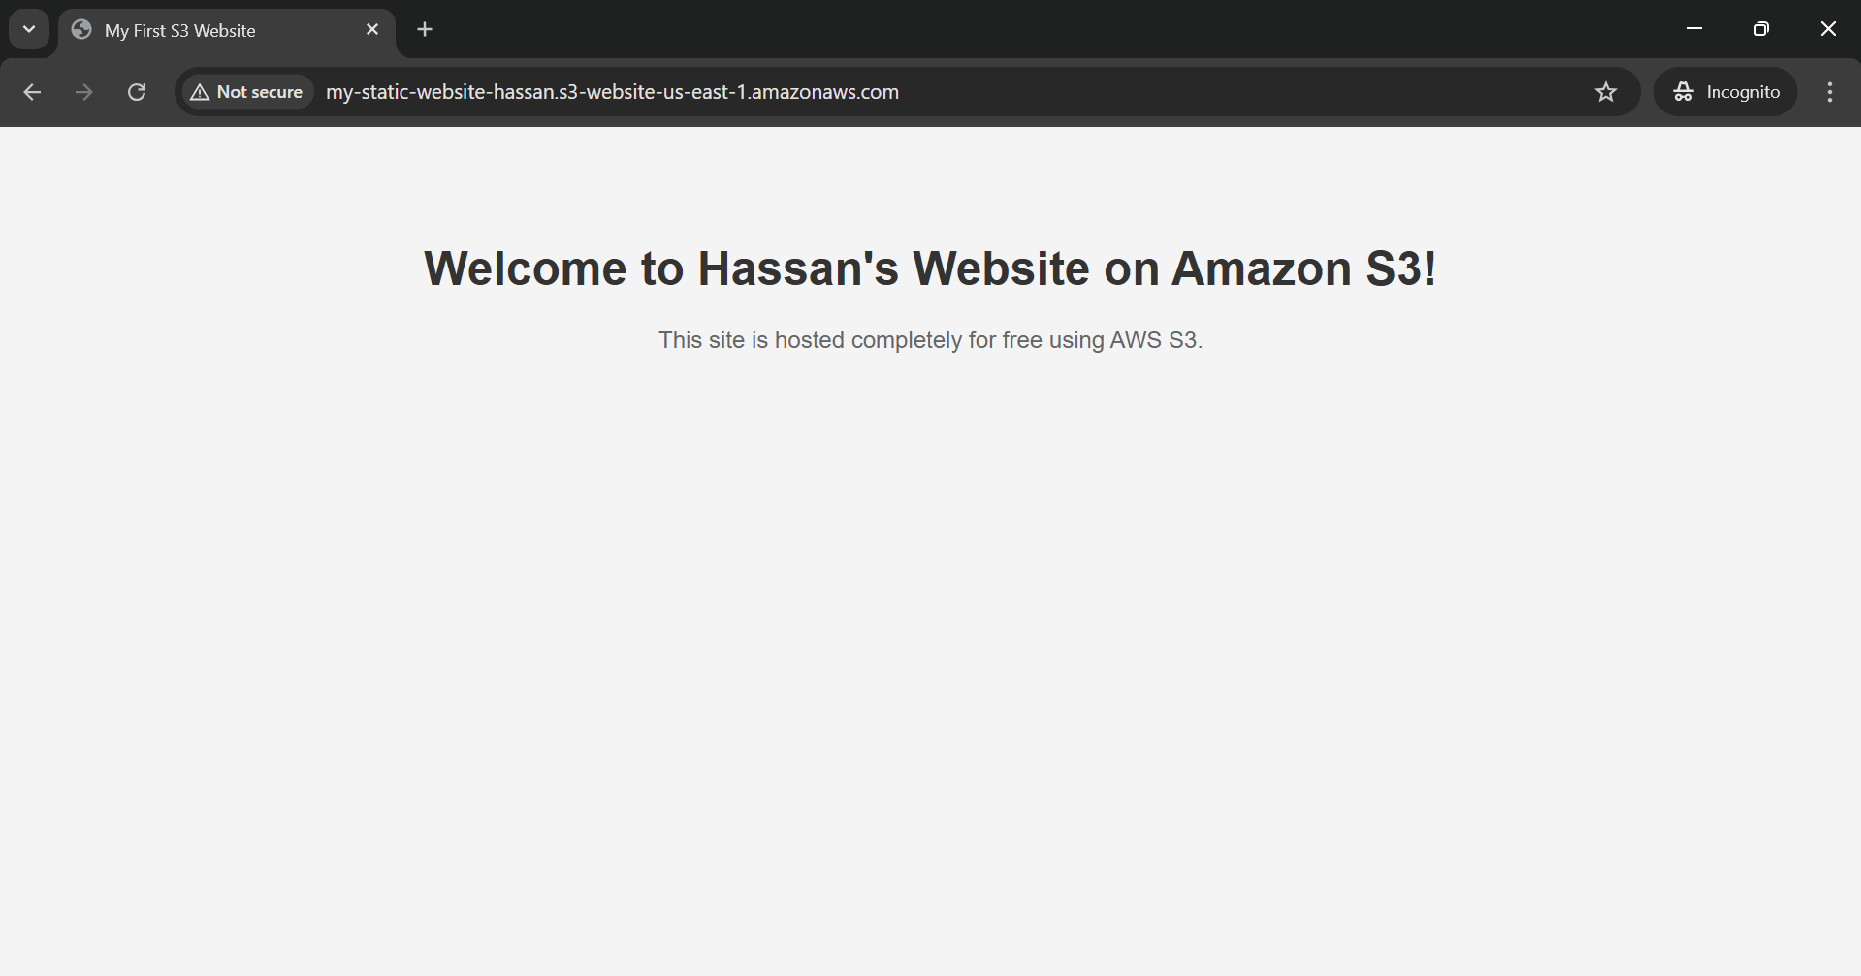

# 10. Final Output (Live Website URL)

<http://my-static-website-hassan.s3-website-us-east-1.amazonaws.com>

# 11. Conclusion

We successfully:  
- Created and configured an Amazon S3 bucket.  
- Enabled versioning for file management.  
- Deployed a static HTML/CSS website.  
- Configured bucket policy for public access.  
- Verified the website using the S3 endpoint.  
  
This demonstrates how AWS S3 can be used as a cost-effective solution for hosting static websites.