Pipeline MFLC-PFC All Objects Except Activity Form Extract
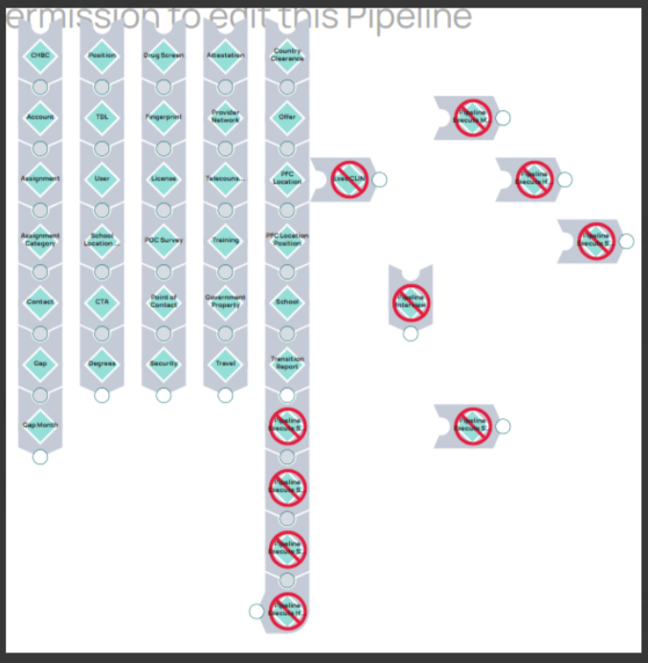

SnapLogic Master Pipeline → AWS (31 Child Pipelines as 31 Glue Jobs)

- Each SnapLogic child pipeline (P1–P31) will become its own AWS Glue job.
- 5 parallel threads
- Sequential execution of child pipelines within each thread
- Independent manual execution of any child pipeline
- Scheduled master execution
- Snowflake → Data Warehouse (SQL Server) ETL

- Proposed Architecture Overview in AWS
- Orchestration for Master Pipeline AWS Step Functions
- Orchestration for Child Pipelines AWS Step Functions
- ETL per child pipeline 31 AWS Glue Jobs
- Scheduling Amazon EventBridge

- Glue Job Design (One‑to‑One Mapping)
Each SnapLogic child pipeline becomes an independent Glue Job:

Child Pipeline P1 → gluejob_p1
Child Pipeline P2 → gluejob_p2
...
Child Pipeline P31 → gluejob_p31
- Note: Each glue job can be executed manually or via Step Functions

- Child Step Function (is the Pipeline Executor)
# create a mapping json table
{
"CP1": "glue_cp1",
"CP2": "glue_cp2",
"CP3": "glue_cp3",
...
"CP31": "glue_cp31"
}

For example if input is CP3 then
Start Child Step Function (Input: CP3)
|
Resolve Glue Job Name (glue_cp3)
|
Start Glue Job
|
Wait for completion
|
Return status

Single Child Step Function for all 31 pipelines

- Master Step Function (Replaces SnapLogic Master)
INPUT TO MASTER STEP FUNCTION
{
"thread1": ["CP1","CP2","CP3","CP4","CP5","CP6","CP7”],
"thread2": ["CP8","CP9","CP10","CP11","CP12","CP13”],
"thread3": ["CP14","CP15","CP16","CP17","CP18","CP19"],
"thread4": ["CP20","CP21","CP22","CP23","CP24","CP25"],
"thread5": ["CP26","CP27","CP28","CP29","CP30","CP31"]
}

Threads will execute in parallel and child pipelines in each thread will execute
sequentially.

- Scheduling (Equivalent to SnapLogic Scheduled Task)
EventBridge Rule will trigger master step function.

- Independent Child Pipeline Execution (Mandatory Requirement)

Manual Trigger Options may include console, CLI or EventBridge with ad-hoc rule.

