**CHAPTER 1**

**INTRODUCTION**

Database is a collection of data and Management System is a set of programs to store and retrieve those data. Based on this one can define DBMS as a collection of inter-related data and set of programs to store & access those data in an easy and effective manner.

# What is the need of DBMS?

Database systems are basically developed for large amount of data. When dealing with huge amount of data, there are two things that require optimization: Storage of data and retrieval of data.

**Storage:** According to the principles of database systems, the data is stored in such a way that it acquires lot less space as the redundant data (duplicate data) has been removed before storage. Let’s take a layman example to understand this. In a banking system, suppose a customer is having two accounts, one is saving account and another is salary account. Let’s say bank stores saving account data at one place (these places are called tables we will learn them later) and salary account data at another place, in that case if the customer information such as customer name, address etc. are stored at both places then this is just a wastage of storage (redundancy/ duplication of data), to organize the data in a better way the information should be stored at one place and both the accounts should be linked to that information somehow. The same thing we achieve in DBMS.

**Fast Retrieval of data**: Along with storing the data in an optimized and systematic manner, it is also important that we retrieve the data quickly when needed. Database systems ensure that the data is retrieved as quickly as possible.

The choice of a database product is often influenced by factors such as:

* + - the computing platform (i.e., hardware, operating system)
    - the volume of data to be managed
    - the number of transactions required per second
    - existing applications or interfaces that an organization may have
    - support for heterogeneous and/or distributed computing
    - cost
    - vendor support

# Design and Modeling:

The first task of a database designer is to produce a [conceptual datamodel](https://en.wikipedia.org/wiki/Conceptual_data_model) that reflects the structure of the information to be held in the database. A common approach to this is to develop an entity-relationship model, often with the aid of drawing tools. Another popular approach is the [Unified Modeling Language.](https://en.wikipedia.org/wiki/Unified_Modeling_Language) A successful data model will accurately reflect the possible state of the external world being modeled: for example, if people can have more than one phone number, it will allow this information to be captured.

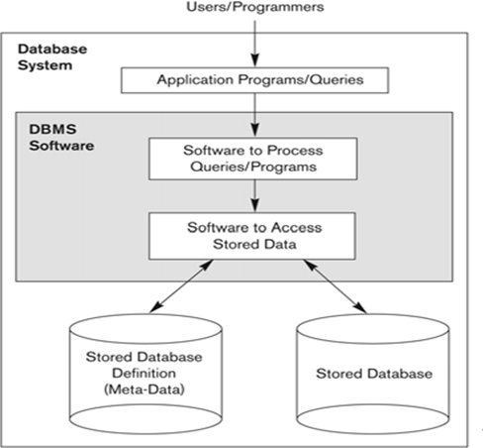

**Figure 1.1: Simplified database system environment**

# Objective

The main objective of this project is to determine how an interactive inventory management system helps in the smooth functioning of a warehouse compared to traditional inventory management, by digitizing all the records and transacting everything on a computer rather than on paper. This project is a two-tier architecture application.

# Problem Statement

Existing systems for Warehouse Inventory Management are very inefficient and mostly involve a lot of manual work to be done by the manager of the system. With this project, we want to automate as many tasks as possible using the available technology and the internet.

# Scope of the report

The essential framework of this report would be to elaborate the design of E.R-diagram, Schema Diagram and to display how the modules of the program work in order to achieve the automation.