**CHAPTER: 3**

**ER DIAGRAM, SCHEMA DIAGRAM**

This chapter of the report describes the structure of the project, followed by Entity Relationship Diagram, Schema Diagram and the table structures.

# ER Diagram with relationships and cardinality ratio

An entity relationship model*,* also called an entity-relationship (ER) diagram*,* is a graphical representation of entities and their relationships to each other, typically used in computing in regard to the organization of [data](http://www.webopedia.com/TERM/D/data.html) within [databases](http://www.webopedia.com/TERM/D/database.html) or information systems. An entity is a piece of data-an [object](http://www.webopedia.com/TERM/O/object.html) or concept about which data is stored.

The cardinalit*y* or fundamental principle of one data aspect with respect to another is a critical feature. The relationship of one to the other must be precise and exact between each other in order to explain how each aspect links together. In simple words Cardinality is a way to define the relationship between two entities.

The following are the notations of the ER diagram:

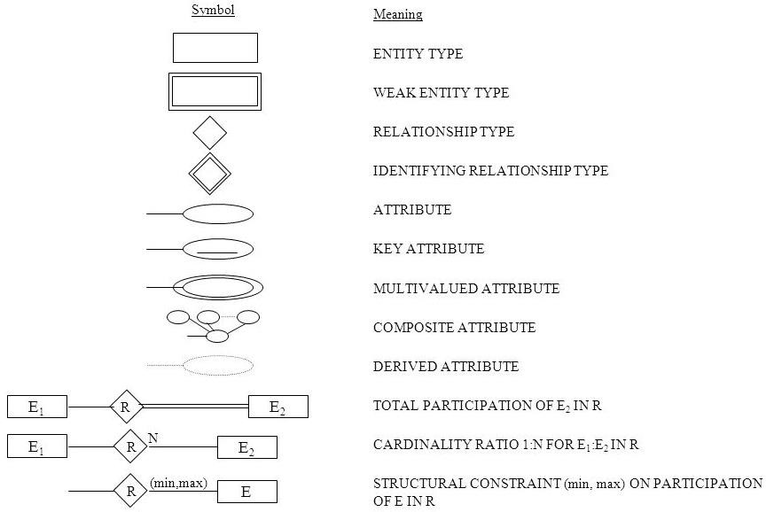

**Fig 3.1: Notations for ER Diagrams**

The ER diagram below shows the relationship between the many tables that exist in the database for the functioning of Warehouse Inventory Management System.

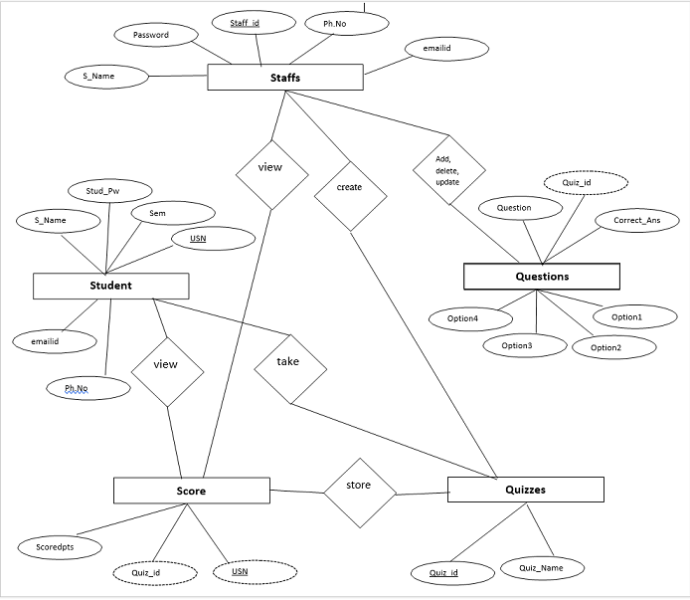

**Fig 3.2: ER Diagram of Online Examination System**

# Schema Diagram

In any data model it is important to distinguish between the description of the database and the database itself. The description of a database is called the database schema, which is specified during database design and is not expected to change frequently.

A displayed schema is called a schema diagram. A schema diagram displays only some aspects of a schema, such as the names of record types and data items, and some types of constraints.

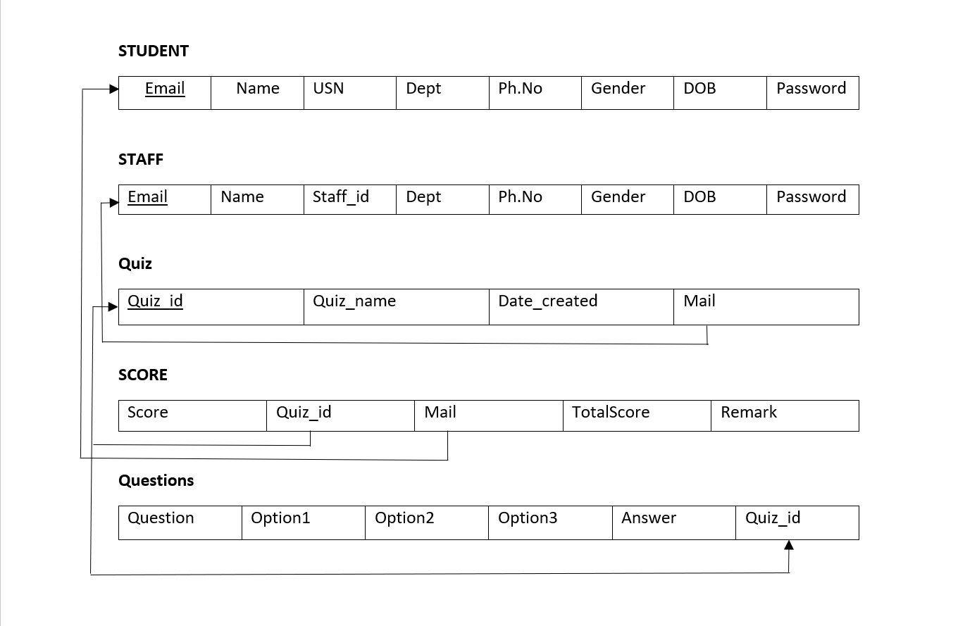

**Fig 3.3: Schema Diagram**