VISVESVARAYA TECHNOLOGICAL UNIVERSITY

“JNANA SANGAMA” , BELAGAVI-590018, KARNATAKA



A Mini Project Report
On

S
“WIN-WALK”

Submitted in the partial fulfillment of the requirement for the completion of Web Technology Laboratory with Mini Project (17CSL77) and award of degree of

BACHELOR OF ENGINEERING
IN
COMPUTER SCIENCE AND ENGINEERING

Submitted By

Rakesh M R | 1VA17CS040
B G Vinayak | 1VA17CS010

Under the Guidance of
Mr. Nagamahesh B S Mrs. Sreelatha P K
Assistant Professor Assistant Professor
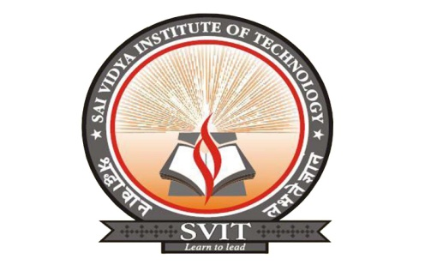
Dept. of CSE, SVIT Dept. of CSE, SVIT

DEPARTMENT OF COMPUTER SCIENCE AND ENGINEERING
SAI VIDYA INSTITUTE OF TECHNOLOGY
(Affiliated to Visvesvaraya Technological University, Belagavi | Recognized by Govt. of Karnataka | Approved by AICTE, New Delhi)
RAJANUKUNTE, BENGALURU – 560 064
2020-21

S

