EXPERIENTIAL HIGHER INSTITUTE OF SCIENCE AND TECHNOLOGY (EXHIST)

**CHALLENGES OBSERVED IN NAVIGATING THE SMS**

**Report Card**

Students are unable to access published results on the SMS after clicking on report card. The window below is what they see, with no information or any other active button to explore for further information.

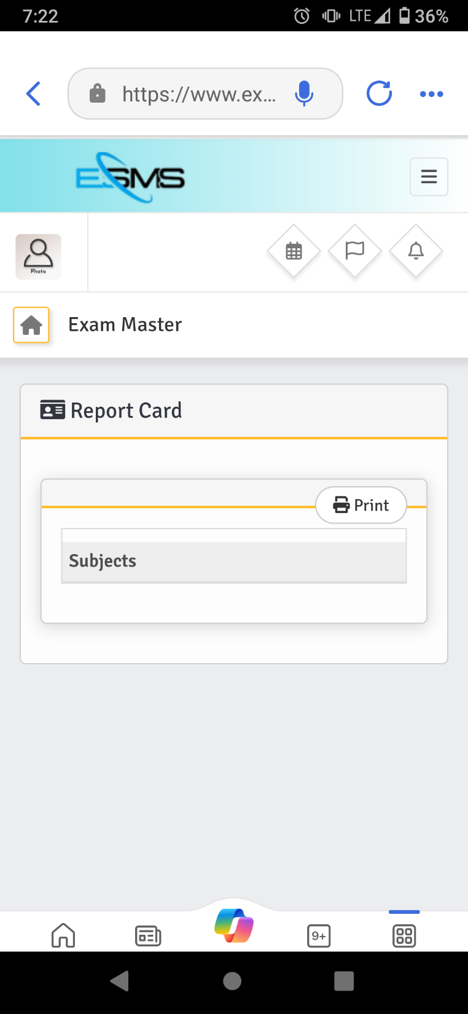

**Button not active**

**Academics: Portal of DAA and HOD**

**Class Schedule**

The button **“add schedule”** is not active though present. This makes it difficult to add more than one course per day on the timetable

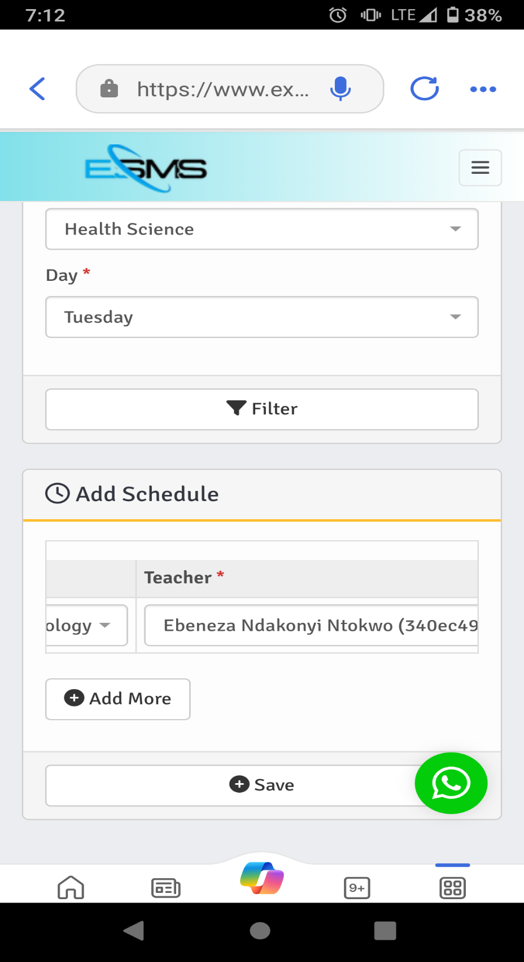

**Attachments: Students Portal**

Students are unable to access uploaded lecture material on the SMS

**Homework**

The option to upload a pdf document before an assignment can be uploaded should not be made compulsory.

