EXPERIENTIAL HIGHER INSTITUTE OF SCIENCE AND TECHNOLOGY (EXHIST)

**CHALLENGES OBSERVED IN NAVIGATING THE SMS**

**Report Card**

Students are unable to access published results on the SMS after clicking on report card. The window below is what they see, with no information or any other active button to explore for further information.

**Comment : which panel admin or teacher or student and menu name not clear**

**And credential student panel or teacher panel**

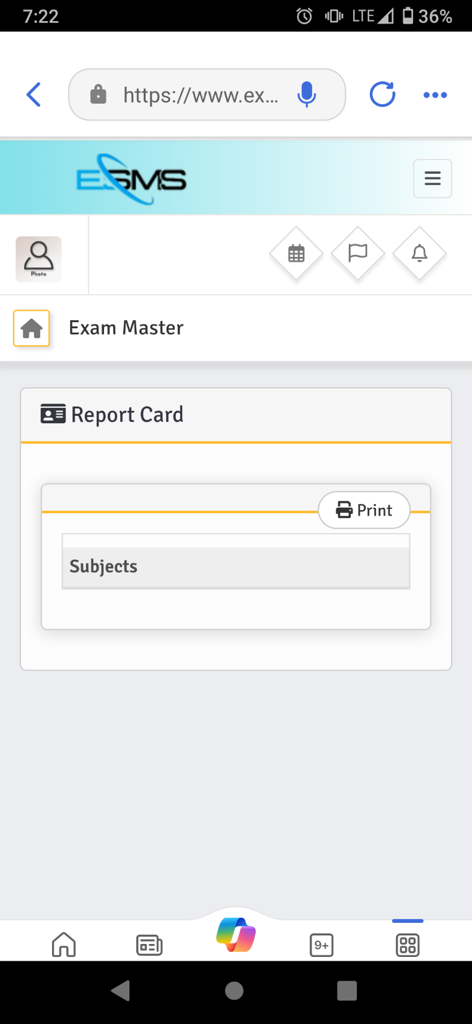

**Button not active**

**Academics: Portal of DAA and HOD**

**Class Schedule**

The button **“add schedule”**is not active though present. This makes it difficult to add more than one course per day on the timetable

**Comment : which panel admin or teacher or student and menu name not clear**

**And credential student panel or teacher panel**

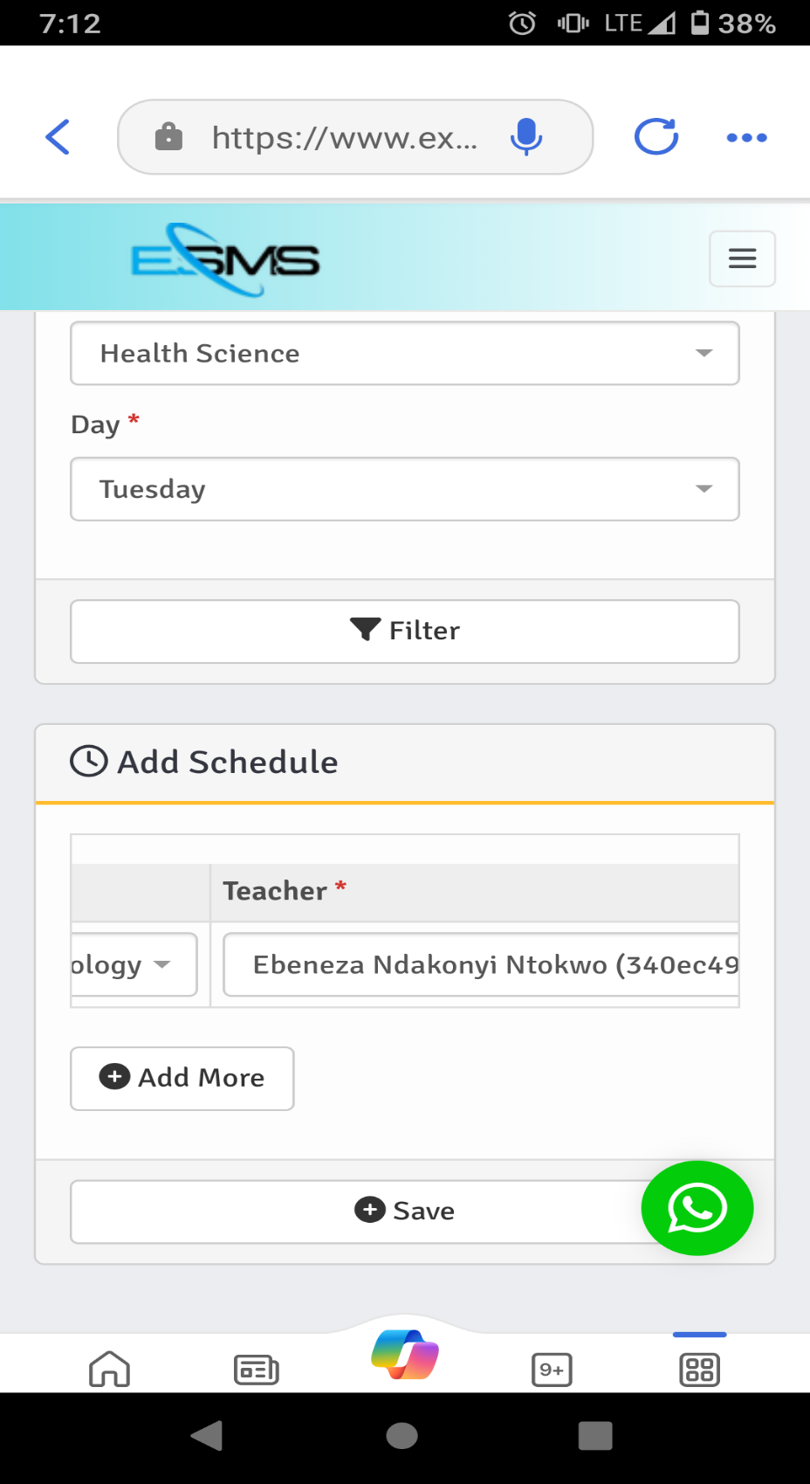

**Attachments: Students Portal**

Students are unable to access uploaded lecture material on the SMS

**Comment : which panel admin or teacher or student and menu name not clear**

**And credential student panel or teacher panel**

**Homework**

The option to upload a pdf document before an assignment can be uploaded should not be

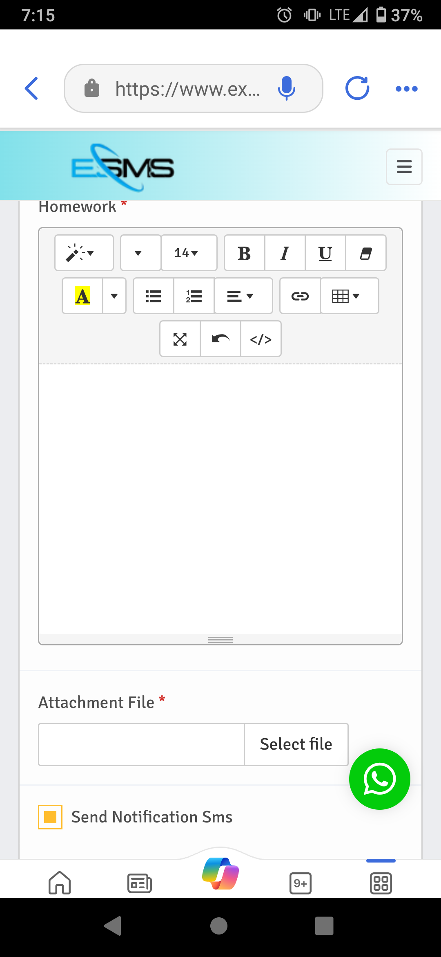

made compulsory.