# A PROJECT SUBMITTED TO

**Sarvodaya College of Science & Technology**

**RAJKOT**

**(Affiliated to Saurashtra University)**



***Submitted in partial fulfillment of the requirements for***

***the degree of***

**“Bachelor of Science in Information Technology”**

**Sem-6**

**(Year 2024-2025)**

**Submitted By** **Guided By**

1. **Kothiya Bhaumik**   **Mr. Parth Sir**
2. **Donga Parth**

INDEX

|  |  |  |
| --- | --- | --- |
| No. | Description | Page No. |
| 1 | Acknowledgment | 3 |
| 2 | Preface | 4 |
| 3 | Project Profile | 5 |
| 4 | Project Definition | 6 |
| 5 | Current System | 7 |
| 6 | Proposed System and its Features | 8 |
| 7 | Introduction to c# | 9 |
| 8 | Introduction to sql server | 10 |
| 9 | System Requirements | 12 |
| 10 | Cost and benefit Analysis | 13 |
| 11 | Fact finding techniques | 14 |
| 12 | Hardware and Software Specification | 15 |
| 13 | Tools And Technology | 16 |
| 14 | System development life cycle (SDLC) | 17 |
| 15 | Data Flow Diagram | 20 |
| 16 | Activity Diagram | 22 |
| 17 | Data Dictionary | 23 |
| 18 | Admin Side –Login | 24 |
| 19 | Admin Side –Dashboard | 24 |
| 20 | Admin Side –Add User | 25 |
| 21 | Admin Side –View User | 25 |
| 22 | Admin Side –Profile | 26 |
| 23 | Pharmacist Side—Login | 26 |
| 24 | Pharmacist Side—Dashboard | 27 |
| 25 | Pharmacist Side—Add Medicines | 27 |
| 26 | Pharmacist Side—View Medicines | 28 |
| 27 | Pharmacist Side—Update Medicines | 28 |
| 28 | Pharmacist Side—Validity check | 29 |
| 29 | Pharmacist Side—Sell Medicines | 29 |
| 30 | About testing | 30 |
| 31 | Future Enhancement | 32 |
| 32 | Vote of Thanks | 33 |

ACKNOWLEDGMENT

First, we are grateful to the pharmacists and healthcare workers who shared their knowledge and ideas with us. Your feedback was very important in making sure the system works well for everyone.

We also want to thank the development team for their hard work and skills in building the system. Your dedication has resulted in a user-friendly platform that improves how pharmacies operate and helps patients.

A special thanks goes to our project sponsors and stakeholders for their support and guidance. Your vision for a better pharmacy management solution encouraged us throughout the project.

We appreciate the efforts of our testing team, who carefully checked the system to find and fix any issues. Your work helped us create a reliable product.

Finally, we want to thank our families and friends for their support and understanding during this project.

Together, we have developed a Pharmacy Management System that makes pharmacy work easier and improves patient care. Thank you all for your help!

PREFACE

In today’s healthcare world, pharmacies play an important role in helping people manage their health. The Pharmacy Management System (PMS) was created to make the work of pharmacies easier and more efficient. This preface explains what the system is about and why it is important.

Pharmacies do many tasks every day, like filling prescriptions, managing inventory, handling payments, and keeping track of patient information. Doing all these tasks by hand can take a lot of time and can lead to mistakes, which might affect patient safety.

The Pharmacy Management System is designed to solve these problems. It uses technology to automate many of the daily tasks that pharmacists need to do. This means pharmacists can spend more time caring for their patients instead of doing paperwork. The system also helps pharmacies follow important rules and regulations, making it a reliable tool for modern healthcare.

In this document, we will look at the features of the Pharmacy Management System and how it benefits both pharmacy staff and patients. We will also share details about how the system was developed and the teamwork involved in creating it.

We believe that the Pharmacy Management System will greatly improve how pharmacies operate, make patient care safer, and contribute to a more efficient healthcare system.

PROJECT PROFILES

#### **Project Title Pharmacy Management System**

Institution :- Sarvodaya College of Science & Technology

Front End Tool :- C#.NET

Back End Tool :- Sql server

Documentation Tool :- Microsoft Word

Operating System :- Windows 11

Editor :- Visual Studio 2015

Requirements

Platform :- Microsoft Windows 10,11

Hardware :- 64-bit Processor, 300 MHz, 4 GB RAM

Submitted By :- Kothiya Bhaumik

Donga Parth

Submitted To :- Sarvodaya College of Science & Technology

PROJECT DEFINITION

A Pharmacy Management System (PMS) is a specialized software designed to help pharmacies streamline their daily operations and improve overall efficiency. It automates key tasks such as prescription handling, inventory management, billing, and patient record maintenance. By using a PMS, pharmacists can quickly and accurately process prescriptions, ensuring that patients receive the right medications without delay. This not only enhances the workflow within the pharmacy but also improves patient safety by minimizing the risk of human errors associated with manual processes.

In addition to prescription management, a PMS provides tools for tracking inventory levels, allowing pharmacies to know when to reorder medications and reduce the chances of running out of essential items. The system also helps maintain comprehensive patient records, which include medication history and allergies, enabling pharmacists to offer personalized care and advice. Furthermore, the PMS can generate reports that assist pharmacy managers in making informed business decisions by analyzing sales data and operational efficiency. Overall, a Pharmacy Management System plays a crucial role in modernizing pharmacy operations, enhancing customer service, and ensuring compliance with healthcare regulations.

CURRENT SYSTEM

This project is useful to bye to computer all devices and meat to all information for the computer device.

Users just have to create his/her profile.

Signup process is completely free for user.It project though to take all information for the computer hardware devices.The admin has already given rights to all users to buy any item from this Application….

PROPOSED SYSTEM AND IT’S FEATURES

Our Pharmacy Management System is providing a flexible way for visitors to listen, view and meet to part of all services.

This desktop application is used to meet all the basic needs of any pharmacy. This provides a user-friendly behavior to the pharmacist in any pharmacy all over.

INTRODUCTION TO C#

* **Understanding :-**
* C# (pronounced "C sharp") is a versatile and powerful programming language developed by Microsoft as part of its.
* NET initiative. Released in 2000, C# has since become one of the most popular programming languages for building a wide range of applications, from web and mobile to desktop and game development.
* C# is an object-oriented language, meaning it is based on the concept of "objects," which can contain data and methods that operate on that data.
* This approach allows developers to create modular, reusable code, making it easier to maintain and scale applications. Its syntax is similar to other C-based languages, such as C++ and Java, which makes it easier for programmers familiar with these languages to learn C# quickly.

INTRODUCTION TO SQL SERVER

* What is SQL Server?

SQL Server is a relational database management system (RDBMS) developed by Microsoft. In C#, you can interact with SQL Server to perform operations such as querying data, inserting, updating, and deleting records.

* **Features :-**

1. **Relational Database Management:**

Supports tables, indexes, views, and stored procedures to manage relational data.

**2. Security:**

* **Transparent Data Encryption (TDE):** Protects data at rest.
* **Row-Level Security:** Controls access to rows in a database table based on user characteristics.
* **Dynamic Data Masking:** Obscures sensitive data in result sets.

**3. Performance and Scalability:**

* **In-Memory OLTP:** Optimizes transaction processing for high- performance applications.
* **Query Optimizer:** Analyzes and optimizes queries for better performance.
* **Partitioning:** Improves query performance and manageability for large tables.

**4. Cross-Platform Support:**

Recent versions support Linux, enabling a broader range of deployment options. So SQL server provides a broader concept of cross platform.

**5. Temporal Tables:**

Automatically keeps track of historical data changes, allowing easy access to previous states of data.

* **Limitation :-**

The default connection pooler time-out is 15 seconds. If the pooler can't satisfy the request before the time-out, an exception is thrown. To return a connection to the pool, you should close it when you're done using it.

The number of objects in a database, or available memory, limits the maximum values of various objects. This includes users, tables, views, stored procedures, and more

SYSTEM REQUIREMENT

It specified minimum requirement of any project .It contain hardware and software requirements of project. The detail about minimum system requirement in this project as given bellow.

1. **Platform (Software):-**
   * Visual Studio 2015
   * Windows 10,11
   * Windows any other platform
2. **Front End And Back End Tools (Software):-**

* **Front End Tools:**
* C#
* **Back End:**
* SQLServer

1. **Hardware Requirement Specification:-**

* 512 GB ROM.
* Processor 1.6GHz or faster

COST AND BENEFIT ANALYSIS

# Feasibility Study :-

Feasibility study provides us information about cost of our project. This work on three-feature technical, economical, operational feasibility study.

* **Technical :-**

Technical feasibility check the project is technically possible or not. Technical feasibility can work for the project to be done with current equipment, existing software technology & available personnel. There is need for new technology.

* **Economical :-**

Economical Feasibility check, there are sufficient benefits to creating the system. It determines costs and expected of each of the alternative

* **Operational :-**

Will the system be used if it is developed & implemented?

Will there be resistance from user that will undermine the possible

application the possible application benefits?

FACT FINDING TECHNIQUE

The analysis doesn’t know the working process of the user for which, he is going to develop information system. The analyst uses specific methods for collecting data about requirement, which is called fact-finding technique.

It includes the interview, questionnaire and record review. Analyst employees more than one of these techniques to help an accurate and comprehensive investigation. Analyst requires progressive lower level of detail for logical design. Hence it is also true that two project are never same in an information system. It means that analyst must use information-gathering tool.

* **Interview:-**

This is technique is used to collect information from individual or from groups. It is an art better learned from practice than books. It is an individual technique to gather qualitative information, opinions, policies, suggestion, underlying problem etc.

* **Questionnaires:-**

This technique is used to collect information from large number of people. Questionnaires give to every person and they fill Questionnaires. According to their answer decision are taken.

* **Record Review:-**

A good analyst gets facts from documentation. An existing system can be better understood by examining existing documents, forms and files. This record review can take place at beginning of the system study or letter in the study for comparing actual operation with what the records indicates.

* **Observation:-**

Observation can bring in missed facts, new ways to improve the existing procedures, duplicate work done inadvertently etc. Observation provides close view of working of real system. This task is delicate because people do not like to be observer when they work.

HARDWARE & SOFTWARE SPECIFICATION

* **Hardware Specification:**

**Supported Architecture :**  x32, x64

**CPU :**  4.8 GHz or higher

**Display** : 1280 x 1024

**Processor** : Intel and Ryzen based system

**RAM** : 4GB or more

**Hard Disk** : 20GB or more, 7200 RPM or higher

* **Software Specification:**

**Language** : C#

**Database** : SQL Database

**Operating System** : WINDOS 2007 and Onwards

TOOLS & TECHNOLOGY

* Front hand tools : Visual Studio 2015
* Back hand tools : SQL Database
* Front hand language : C#
* Database : pharmacy.sql
* Operating System : WINDOWS 2007 and Onwards

SYSTEM DEVELOPMENT LIFE CYCLE (SDLC)

* **Feasibility Study**
* **Requirements and Specification**
* **Design**
* **Coding and Testing**
* **Implementation**
* **Documentation**

Update

Requirements

Verify

Requirements

Verify

Specification

Verify

Design

Verify

Implementation

Test

Integration

Test

Maintenance

**This diagram gives information about day scheduling information in our project**.

|  |  |  |  |  |  |
| --- | --- | --- | --- | --- | --- |
| Planning |  |  |  |  |  |
|  | Design |
|  | Analysis &  Coding |
|  | Testing &  Implemen-  tation |
|  | Final Testing |
|  | Documen-  tation |
| 10 Days | 10 Days | 10 Days | 20 Days | 10 Days | 5 Days |

DATA FLOW DIAGRAM

(Admin Side)

Categories

New Add

View

**Admin**

User

Logout

DATA FLOW DIAGRAM

(Pharmacist Side)

Chart

Product

Medicine

Update

Registration

Logout

ACTIVITY DIAGRAM

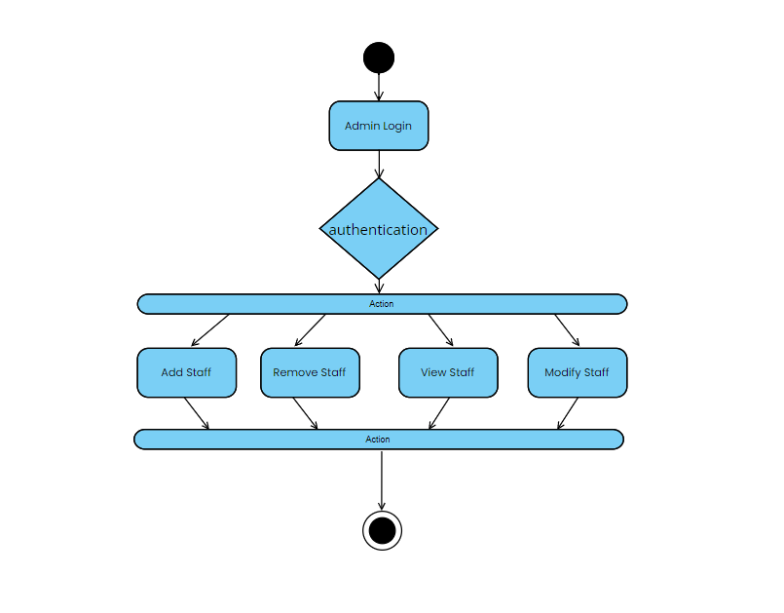

DATA DICTIONARY

(TABLE)

**● Medic table**

|  |  |  |  |
| --- | --- | --- | --- |
| **Field** | **Data type** | **Constraints** | **Description** |
| Id | int(11) | Primary Key | Id |
| mid | varchar(255) | Not Null | mid |
| mname | Varchar(250) | Not Null | mname |
| mDate | Varchar(250) | Not Null | mDate |
| eDate | Varchar(250) | Not Null | eDate |
| Quantity | BIGINT | Not Null | Quantity |
| perUnit | BIGINT | Not Null | perUnit |

**● Users table**

|  |  |  |  |
| --- | --- | --- | --- |
| **Field** | **Data type** | **Constraints** | **Description** |
| Id | int(11) | Primary Key | Id |
| userRole | varchar(50) | Not Null | userRole |
| Name | varchar(250) | Not Null | Name |
| Dob | varchar(250) | Not Null | Dob |
| Mobile | bigint | Not Null | Mobile |
| Email | Varchar(250) | Not Null | Email |
| Username | Varchar(250) | Not Null | Username |
| Password | varchar(250) | Not Null | Password |

ADMIN SIDE

LOGIN

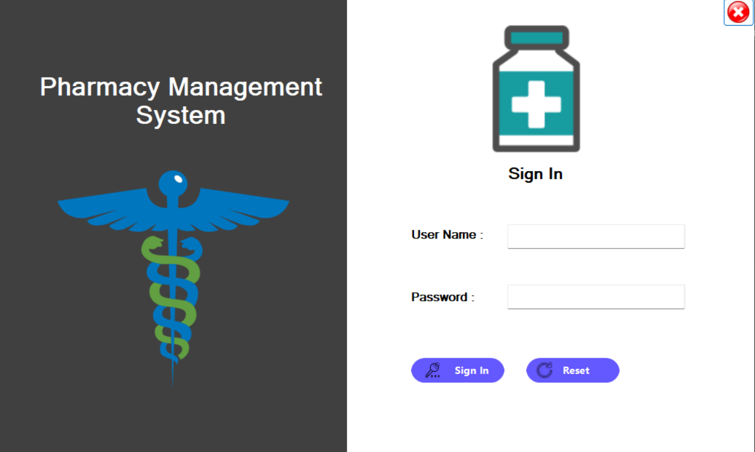  
DASHBOARD

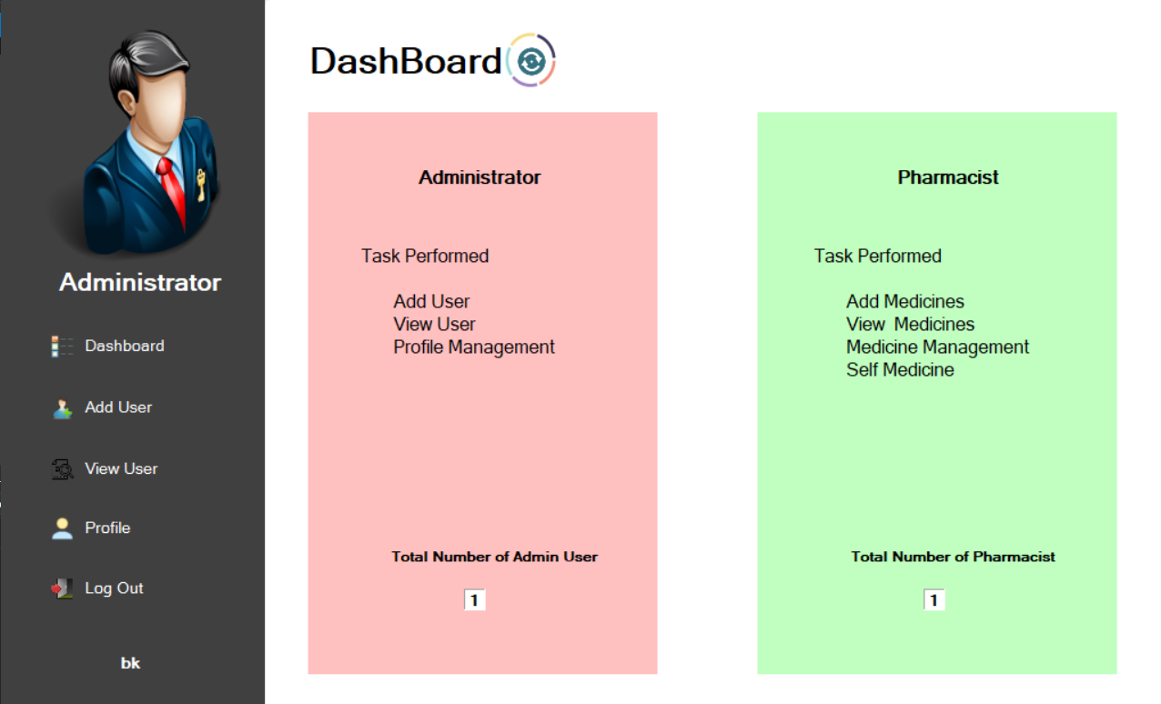

ADD USER

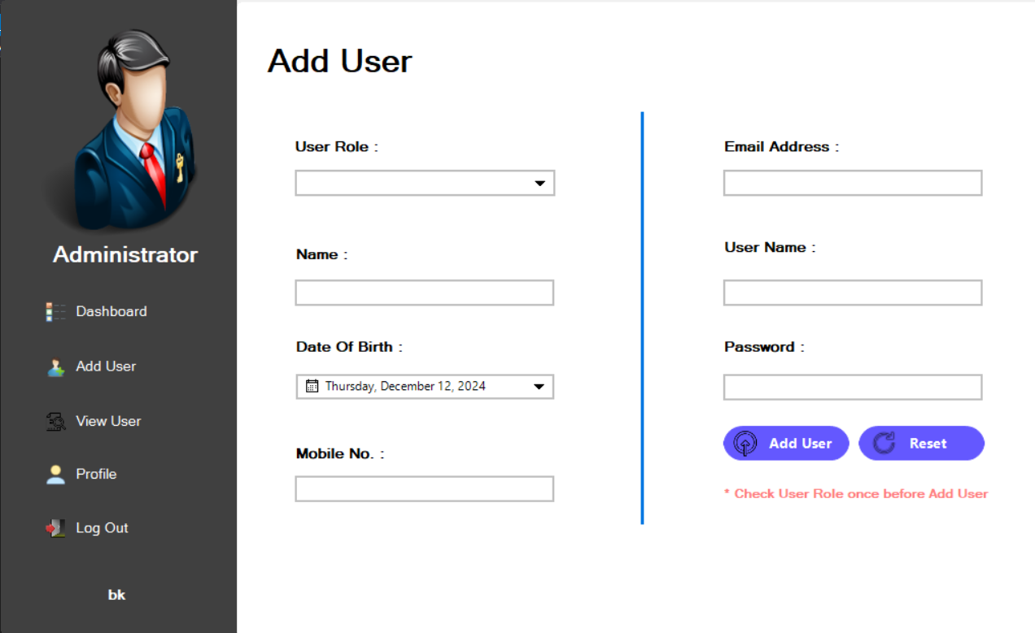

VIEW USER

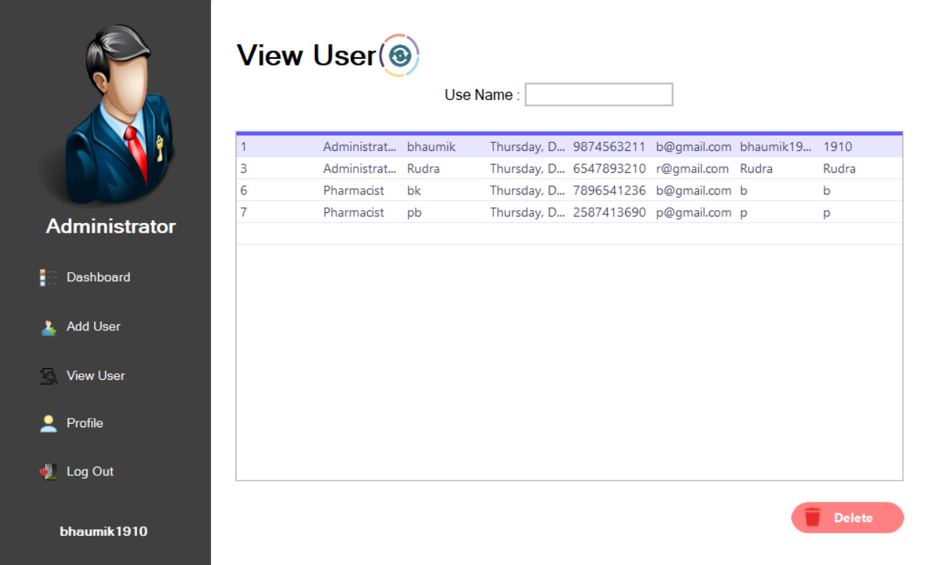

PROFILE

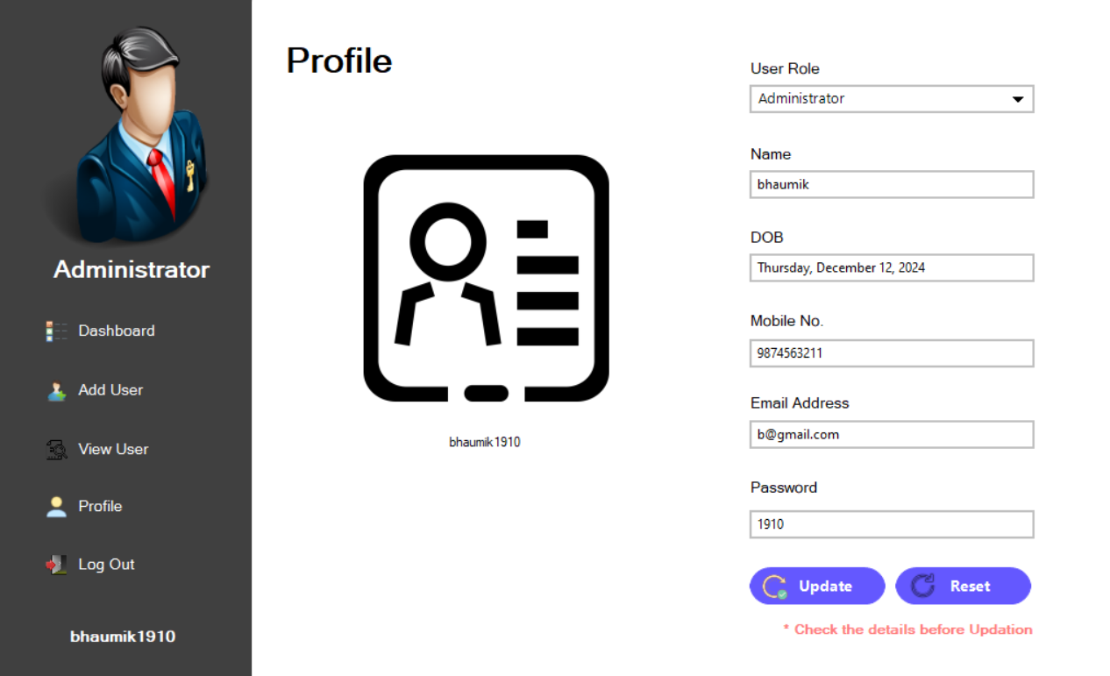

PHARMACIST SIDE

LOGIN



DASHBOARD

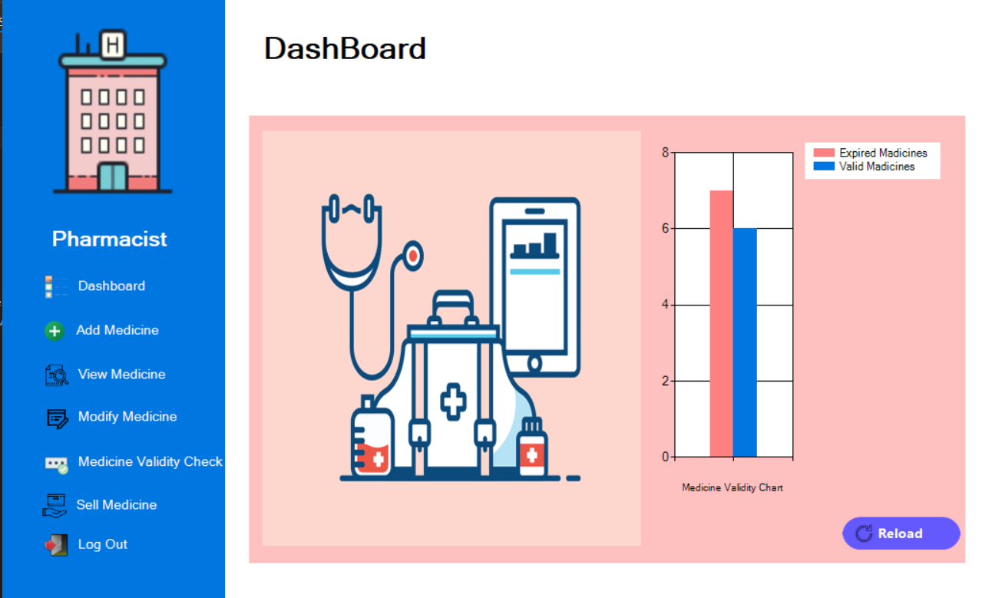

ADD MEDICINE

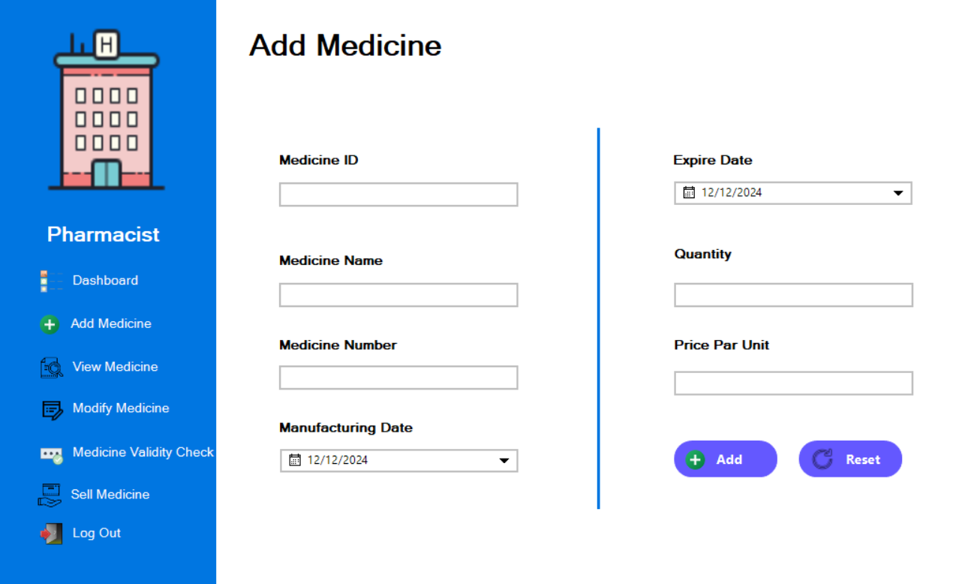

VIEW MEDICINE

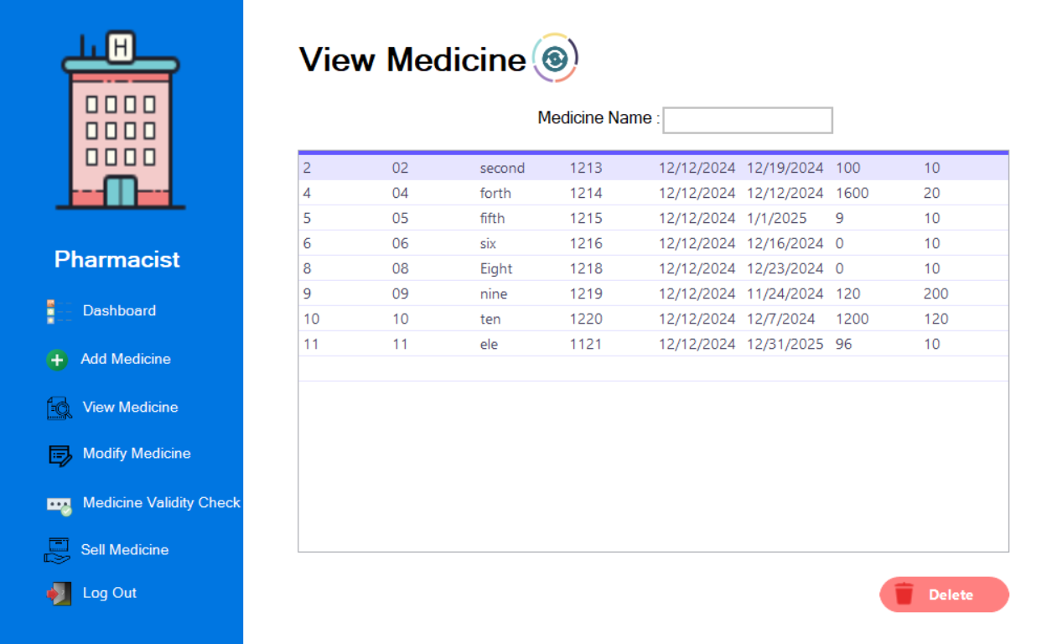

MODIFY MEDICINE

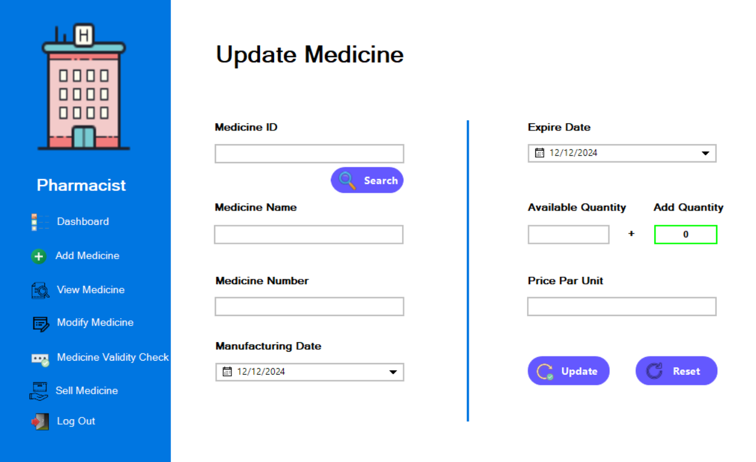

MEDICINE VALIDITY CHECK

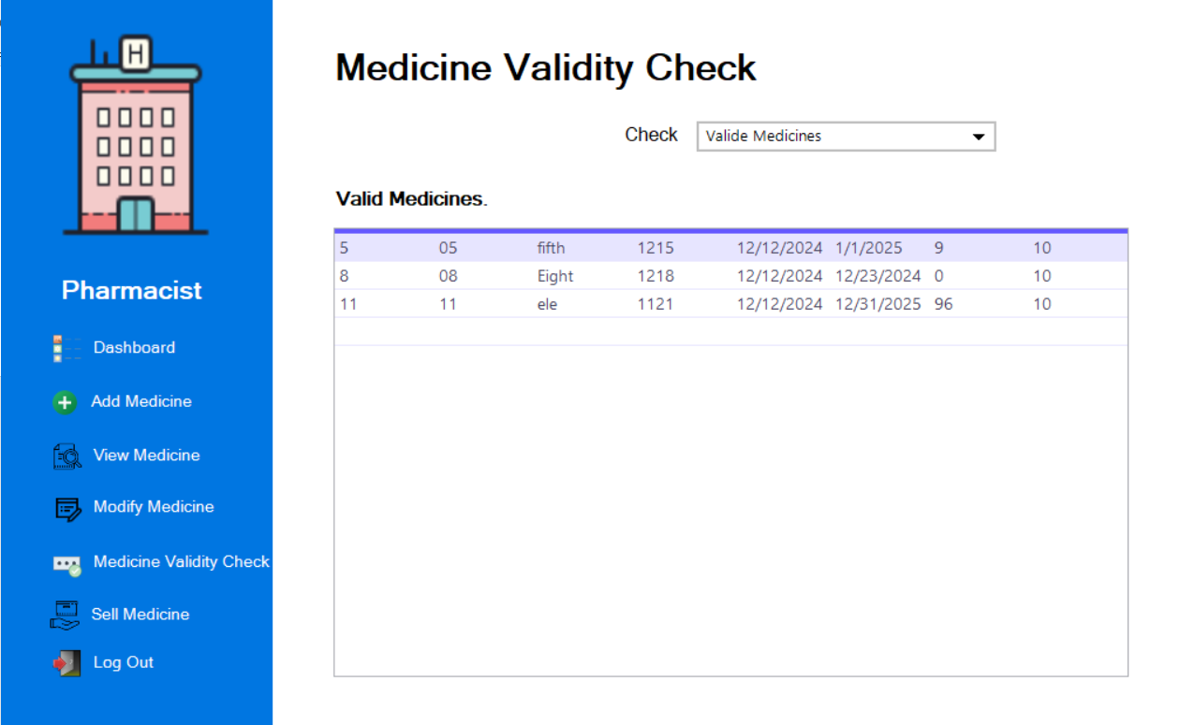

SELL MEDICINE

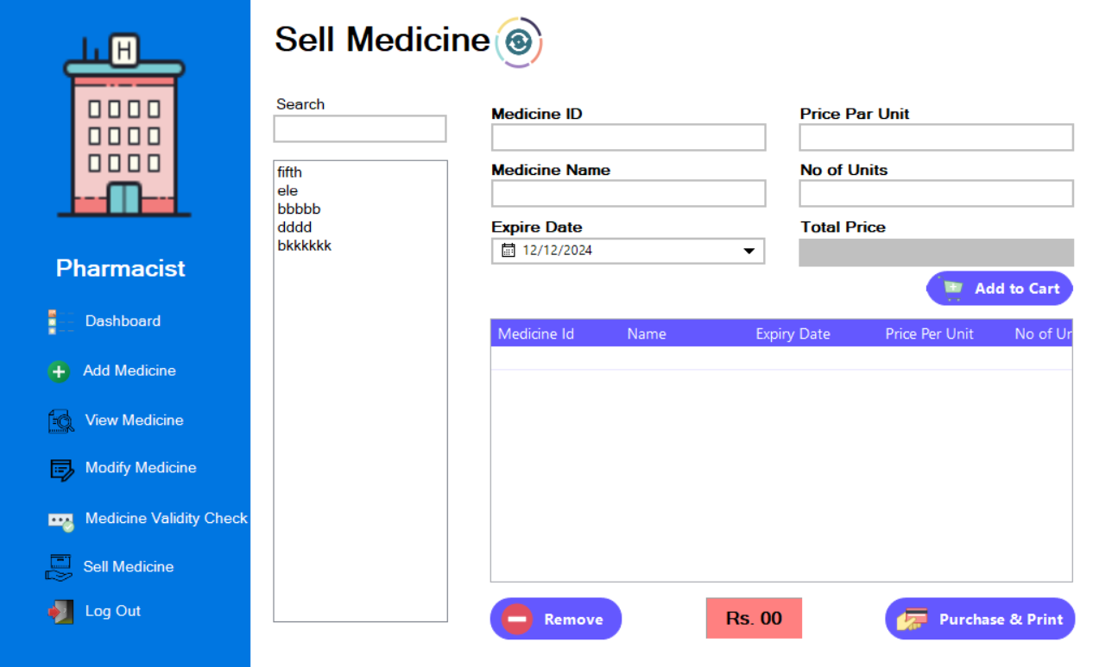

ABOUT TESTING

This is the most crucial phase in the desktop application development cycle. The developed application is thoroughly tested. Testing procedures and requirements differ with the nature of the product. It basically involves running through the whole application and verifying that the functionality is as per the designs.

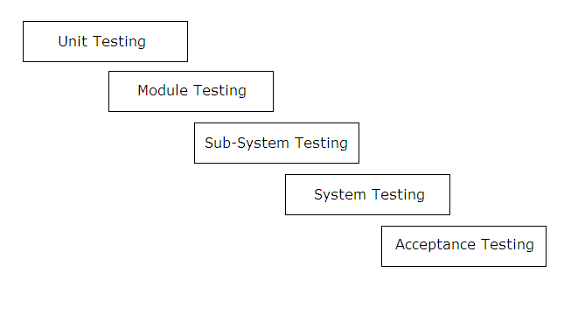

process is an iterative one with information being fed back from later stages to earlier parts of the process. The stage defines to earlier parts of the process. The stages defined in the above figure are explained as further :

**Unit Testing :-**

Individual components are tested to ensure that they operate correctly. Each component is tested independently without other system components. For example, whether an individual procedure is working properly or not is tested here.

**Module Testing :-**

A module is a collection of dependent components. A module

encapsulates related components so that it can be tested without other system modules.

In this project, one module is their, which contains a procedure,

which is used by the project.

**Sub-System Testing :-**

This phase involves testing of collection of modules, which have been integrated into sub-systems. In this project, public module is, which is used by the project.

**System Testing :-**

The sub-systems are integrated to make the entire system. This testing process is concerned with finding errors, which normally results from unanticipated interaction between sub-system and components.

**Acceptance Testing :-**

This is the final test in the testing process before the system is accepted for operational use, some times called alpha testing. This process states whether the project satisfies all requirements specified by the customer or not.

FUTURE ENHANCEMENT

Healthmart Pharmacy provides a flexible way for pharmacists to collaborate with the customers as per their medicines needs…

Healthmart Pharmacy this time is just a demo desktop application but in future publicity to add advertises uploads any kind of User information in our site.

Healthmart Pharmacy proved to meet to all the informations and services regarding Pharmacy…

BIBLIOGRAPHY

* **WEB SITE :-**
  + - 1. <http://www.youtube.com>
      2. [http://www.google.com](http://www.google.com/)
      3. [http://chatgpt.com](http://www.codeguru.com/)

VOTE OF THANKS

At last but not the least, we would like to extend our thanks to all supporters, including family members and as well as our classmates and external friends who have helped us implicitly or explicitly. No amount of words written here will suffice for our sense of gratitude towards all of them.